WEEK 3 TASK – MANUAL TESTING EXECUTION
Selected Software: Mozilla Firefox
Internship: YUVA Intern – QA Engineer Internship
Prepared by: Rhythm Shetty
Reference: Week 2 – Test Case Development

1. Objective
Manually execute the 14 test cases developed in Week 2 for Mozilla Firefox, and document the outcome of each in the Actual Result and Status fields. Each result is recorded from direct observation and supported by a screenshot. Any deviation from the expected result is recorded as a Fail with the exact behaviour observed.

2. Test Environment
Software under test | Mozilla Firefox web browser
Test approach | Manual functional and basic usability testing
Device | Laptop (LAPTOP-JVGO9MA0), Intel Core i5-12450H, 8 GB RAM, NVIDIA GeForce RTX 2050
Operating system | Windows 11, Version 25H2 (64-bit)
Firefox version | 158.0
Network | Wi-Fi
Test date(s) | 19 oct 2026
Tester | Rhythm Shetty

3. Test Case Execution
Status values: Pass, Fail, Blocked, Not Executed. Red italic text marks fields to complete after running the test.

TC-01: Launch Firefox
Test Case ID | TC-01
Test Scenario | Launch Firefox (Positive)
Purpose | Verify Firefox starts successfully.
Test Steps | 1. Open Firefox from the application menu or desktop shortcut.
Expected Result | Firefox opens and displays a browser window without an unexpected error.
Actual Result | Firefox 158.0 opened in about 2 seconds from the Start menu and displayed the Home page. No error message appeared.
Status | PASS
Screenshot Evidence | 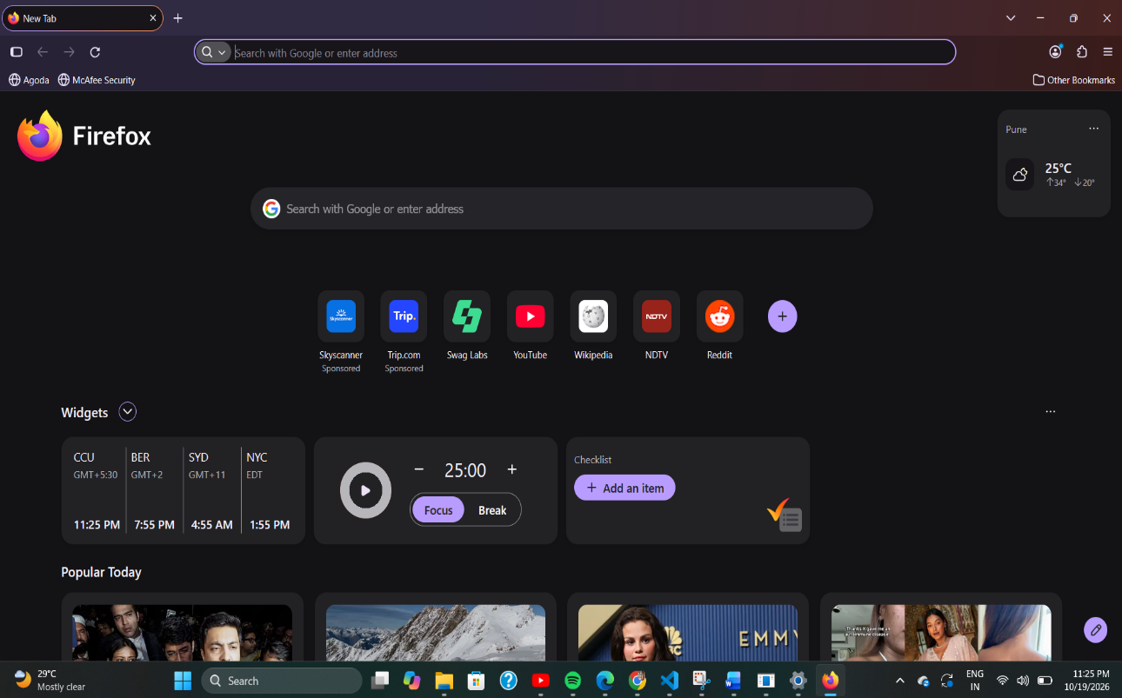

TC-02: Open a valid website
Test Case ID | TC-02
Test Scenario | Open a valid website (Positive)
Purpose | Verify Firefox loads a valid URL.
Test Steps | 1. Launch Firefox.  2. Enter a known valid website address in the address bar.  3. Press Enter and wait for the page to load.
Expected Result | The requested website loads and its main content is visible.
Actual Result | Entered wikipedia.org in the address bar and pressed Enter. The Wikipedia home page loaded in about 2 seconds with the logo, search box and language links visible. No error appeared.
Status | PASS
Screenshot Evidence | 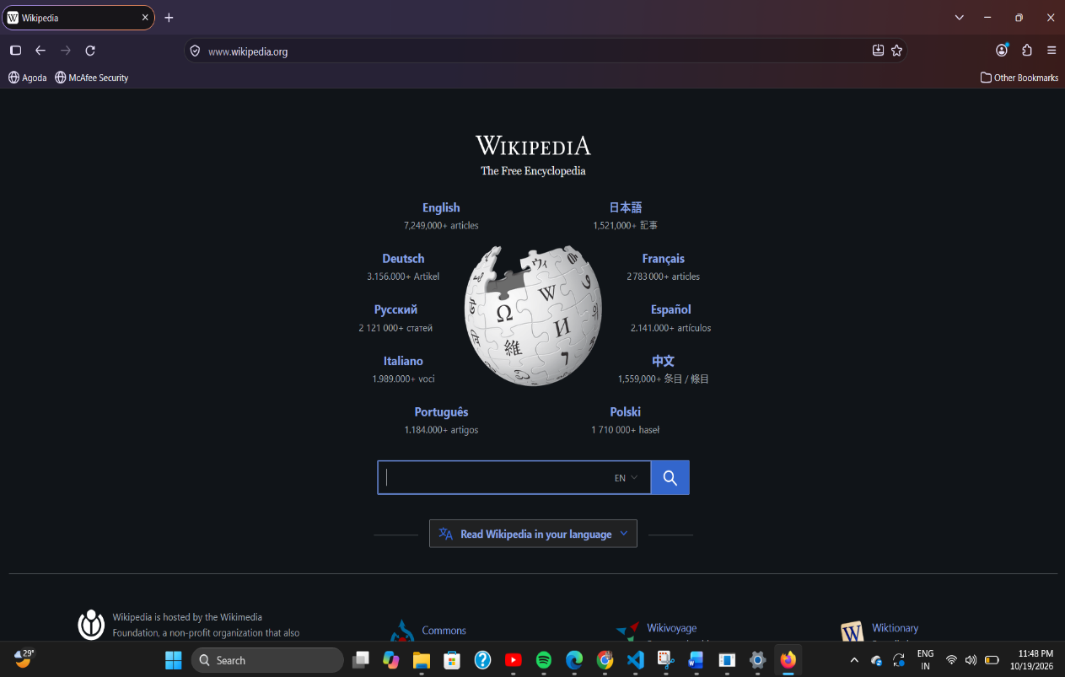

TC-03: Search using the address bar
Test Case ID | TC-03
Test Scenario | Search using the address bar (Positive)
Purpose | Verify a search query can be entered and results displayed.
Test Steps | 1. Click the address/search bar.  2. Enter a simple search query.  3. Press Enter.
Expected Result | A search results page appears for the entered query.
Actual Result | Clicked the address bar, typed 'what is software testing' and pressed Enter. Firefox opened a Google search results page for the query, showing an AI Overview, related links (IBM, GeeksforGeeks, YouTube) and the standard result tabs. No errors appeared.
Status | PASS
Screenshot Evidence | 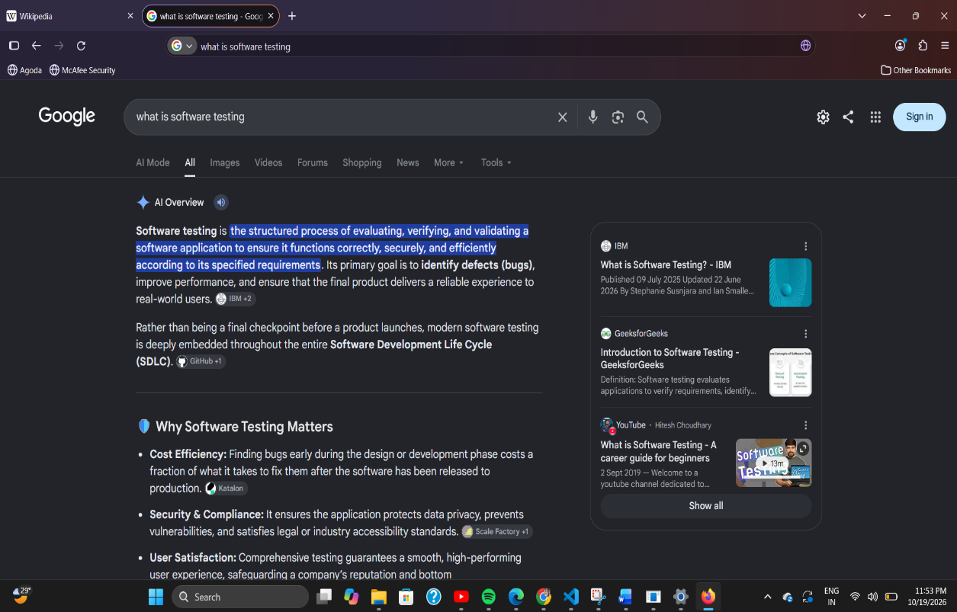

TC-04: Open and switch tabs
Test Case ID | TC-04
Test Scenario | Open and switch tabs (Positive)
Purpose | Verify tab creation and switching.
Test Steps | 1. Open a new tab using the new-tab button or Ctrl+T.  2. Open a website in the new tab.  3. Switch between the tabs.
Expected Result | A new tab opens, each tab can be selected, and the correct page is displayed.
Actual Result | Pressed Ctrl+T and a new tab opened. Entered mozilla.org and the Mozilla home page loaded. Clicked between the Wikipedia, Google search and Mozilla tabs; each tab became active and displayed its correct page. Three tabs were open in total.
Status | PASS
Screenshot Evidence | 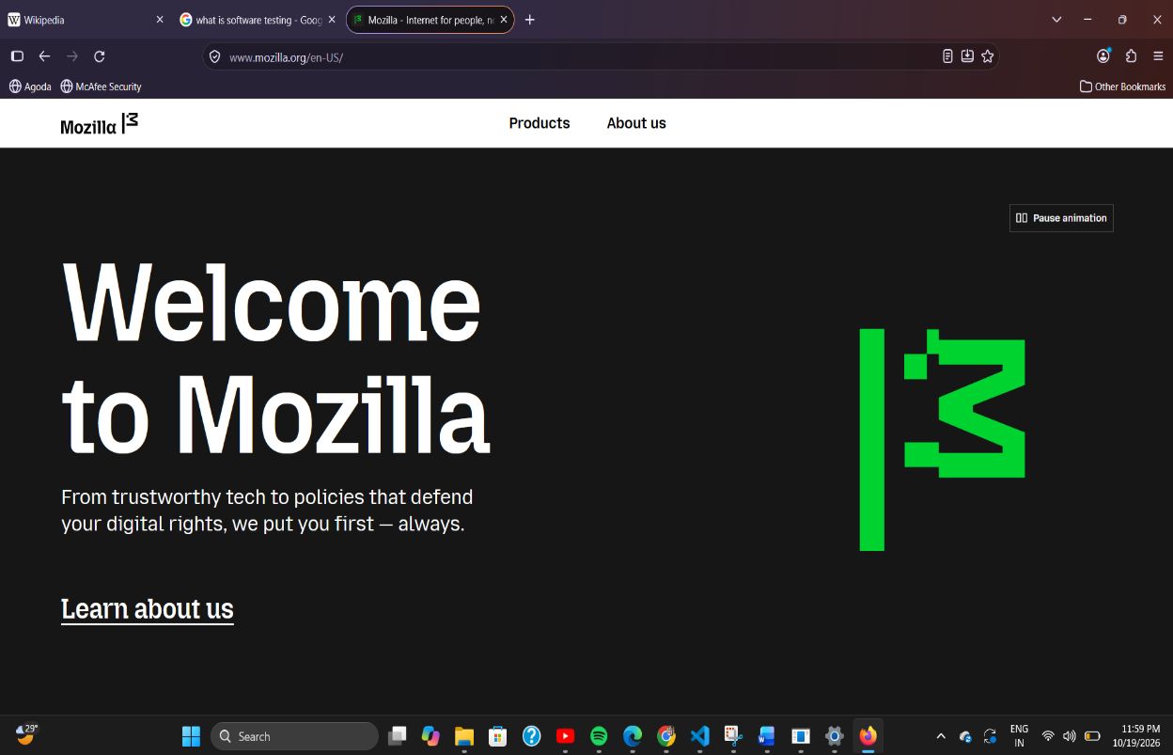

TC-05: Close a tab
Test Case ID | TC-05
Test Scenario | Close a tab (Positive)
Purpose | Verify a selected tab can be closed.
Test Steps | 1. Open two or more tabs.  2. Select one tab.  3. Close it using its close control or Ctrl+W.
Expected Result | The selected tab closes and another open tab remains accessible.
Actual Result | Selected the Mozilla tab and closed it using the X button. The tab closed immediately and the Wikipedia and Google search tabs remained open. The page displayed correctly in the remaining active tab.
Status | PASS
Screenshot Evidence | 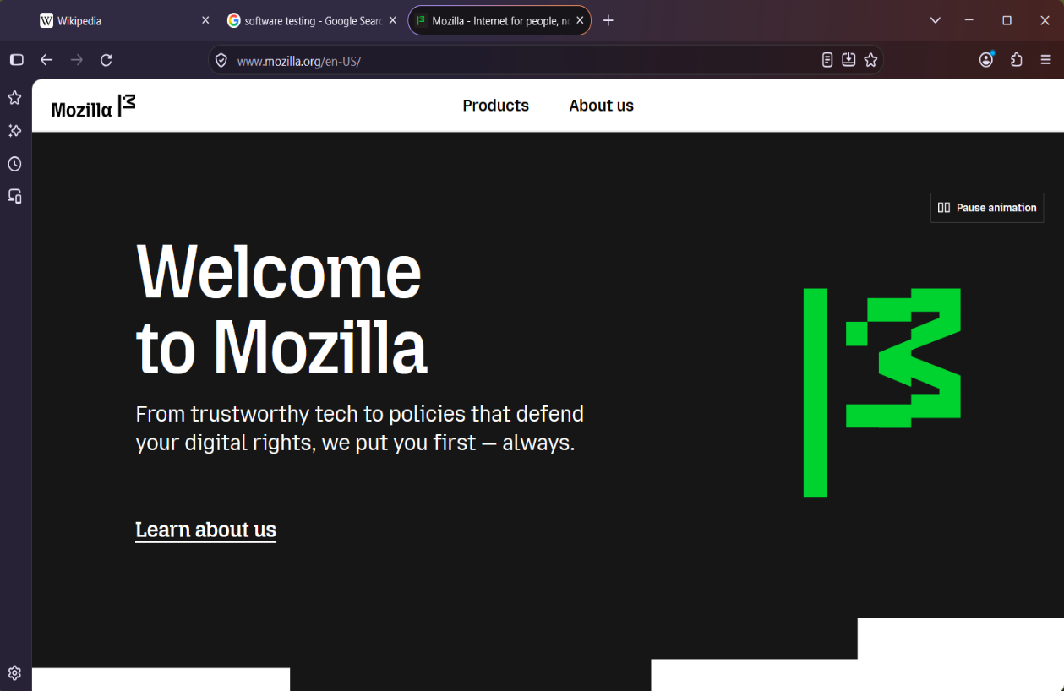  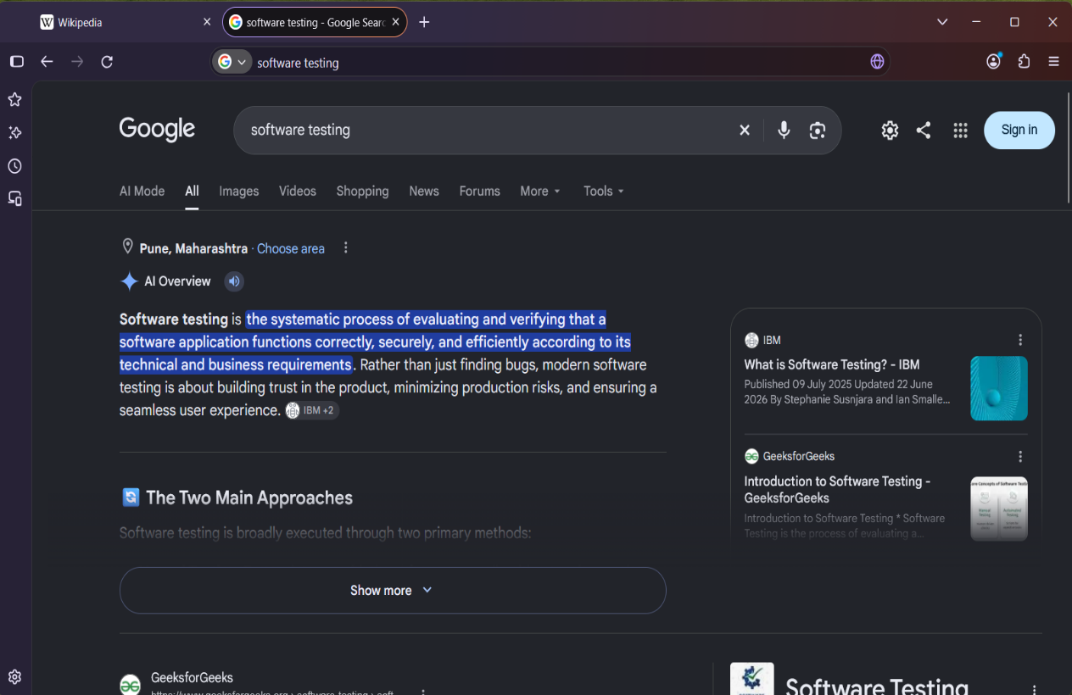

TC-06: Use Back, Forward, and Refresh
Test Case ID | TC-06
Test Scenario | Use Back, Forward, and Refresh (Positive)
Purpose | Verify basic page navigation controls.
Test Steps | 1. Open a website.  2. Follow a link to another page.  3. Use Back, then Forward, then Refresh.
Expected Result | Back and Forward navigate through visited pages, and Refresh reloads the current page.
Actual Result | Opened wikipedia.org and clicked an article link. Clicked Back and the Wikipedia home page appeared. Clicked Forward and the article reappeared. Clicked Refresh and the page reloaded with the same content. No errors appeared
Status | PASS
Screenshot Evidence | 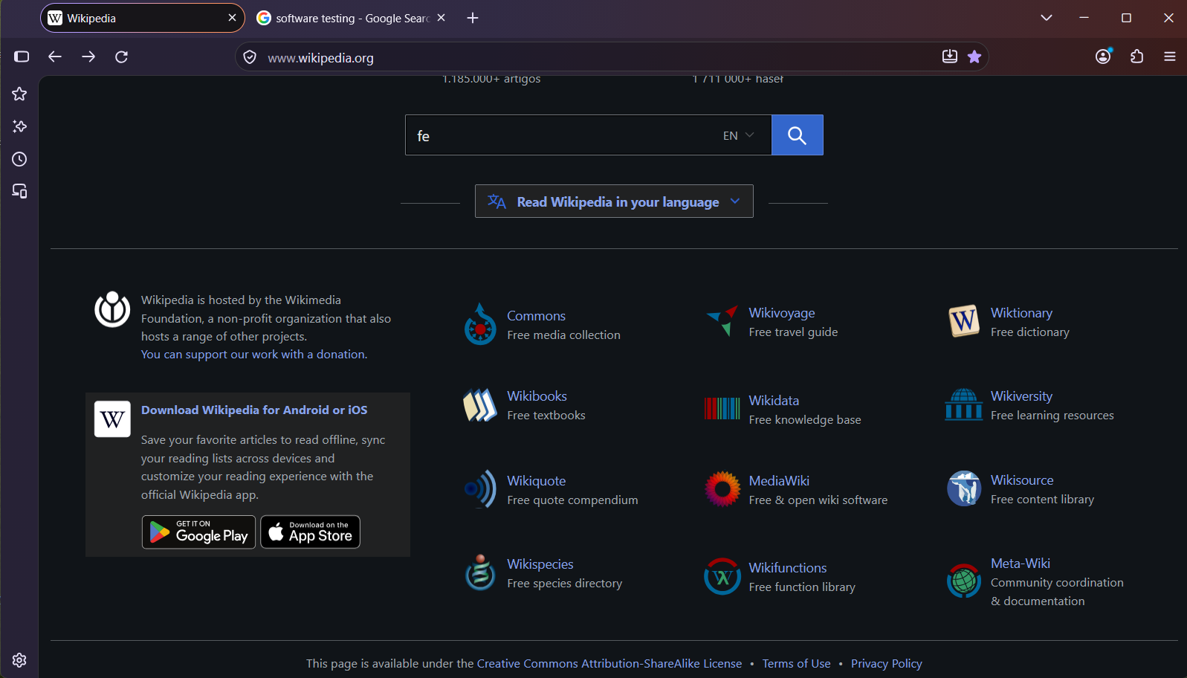  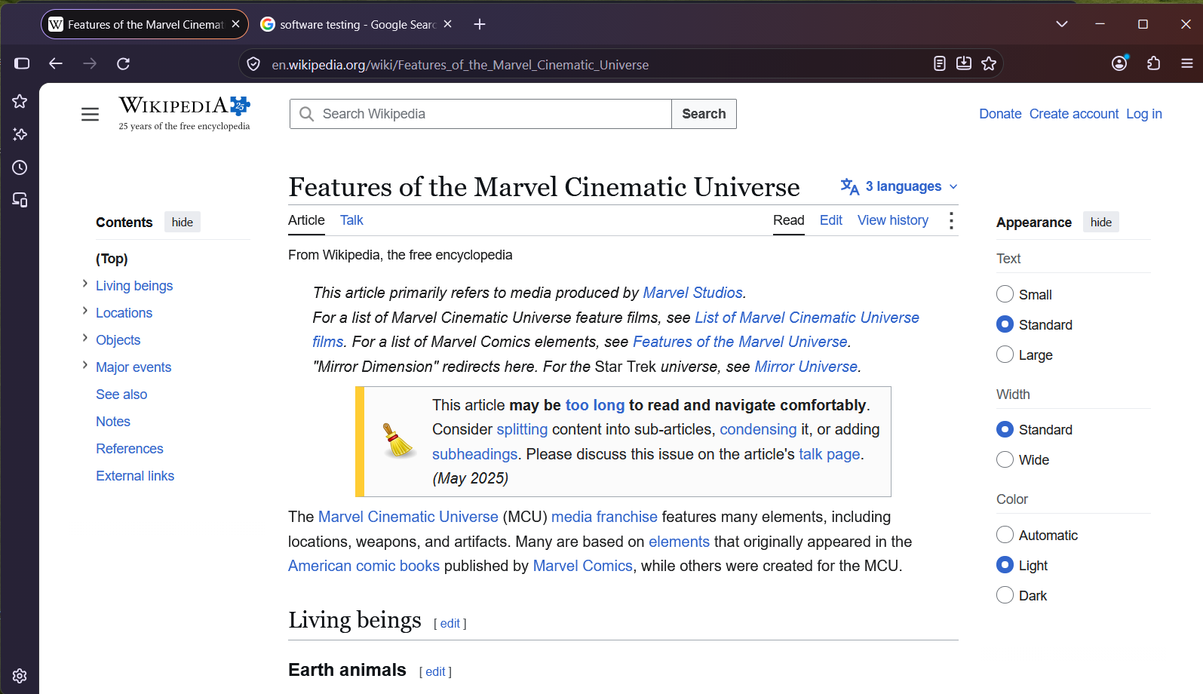  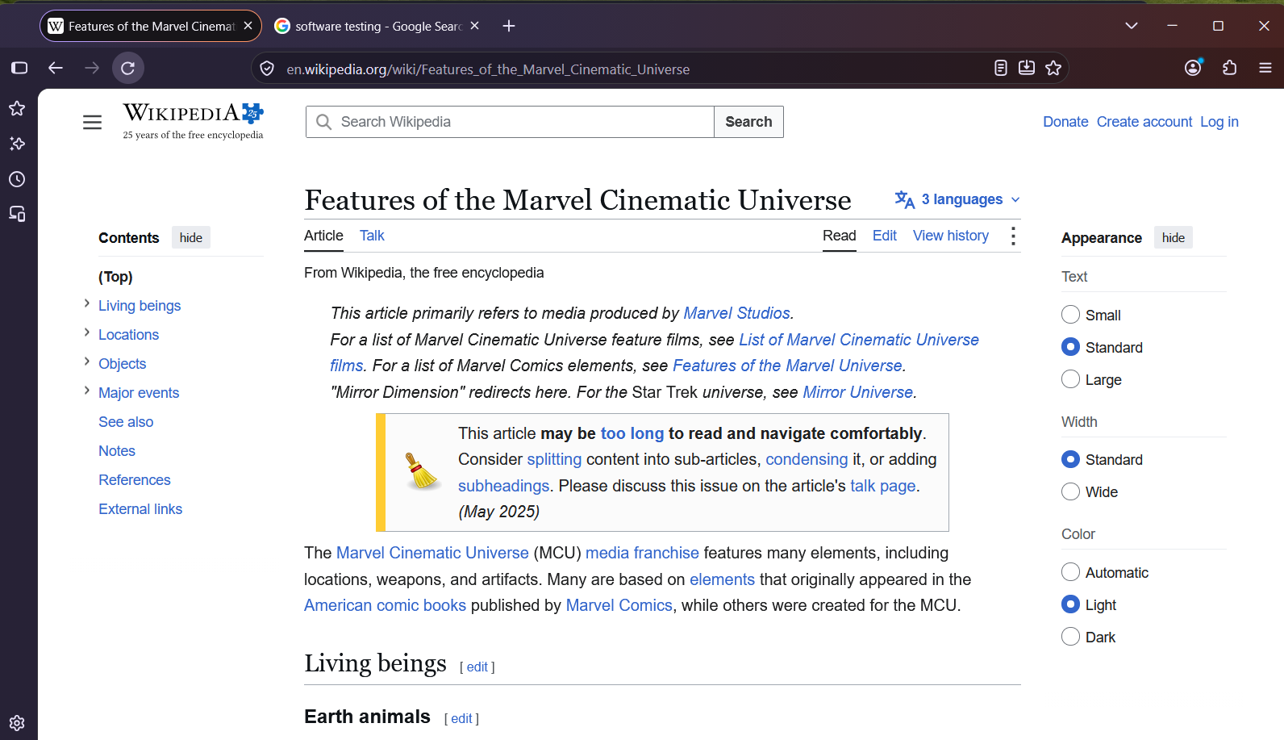

TC-07: Bookmark a page
Test Case ID | TC-07
Test Scenario | Bookmark a page (Positive)
Purpose | Verify a page can be bookmarked and found again.
Test Steps | 1. Open a website.  2. Use the bookmark control to bookmark it.  3. Open bookmarks and locate the saved page.
Expected Result | The page is saved as a bookmark and can be opened from the bookmarks list.
Actual Result | Opened the Wikipedia article ‘Features of the Marvel Cinematic Universe’ and clicked the star icon. The star turned blue and the bookmark was added, appearing in the Bookmarks panel under Recent bookmarks and on the bookmarks toolbar. Opened the bookmark from the saved list and the Marvel article loaded correctly.
Status | PASS
Screenshot Evidence | 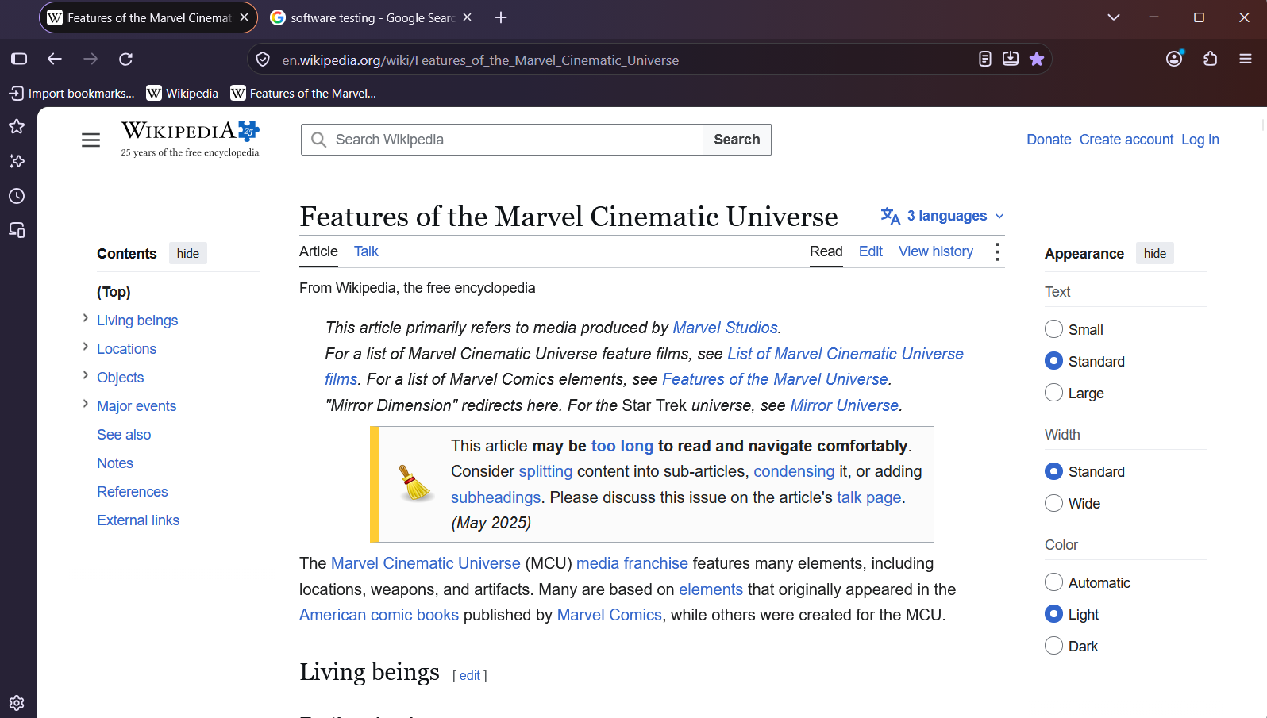  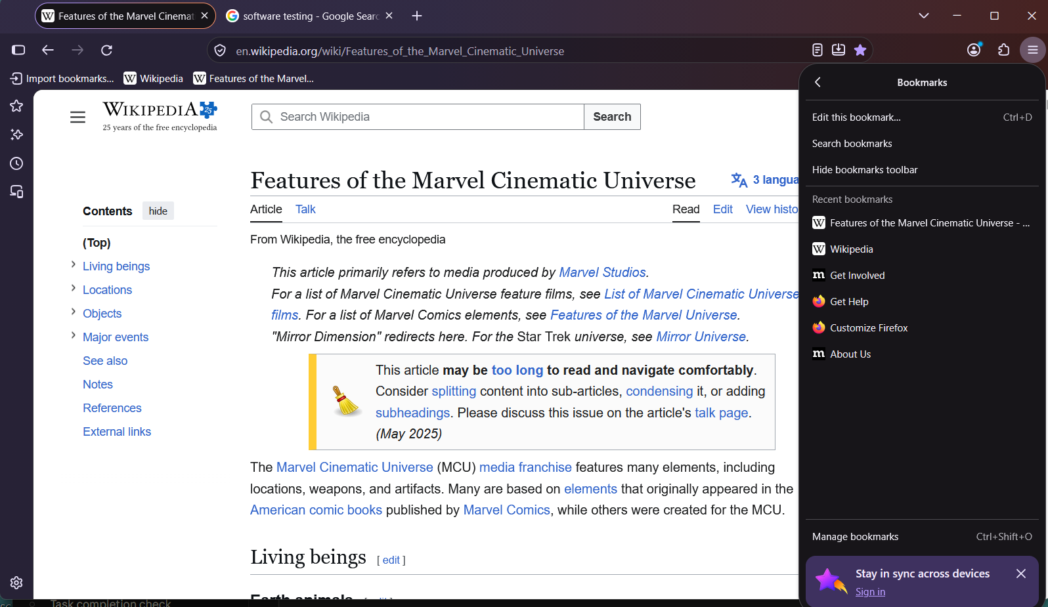

TC-08: View browsing history
Test Case ID | TC-08
Test Scenario | View browsing history (Positive)
Purpose | Verify recently visited pages appear in history.
Test Steps | 1. Visit a website.  2. Open Firefox History from the menu.  3. Locate the website just visited.
Expected Result | The visited page appears in browsing history, subject to current history settings.
Actual Result | Visited the Wikipedia article “Features of the Marvel Cinematic Universe”, then pressed Ctrl + H to open the History sidebar. The page was listed under “Today” with the correct title. Clicking the entry opened the same article. No errors appeared.
Status | PASS
Screenshot Evidence | 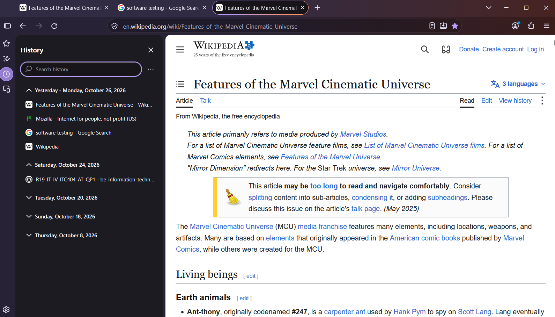

TC-09: Open Private Browsing
Test Case ID | TC-09
Test Scenario | Open Private Browsing (Positive)
Purpose | Verify a Private Browsing window can be opened.
Test Steps | 1. Open the Firefox menu.  2. Select New Private Window.  3. Confirm that a private window opens.
Expected Result | A separate window opens and indicates that Private Browsing is active.
Actual Result | Opened the Firefox menu and selected New private window. A separate window opened with a purple private browsing indicator and a message that I was in a private window. The original window stayed open. No errors appeared.
Status | PASS
Screenshot Evidence | 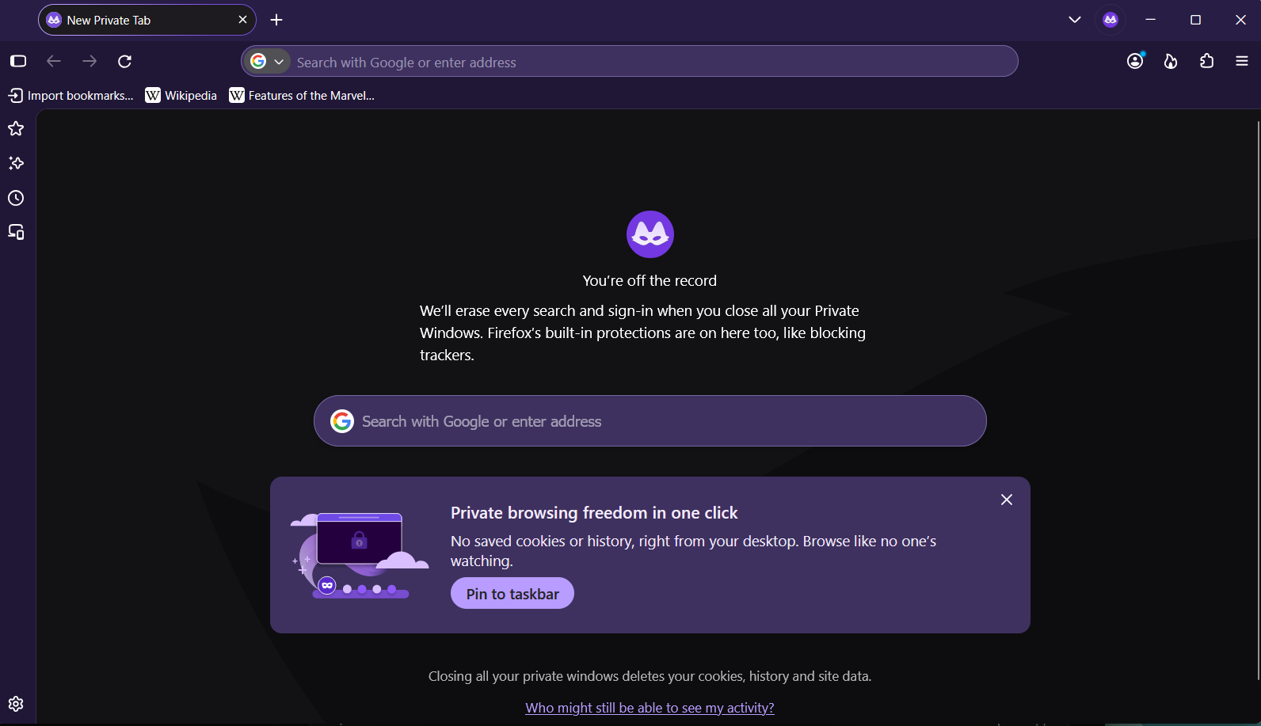

TC-10: Handle an invalid URL
Test Case ID | TC-10
Test Scenario | Handle an invalid URL (Negative)
Purpose | Observe how Firefox handles an invalid or unreachable address.
Test Steps | 1. Enter a deliberately invalid address or reserved invalid domain.  2. Press Enter.
Expected Result | Firefox does not show a successful page for an unreachable address and provides an appropriate error or search response.
Actual Result | Entered http://nosuchsite12345.invalid in the address bar and pressed Enter. Firefox did not load a page and showed an error message saying it could not find the server, with a Try Again button. No website content was displayed
Status | PASS
Screenshot Evidence | 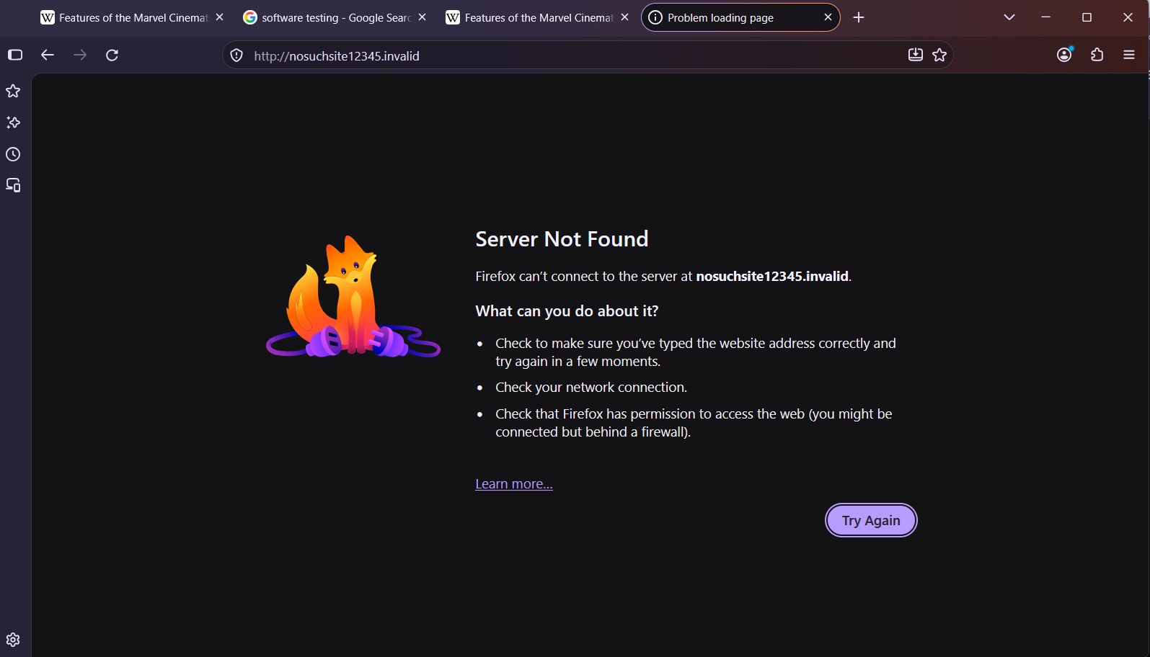

TC-11: Download a supported file
Test Case ID | TC-11
Test Scenario | Download a supported file (Positive)
Purpose | Verify a supported file can be downloaded.
Test Steps | 1. Open a trusted page providing a test download.  2. Start the download.  3. Open the Downloads panel and inspect the result.
Expected Result | The download completes or reports its state clearly, and the file is listed in Downloads.
Actual Result | Opened a PDF from muquestionpapers.com in Firefox and downloaded it using the viewer’s download option. The Downloads panel listed the file “be_information-technology_sem...-theory-rev-2019-c-scheme.pdf” with the status “Completed - 724 KB”. The PDF also displayed correctly in the built-in viewer (5 pages). No errors appeared.
Status | PASS
Screenshot Evidence | 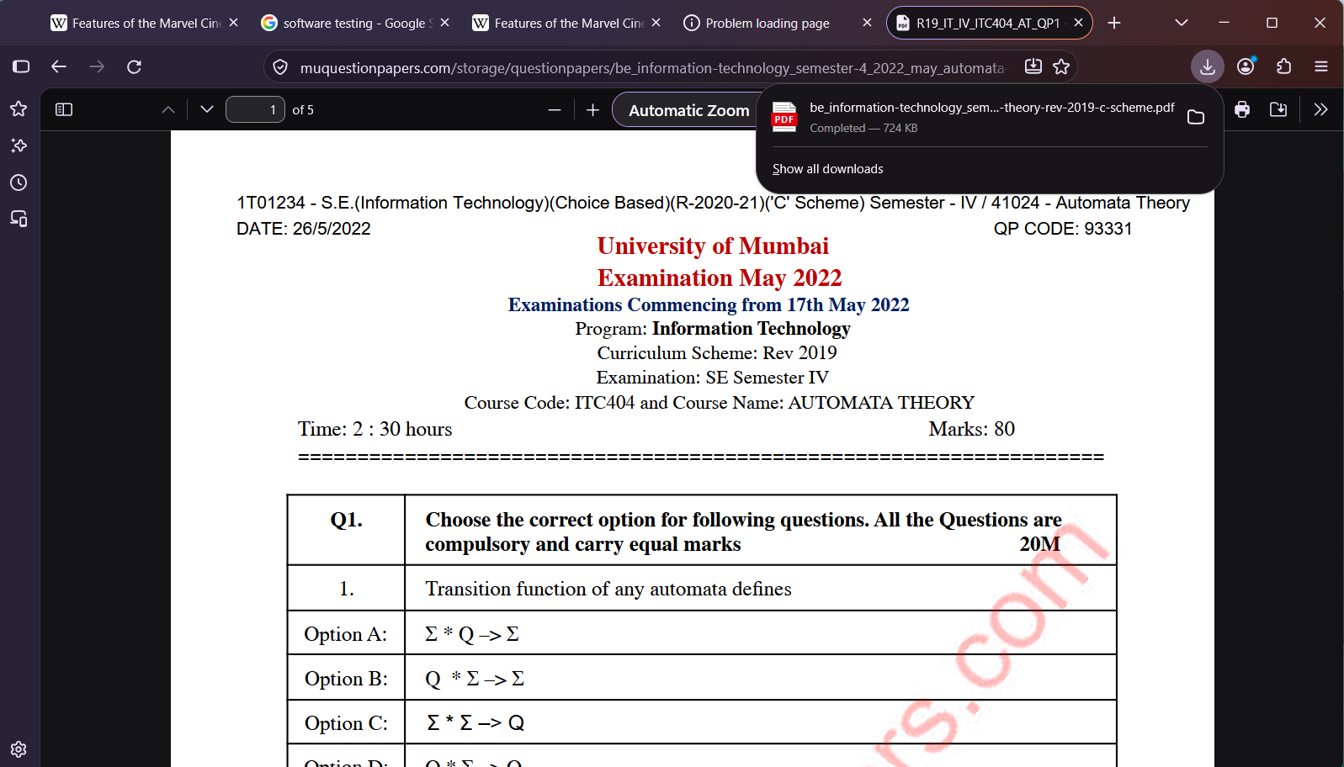

TC-12: Change a browser setting
Test Case ID | TC-12
Test Scenario | Change a browser setting (Positive)
Purpose | Verify a browser preference can be changed.
Test Steps | 1. Open Settings.  2. Change a non-sensitive preference, such as a display preference.  3. Return to the setting and confirm the value.
Expected Result | The preference is saved and remains set when checked again.
Actual Result | Opened Menu → Settings → General and changed Default zoom from 100% to 120%. A website then displayed larger than before. Returned to Settings and the default zoom still showed 120%. No errors appeared.
Status | PASS
Screenshot Evidence | 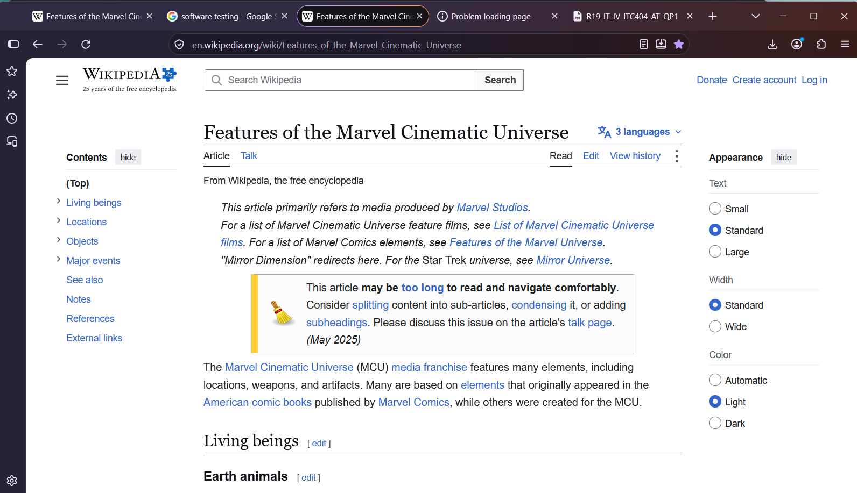  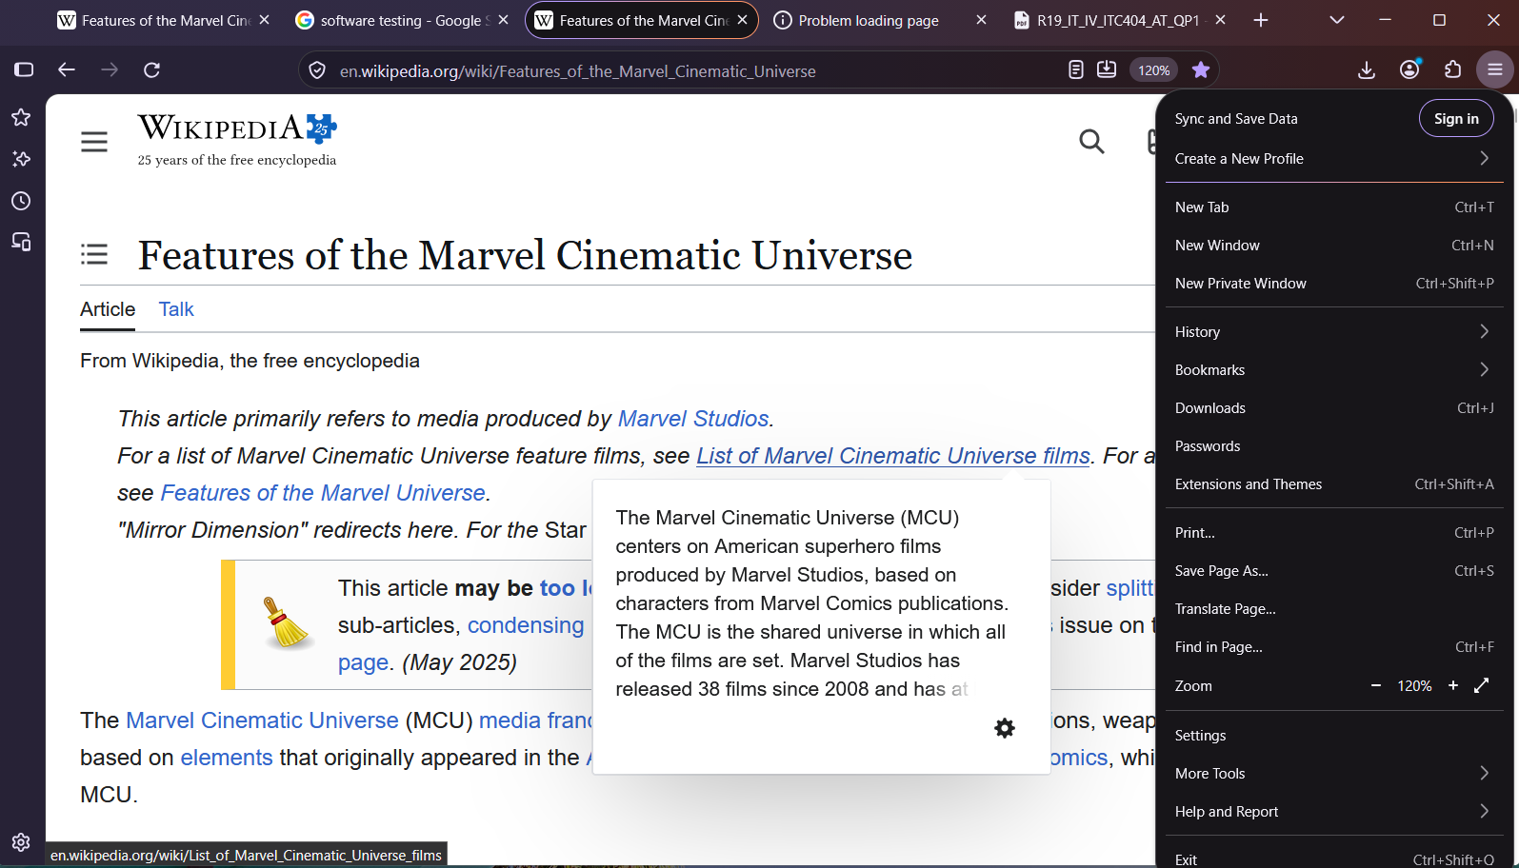

TC-13: Check a security warning safely
Test Case ID | TC-13
Test Scenario | Check a security warning safely (Negative)
Purpose | Check warning behavior using a recognized safe browser-security test resource or a URL supplied by the supervisor.
Test Steps | 1. Open the approved test resource.  2. Observe the warning, if shown.  3. Do not bypass warnings or enter personal information.
Expected Result | If Firefox recognizes the resource as unsafe, it shows a warning instead of silently treating it as a normal secure page.
Actual Result | Opened Mozilla’s phishing test page itisatrap.org/firefox/its-a-trap.html in Firefox 158.0. Firefox did not load the page. It showed a red warning page titled “Deceptive site ahead”, explaining that the page was blocked because it could trick users into installing software or revealing personal information. The page offered “Go back” and “See details” buttons. I did not bypass the warning or enter any information
Status | PASS
Screenshot Evidence | 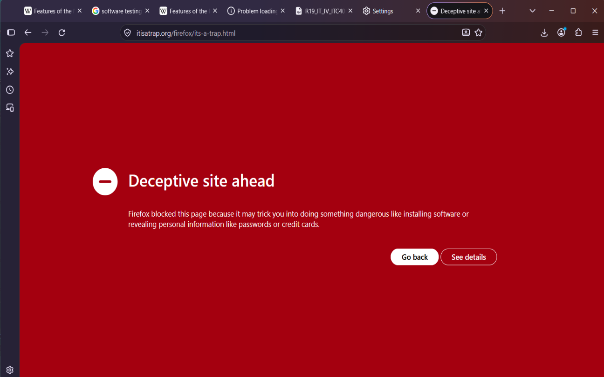

TC-14: Check page rendering at different window sizes
Test Case ID | TC-14
Test Scenario | Check page rendering at different window sizes (Positive)
Purpose | Perform a basic usability and compatibility check.
Test Steps | 1. Open a website.  2. View it in a maximized window.  3. Resize the browser to a narrower width.  4. Inspect key content and controls.
Expected Result | The browser remains usable and the page can be viewed without unexpected browser-level layout failures.
Actual Result | Opened the Wikipedia home page and viewed it in a maximized window, where all content was displayed normally. Resized the window to a narrow width. The page layout adjusted, the text remained readable and the navigation stayed usable. No content overlapped.
Status | PASS
Screenshot Evidence | 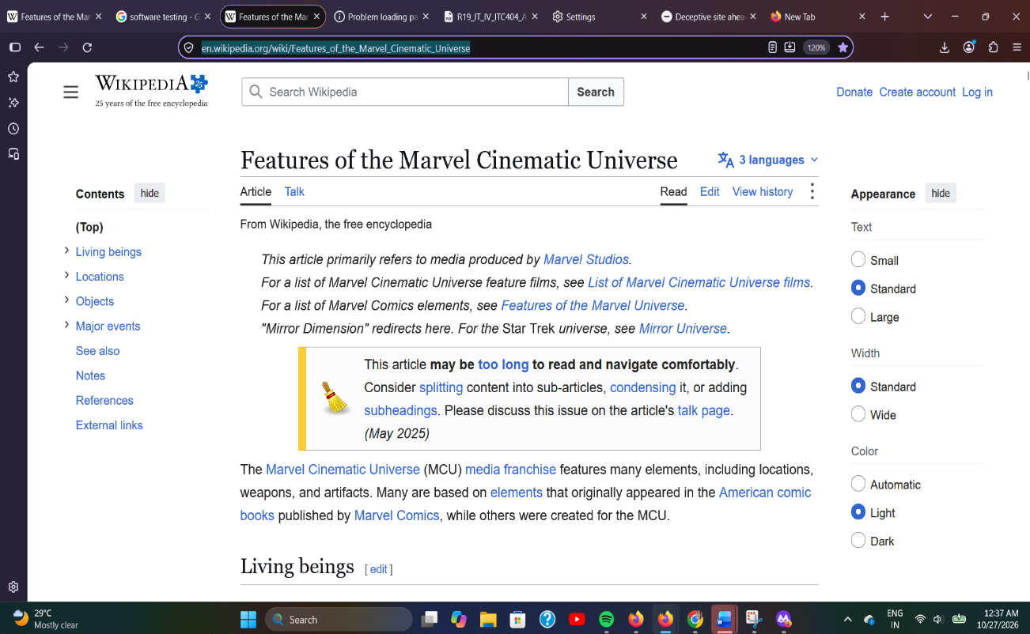  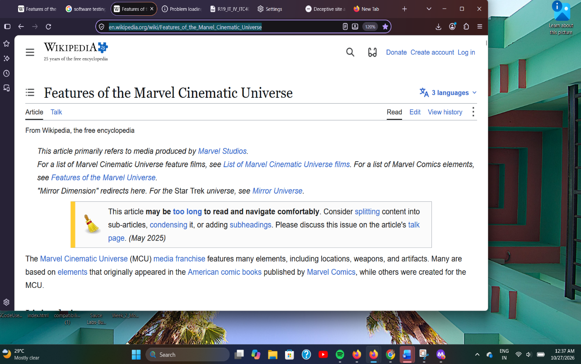

4. Test Execution Summary
Metric | Count
Total test cases | 14
Passed | 14
Failed | 0
Blocked | 0
Not Executed | 0

Overall observations: All 14 test cases were executed manually on Firefox 158.0 on Windows 11 (25H2) using a laptop with an Intel Core i5-12450H processor and 8 GB of RAM. All 14 passed. Launching, opening websites, address-bar search, tab management, navigation controls, bookmarks, history, private browsing, downloads, settings and window resizing worked as expected. Firefox showed an error page for an invalid address, and it blocked Mozilla’s phishing test page with a “Deceptive site ahead” warning. A screenshot was captured for each test case as evidence.

5. Defect Reporting

No defects were observed during execution. All test cases met their expected results.

6. Conclusion

Firefox 158.0 performed reliably across all tested areas: launching, navigation, tab handling, bookmarks, history, private browsing, downloads, settings, error handling, security warnings and window resizing. All 14 test cases passed with no defects found. Testing was limited to one device, one operating system and one browser version, and it covered basic functional and usability behaviour only, so results may differ on other systems or with deeper testing

