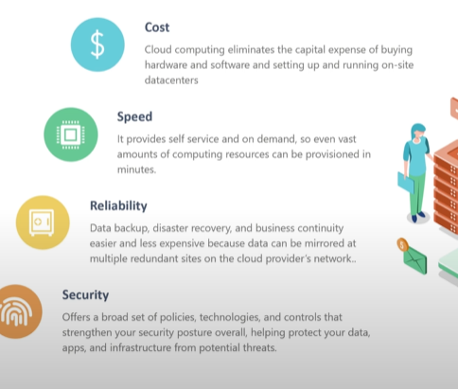

On Premise Example:

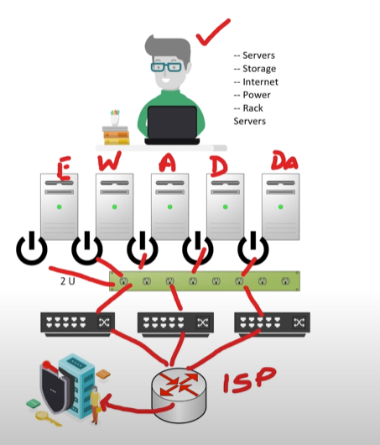

As you can see, In on premise service the administrator have to manage and monitor a lot of inputs such as the different servers (Email, web, application, etc) then in order to have a communication between them the server has to be connected to switches and for internet connectivity the routers, security is the other need. Hence a lot of work is involved in the on-premise.

**Cloud Example:**

In cloud, we do not have to worry about any monitoring and management of servers, as we can use as much servers as we need and pay for what we use. In just few clicks any servers (Email, web, application, etc) can be setup and used.

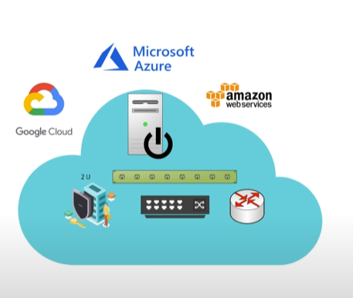

Advantages:

