Bug ID: BUG_001
Test Case ID:TC_04
Title: Large Spacing Between Product Description and Price on Mobile View.
Module: Product module
Severity:Major
Priority: Medium

Step to Reproduce:
- Login to SauceDemo.
- Go to the Products/Landing page.
- Open Developer Tools.
- Enable Device Toolbar.
- Select iPhone XR/Pixel and preview the page.
- Observe the UI responsiveness.

Expected Result:
SauceDemo landing page should be responsive and properly adapt to the selected mobile screen size.

Actual Result:
There is a large gap between the product description and the price, causing improper spacing in the mobile view.

Attachment:
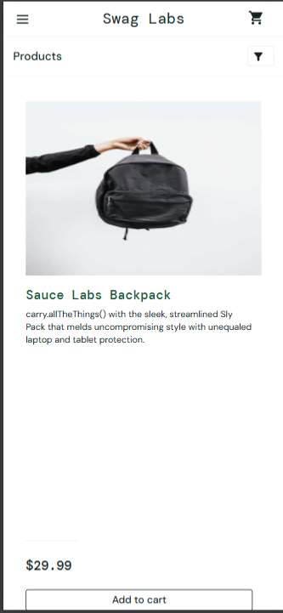

Bug ID: BUG_002
Test Case ID:TC_05
Title:Keyboard Navigation Not Working on the Product Page
Module: Product module
Severity:Minor
Priority: Low

Step to Reproduce:
- Login to SauceDemo.
- Go to the Products/Landing page.
- Use the Tab key to navigate through the page elements.
- Observe the cursor movement.

Expected Result:
The cursor/focus should move sequentially from top to bottom through all interactive elements with ease.

Actual Result:
The cursor/focus does not move when using keyboard navigation.

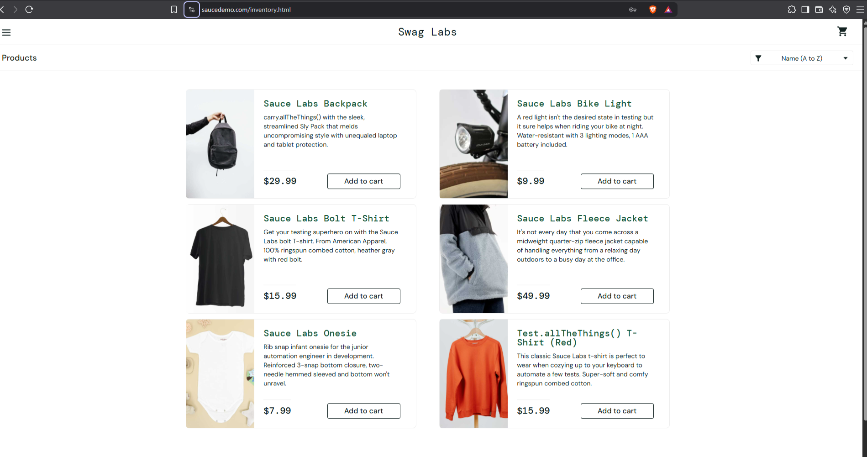
Attachment:
Bug ID: BUG_003
Test Case ID:TC_09
Title : Reset App State Does Not Reset Added Products
Module: Product module
Severity: Minor
Priority: Low

Step to Reproduce:
- Login to SauceDemo.
- Add a product to the cart.
- Open the menu.
- Click Reset App State.
- Check the cart and product page.

Expected Result:
All application states should be reset, including removing added products from the cart.

Actual Result:
Only the cart item count is reset, while the added product remains in the cart/product state.

Attachment:
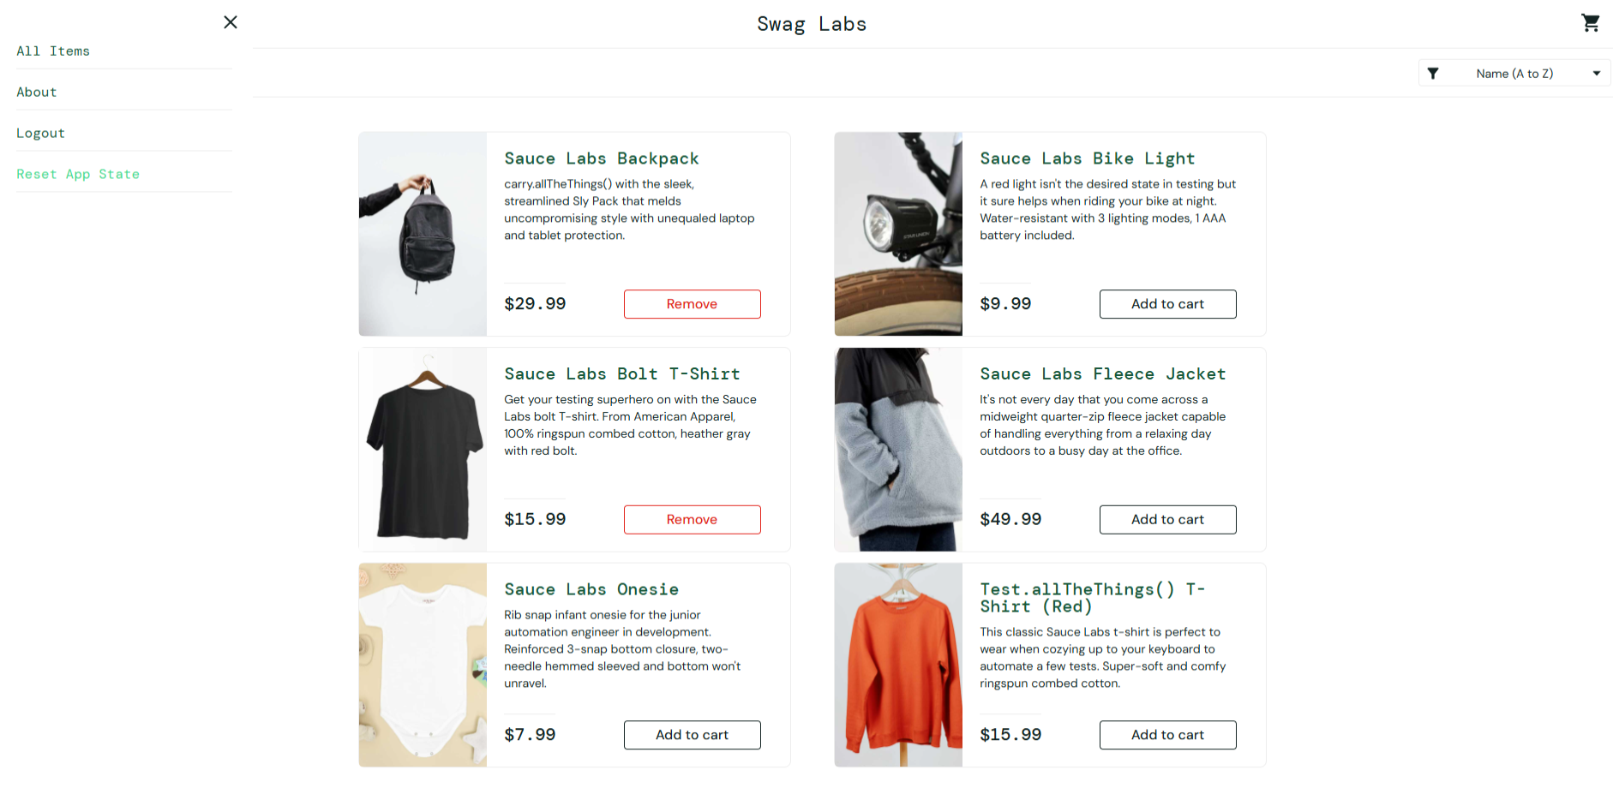

Bug ID: BUG_004
Test Case ID:TC_10
Title : Product Filter Dropdown Does Not Appear on Click
Module: Product module
Severity: Major
Priority: High

Step to Reproduce:
- Login to SauceDemo.
- Go to the Products/Landing page.
- Locate the Filter/Dropdown button.
- Click on the dropdown icon.
- Observe the response.

Expected Result:
The filter dropdown should appear and display the available sorting options.

Actual Result:
The dropdown does not appear or respond when the filter button is clicked.

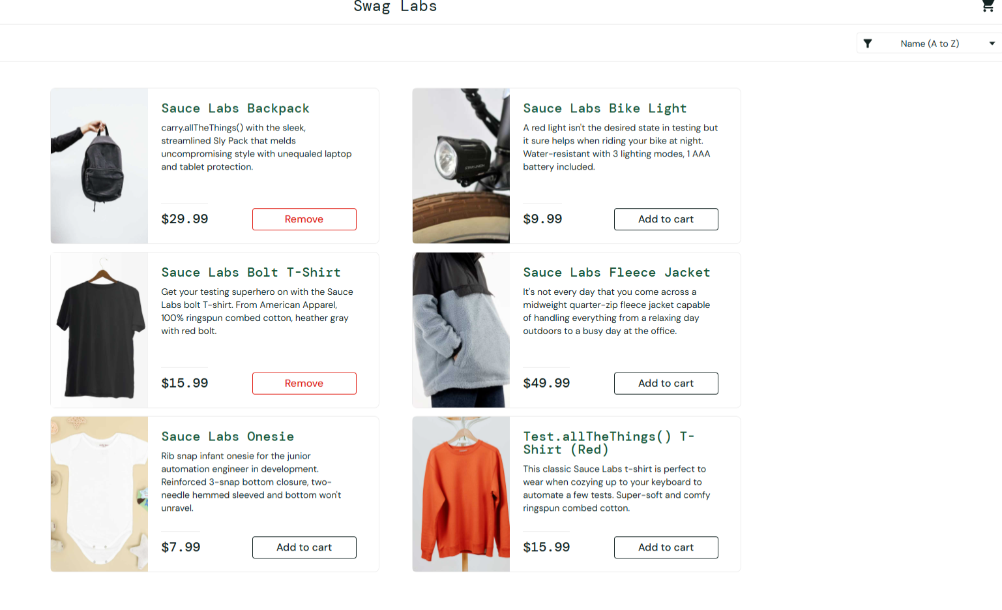
Attachment:
Bug ID: BUG_005
Test Case ID:TC_13
Title : Product Title and Description Content Are Incorrect
Module: Product module
Severity: Minor
Priority: Medium

Step to Reproduce:
- Login to SauceDemo.
- Go to the Products/Landing page.
- Observe the product title and description.
- Verify the text content for clarity, spelling, and grammar.

Expected Result:
Product titles and descriptions should be clear, accurate, properly spelled, and grammatically correct.

Actual Result:
The product title and description are not clearly mentioned, resulting in incorrect or unclear content.

Attachment:
Bug ID: BUG_006
Test Case ID:TC_17
Title :Footer Are Not Properly Aligned
Module: Product module
Severity: Major
Priority: Medium

Step to Reproduce:
- Login to SauceDemo.
- Go to the Products/Landing page.
- Observe the header, body, and footer alignment.
- Check whether all sections are properly aligned.

Expected Result:
The header, body, and footer should be properly and consistently aligned across the page.

Actual Result:
The header, body, and footer are not properly aligned, resulting in an inconsistent page layout.

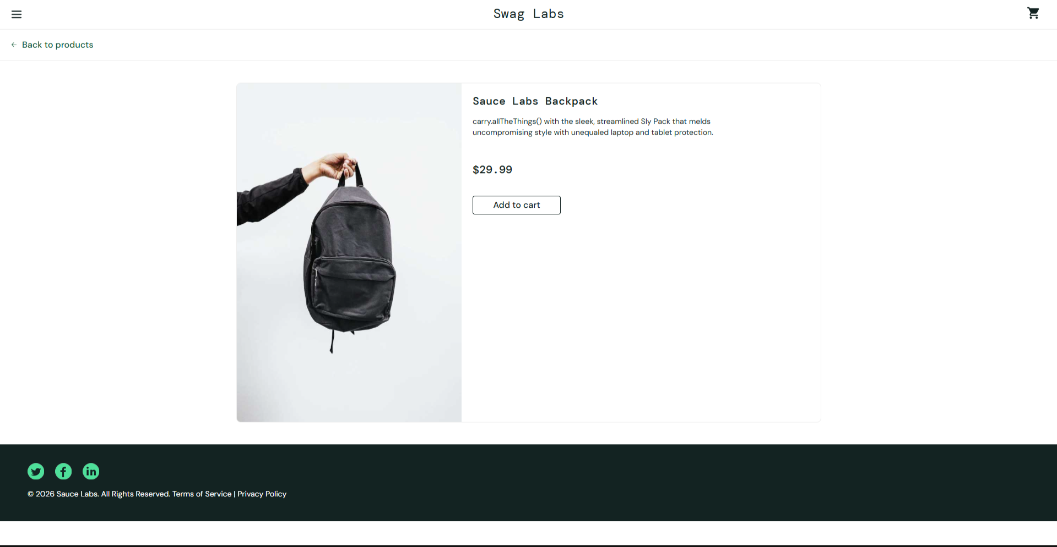
Attachment:

Bug ID: BUG_007
Test Case ID:TC_06
Title : System Allows Checkout with Invalid Credentials
Module: Cart module
Severity: Critical
Priority: High

Step to Reproduce:
- Login to SauceDemo.
- Add a product to the cart.
- Proceed to checkout.
- Enter invalid checkout credentials.
- Click Continue.
- Observe the page behavior.

Expected Result:
The system should reject invalid credentials and display an appropriate error message without redirecting to the Checkout Overview page.

Actual Result:
The system accepts invalid credentials and redirects to the Checkout Overview page successfully without displaying an error message.

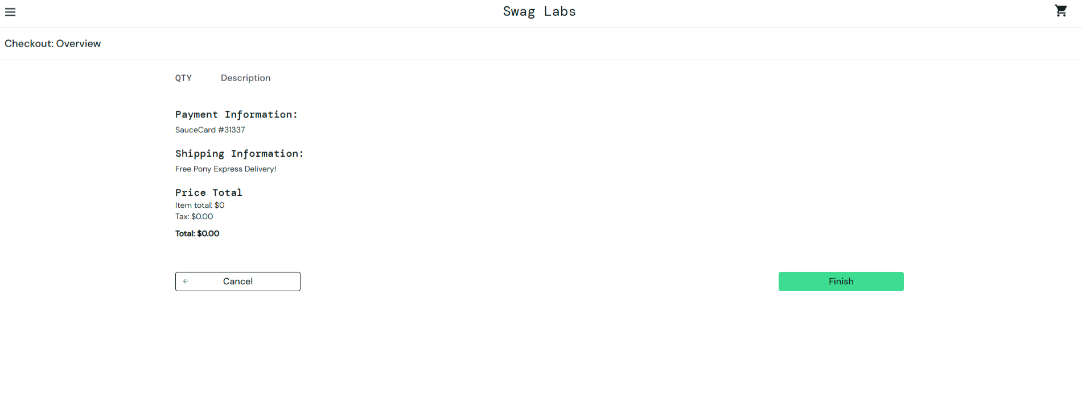
Attachment:
Bug ID: BUG_008
Test Case ID:TC_14
Title: System allows user to checkout with empty cart.
Module: Cart module
Severity:Major
Priority: Medium

Step to Reproduce:
- Login to saucedemo
- Click on cart without adding an item to card
- Complete the checkout process without an item in cart

Expected Result:
System should display validation message for empty cart checkout process

Actual Result:
The system allowed user to checkout without any item in the cart.

Attachment:

