Code in text format :  
  
function generatePattern(N, T) {

  if (N < 1 || N > 26) {

    throw new Error("N must be between 1 and 26.");

  }

  let pattern = "";

  // Function to generate alphabet or number sequence

  function generateSequence(startChar, count) {

    let sequence = "";

    for (let i = 0; i < count; i++) {

      sequence += String.fromCharCode(startChar.charCodeAt(0) + i);

    }

    return sequence;

  }

  if (T === "a") {

    // Generate the alphabet sequence from 'a' to the Nth letter

    let sequence = generateSequence("a", N);

    pattern += sequence + "\n";

    // Spaces at the middle of a row

    for (let i = 1; i < N - 1; i++) {

      pattern += sequence[i] + " ".repeat(N - 2) + sequence[N - i - 1] + "\n";

    }

    // Reverse of the alphabet sequence

    pattern += sequence.split("").reverse().join("") +'\n';

  } else if (T === "1") {

    // Number sequence from 1 to N

    let sequence = "";

    for (let i = 1; i <= N; i++) {

      sequence += i;

    }

    pattern += sequence + "\n";

    // Spaces at the middle of a row

    for (let i = 1; i < N - 1; i++) {

      pattern += sequence[i] + " ".repeat(N - 2) + sequence[N - i - 1] + "\n";

    }

    // Reverse of the number sequence

    pattern += sequence.split("").reverse().join("");

  } else {

    throw new Error('Invalid value for T. Please use "a" or "1".');

  }

  return pattern;

}

code screen shot :

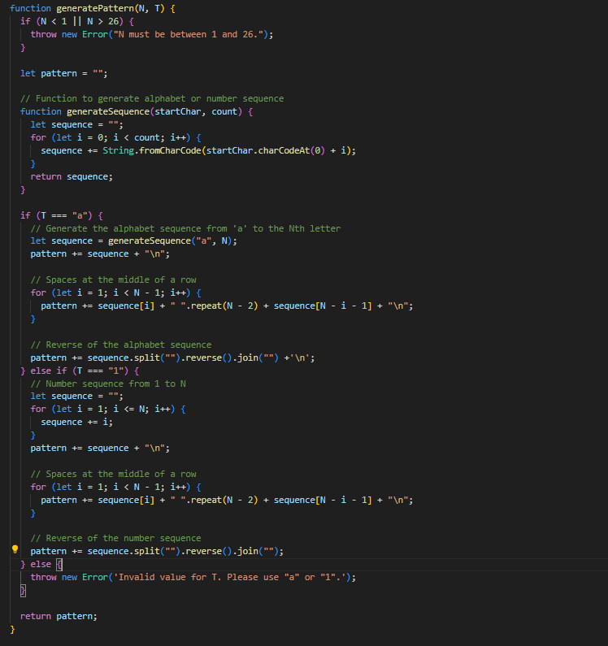  
output :

