**Shaw Communications – Vendor SEO Guideline**

The objective of this document is to provide 3rd Party Vendors of Shaw Media Inc. with a detailed SEO process for website production.

Presented by:

Shad Jafari

|  |
| --- |
| Table of Content |

Table of Content 2

Overview 3

Headers : Robots 4

Headers: Webmaster Tools 5

Headers: Dynamic Title Tag & Description 6

On Page : H1 Headers 7

# Overview

Any SEO project, large or small – should include some sort of early and upfront strategy before ANY work commences. Strategy is one of the major keys to SEO success it should include objectives including, but not limited to the following:

* Robots
* Webmaster Tools
* Dynamic Title Tags / Description Tag
* H1 Header Tag

Depending on the scope of a digital property, not all items listed may be needed. However, it should include how many hours it will take and estimated time of delivery. This initial phase is fairy finite; restrictive measures could include number of pages, number of sites, etc.

# Headers : Robots

All websites published for Shaw Media must have the following tags on all global headers of a website.

(No exceptions on the following)

**Robots.txt**

The robots.txt is a simple text file, hosted on the root of a web site that informs search engine bots how to crawl and index website or web pages. By default search engine bots crawl everything possible unless they are forbidden from doing so. Search engines always scan the robots.txt file before crawling the web site. Declaring a robots.txt means that visitors (bots) are not allowed to index sensitive data but it doesn’t mean that they can’t.

**Implementation:**

Root folder of site should have a static file called “robots.txt” which will be populated with the below. Note, not all folders below are needed, depending on the site and CMS setup for the given project.

|  |  |
| --- | --- |
| **Line** | **Contents** |
| 1 | User-agent: * |
| 2 | Disallow: /pages/searchresult.aspx |
| 3 | Disallow: /Pages/searchresult.aspx |
| 4 | Disallow: /Pages/Searchresult.aspx |
| 5 | Disallow: /workarea/ |
| 6 | Disallow: /WorkArea/ |
| 7 | Disallow: /Workarea/ |
| 8 | Disallow: /cmslogin.aspx |
| 9 | Disallow: /CMSLogin.aspx |

# Headers: Webmaster Tools

Google Webmaster Tools is a free service that provides fast amount of technical information for a website directly from Google. As such, all Shaw Media sites must be produced with Webmaster Tools Verification Code.

Before the launch of any site, Vendors must contact [Shad.Jafari@shawmedia.ca](mailto:Shad.Jafari@shawmedia.ca) in order to setup and obtain Verification.

**Implementation:**

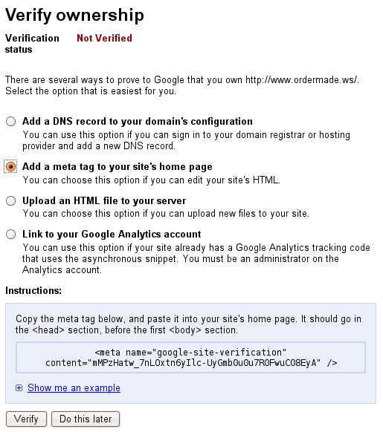Once, Shad Jafari supplies the verification code, please implement the tag within the first 20 lines of code of the sites global, or universal header file.

# Headers: Dynamic Title Tag & Description

The HTML title tag defines the name of a web page and should be used to describe content of that page in a concise way. Thus, what is placed between the opening and closing HTML title tag is extremely important for both usability and Search Engine Optimization (SEO).

Before the launch of any site, Vendors must contact [Shad.Jafari@shawmedia.ca](mailto:Shad.Jafari@shawmedia.ca) in order to receive the optimized title tags for implementation.

**Implementation:**

Once, Shad Jafari supplies the optimized title tags, please implement said tag within the first 20 lines of code, of the sites global, or universal header file.

Title Tag Example:

****Description Tag Example:

Note – all title & description tags must be approved by SEO QA prior to launch

# On Page : H1 Headers

There are 6 tags that define a heading in HTML.  These tags are designated from H1 to H6.  By default, the H1 tag is the largest or most important heading while the H6 is the least.  All of these tags are supported by all major browsers.

All pages must have one H1 Tag above the fold.

Before the launch of any site, Vendors must contact [Shad.Jafari@shawmedia.ca](mailto:Shad.Jafari@shawmedia.ca) in order to receive the optimized H1 tags for implementation.

**Implementation:**

Once, Shad Jafari supplies the optimized H1 tags, please implement said tag as visible text.

