**King**

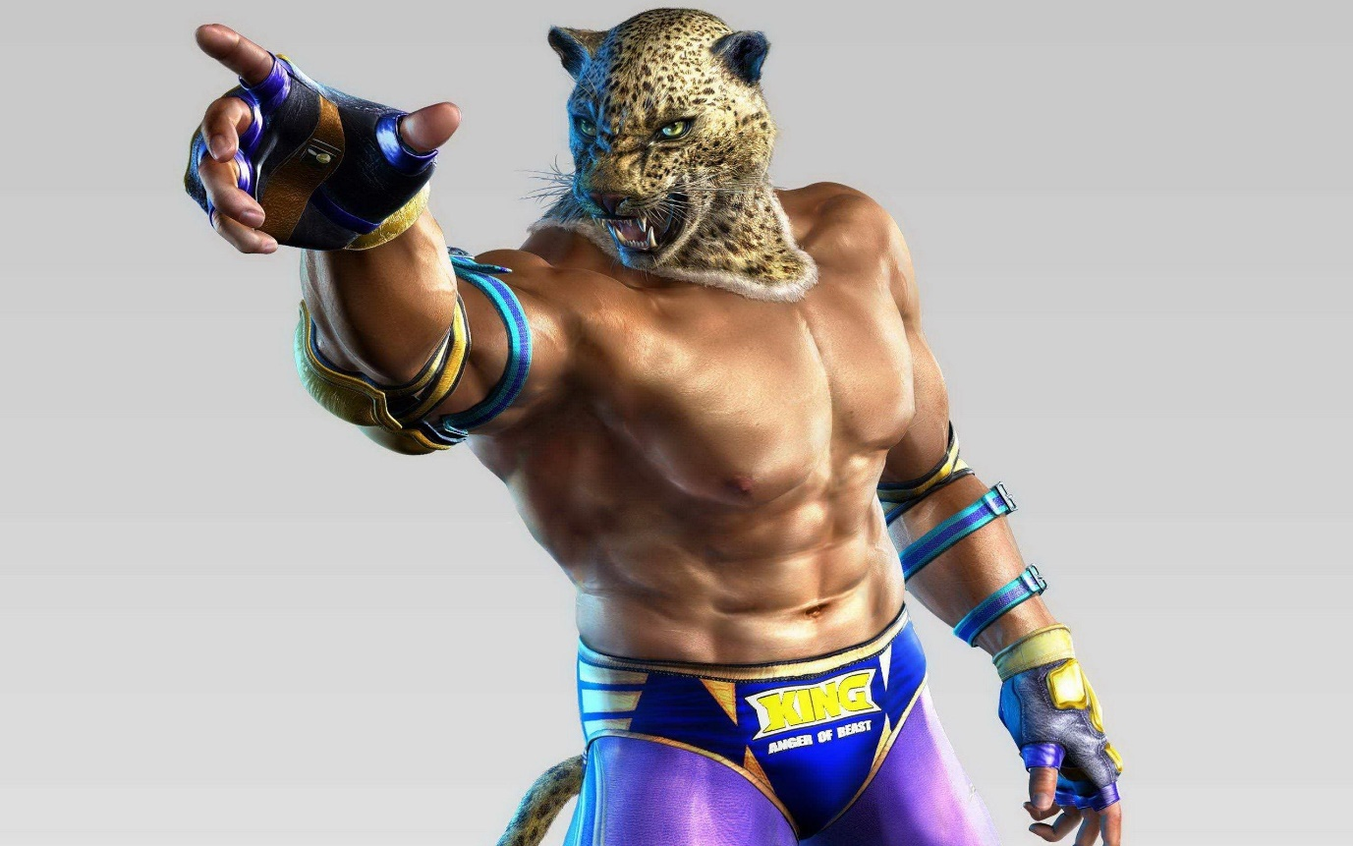

**Full Name** - King I

**AKA** - Beast Priest, Mysterious Masked Wrestler

**Status** - Deceased

**Fighting Style** - Pro-Wrestling (US Style)

**Origin** - Mexico

**Height** - 190cm (6’3’’)

**Weight** - 85 kg

**Likes**  - Jaguars, children, Armor King

**Dislikes** - Tears of Children

**Age** - 30 (TK1) 47(Death)

**Occupation** - Pro-wrestler,Priest, Owner of an orphanage

**Cause of death** - Murdered by Ogre

**King** (キング *Kingu*) is a title that two characters have taken in the Tekken series. Even though there have been two characters who have taken the name, each is simply called King in their respective games, though a numerical value is sometimes given to them to separate them as different characters.

King is luchadore from Mexico who support orphans across the world. In the games, they are never seen without their jaguar masks (except on only one occasion). There has been a King in every game in the *Tekken* series, and this, along with their unique appearance and trademark "point", has made them one of the most recognizable characters, not only in the series but also in the fighting game genre.

Biography

King used to be a street brawling orphan with no care in the world except fighting. In one of his fights, King was grievously wounded and collapsed in front of a monastery. The Marquez priests took him in, saving him from death. After recovering, King realized the error of his ways and resolved to start a new life. He became a Catholic priest and renounced his old fighting ways. He then became a man with a mission: he dreamed of building an orphanage for street children, hoping to save them from becoming the kind of fighter he used to be.

King was successful in building an orphanage, but funds were tight. To bring income to the orphanage, King fought in wrestling matches, donning his now iconic Jaguar mask to conceal his identity and acquiring the title "Beast Priest". It was at this time that King came to the attention of his future rival Armor King, one of a wrestling Tag Team who also wore Jaguar masks. Early in his career King accidentally crushed the eye of Armor King during a match. King has won many titles since, whilst the injury caused Armor King's career to plummet.

As King continued fighting to fund the orphanage, he comes across the King of The Iron Fist Tournament, a martial arts tournament with a large cash prize. Seizing the opportunity, King entered the tournament. When Armor King came across the tournament and saw his rival participating, he entered, keen to better his rival and reinstate his name in the wrestling world. The two met in the tournament and King emerged victorious. King went on to claim third place in the tournament, securing enough prize money to fund the running of the orphanage. King and Armor King would go on to put aside their differences, and the two became friends and sparring partners.

As time passed, however, the orphanage began to struggle. King turned to drink, and the death of a child in his care pushed him to breaking point. He took to the streets, stumbling around in a drunken stupor. Armor King, worried for his friend, sought him out and helped him get his life back on track, and persuaded him to resume training for a second King of Iron Fist tournament. With the help of his friend, King fully recovered from his depression and alcoholism and trained intensely for the tournament, with the intention of winning the prize money to fund the orphanage. However, King lost in the tournament, and resorted to teaching the orphans his fighting skills instead, as a means of self-defense.

Sometime after the second tournament, King was attacked and killed by Ogre, the god of fighting. This led one of the orphans in his care to don the jaguar mask himself and take on the title of King II, in order to provide further funding for the orphanage and continue the first King's legacy.

**Personality**

Despite his fearsome reputation in the wrestling ring, King is actually a kind and considerate individual, with his own troubled childhood leading him to dedicate himself to helping disadvantaged children, to prevent them from going through the same issues he faced. The fact that he would go on to become his one-time rival’s friend also suggests that he has a positive outlook, favoring peace and friendship over holding grudges. King is also revealed to be a sensitive and soft-hearted man, something which can be seen as an exploitable weak spot by his opponents. It is also this that led him to drink, in an attempt to drown out what he saw as his failure to protect those in his care.

**Appearance**

Aside from a brief shot in the Tekken intro movie, King's face is always hidden behind his trademark jaguar mask, so his eye and hair color is unknown. As a wrestler, King is very muscular and, at over six feet tall, he towers over most of the other playable characters in the series. When his upper body is exposed, King is revealed to have dark, tanned skin.

**Story**

[**Tekken**](https://tekken.fandom.com/wiki/Tekken) **I**

**Version 1:**King, the friendly rival of Armor King, was in need of money to fund the orphanage that he was taking care of. With the little money he had, King decided to enter The King of Iron Fist in the hopes of winning the prize money. King entered the tournament, where he accidentally damaged Armor King's eye during their fight. King emerged victorious, managing to secure third place, winning enough prize money for the orphanage.

**Version 2:** Ordinarily, he's the kind-hearted man who looks after orphans, but once he puts on his masked disguise, he transforms into the unstoppable masked wrestler. In his past, King too was once an orphan who was rescued by a charitable person. He has joined the tournament to earn money for the orphanage which he sponsors.

**Version 3:** A mysterious masked wrestler. He is an outstanding young man who usually takes care of orphans. However, once he puts on his mask, he turns into an extremely strong masked wrestler who cannot be stopped by anybody. He is taking part in the tournament in order to get funds to found an orphanage. In the past he was an orphan himself and was taken in by a friendly family.

[](https://www.youtube.com/embed/JQegvJQYz24?feature=oembed)

**Tekken 1 King – Church**

[**Tekken II**](https://tekken.fandom.com/wiki/Tekken_2)

**Version 1:** After winning 3rd place in the first tournament, an orphan died within King's care. Depressed and enraged, King threw away his jaguar mask and ran away. Armor King worried about his rival, and went in search of him. After a long and tiring day of searching and finding no clues as to where King may be, he found him in an alleyway behind a bar. Armor King saw how his friend's life had crumbled and convinced him to return to the orphanage in order to take care of the kids, who were still in need of him. Armor King also convinced him to resume training for The King of Iron Fist Tournament.

**Version 2:** King is a veteran wrestler. Armor King approached King, who had become preoccupied by booze and bars, one day and gave him a flyer to an upcoming martial arts tournament. For the trust of the children, and for the respect he once had for himself, King decided to participate in the tournament.

**Version 3:** King helps orphans by managing an orphanage with money he earns from Pro Wrestling. Unfortunately, the orphanage is running out of money and King has turned to heavy drinking. He decides to participate in the tournament to regain the children's hearts and to pull his life together

[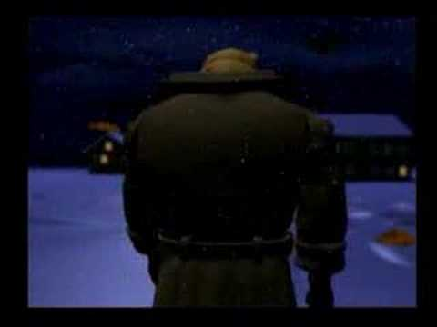](https://www.youtube.com/embed/pD-YdV1DSCU?feature=oembed)

**Tekken 2 King – Children**

**Gameplay**

Contrary to expectation, King rewards a more defensive approach, as he has short reach and few moves which allow him to close the space between an opponent. While he does have some ranged moves, such as his lariat and exploder, they are very unsafe and have slowly start up and recovery times.

When engaged is close-quarters combat, King excels; he has some powerful strikes and follow-ups, and he has several multiple hit combos which follow the same general pattern, making it difficult for opponents to anticipate and counter them. As a wrestler, King has the largest and most powerful arsenal of throws in the game, and is one of very few fighters to utilize chain throws. Some, such as the Bostin Crab, have simple inputs and are in chains of only two moves, while others have multiple, complex inputs which can chain into up to five hits, dealing enough damage to KO an opponent from full health. These chains can, however, be broken with the correct button input, so are a risky strategy against experienced players.

While King is not a beginner-friendly character, he is a character well worth taking the time to learn as his devastating throws and punishers make him formidable opponent, able to deal significant damage on reckless or unwary foes.

**Fighting Style**

King and Armor King fight using Pro Wrestling. However, King uses the” catch” variation, focusing more on holds and submissions, whereas Armor King uses the “Shoot” variation, which focuses more on strikes.