**1. Check if your processor supports Intel/AMD virtualization technology. Enable Intel virtualization technology in BIOS if possible.**

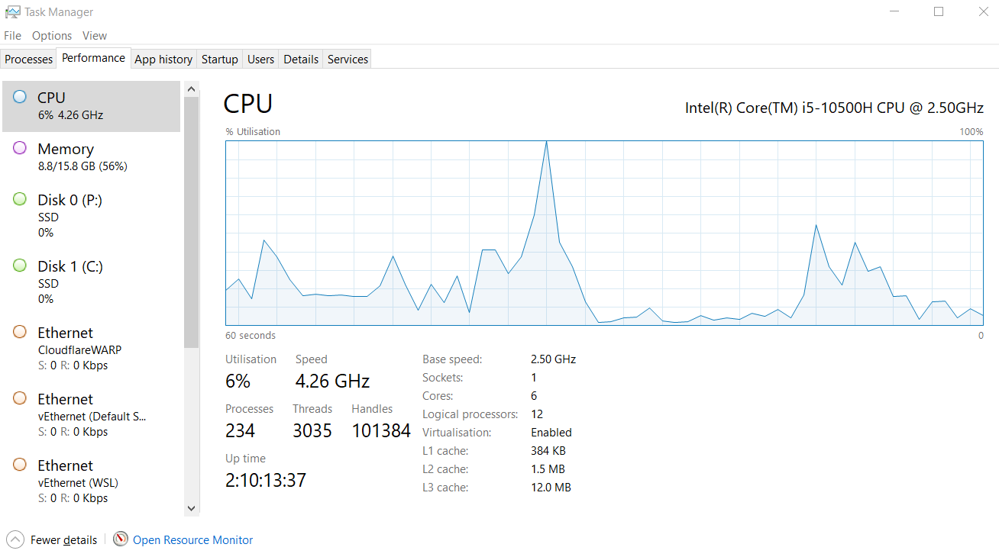

**2. The cloud is almost everywhere in our lives now. What do you think are the fundamental reasons behind its success? Name three pros and three cons of cloud.**

* **Fundamental Reasons for Cloud Success:**
  1. **Scalability and Elasticity:** Cloud platforms allow businesses and users to easily scale resources (computing power, storage, bandwidth) up or down based on demand, often automatically. This avoids the need for large upfront investments in hardware that might sit idle or become insufficient.
  2. **Cost-Effectiveness (Economies of Scale & OpEx):** Cloud providers operate massive data centers, benefiting from economies of scale that translate to lower costs for users compared to managing their own infrastructure. It shifts IT spending from Capital Expenditures (CapEx - buying hardware) to Operational Expenditures (OpEx - paying for services as you use them), which is often financially advantageous.
  3. **Accessibility and Convenience:** Cloud services can be accessed from anywhere with an internet connection, using various devices. This facilitates remote work, collaboration, and global reach. Providers also handle the underlying infrastructure management (maintenance, updates, power, cooling), freeing users to focus on their applications and data.
  4. **Rapid Innovation and Deployment:** Cloud providers offer a vast array of pre-built services (databases, AI/ML tools, analytics, etc.) that allow organizations to innovate and deploy applications much faster than if they had to build everything from scratch.
* **Three Pros of Cloud:**
  1. **Cost Savings:** Pay-as-you-go models, reduced hardware/maintenance costs, lower staffing needs for infrastructure management.
  2. **Flexibility and Scalability:** Easily adjust resources to meet fluctuating demands without hardware procurement delays.
  3. **High Availability and Reliability:** Providers often offer Service Level Agreements (SLAs) guaranteeing uptime, built-in redundancy, and disaster recovery options.
* **Three Cons of Cloud:**
  1. **Security Concerns:** Entrusting sensitive data to a third party raises security and privacy concerns. Shared infrastructure can potentially increase exposure if not properly managed.
  2. **Dependency and Vendor Lock-in:** Migrating applications and data between cloud providers can be complex and costly, leading to reliance on a single vendor.
  3. **Requires Internet Connectivity:** Access to cloud services is entirely dependent on a stable and sufficiently fast internet connection. Outages can halt operations.

**3. What is the primary function of a hypervisor in virtualization?**

The primary function of a hypervisor is to **create, run, and manage virtual machines (VMs)**. It acts as an abstraction layer, separating the physical hardware resources (CPU, RAM, storage, network) from the virtual machines that use them. The hypervisor allocates these hardware resources to the various VMs as needed and ensures they remain isolated from each other and the host system.

**4. What is a virtual machine (VM)?**

A virtual machine (VM) is a **software-based emulation of a physical computer system**. It runs on a physical "host" machine but behaves like an independent computer with its own virtual CPU, memory, storage, and network interface. A VM runs its own operating system (called the "guest" OS) and applications, completely isolated from the host operating system and other VMs running on the same host.

**5. What are the benefits of using virtual machines?**

Using virtual machines offers several benefits:

* **Server Consolidation:** Run multiple operating systems and applications on a single physical server, reducing hardware costs, power consumption, and physical space requirements.
* **Resource Optimization:** Improve the utilization of physical hardware resources, as multiple VMs can share the underlying capacity.
* **Isolation:** VMs are isolated from each other and the host system. A crash or security issue in one VM typically does not affect others.
* **Ease of Provisioning and Deployment:** New VMs can be created quickly from templates or clones, significantly speeding up server deployment.
* **Testing and Development:** Provide safe, isolated environments (sandboxes) for software development, testing updates, or experimenting with different operating systems without risking the production environment.
* **Disaster Recovery and Business Continuity:** VMs can be easily backed up, replicated, and migrated to different hardware, simplifying disaster recovery planning. Features like snapshots allow reverting to a previous state.
* **Legacy Application Support:** Run older applications that require outdated operating systems on modern hardware.
* **Portability:** VMs can be moved between different physical machines with compatible hypervisors.

**6. List five use cases of virtual machines.**

1. **Server Consolidation:** Combining multiple physical servers (e.g., web server, database server, application server) onto fewer physical machines as VMs to save costs and improve resource utilization.
2. **Software Development and Testing:** Creating isolated environments for developers to write code and testers to verify software on various operating systems and configurations without interfering with each other or production systems.
3. **Disaster Recovery:** Replicating production VMs to a secondary location. If the primary site fails, the replicated VMs can be quickly brought online.
4. **Running Legacy Applications:** Hosting applications that require older, unsupported operating systems (like Windows XP or older Linux versions) within a VM on modern, secure hardware.
5. **Desktop Virtualization (VDI - Virtual Desktop Infrastructure):** Hosting desktop operating systems (like Windows 10/11) as VMs in a data centre and allowing users to access them remotely from various devices (thin clients, laptops, tablets).

**7. In virtualization, what is the guest operating system?**

The correct answer is:  
**b) The operating system installed on a virtual machine**

Explanation: The "host" operating system runs directly on the physical hardware. The "guest" operating system is installed and runs inside the virtual machine, using the virtual hardware provided by the hypervisor.

**8. What does virtual machine isolation mean?**

The correct answer is:  
**c) Virtual machines run independently and are isolated from each other and the host system.**

Explanation: Isolation is a key security and stability feature of virtualization. It means that the activities, errors, or security breaches within one VM do not directly affect the host operating system or any other VMs running on the same physical hardware. They operate in their own protected memory space and have controlled access to resources managed by the hypervisor.

**9. What is the benefit of virtual machine portability?**

The correct answer is:  
**c) It allows virtual machines to be moved between different physical machines with compatible hypervisors.**

Explanation: Portability refers to the ability to easily move an entire VM (its configuration files and virtual disk files) from one physical host computer to another, provided the destination host runs a compatible hypervisor. This facilitates hardware maintenance, load balancing, and migration without reinstalling the OS or applications within the VM.

**10. What is the purpose of cloning a virtual machine?**

The purpose of cloning a virtual machine is to **create an exact, independent copy of an existing VM**. This includes the guest operating system, installed applications, data, and configuration. Cloning is useful for:

* **Rapid Deployment:** Quickly creating multiple identical VMs based on a pre-configured template or "golden image" (e.g., for setting up a web server farm, a virtual desktop pool, or lab environments).
* **Testing and Experimentation:** Creating a duplicate of a production VM to safely test software updates, patches, or configuration changes without impacting the live system.
* **Development Environments:** Providing developers with identical, pre-configured development environments.
* **Creating a Backup Point:** While snapshots are often used for short-term rollback, a clone can serve as a full, independent backup at a specific point in time.