**C00274825 – PETER HYLAND**

**Publishing and exposing ports**

I installed Docker on my Windows 10 machine

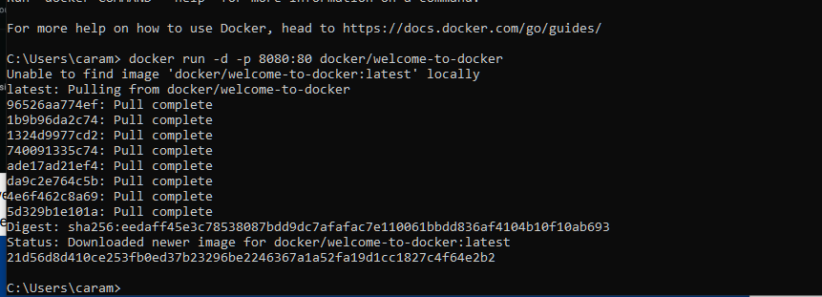

Ran the command

Then I verified it installed and was published

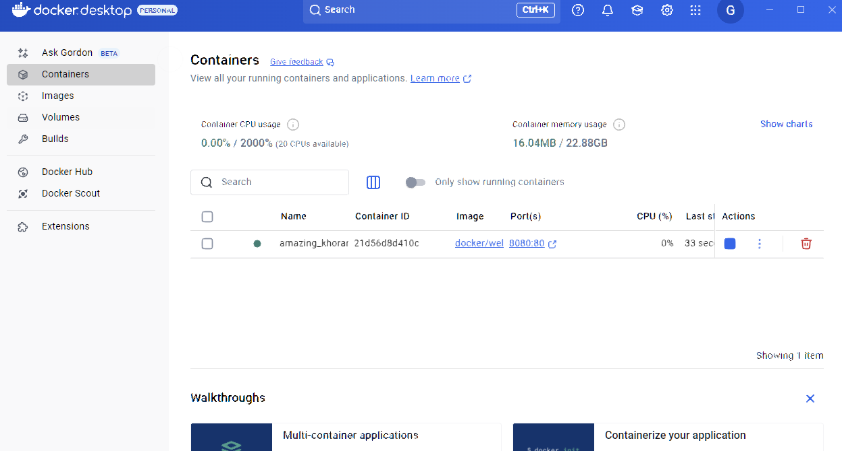



As you can see it is running on my localhost.

I created the yaml file

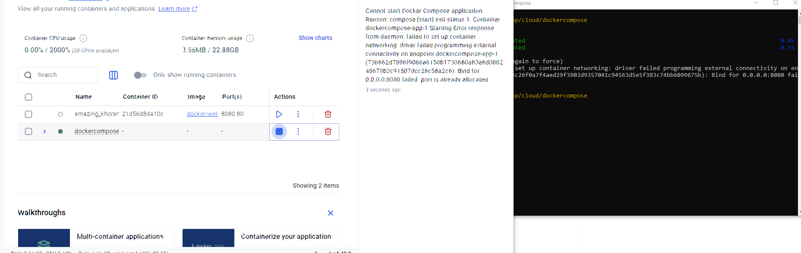

Had to shut down the previous Docker one to make this one work as the port was occupied.

**Overriding Container Defaults**

Both my containers are running

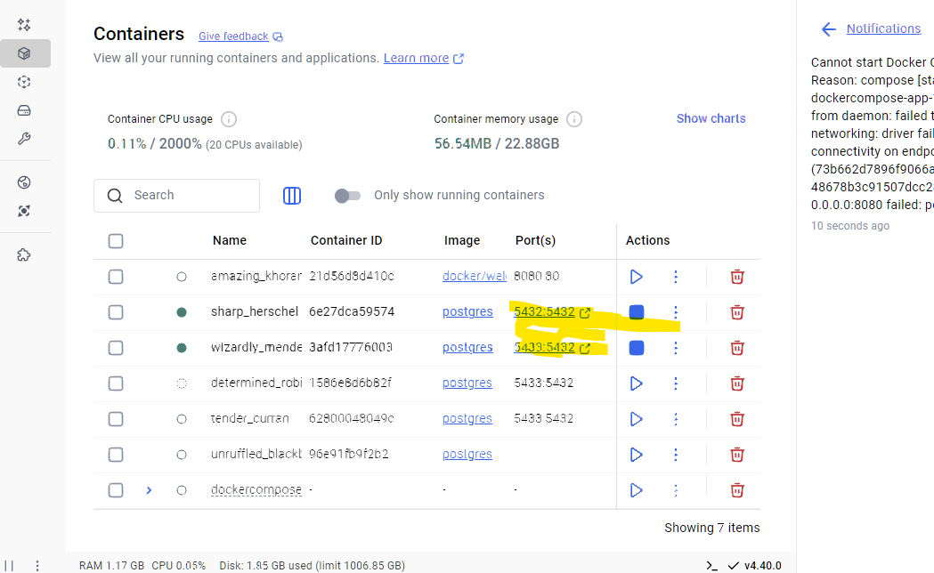

I have setup a custom network

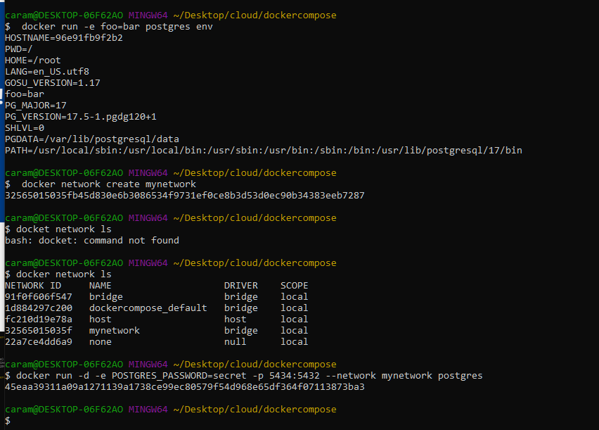

Running the yaml file

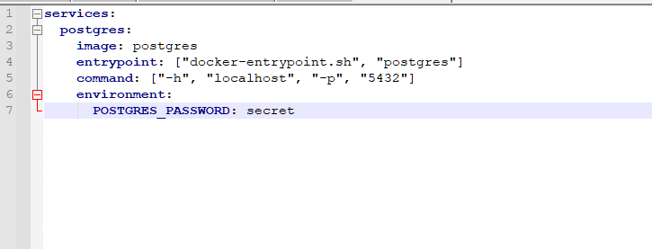

Verified psql is running

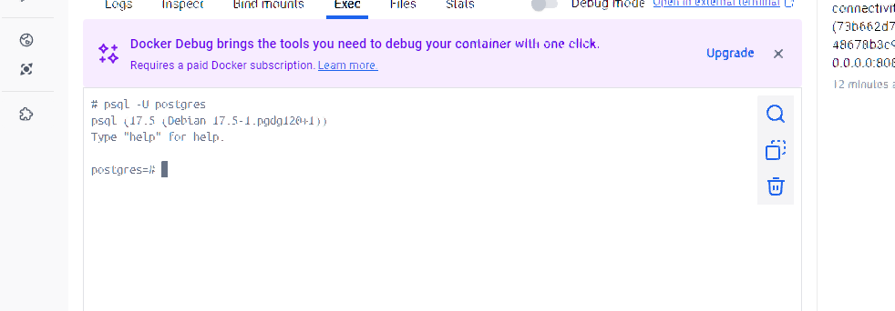

**Persisting container data**

**I ran the required commands**

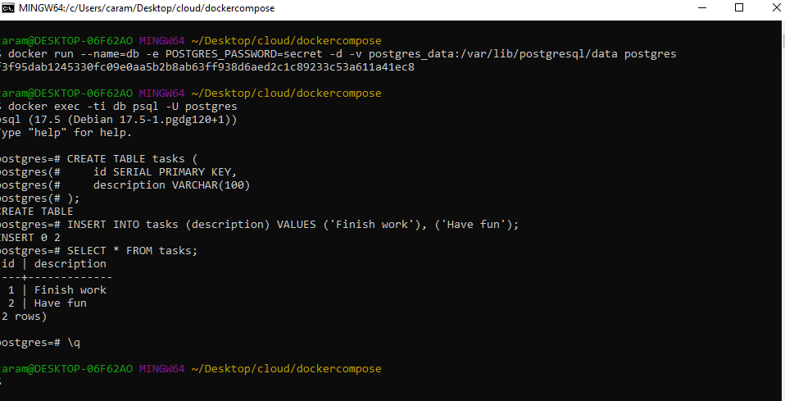

**I then created and removed the volume data**

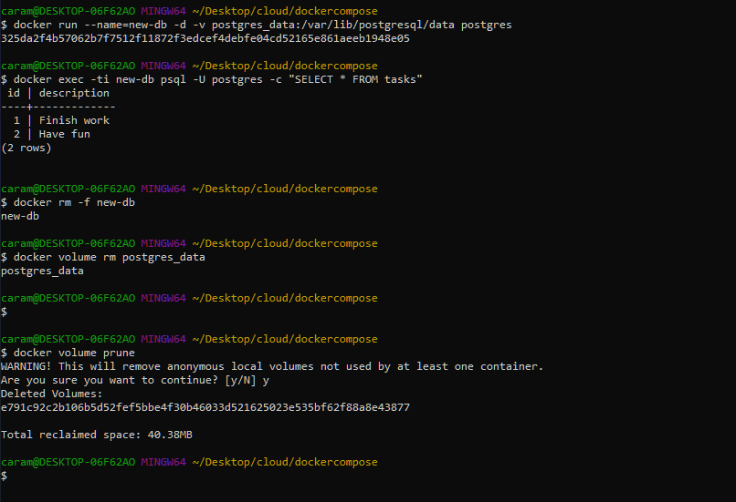

**Sharing local files**

**Requested container was deleted**

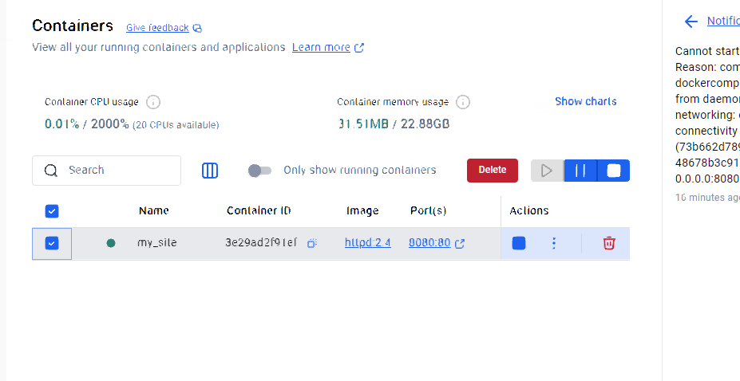

**Ran the commands one of which I had to fix to make run**

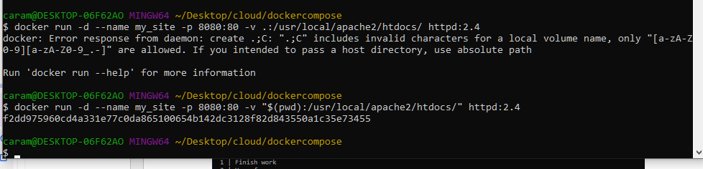

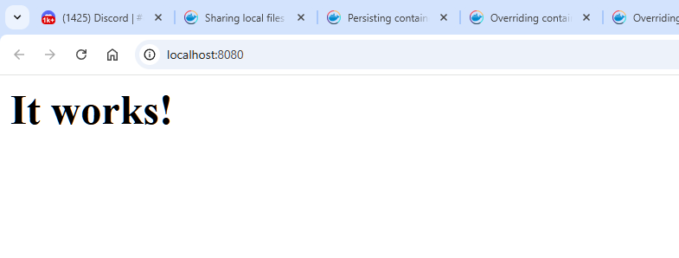

**I deleted the index under /usr/**

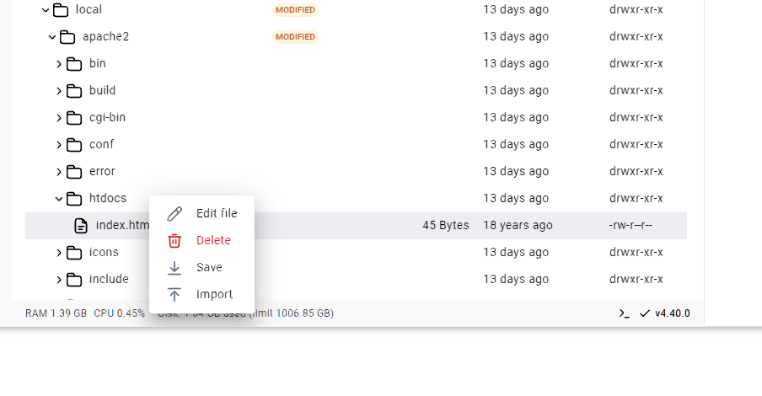

**Then recreated it**



**Then deleted the container**

**Multi container applications**

**I ran the requested containers**

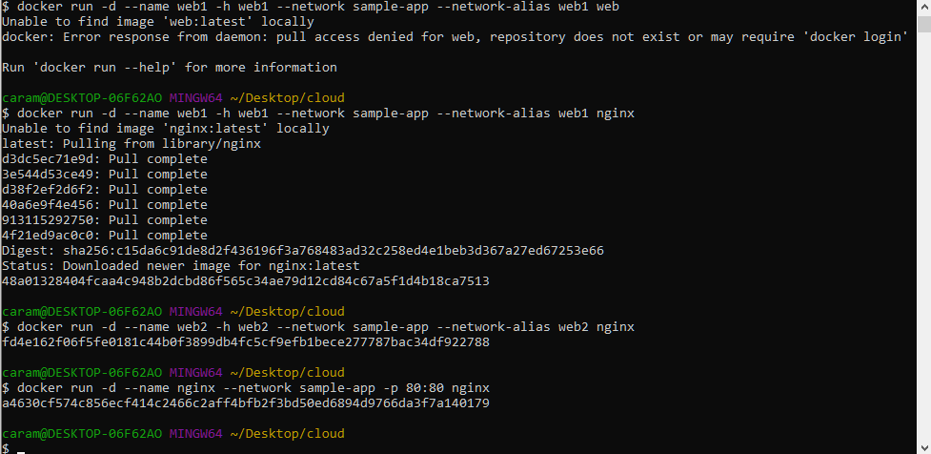

**They are all running**

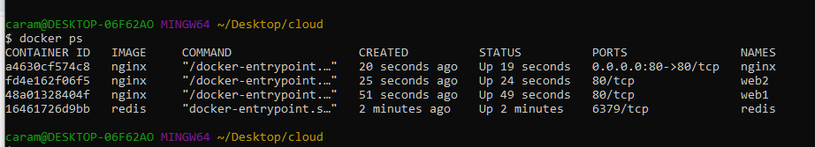



**The number of web visits increments as I refresh the page**