PETER HYLAND – C00274825

I installed minikube

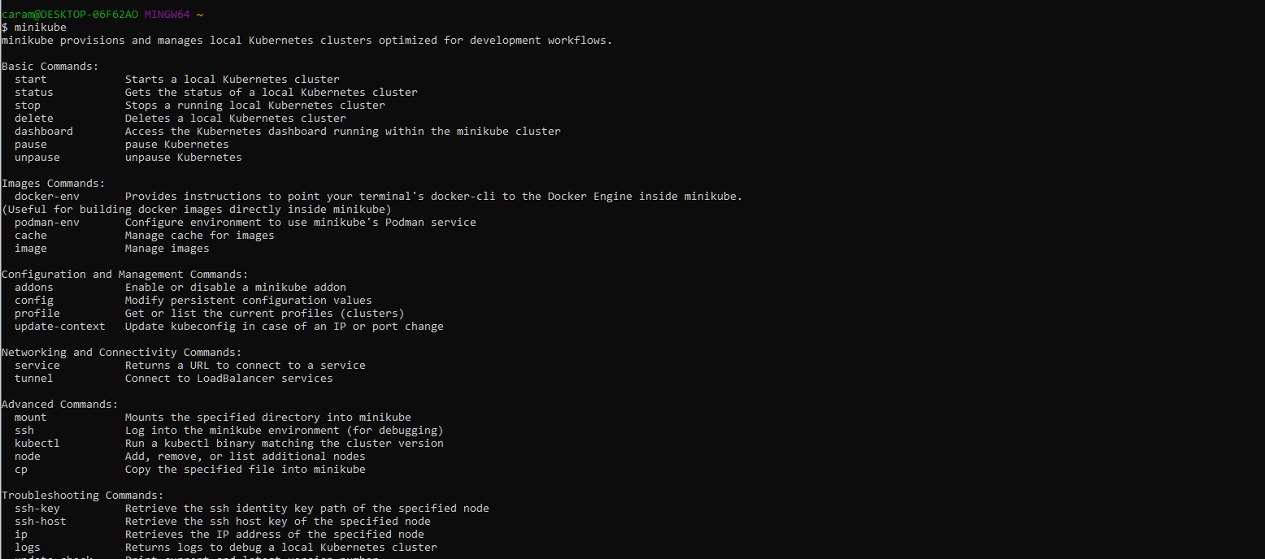

Minikube was installed

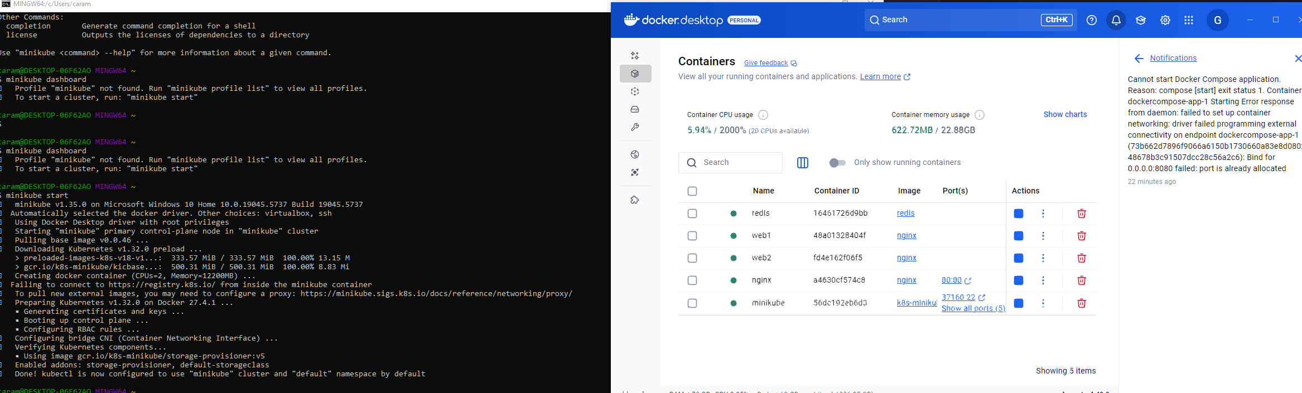

I created the bootcamp image

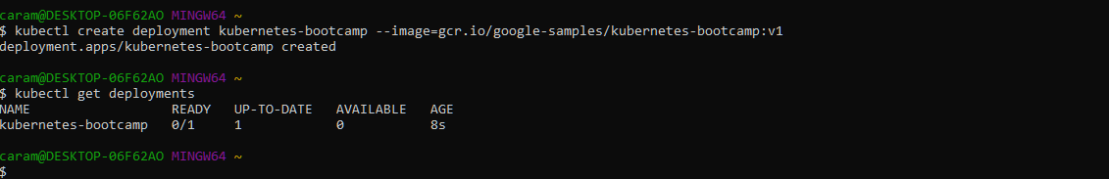

Latest version was curled

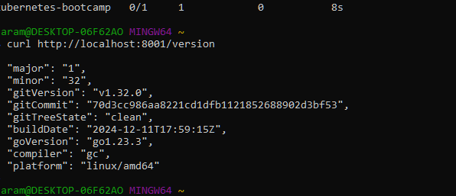

Used the describe pods command

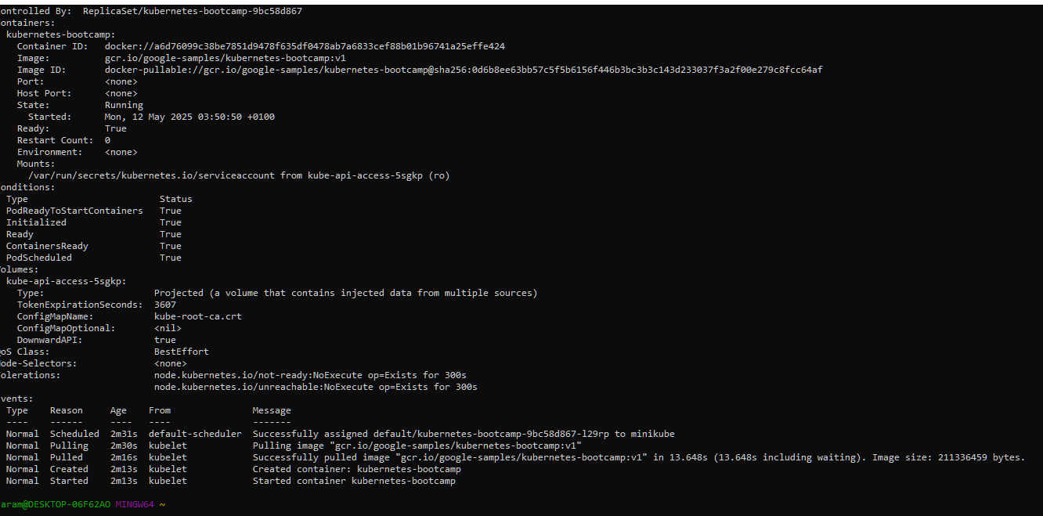

**I started a bash session within the container of the pod**

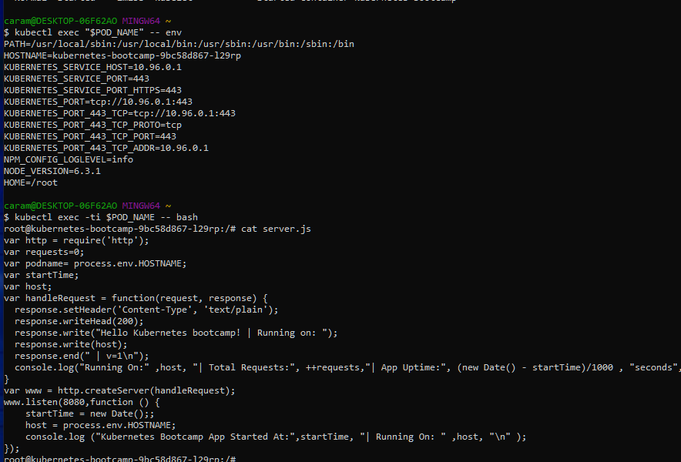

**I checked the pods and services**

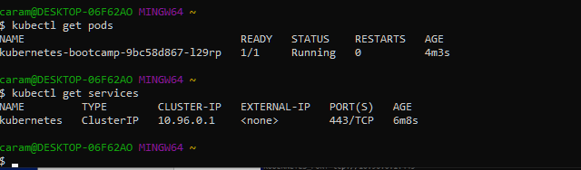

**I exposed the service however it doenst seem to run locally.**

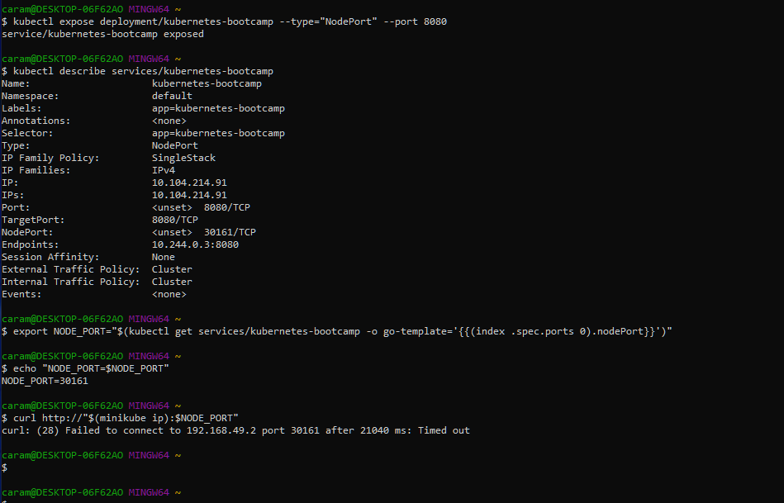

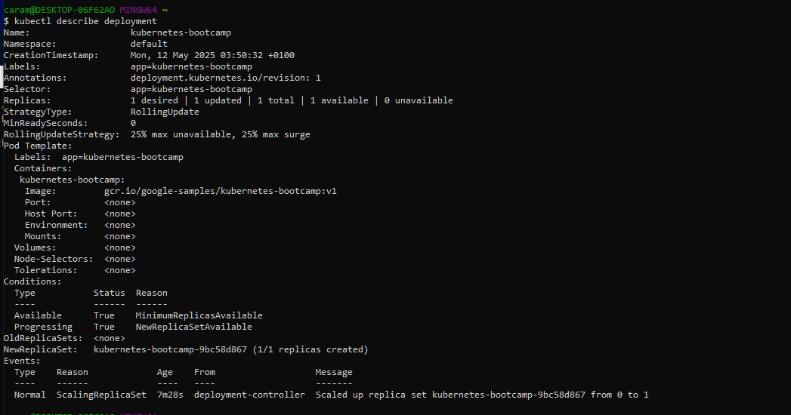

**I ran the describe deploiyment command**

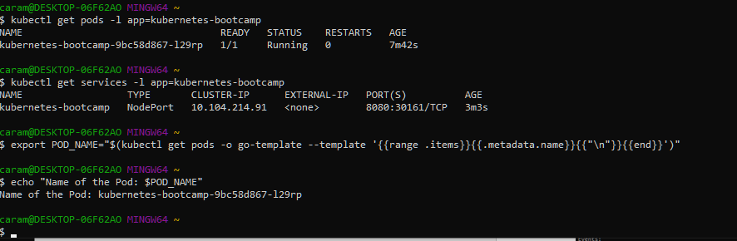

**Got all of the existing services and stored the name of the pod as an environment variable**

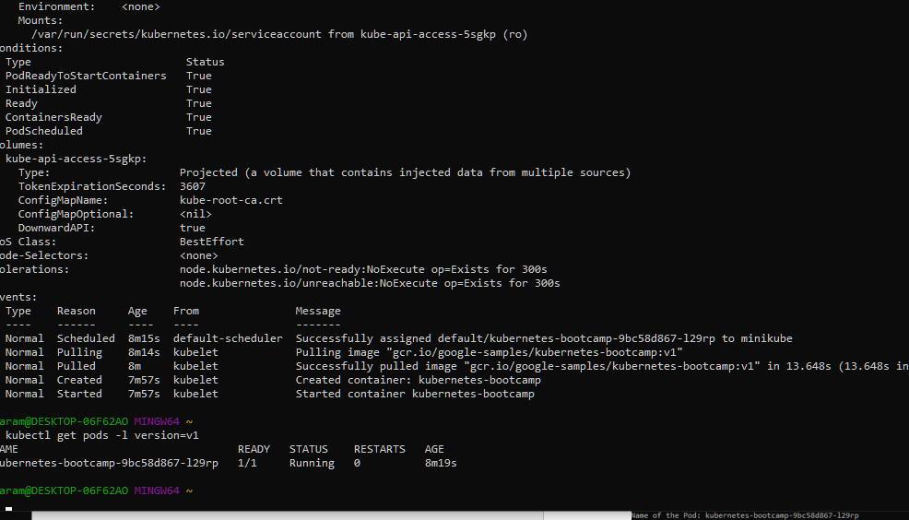

**The label is attached**

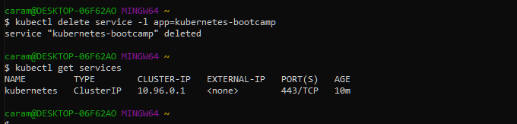

**I deleted the service!**

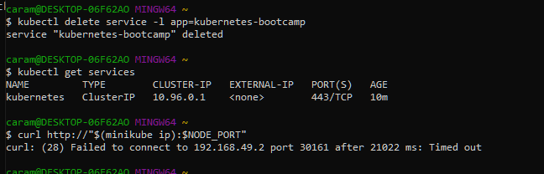

**Does not load, definitely deleted.**

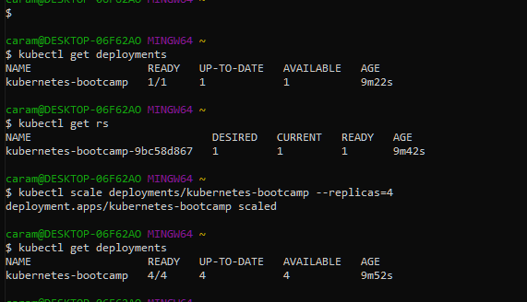

**I created 4 replicas**

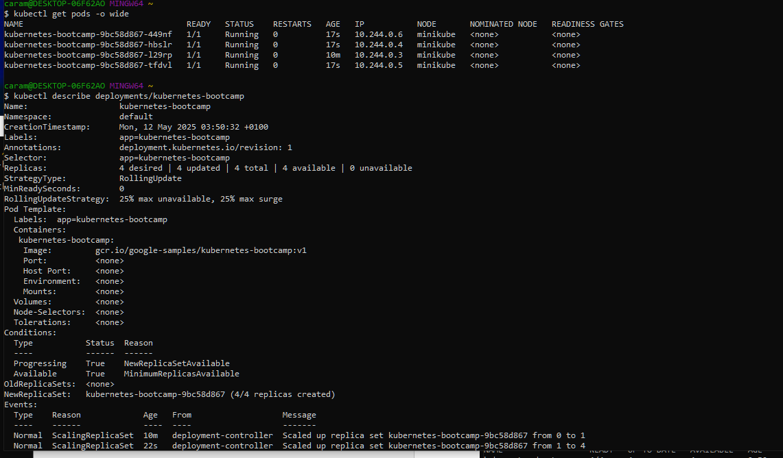

**4 replica pods are present as seen above**

**I confirmed all the load balancing is working**

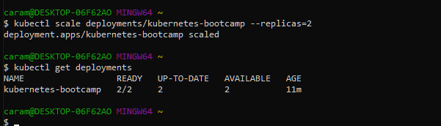

**I scaled down the number of deployments**

**I updated the bootcamp image**



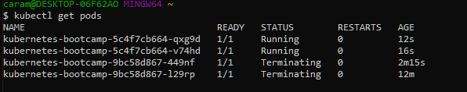

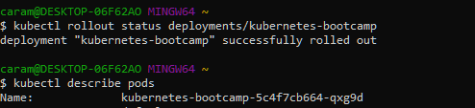

**I note the update was successfully rolled out**

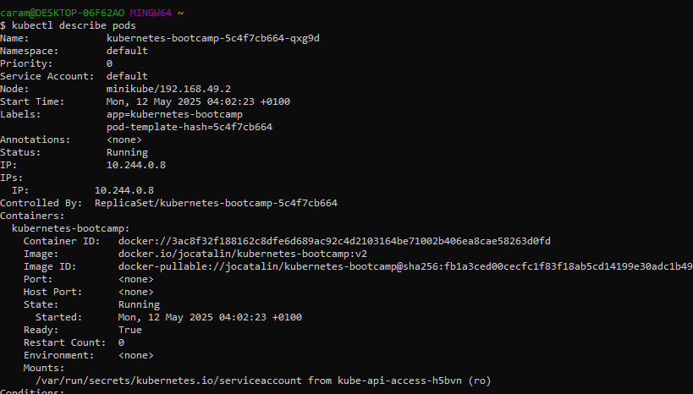

**And the version is the one I want**

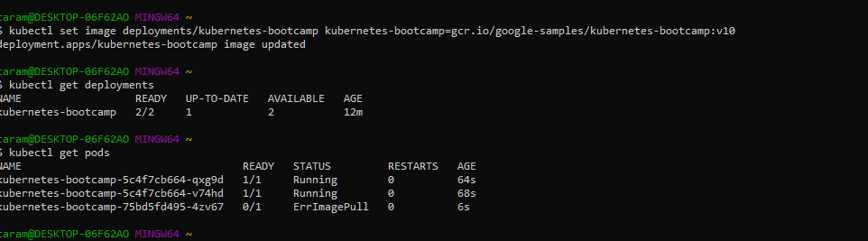

**I then rolled back the update**

