**Peter Hyland C00274825**

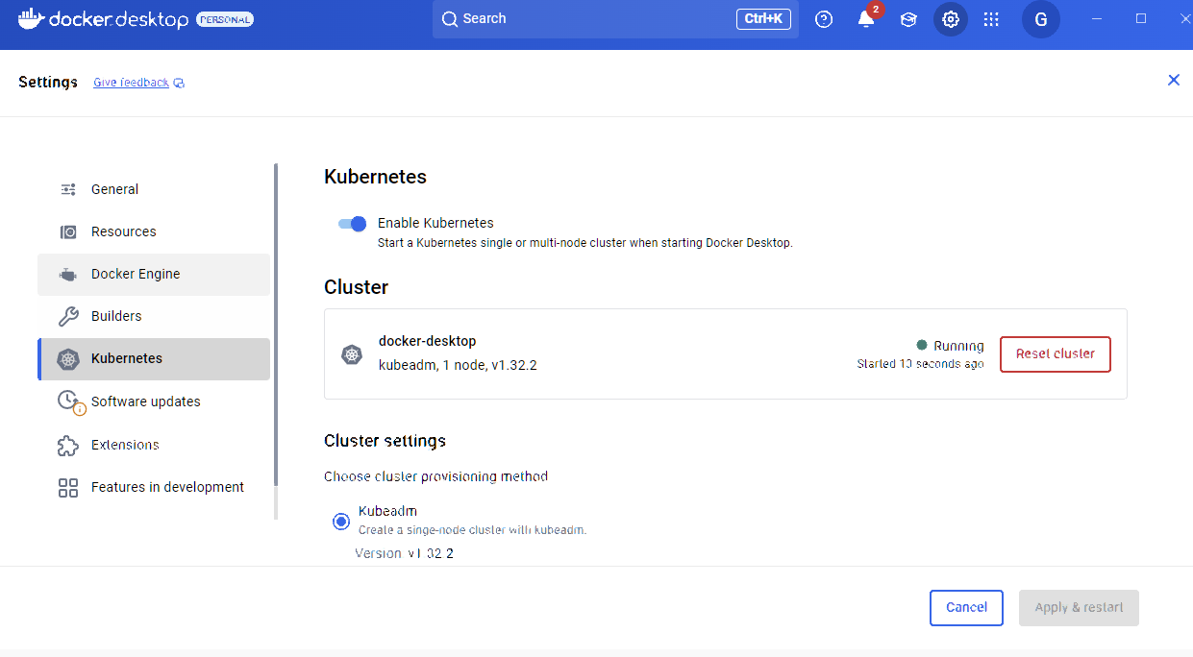

Kernebetes is installed

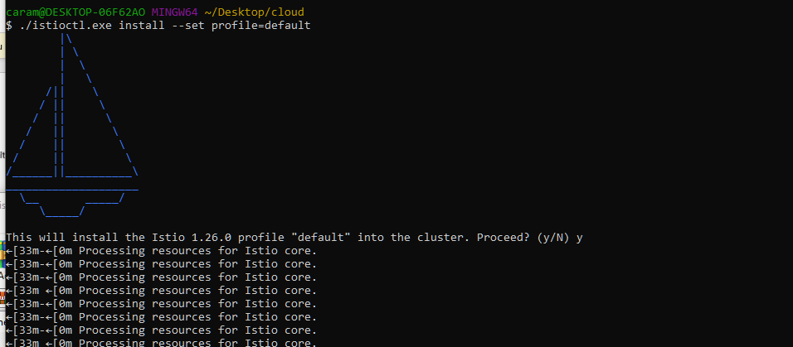

I had issues and had to do various tweaks to the kube config to get it working

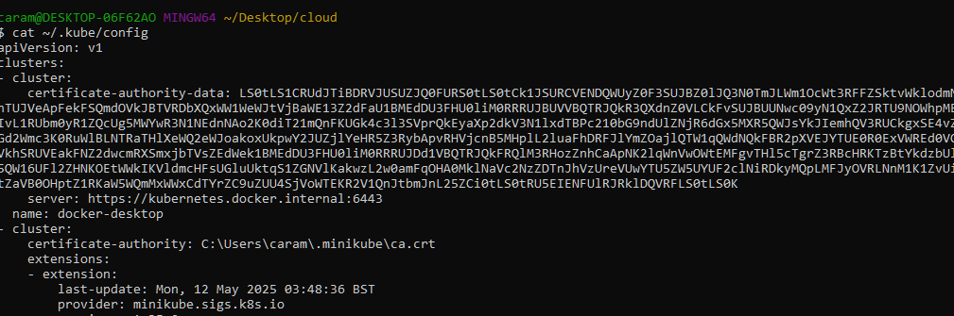

Deploying sample application:

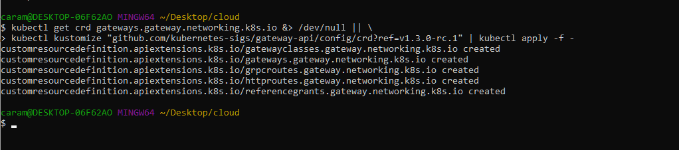

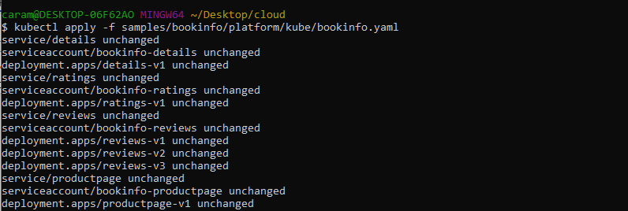

**Everything up and running**

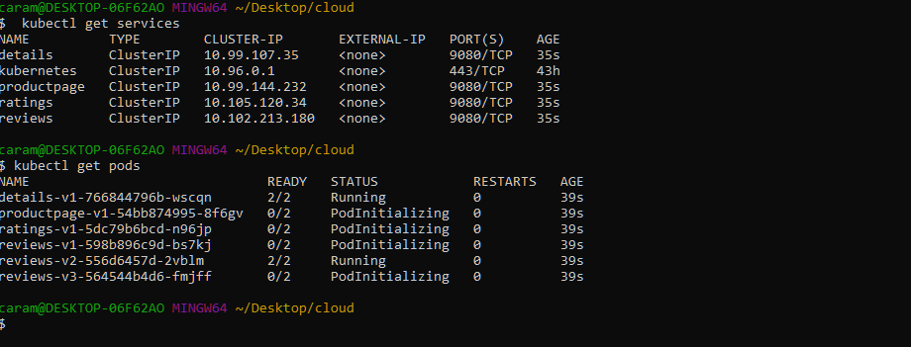

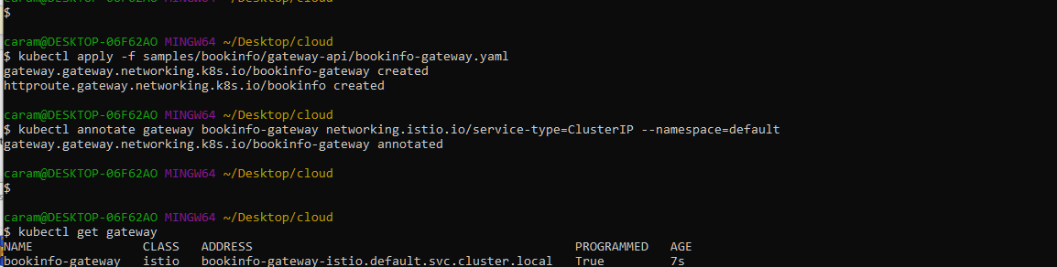

**It is running externally**



**And accessibly via my browser**

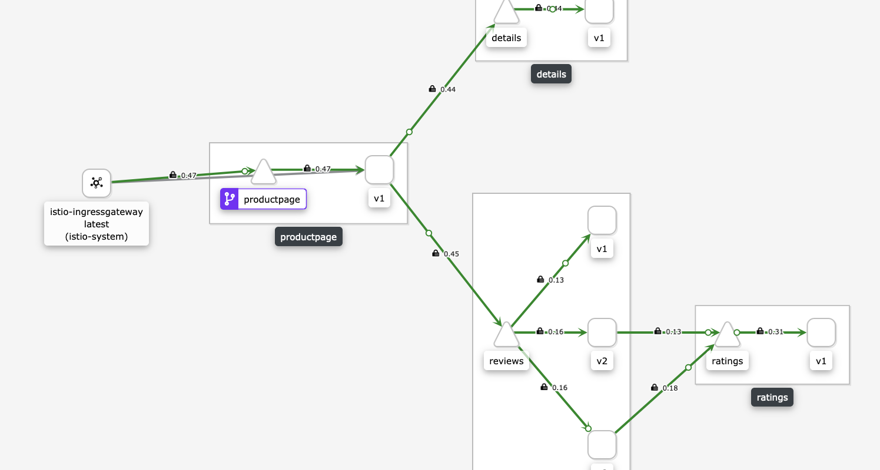

**The dashboard is also accessibly**