**Peter Hyland C00274825**

**This lab exercise will give you hands-on experience with Istio's traffic management capabilities. For example, you can demonstrate how the traffic shifting can be used to manage deployments and migrations of service versions in a microservices architecture.**

**For the following four topics, please submit a word or pdf document containing your compiled screenshots for the key steps.**

**https://istio.io/latest/docs/tasks/traffic-management/traffic-shifting/**

**https://istio.io/latest/docs/tasks/traffic-management/request-routing/**

**https://istio.io/latest/docs/tasks/traffic-management/fault-injection/**

**https://istio.io/latest/docs/tasks/traffic-management/circuit-breaking/**

**TrAFFIC SHIFTING**

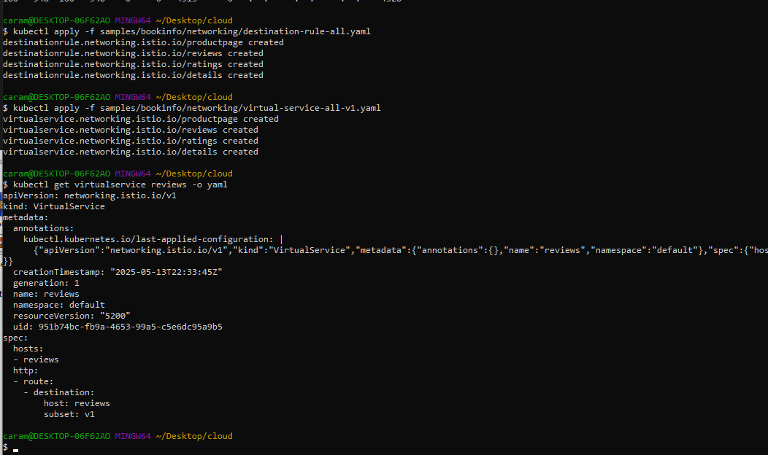

**ALL NEEDED FIELS WERE DOWNLOADED – TRAFFCI ALL ROUTER TO V1**



**The book review page was when visible, the rukle was verified, 50% of the time the red starts the other time no stars.**

**Request routing**

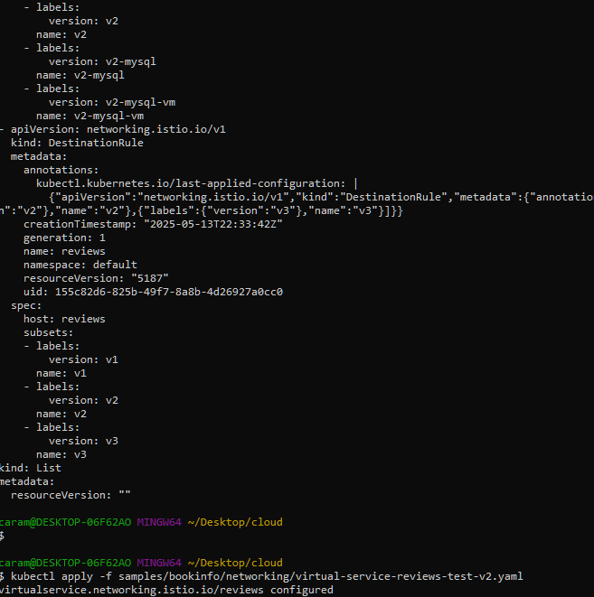

**Requested commands were ran including one to enable user based routing**

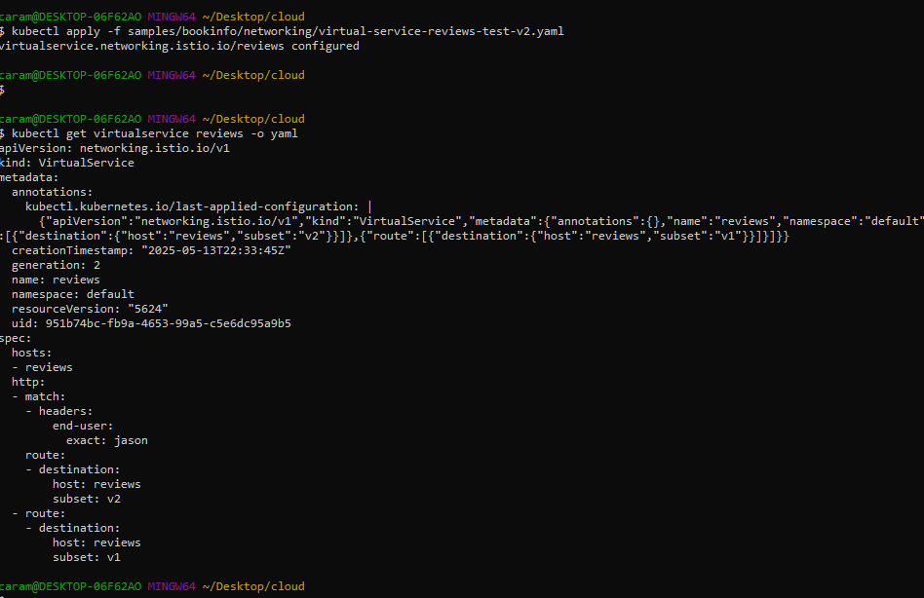

**I confirmed the rule was created**

**FAULT Injection**

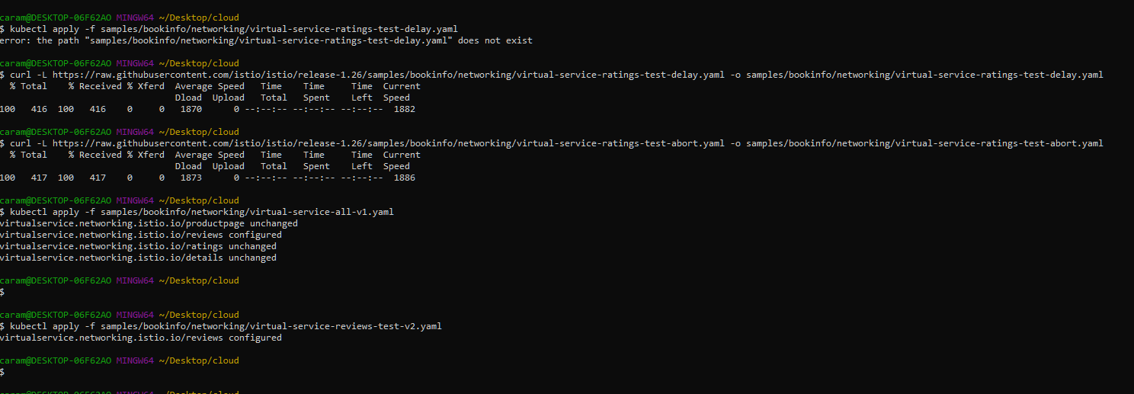

**Downloaded requested files**

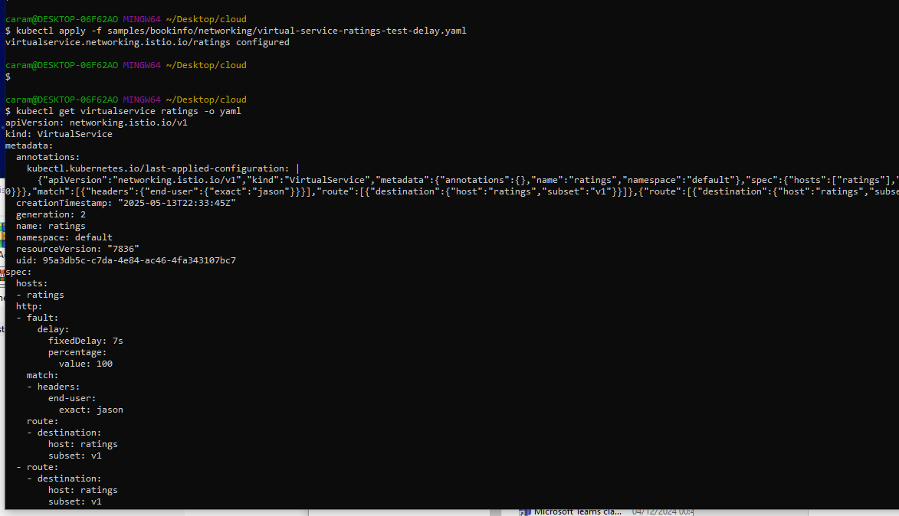

**Created the rule and verified its running**

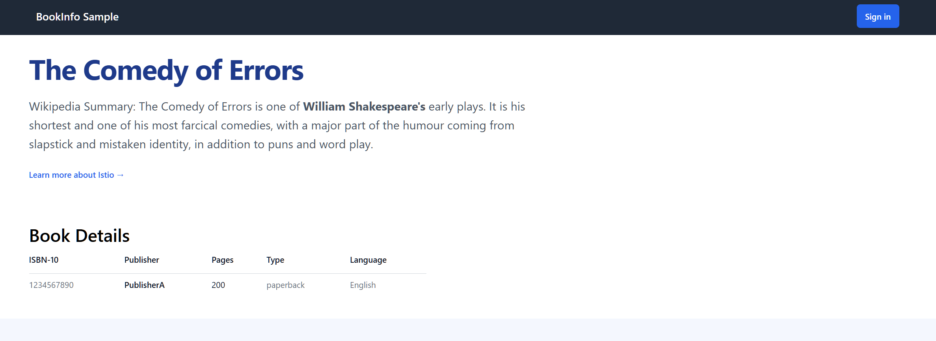

**Website up and running**

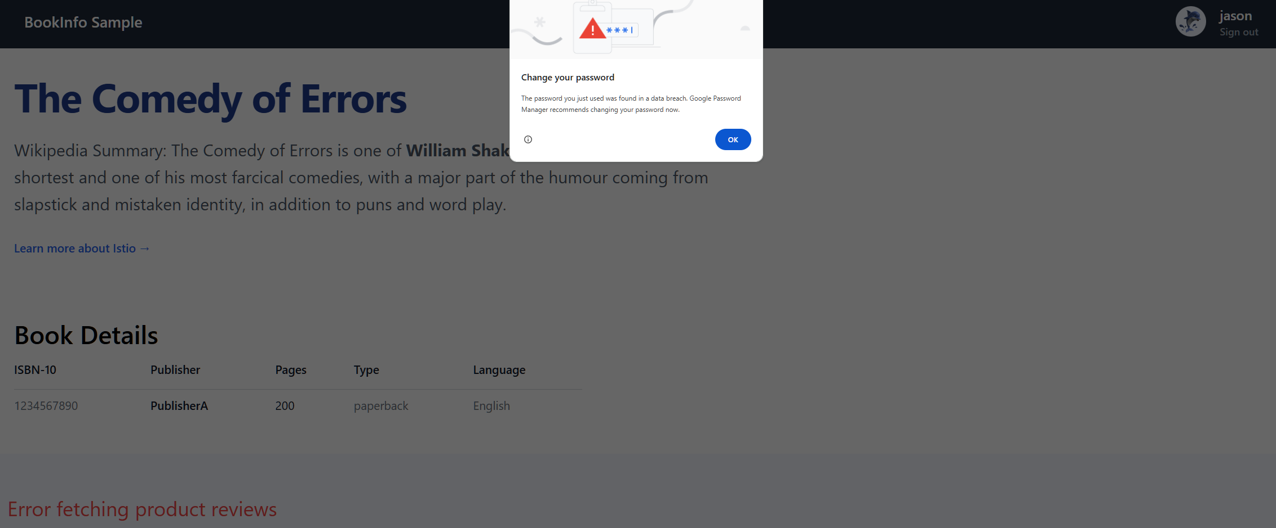

**I logged in as Jason and noted the delay when logging in**

**Circuit breaking**

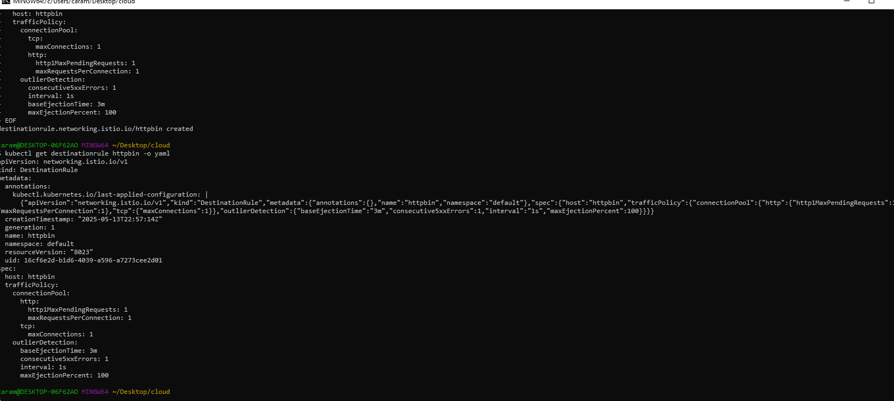

**I created the rule and verified it is running**

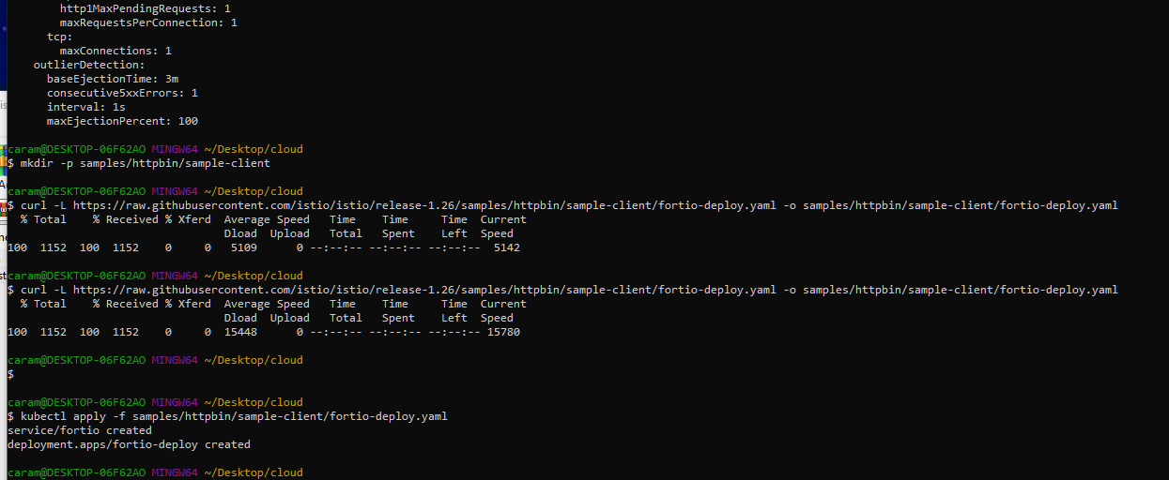

**I deployed fortio**

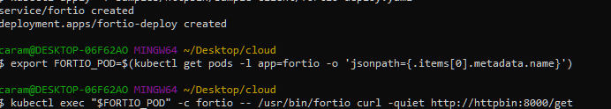

**I vertified its running**

**I tested it and saw in the proxy stats that ti si rworking**