**PETER HYLAND – C00274825 LAB 6**

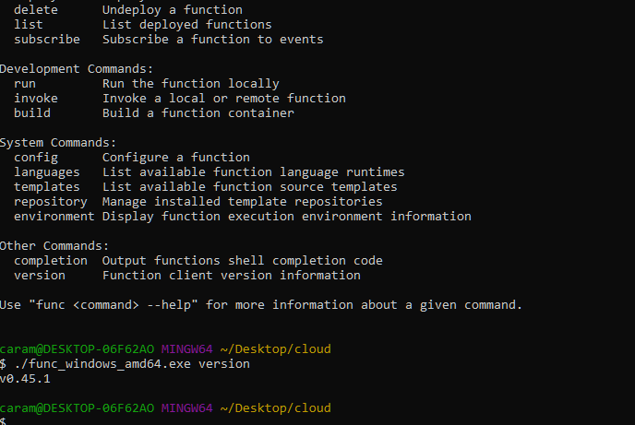

**Func is running on my machine**

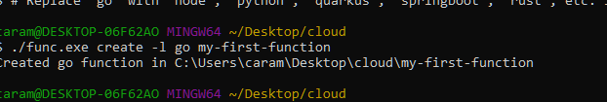

**Created my first function**

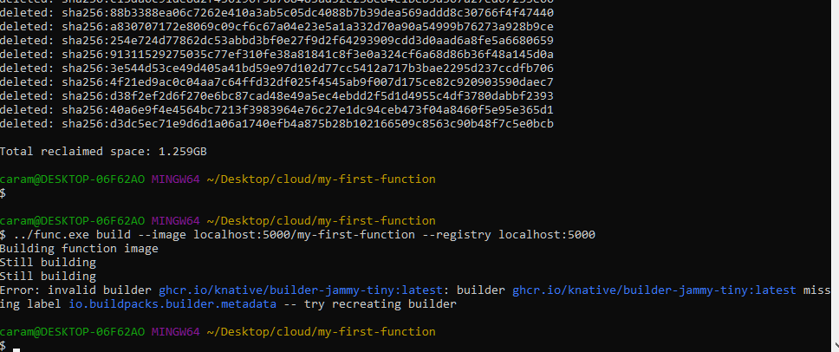

**Despite pruning docker, ensuring latest version, I still get the invalid builder message.**

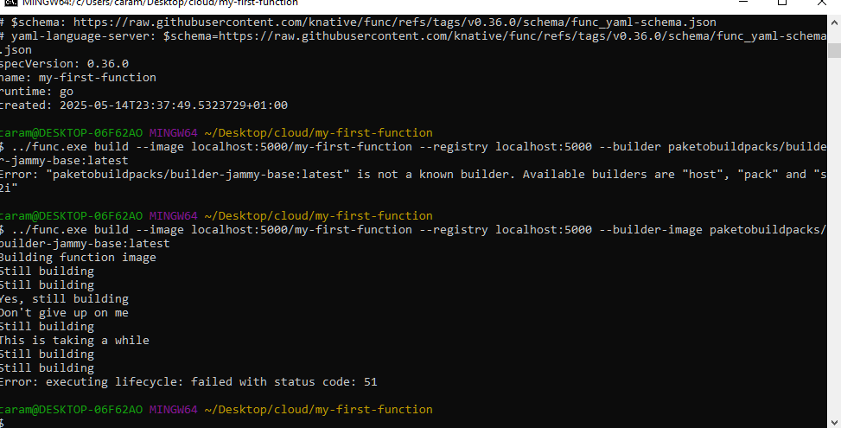

**Even when attempting with another builder version I was unable to continue the lab**

**I attempt to continue the lab, screenshot of hello-serviuce attached**

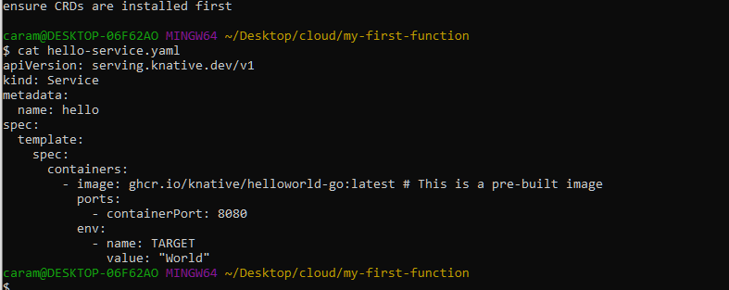

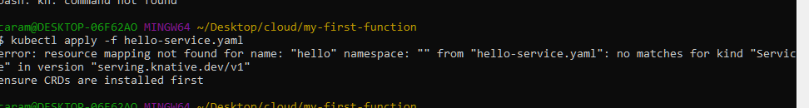

**However this as well was failing on me**

**o**