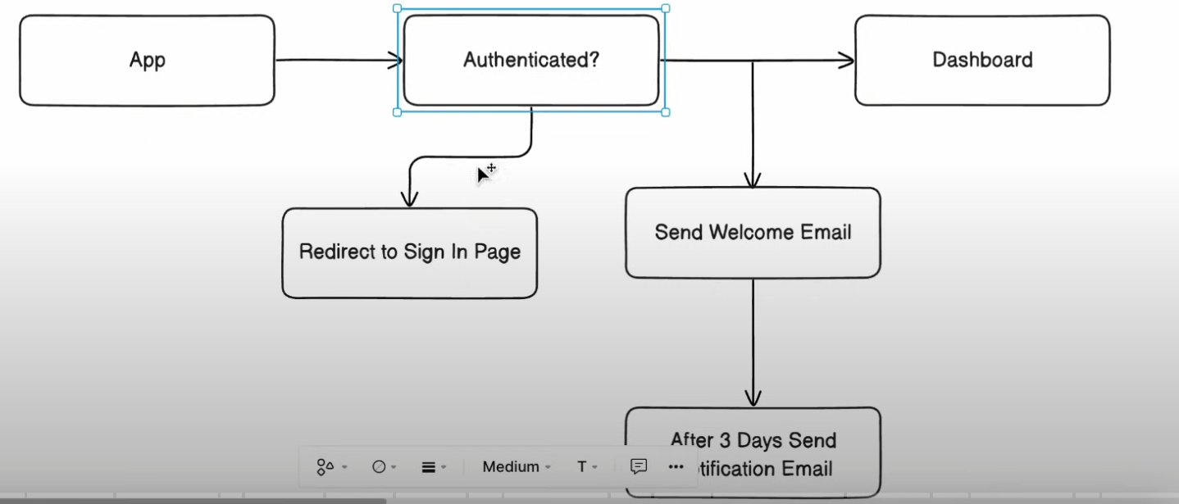

1. Saved user record to DB
2. Generate Course Outline
3. Save to DB
4. Generate Chapters and detailed content
5. Save to DB
6. Generate Quiz
7. Save to DB
8. Send Email to Notify
9. Send Email Notification after 2-3 days/ certain condition

**What is Inngest.com? (In Simple Words)**

**Inngest** is a tool that helps developers **run background jobs** and **schedule tasks** in web applications, especially in **Next.js, React, and Node.js** apps.

**Why Use Inngest?**

Sometimes, you need to perform tasks that take time, like:  
✅ Sending emails after a user signs up  
✅ Processing large files (e.g., images, PDFs)  
✅ Running scheduled jobs (e.g., sending daily reports)  
✅ Retrying failed tasks automatically