Susmag Installation instructions

Software installation
- Get the latest Pylon version from: https://www.baslerweb.com/en/sales-support/downloads/software-downloads/
- Get Python version 3.5 from: https://www.python.org/downloads/
- Get the python dependencies:
  - Open a terminal (add to .bat file?)
  - >> pip install numpy, matplotlib, opencv-python, pillow, cython
  - >> pip install tesseract a prospect, used to find text
  - Test to open tessaract by open python and type “import tessaract”
  - If tessaract cannot be open add tessaract binaries to the PATH. ( Should be C:\Program Files (x86)\Tesseract-OCR\tesseract on windows)

- Copy the PySusmag software to <python folder>

Camera setup
Position the camera
- Open Pylon Viewer software
- Load features file <?.pfv>
- In Pylon, start a live view.
- Position the camera as close to the carrier as possible but make sure that it can allways take a picture of the whole harddrive, no matter rotation or position at the carrier.
- Set focus and light by turning the wheels on the camera
- If needed only, edit the SW features. If so make sure that setting does not adapt to the taken image. This is very important.
- Make sure that the camera and carrier movement is aligned. That is, carrier movment in just the x direction. Not done

Optimize the speed measurement
- Copy settings.json to .settings_bak
- Open Pylon
- Open the video recording settings (window → asdasd)
- Run speedcheck.py <dir>*.avi

Optimize the disc finder
This step will optimize the settings to find the hard drives in the . (make a file called .settings_default.bak and a script to restore to defaults)
In this step we will record some data, perform
- Copy settings.json to .settings_bak
- Open Pylon
- Open the video recording settings (window → asdasd)
- Set time output folder … asdasda, adasd
- Start the carrier
- Start a recording (or use the same file as Camera setup)
- Take a few images on hard drives with labels on them.
- Save the images as PNG files in the video output folder
- Open settings/settings.json
- Open a terminal in susmag/code folder and type: python bandcheck.py <dir>
- Use the plots to set the limits, lower and upper:

The histograms shows the distibution of pixel values in RGBHSV order, for the video (just the carrier band) and the images (band and harddrive). The lists sets the lower and upper limits to where we see the carrier band. It’s not needed to use limits for all colors, If the lower and upper is set to “0”, the color will not be used when finding the hard drive.

Example:
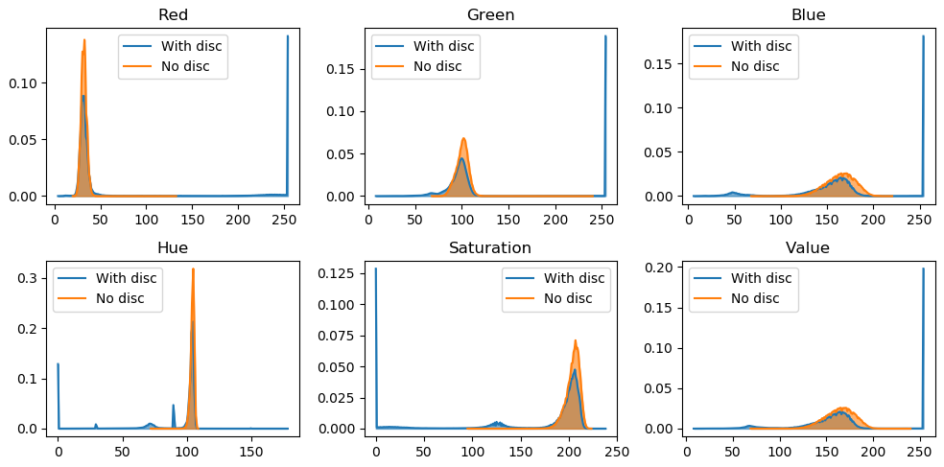
In this case, the result may be:
"limits": {
"lower": [0, 0, 100, 50, 0, 0],
"upper": [100, 200, 230, 150, 0, 230]
}
- Check the result by … and adding more images Not done

OLD
Arbetsflöde:
1. Öppna Pylon och spela in en en (.avi) film då det tomma bandet rör på sig.
2. Ta några bilder (ca fem) på diskar.
3. Lägg filerna (bilder och video) i en mapp under susmag.
4. Kör bandcheck.py <mappnamn>
5. I histogrammet för videon (på det tomma bandet), hitta min och max värden för varje lager.
6. I histogrammen för bilderna på diskarne, hitta i vika lager dom skiljer sig åt.
7. Lägg in min max värden för videon för lagren som skiljer sig från bilderna i settingsfilen.
8. Testa.
Om det inte funkar bra:
* Kör lagrena en och en genom att sätta min och max till 0.
* Flytta min och max neråt resp. uppåt för att göra området lite större.
Band check

