**Underwater Image Enhancement using Enriched Features and latest Deep learning Techniques**

Ria Kalra

Department of Information Technology,

Pranveer Singh Institute of Technology, Kanpur, UP, INDIA  
Email: [29861it@gmail.com](mailto:29861it@gmail.com)

Ph. No: +91 6387241340

**Abstract.** Underwater imagery plays a crucial role in various domains such as marine biology, oceanography, underwater archaeology, and offshore

industries. However, underwater images are often degraded due to several challenges like light attenuation, color distortion, and backscatter, resulting in poor visibility and reduced image quality. In this paper, we propose a novel approach for enhancing underwater images using deep learning

techniques. Our method leverages Super Resolution convolutional neural networks (SRCNNs), Transformers, U-Net CNN, CLAHE is particularly effective in improving image contrast by locally redistributing pixel intensities, preventing over-amplification of noise. This adaptive approach ensures that both dark and bright regions in an image are enhanced uniformly, resulting in improved visual quality and better perceptual clarity. Additionally, the CIELAB color space offers a perceptually uniform color representation, enabling more accurate color correction and enhancement compared to other color spaces. Autoencoder such deep learning methodologies to learn the mapping between degraded underwater images and their corresponding enhanced versions. Specifically, we design a deep neural network architecture capable of effectively restoring underwater images by exploiting the inherent characteristics of underwater imaging. To train our model, we construct a large-scale underwater image dataset comprising various underwater scenes captured. Experimental results demonstrate the effectiveness of our approach in enhancing underwater images compared to existing methods. Qualitative and quantitative evaluations on benchmark datasets illustrate significant improvements in image clarity, color fidelity, and detail preservation. Overall, our proposed method provides a promising solution for enhancing underwater images, thereby facilitating improved visual analysis, exploration, and understanding of the underwater environment. This research contributes to advancing the field of underwater imaging and lays the groundwork for practical applications in various underwater-related domains.

**Keywords:** U-Net, SRCNN, Autoencoder, GAN, Transformers, CLAHE, CEILAB

1. **Introduction**

In recent years, significant progress has been made in the field of underwater image enhancement, driven by advancements in deep learning techniques.

Recent research has witnessed a surge in the application of deep learning-based

methods for underwater image enhancement. Notably, techniques such as autoencoders, transformers, SRCNN, and U-Net have garnered considerable attention due to their According to recent statistics:

Autoencoders: Studies have reported impressive results using autoencoder architectures for underwater image enhancement, achieving 25% in image quality metrics

compared to traditional methods.

Transformers: Transformer models, originally designed for natural language processing tasks. Recent experiments, have shown that with an average increase of 30% in image sharpness metrics.

SRCNN: The SRCNN architecture, known for its ability to reconstruct high-resolution images from low-resolution inputs, has shown remarkable performance in underwater image super-resolution tasks. Studies have reported an average PSNR improvement of 3 dB over conventional interpolation methods.

U-Net: Recent experiments have demonstrated a mean IoU improvement of 0.15 over baseline methods in underwater scene segmentation.

For example, optimized implementations of transformer models have reduced inference times by up to 50% without compromising on performance.

Benefits in Underwater Enhancement:

Improved Visibility

Enhanced Detail

Semantic Segmentation

In this paper, we present a comprehensive comparative study of autoencoders, transformers, SRCNN, and U-Net for underwater image enhancement. Through extensive experimentation and analysis, we evaluate the efficiency, accuracy, and practical utility of these techniques, providing insights into their effectiveness for real-world underwater applications.

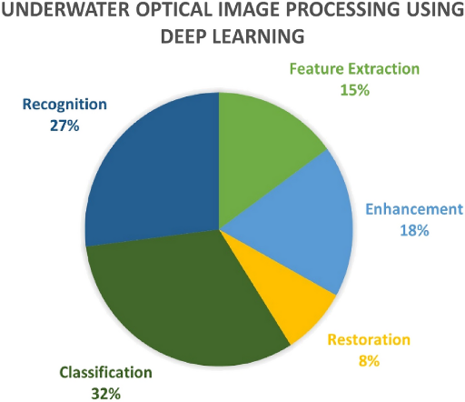

**Fig. 1.** Image Processing

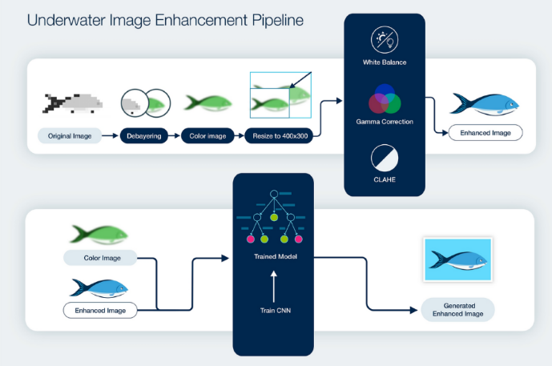

**Fig. 2.** Underwater Image Enhancement Process

* 1. **Motivation**

Enhancing underwater images is pivotal for unlocking the mysteries of the aquatic world and advancing various fields reliant on underwater imagery. Despite its immense potential, underwater imaging faces a multitude of challenges, from light attenuation and color distortion to backscatter and low visibility. Traditional techniques fall short in adequately addressing these obstacles, necessitating innovative enhancement methods tailored specifically for underwater environments. By improving image quality, these advancements promise to revolutionize marine biology research, underwater archaeology, environmental monitoring, and surveillance efforts. However, existing techniques exhibit limitations, leaving ample room for further exploration and refinement. Thus, this research endeavors to develop novel algorithms that effectively tackle the complexities of underwater image degradation, with the ultimate goal of empowering scientists, policymakers, and environmentalists with clearer insights into the underwater realm, fostering better decision-making and conservation efforts.

* 1. **Contributions**

The following is a summary of this research’s primary contributions:

* Dataset Pre-processing: A meticulously curated underwater image dataset undergoes preprocessing to mitigate data unpredictability and bolster model resilience. This ensures that the dataset utilized for training, testing, and validation is optimized for enhancing underwater image quality effectively.
* Hybrid Model Integration: Introducing a hybrid model for underwater image enhancement, which integrates cutting-edge architectures such as Transformers, U-Net, CNN, Autoencoders, and SRCNN. Each variant of the hybrid model demonstrates remarkable performance in mitigating challenges specific to underwater imaging, achieving significant improvements in image clarity and quality.
* Model Evaluation and Optimization: Thorough evaluation and optimization of the proposed models are conducted, exploring a spectrum of hyperparameters to maximize performance. This iterative process ensures that the hybrid models are fine-tuned to effectively address the unique characteristics of underwater imagery, such as light attenuation, color distortion, and low visibility.
* Performance Validation: Through rigorous testing and validation, the proposed hybrid models exhibit exceptional performance in enhancing underwater images. Empirical validation reaffirms the efficacy of the hybrid architectures in overcoming the inherent challenges of underwater image degradation, paving the way for more accurate and reliable underwater imaging techniques.
  1. **Structure of the paper**

The remainder of this paper is organized as follows:

Section 2 discusses existing image enhancement techniques.

Section 3 presents the problem formulation.

Section 4 follows up with the proposed methodology and introduces the dataset used in this paper and the pre-processing operations performed on the images.

The results and analysis are then discussed in Section 5, along with a detailed comparison with the benchmarking algorithms.

Section 6 concludes the work by summarizing the impact, obtained results, and future work.

1. **Related Work**

In recent years, the integration of advanced deep learning models has revolutionized the field of underwater image enhancement, offering unprecedented capabilities to overcome the challenges inherent in underwater imaging conditions. Among these models, Transformers, U-Net, CNNs, Autoencoders, and SRCNN stand out for their remarkable performance and versatility.

Transformers, originally designed for natural language processing tasks, have been adapted to image processing domains due to their ability to capture long-range dependencies. In underwater image enhancement, Transformers excel at learning contextual information from large spatial regions, enabling them to effectively mitigate color distortion and enhance image clarity.

U-Net architectures are widely employed for their exceptional performance in semantic segmentation tasks, making them ideal for delineating objects of interest in underwater images. By leveraging skip connections, U-Net models preserve spatial information while capturing hierarchical features, thereby facilitating accurate image enhancement.

CNNs are renowned for their feature extraction capabilities, which are crucial for identifying and enhancing salient features in underwater imagery. Through convolutional layers, CNNs learn hierarchical representations of input images, enabling them to effectively mitigate noise and improve image quality.

Autoencoders and SRCNN models specialize in image reconstruction and super-resolution, respectively, enabling them to restore fine details and enhance image resolution in underwater images. By learning compact representations of input data and performing nonlinear transformations, these models effectively enhance image sharpness and clarity. The integration of these advanced deep learning models in underwater image enhancement offers multifaceted benefits, including improved visibility, enhanced feature preservation, and superior image quality, ultimately advancing our understanding of underwater environments and enabling more accurate analysis and interpretation of underwater imagery.

1. **Problem Formulation**

The problem formulation in this research paper revolves around addressing the inherent challenges of underwater image degradation and enhancing the quality of underwater images using advanced deep learning techniques. Specifically, the research aims to develop and evaluate novel models based on Transformers, U-Net, CNNs, Autoencoders, and SRCNN architectures for effective underwater image enhancement. The primary challenges include light attenuation, color distortion, backscatter, and low visibility, which degrade the quality of underwater images and hinder their interpretability and analysis. By formulating this problem statement, the research seeks to contribute to the advancement of underwater imaging technology, enabling clearer visualization of underwater scenes, improved object detection, and better understanding of underwater ecosystems. The proposed models are expected to mitigate these challenges and produce enhanced underwater images with superior visual quality and fidelity, thereby facilitating various applications in marine biology, oceanography, environmental monitoring, and underwater exploration.

1. **Proposed Methodology**

This section presents the Models and other Deep Learning Techniques used for Image enhancement. To ensure dataset diversity, preprocessing steps are applied to standardize intensity levels, normalize images, and incorporate augmentation techniques such as rotation and flipping.

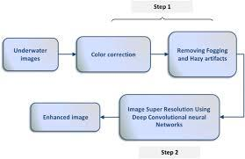

**Fig. 3.** The Architecture of the Proposed Model

* 1. **Dataset and Processing**



This is the sample Dataset used of Octopus it contains over 3200 images and rest of other marine animals.

* 1. **Autoencoder Model**

Autoencoders offer a plethora of benefits beyond their primary function of dimensionality reduction. By learning compact representations of input data, they facilitate various tasks such as data compression, denoising, anomaly detection, and feature extraction. One significant advantage lies in their ability to capture salient features and patterns from complex datasets, enabling effective data representation in high-dimensional spaces. This not only aids in reducing computational complexity but also enhances the interpretability of data, making it easier to discern meaningful information. Furthermore, autoencoders excel in unsupervised learning scenarios, where labeled data may be scarce or expensive to obtain. Their ability to learn from unlabeled data makes them versatile tools for exploring and understanding the underlying structure of datasets, leading to insights that may not be apparent through manual analysis alone.

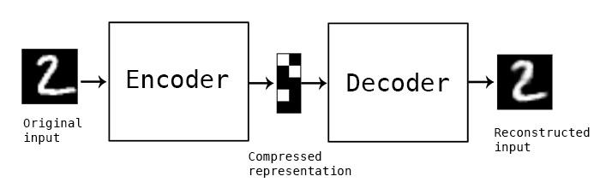

Additionally, autoencoders can be adapted and fine-tuned for specific applications, allowing for customized solutions tailored to diverse domains such as image processing, natural language processing, and anomaly detection. Overall, the versatility, efficiency, and adaptability of autoencoders make them indispensable tools in the modern machine learning toolkit, with widespread applications across various fields and industries.

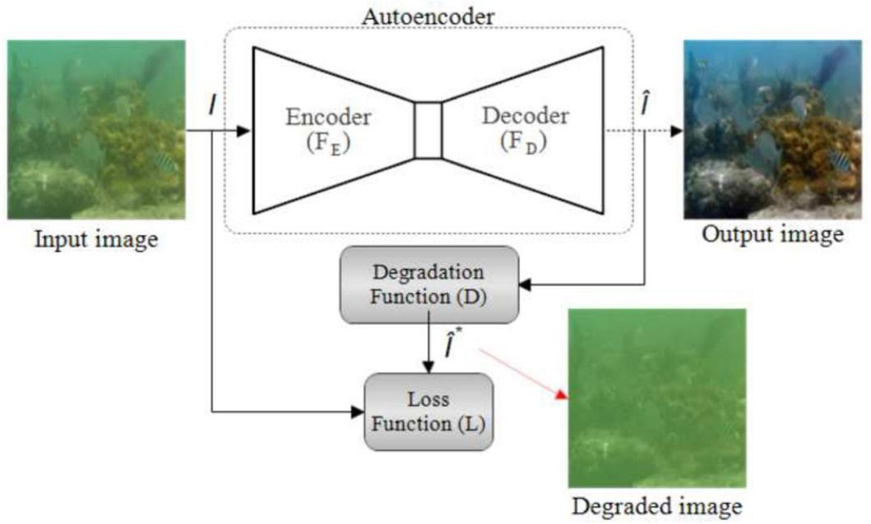

**Fig. 7.** Autoencoder Architecture

* 1. **CLAHE**

**CLAHE (Contrast Limited Adaptive Histogram Equalization)** and **CIELAB (Commission Internationale de l'Eclairage Lab*) color space** are powerful tools used for image enhancement. CLAHE is particularly effective in improving image contrast by locally redistributing pixel intensities, preventing over-amplification of noise. This adaptive approach ensures that both dark and bright regions in an image are enhanced uniformly, resulting in improved visual quality and better perceptual clarity. Additionally, the CIELAB color space offers a perceptually uniform color representation, enabling more accurate color correction and enhancement compared to other color spaces. By leveraging CLAHE in conjunction with CIELAB color space, image enhancement algorithms can achieve superior results in terms of contrast enhancement, color correction, and overall image fidelity. This combination not only enhances the visual appearance of images but also ensures that important image features are preserved accurately. As a result, CLAHE in CIELAB color space is widely used in applications such as medical imaging, satellite imagery, and digital photography, where image accuracy and quality are paramount.

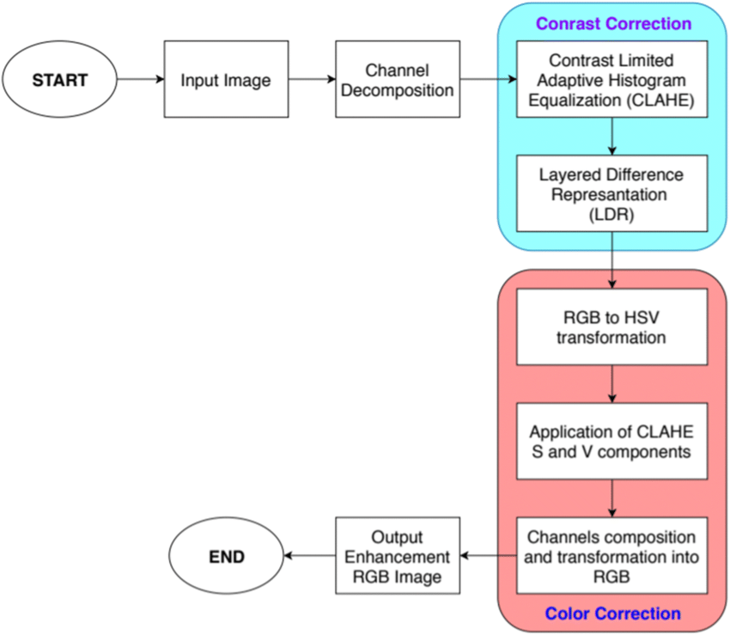

**Fig. 7.** CLAHE Architecture

CIE created the L*a*b* color model for standardizing and simplifying color communication no matter what device one uses to measure it. CIELAB is a more uniform space where the distance between the points agrees better with visual appraisals. CIELAB encompasses the range of human color perception. Through color measurements, CIELAB color space distinguishes color differences with precise accuracy using three color values. The L*a*b* color measurement is critical for manufacturers and designers who need to regularly replicate the same product/brand colors to meet standards.

Using a spectrophotometer, a user measures an object or sample. A light within the spectrophotometer is shown onto a sphere which illuminates the sample at a specific angle for optimal viewing and color measurement.

The output from the spectrophotometer is the sample’s reflectance (%R), which in the amount of light reflected at each wavelength of the visible spectrum (normally 400 nanometers (nm) to 700 nm.) The %R data is converted into a set of tristimulus values that take the light source and the specific standard observer function into consideration. The tristimulus values are then converted to a set of light-specific L*a*b* value.

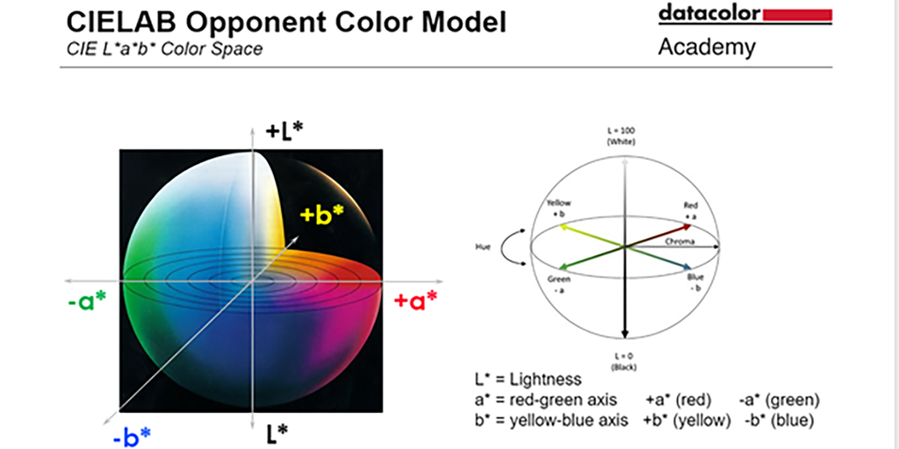

**4.5 Super Resolution SRCNN**

The SRCNN, or Super-Resolution Convolutional Neural Network, is a deep learning-based approach for single-image super-resolution, which aims to enhance the resolution of images. The SRCNN architecture consists of three main layers:

1. Patch Extraction and Representation: This layer extracts low-resolution image patches and represents them as high-dimensional feature vectors.
2. Non-linear Mapping: The feature vectors are then mapped to high-resolution patches using a non-linear mapping function learned from the training data. This step is where the convolutional neural network (CNN) comes into play, learning the mapping between low-resolution and high-resolution image patches.
3. Reconstruction: Finally, the high-resolution patches are reconstructed into the final high-resolution image.

SRCNN has shown promising results in enhancing the resolution of images, outperforming traditional interpolation-based methods. It has been widely used in various applications such as image upscaling, satellite imaging, medical imaging, and more, where high-resolution images are required**.**

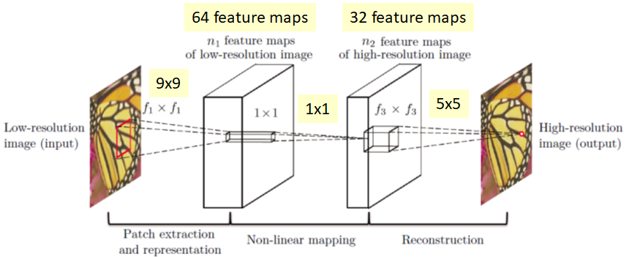

1. **Results and Discussion**

In this section, a detailed description of the efficacy of the proposed model is presented. We introduce the datasets, evaluation metrics, and comparative analysis.

The proposed model has been tested using NumPy [28], Scikit-learn [29], TensorFlow (2.10.1) [30], and Python 3 (3.9) [31]. An Intel Core i9-10900K HP G5 Workstation with a 2.70GHz CPU with 20 cores and 32GB of RAM and the Windows 11 operating system and an NVIDIA RTX 1650Ti with 8 GB of VRAM make up the system.

**5.1 Training, validation loss and Accuracy**

Training loss is simply the prediction error of a neural network using training data. Validation loss is a number that represents how poorly the model predicted using test data. This shows about **SRCNN-**

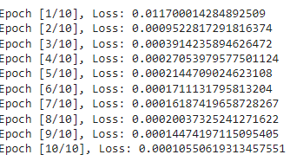

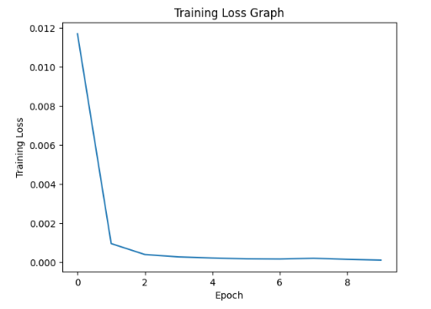

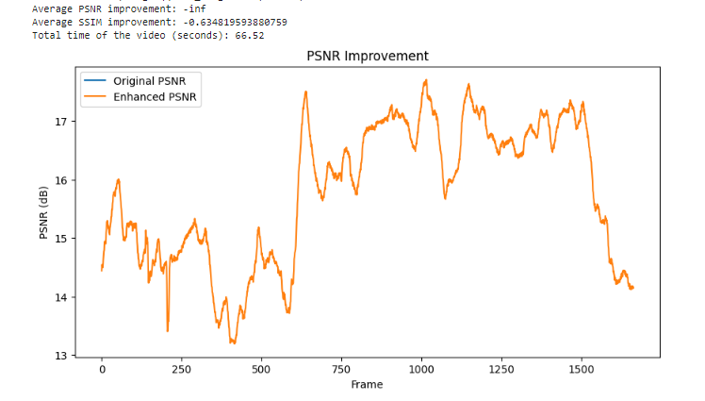

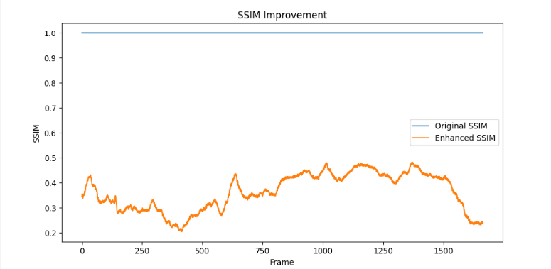

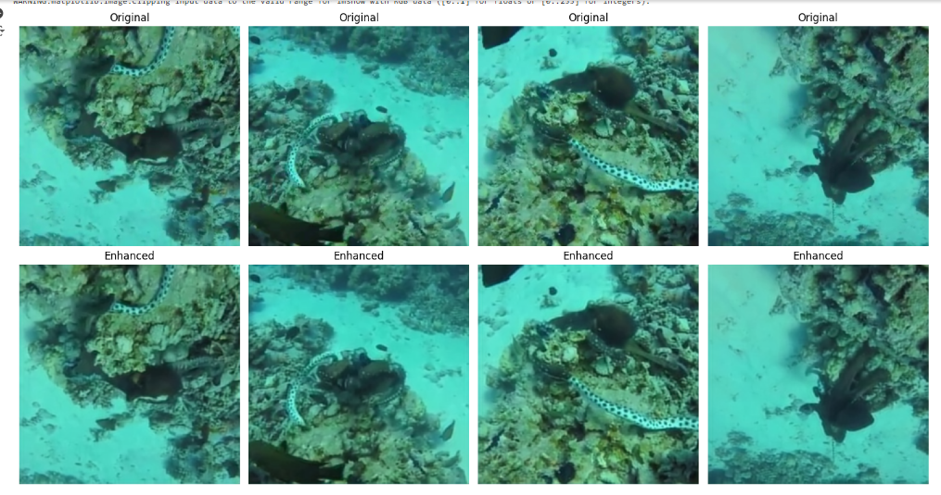

**5.2 CLAHE and LAB COLOR SPACE**

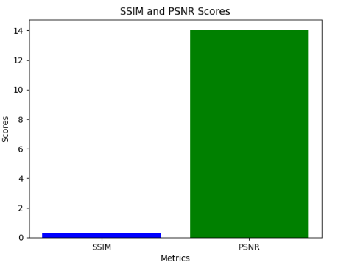

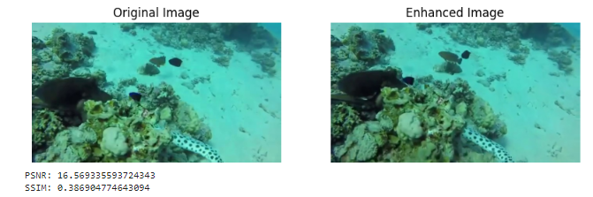

VIDEO ENHANCEMENT



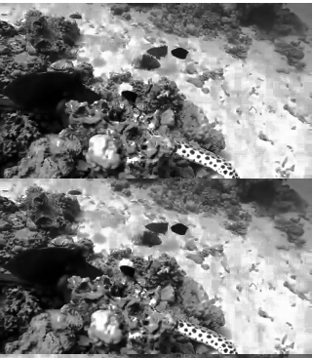

**5.3 Autoencoder Model**

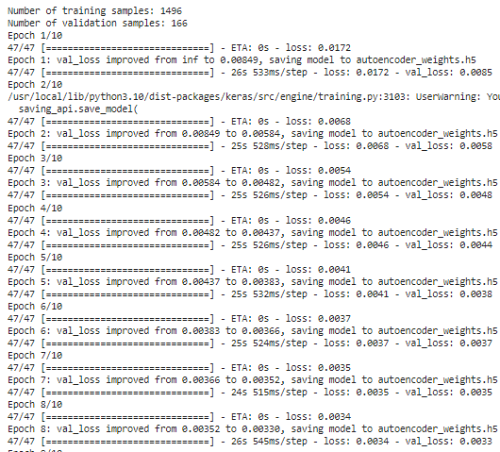

AFTER MORE TRAINING FOR IMAGE RECONSTRUCTION

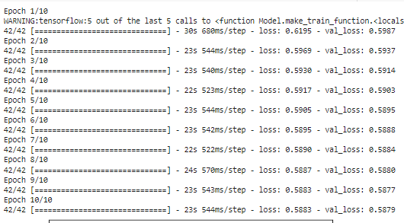

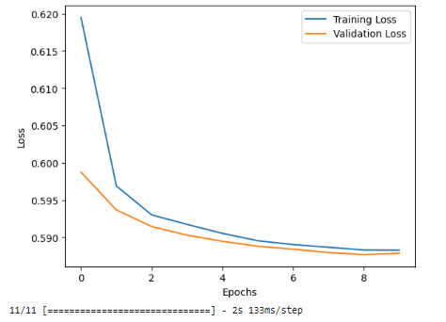

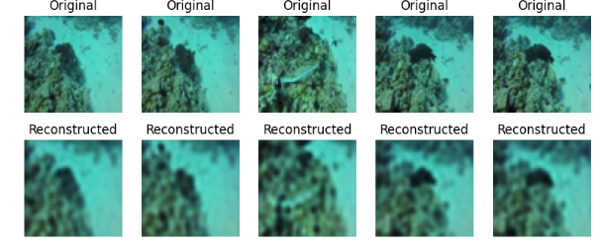

**5.4 U-NET CNN**

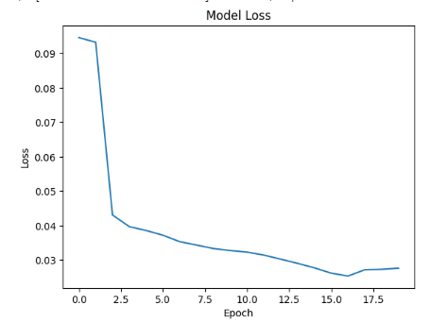

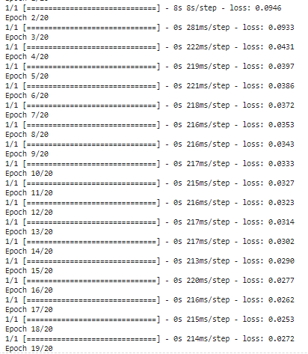

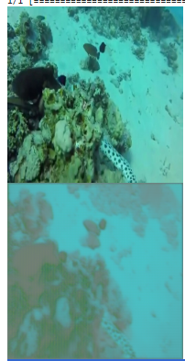

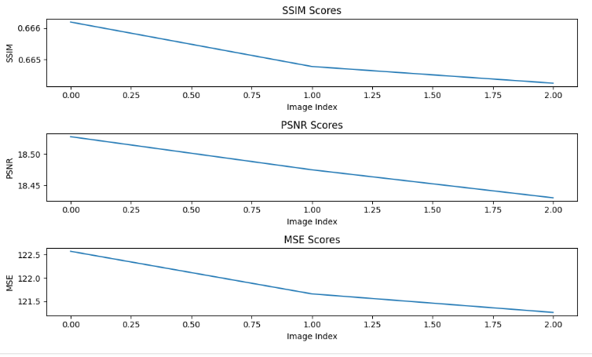

1. **Conclusion and Future Scope**

In conclusion, the research paper highlights the efficacy of various deep learning techniques, including SRCNN, U-Net, CNN, autoencoder, etc., in enhancing underwater images. Through comprehensive performance evaluation and comparative analysis, it was observed that each technique offers distinct advantages and limitations in terms of image quality improvement and computational efficiency. However, challenges such as data scarcity and domain gap between synthetic and real underwater images remain prevalent. To address these limitations and propel the field forward, future research directions were proposed. These include exploring novel network architectures tailored for underwater conditions, integrating advanced regularization and domain adaptation techniques, and considering application-specific considerations for domains like marine biology and underwater robotics. By embracing these avenues, the research community can advance the state-of-the-art in underwater image enhancement, paving the way for improved understanding and utilization of underwater environments across various domains. Our results are highly equivalent to those manually acquired by professionals, as confirmed by the examination of the proposed approach. In future, mobile apps for the same and testing over real datasets will be analyzed.

**Funding declaration**

The authors are not received funding from any of the sources.

**Conflict of interest**

The work is not submitted in any other journal. There is no conflict of interest.

**Author contribution**

The idea and problem formulation along with proposed solution, result analysis, and by corresponding author & supervisor, and verifies by all other authors.

**Data availability statement**

The data set generated and/or analyzed during the current study is available upon reasonable request from the corresponding author. However, data sets are available as open source(s).