Form:

from tkinter import *

r = Tk()

r.title("Student Registration Form")

r.geometry=('400x400')

r.configure(background='white')

a = Label(r ,text = "First Name")

a.grid(row = 0,column = 0)

b = Label(r ,text = "Last Name")

b.grid(row = 1,column = 0)

c = Label(r ,text = "Email Id")

c.grid(row = 2,column = 0)

d = Label(r ,text = "Contact Number")

d.grid(row = 3,column = 0)

a1 = Entry(r)

a1.grid(row = 0,column = 1)

b1 = Entry(r)

b1.grid(row = 1,column = 1)

c1 = Entry(r)

c1.grid(row = 2,column = 1)

d1 = Entry(r)

d1.grid(row = 3,column = 1)

v = IntVar()

e = Label(r,text="Gender:")

e.grid(row = 4,column =0 )

e1 = Radiobutton(r,text="Male",variable=v,value=1)

e1.grid(row = 4,column =1, sticky=W)

e2 = Radiobutton(r,text="Female",variable=v,value=2)

e2.grid(row = 4,column =1, sticky=E)

f = Label(r ,text = "Subject")

f.grid(row = 5,column = 0)

var1 = IntVar()

f1 = Checkbutton(r, text="Python", variable=var1)

f1.grid(row=5,column=1 , sticky=W)

var2 = IntVar()

f2 = Checkbutton(r, text="DSA", variable=var2)

f2.grid(row=5,column=1, sticky=E)

g = Button(r, text="Register")

g.grid(row=6, column=1)

r.mainloop()

Output:

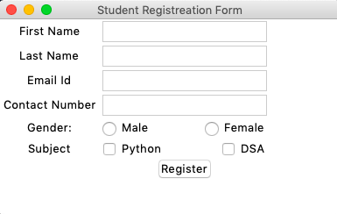

Canvas:

from tkinter import *

r = Tk()

global c

win = Tk()

c = Canvas(win, width = 800, height = 800)

c.grid()

c.create_oval(70, 70, 350, 350, outline = "black", fill = "yellow")

eye1 = c.create_oval(125, 125, 175, 175, fill = "black")

eye2 = c.create_oval(225, 125, 275, 175, fill = "black")

mouth = c.create_line(125, 250, 275, 250, width = 5)

r.mainloop()

Output:

