# Program:

from tkinter import * root = Tk()

root.geometry("500x500") root.title("Form")

label_1=Label(root, text="First Name",width=20 ,font = "Times 16 bold") label_1.place(x=80,y=130)

e1 = Entry(root) e1.place(x=245,y=130)

label_2=Label(root, text="Second Name",width=20 ,font = "Times 16 bold") label_2.place(x=70,y=180)

e2 = Entry(root) e2.place(x=245,y=180)

label_3=Label(root, text="Email",width=20 ,font = "Times 16 bold") label_3.place(x=65,y=230)

e3 = Entry(root) e3.place(x=245,y=230)

label_4=Label(root, text="Gender",width=20 ,font = "Times 16 bold") label_4.place(x=65,y=280)

var=IntVar()

Radiobutton(root, text="Male",padx = 5, variable=var, value=1).place(x=220,y=280)

Radiobutton(root, text="Female",padx = 20, variable=var, value=2).place(x=290,y=280)

label_5=Label(root, text="Country",width=20 ,font = "Times 16 bold") label_5.place(x=45,y=330)

list1=("Canda","Germany","India","Ireland"); c=StringVar() droplist=OptionMenu(root,c,*list1) droplist.config(width=15)

c.set("select ur country") droplist.place(x=200,y=330)

Button(root, text="submit", width=20, bg="brown", fg="white").place(x=180 ,y=380) mainloop()

# Output:

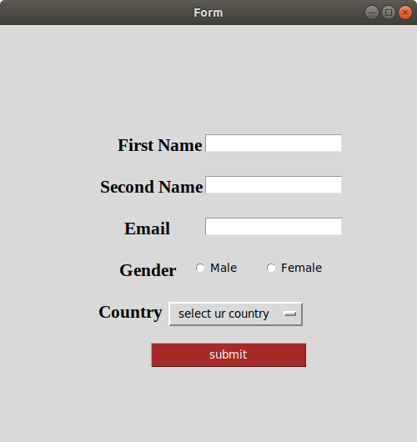

**Program:**

from tkinter import * canvas_width = 200

canvas_height =200

python_green = "#476042" master = Tk()

w = Canvas(master, width=canvas_width, height=canvas_height) w.pack()

points = [0,0,canvas_width,canvas_height/2, 0, canvas_height] w.create_polygon(points, outline=python_green,

fill='yellow', width=3) mainloop()

# Output:

