**Project 1 State-Wise Development Analysis In India**

1.Find out the districts who achieved 100 percent objective in BPL

-**Store the data in Hadoop Cluster using Flume**

**-Clean the data using pig script**

**-Store the results in HBASE/RDBMS using Sqoop**

**-Insert datasets in HDFS from local file system**

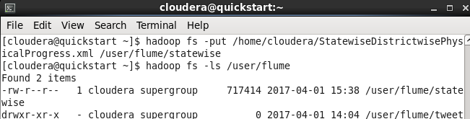

**-Starting FLUME job**

**-Create a conf file in flume-ng/conf folder**

**-Named it as state-wise.conf**

**-Edit the configuration file with below**

- Name the components of the agent

- Describe the source where should read

- Describe the sink where should write

- Use a channel which moves in memory so when moving into HDFS give it as a file

- Define the source directory, bind the sources and sinks to the channel

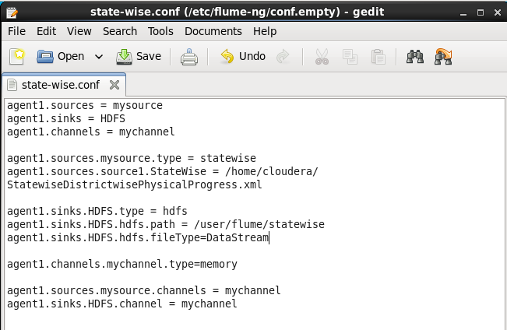

**-Given the configuration file**

**-Start flume-ng agent as follows :**

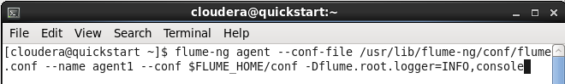

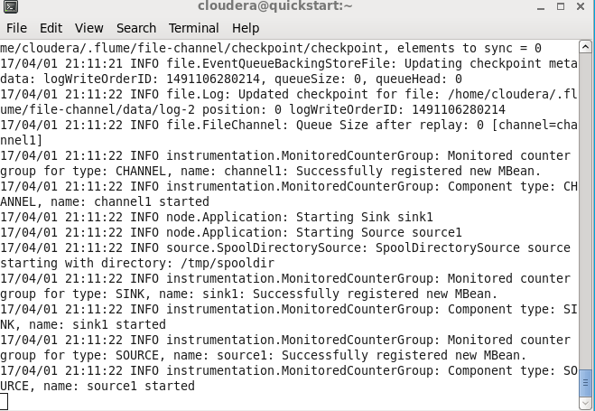

**-PERFORMING PIG**

**-Clean the data using PIG**

**-Start the grunt shell with help of pig command**

**-To read xml format we XMLLoader() in piggybank. So for this we need to register a piggybank-0.15.0.jar**

**-Download the jar and using register command register the jar**

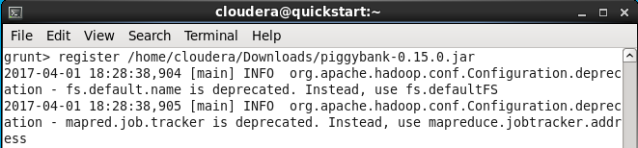

**-Load the xml file using the default XML Loader available in pig, inside the XML loader we are specifying that our root element is property**

**-we are storing the whole thing with an alias name** state **as** chararray



**-Pig job for parsing xml data**

**-Now get the values of each state from the relation A and store it into another relation named B using the foreach operator and separate the record by using flatten function**

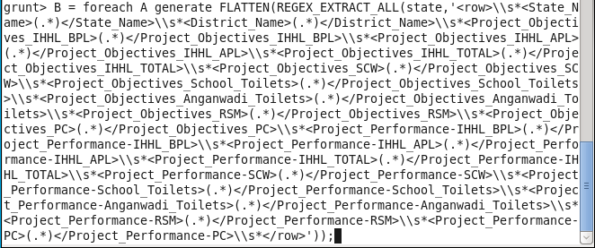

**-Define XPath**

**-Now store the relation in HDFS directory ‘/user/flume/xml_to_csv’ inside the CSVExcelStorage**



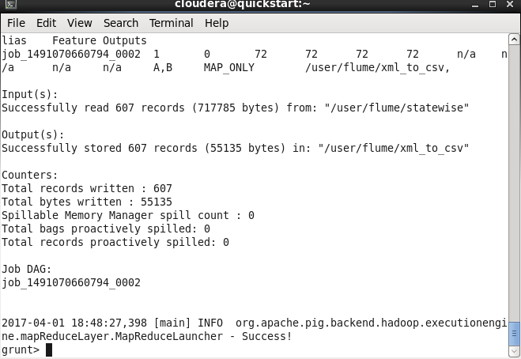

**-Loading the csv file into pig**

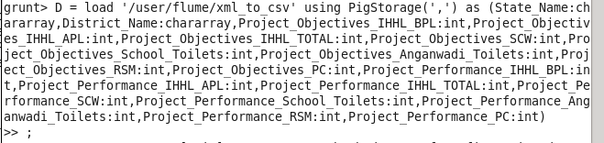

**-Now use the Filter operator to get the details of the Project_Objective_IIHL_BPL**

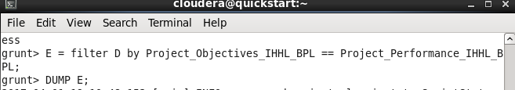

**-dump E;**

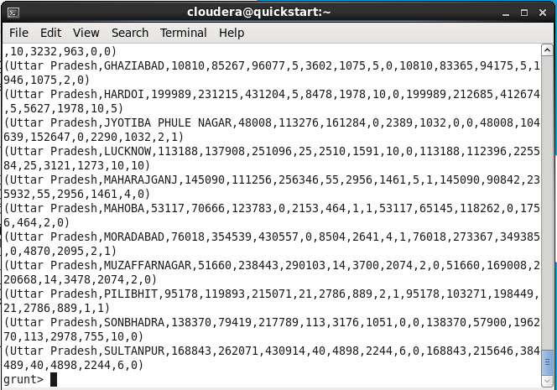

**-now group the records/tuples in the relation by District_Name**

**- Store the filter details in ‘/user/flume/xml_to_csv/output**

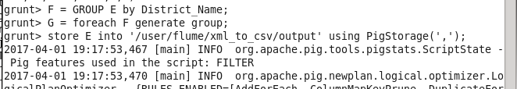

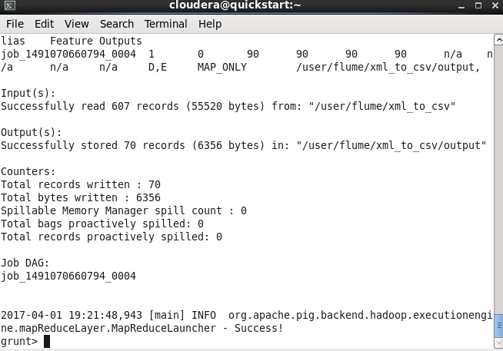

**-PERFORMING SQOOP**

**-Store the result in hbase/RDBMS**

**-Before exporting we need to create a empty table in mysql**

**-Start mysqld**

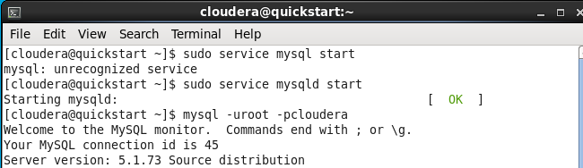

**-create table in mysql**

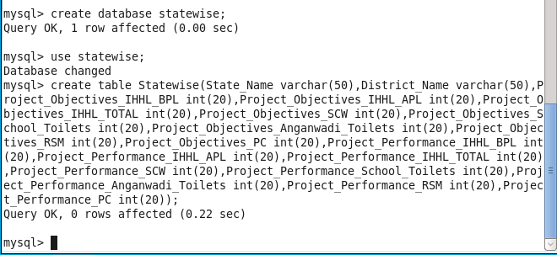

**-Exporting to sql using sqoop**

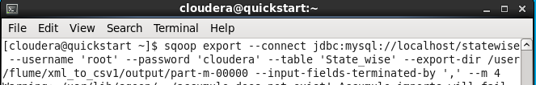

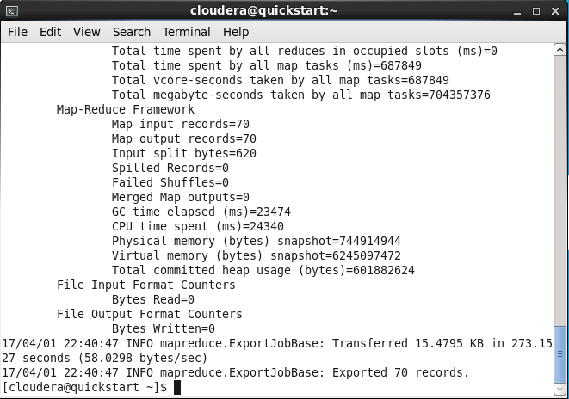

**-now we can check the result in mysql by select command**



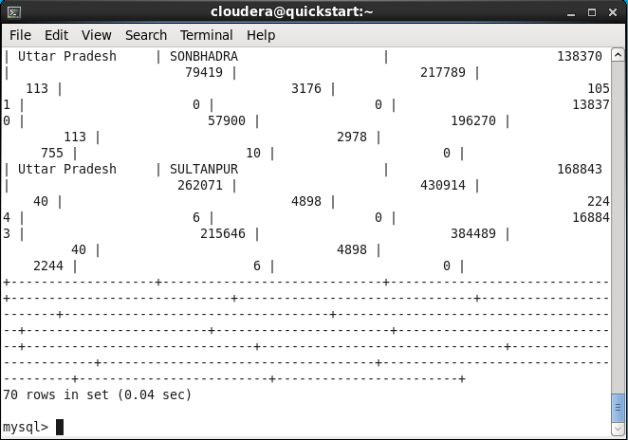

**-So the result is**

**-70 districts has achieved 100% objective in BPL cards.**