**Project 1 State-Wise Development Analysis In India**

2.Write a Pig UDF to filter the districts who have reached 80% of objectives of BPL ca

**-Write a PIG UDF PROGRAM**

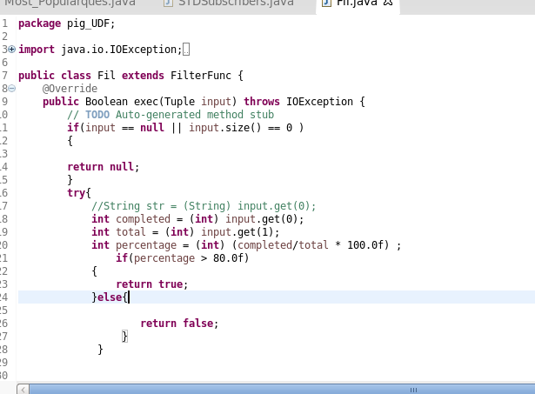

**-export the jar file in localfilesystem**

**-named jar file as Fil_pigUDF.jar**

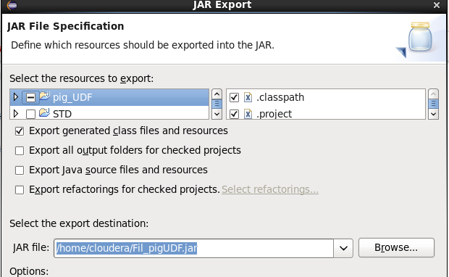

**-Open the pig grunt shell to register**

**-register the jar file**

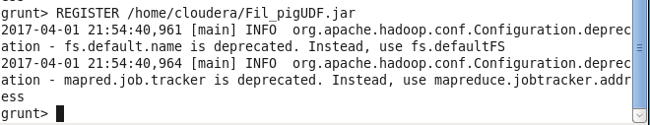

**-filter the data by classname**

**-Now get the values of filterd data from the relation H and store it into another relation named I using the foreach operator**

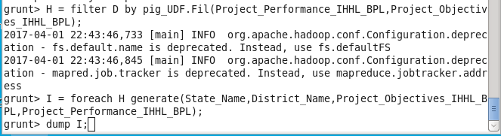

**-dump I;**

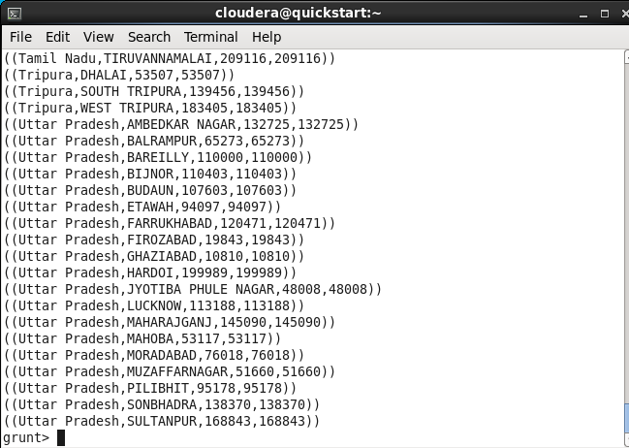

**-So here values are storing with()**

**-Use FLATTEN to remove**

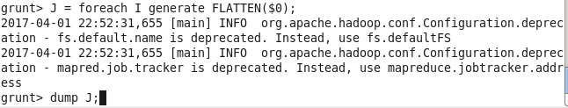

**-Store the data into ‘/user/flume/xml_to_csv1/pigudf_output’ using PigStorage**

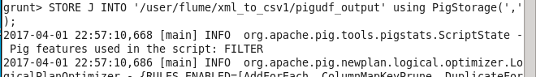

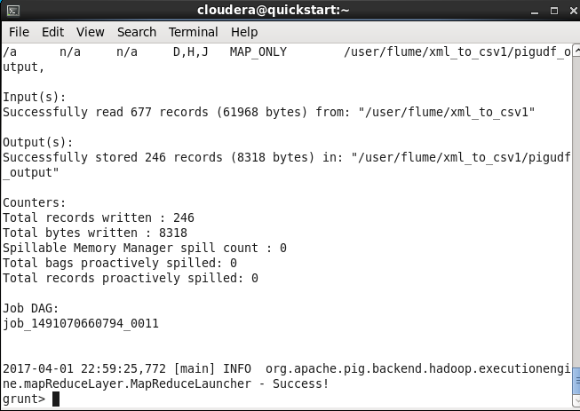

**-PERFORMING SQOOP**

**-Store the result in hbase/RDBMS**

**-Before exporting create empty table in mysql**

**-start mysqld**

**-create table named Statewise_udf**

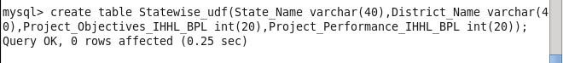

**-Exporting to mysql using sqoop**

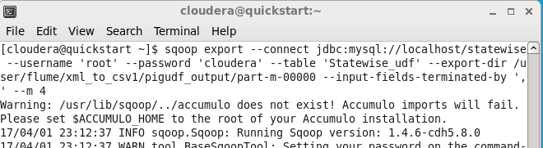

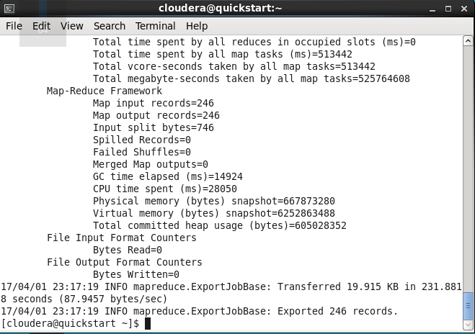

**-Check output in mysql using select command**



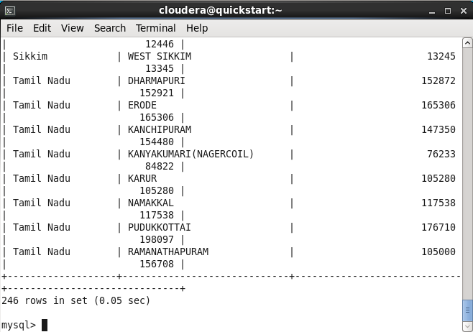

**-So the result is**

**-246 districts has reached 80% objective in BPL cards.**