how many times each question is questioned

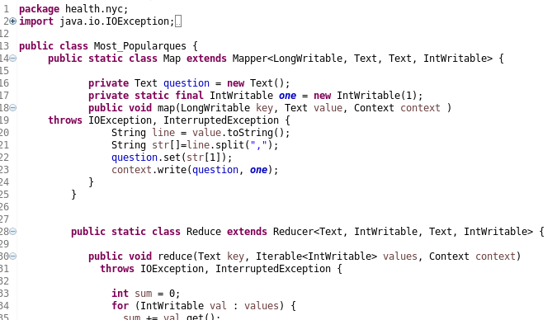

-create a jar file and export into hdfs.

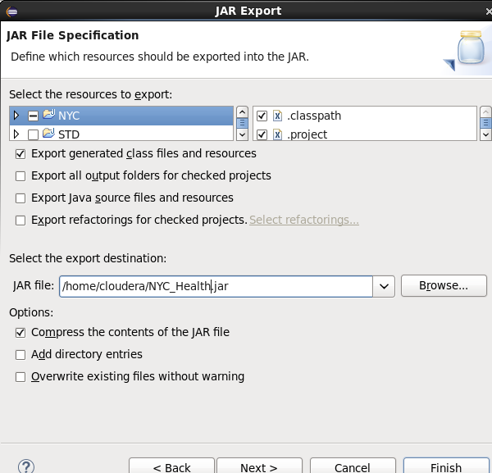

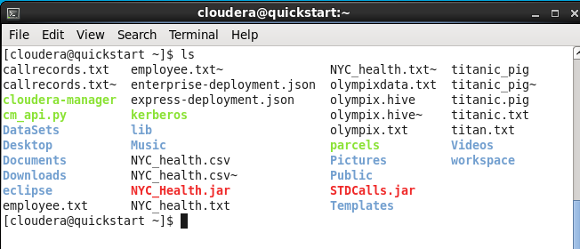

-inserted datasets in hdfs using put command

-I have start running job using command Hadoop jar jar_name package.classname /inputpath /outputpath

-It has successfully started running

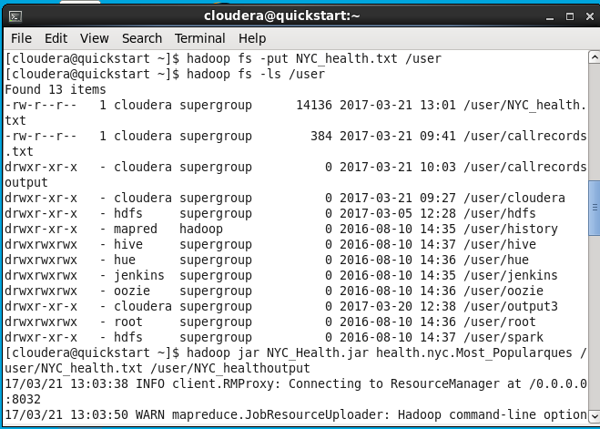

-output

