**Session 15: Hive Operarions**

**Assignment 1**

**In this assignment you need to implement various file formats in Hive.**

**1. Text File Format .**

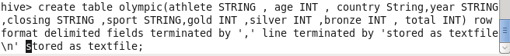

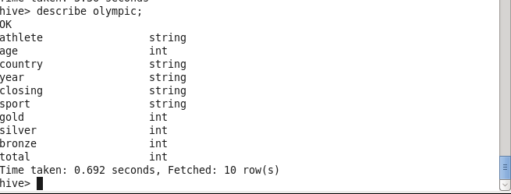

Put the file in hdfs using command

Hadoop fs –put /home/acadgild/jars/OlympicData.csv /

Load the data in table directory

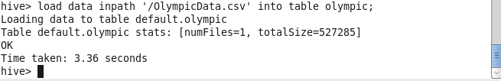

Select athlete from olympic.

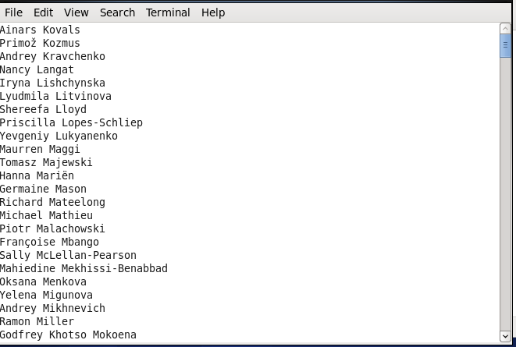

**2. As Sequence File**

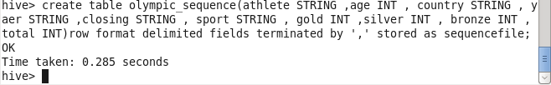

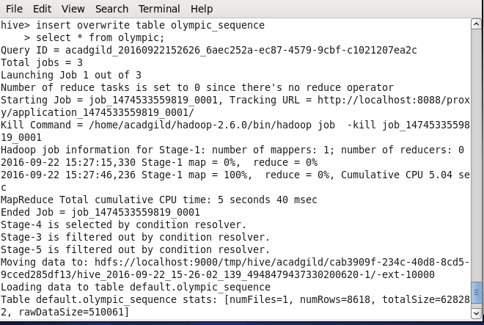

Select athlete from Olympic_sequence;

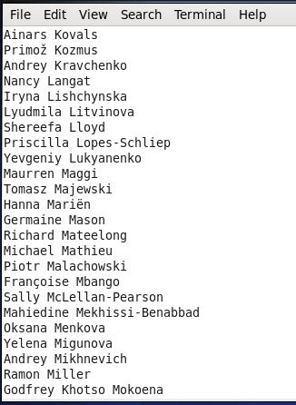

**3. RCFILE**

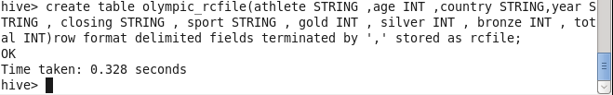

INSERT OVERWRITE TABLE olympic_rcfile

SELECT * FROM olympic;

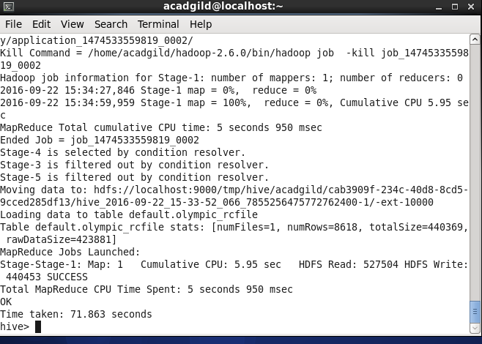

Select athlete from olympic_rcfile;

