Session 15: Hive Operations

Assignment2

1. Write a Hive program to find the number of medals won by each country in swimming.

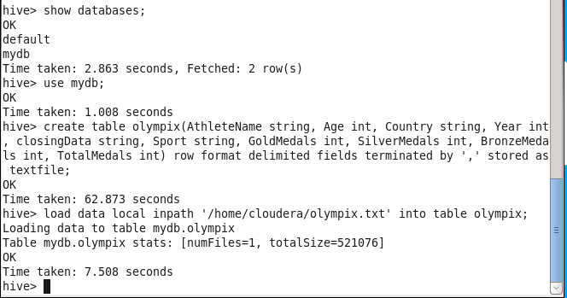

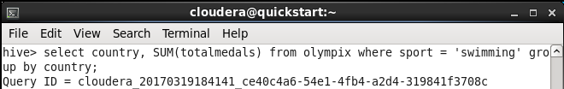

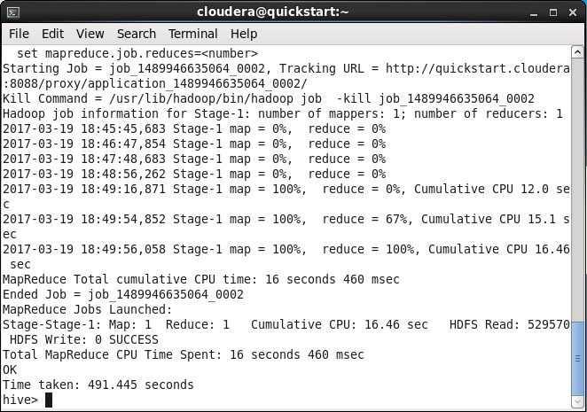

3. Write a Hive Program to find the total number of medals each country won.

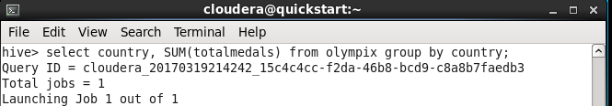

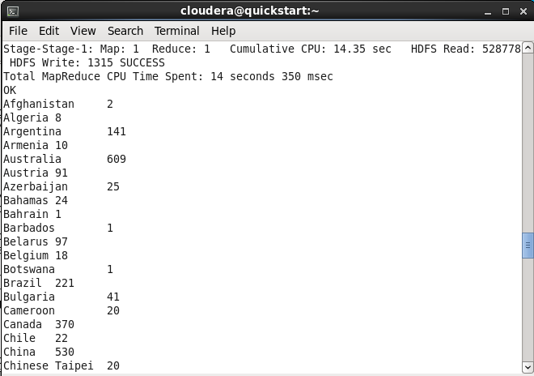

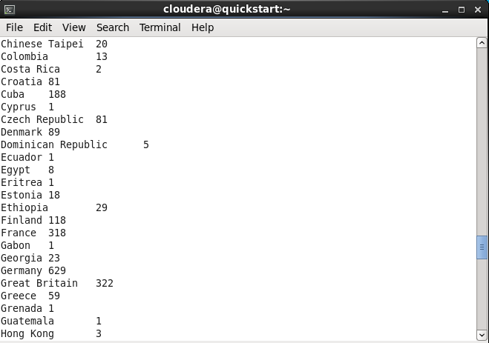

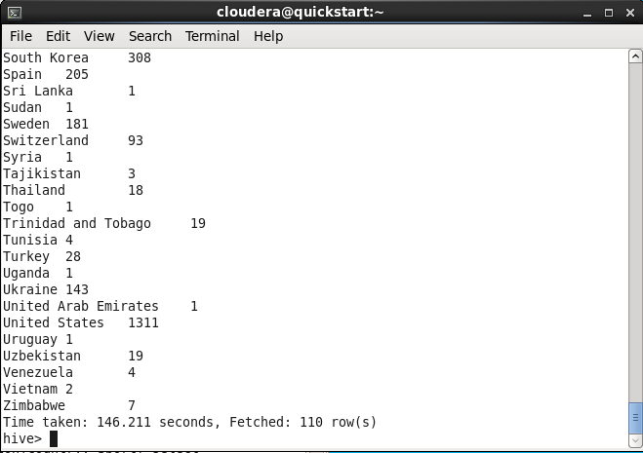

4. Write a Hive program to find the number of gold medals each country won.

