**Session 16: Advanced Hive**

**Assignment 1**

**Transactions in Hive**

1. Properties

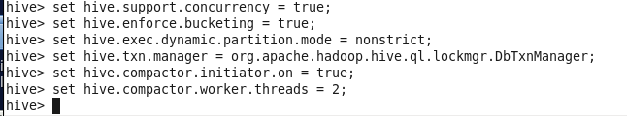

1. Create Table

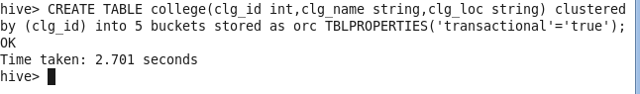

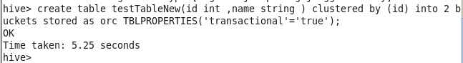

1. Insert into the table

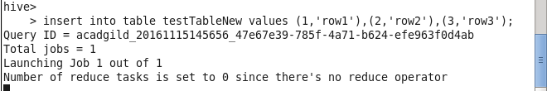

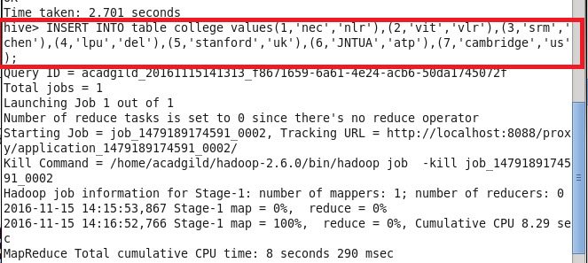

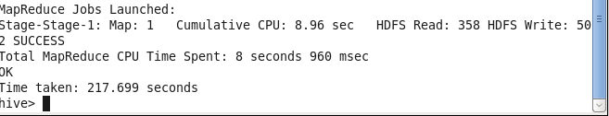

1. See the table details using select command.

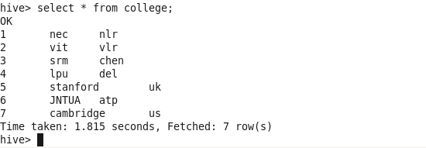

1. Update the table

