**Session 16: Advanced Hive**

**Assignment 2**

To implement the concepts of Indexing in Hive

### Types of Indexes in Hive

* Compact Indexing
* Bitmap Indexing

Bit map indexing was introduced in Hive  0.8 and is commonly used for columns with distinct values.

Data Sets

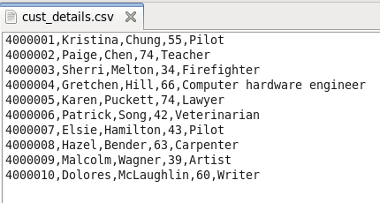

Create Table

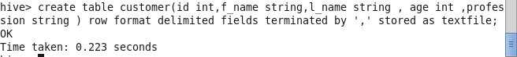

check the schema of your created table using the command ‘describe olympic;

**load data local inpath ‘path of your file‘into table customer;**

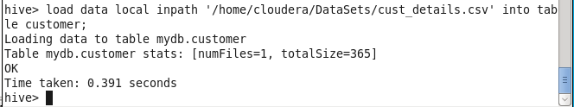

**SELECT AVG(age) from customer;**



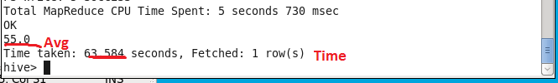

Here note down the time and do same perform by creating index

**Create Index**

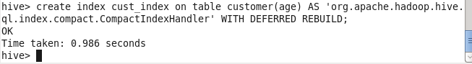

**Now alter the table:**

Create the index for customer

***ALTER INDEX cust_index on customer REBUILD;***

Here we have created an index for the ‘customer’ table on the **age** column. We can view the indexes created for the table by using the below command:

show formatted index on customer;

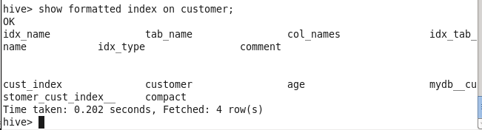

**Now, let’s perform the same Average operation on the same table.**

SELECT AVG(age) from customer**;**

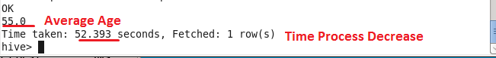

## **We can analyze the process time decrease.**

**TO drop the index:**

***DROP INDEX IF EXISTS cust_index ON customer;***

## 