**Session 18:HBase Data Model and CRUD Operations**

**Assignment1**

1. Start Hbase



1. Start hbase shell

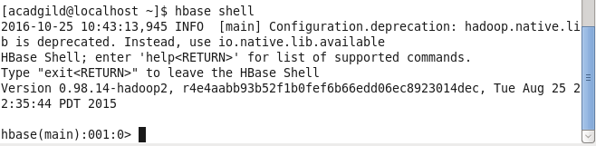

1. Create the table customer with two column families Personal details and order details as column families

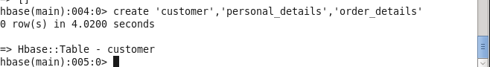

1. altering the number of versions

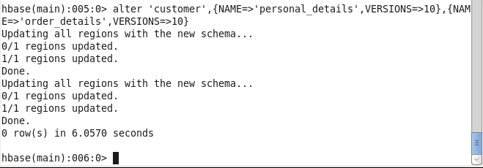

1. Table structure

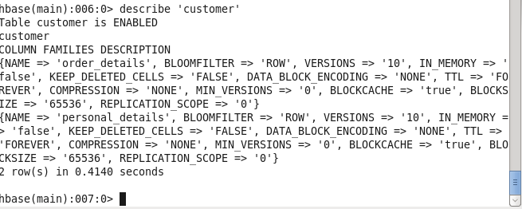

1. Insert following values for personal details column family

Name, age, city, state

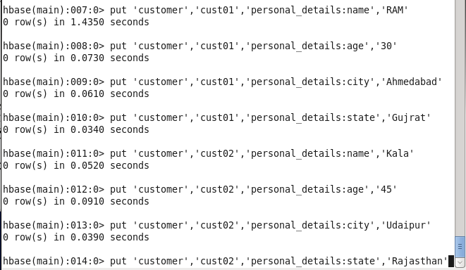

1. Insert following values for order details column family

Order no., order quantity, and order amount

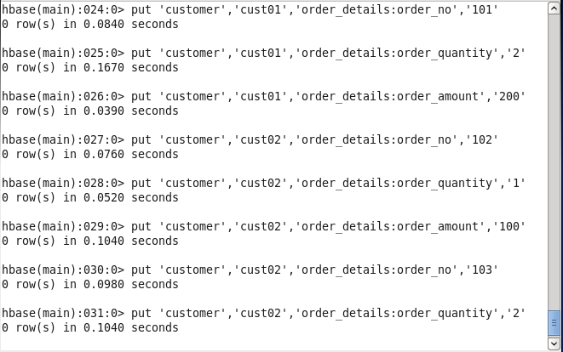

1. Use get command, to retrieve all the records of single customer.

