**Session 18: HBase Data Model and CRUD Operations**

**Assignment 2**

1. Create a project named it as HbaseExample

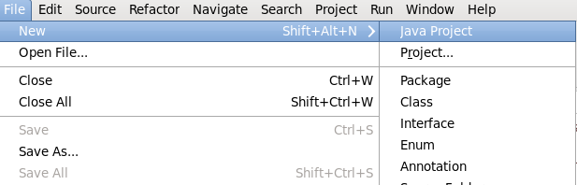

1. Import all the jars rightclick on project created🡪select build path🡪configure build path

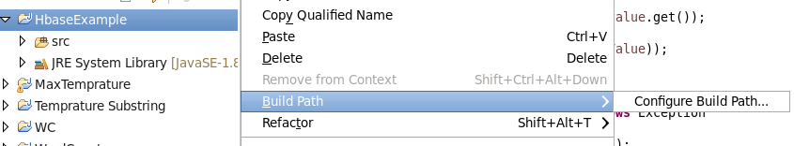

1. Select Add external jars

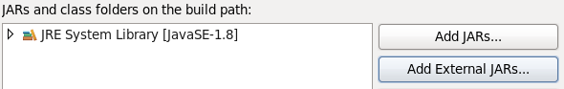

Add following jar

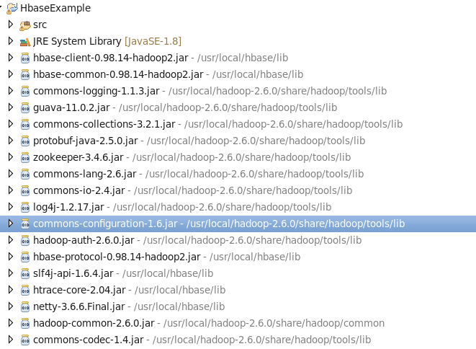

**Use HBaseAdmin class and create the table named company with one column family name details.**

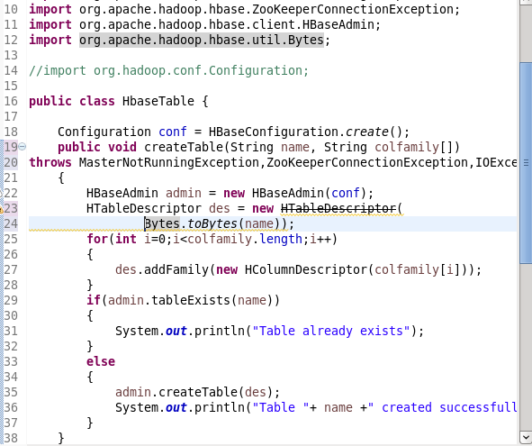

**Create the method name insert and use put class to insert records to company ta-ble.**

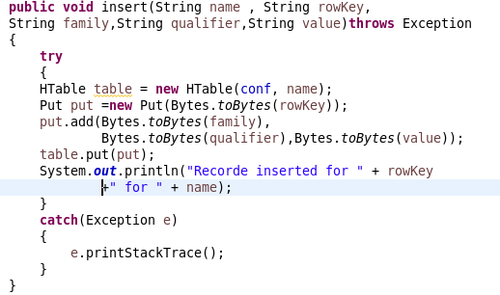

**Create the method name get record and use get class to retrieve on record at a time record from company table**.

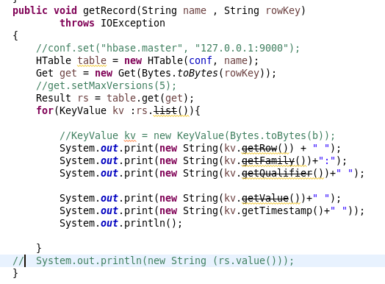

**Create the method name display and use scan class to display all records from company table.**

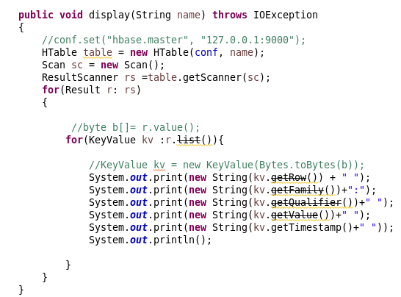

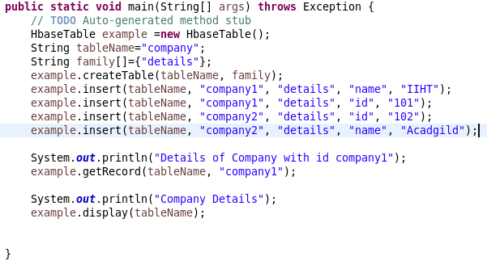

**Start Hbase with command start-hbase.sh**

**Output**

