**Session 19:HBase Thrift and Rest Server**

**Assignment1**

**Integrating Hive with Hbase**

1. Create table student with two column families studentdetails and address

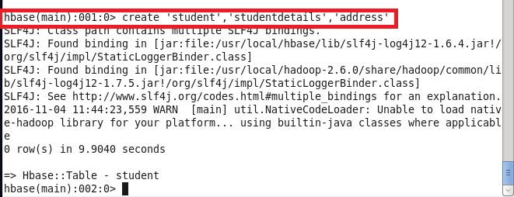

1. Insert The data

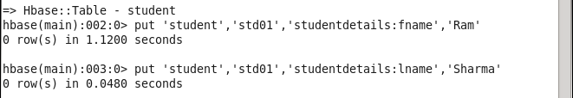

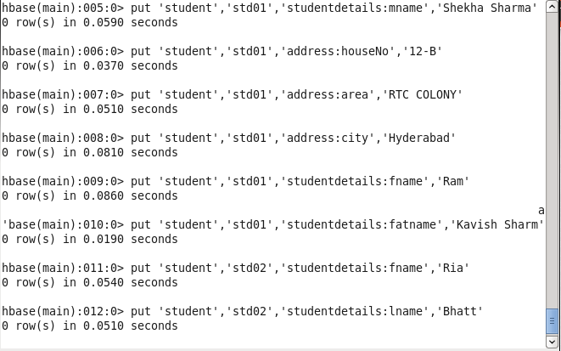

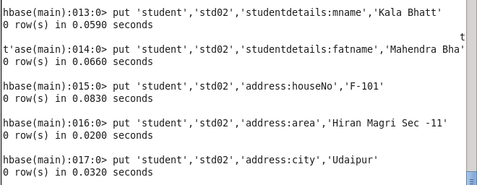

1. Create two hive tables for each column family after starting hive

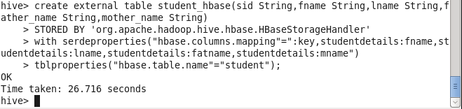

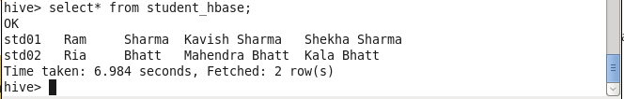

1. Create another table for column family address

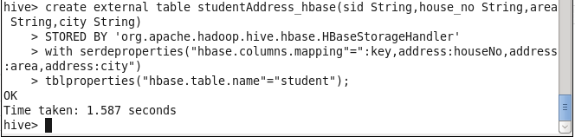

1. Select Query on two tables

