**Session 19:HBase Thrift and Rest Server**

**Assignment2**

**Loading Data Into HBase Using PIG Scripts.**

1. Users.txt file contain detail of user_name,age,city

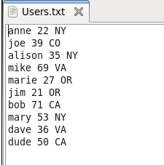

1. Start HDFS using command **start-all.sh**

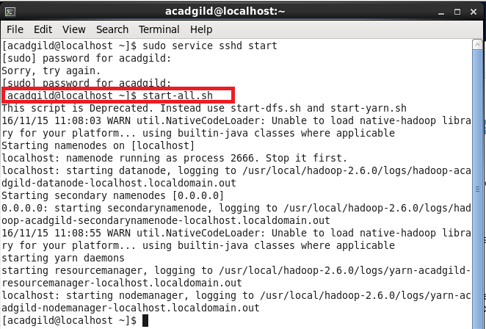

1. Load data into HDFS using **put** command.

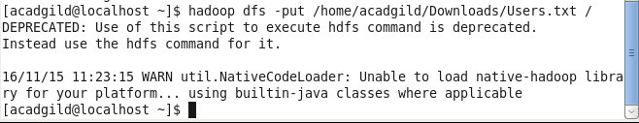

1. Export jar files of HBASE to pig classpath



1. Start mysql, hbase and hbase shell.

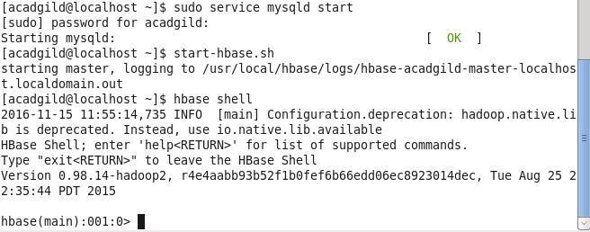

1. Create table user with filed user_detail

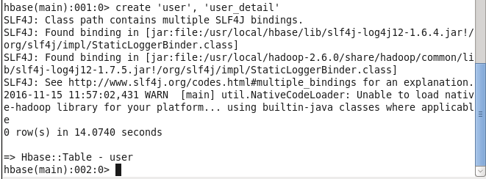

1. Start pig grunt using **pig command**
2. Load the data into Pig using **LOAD command**

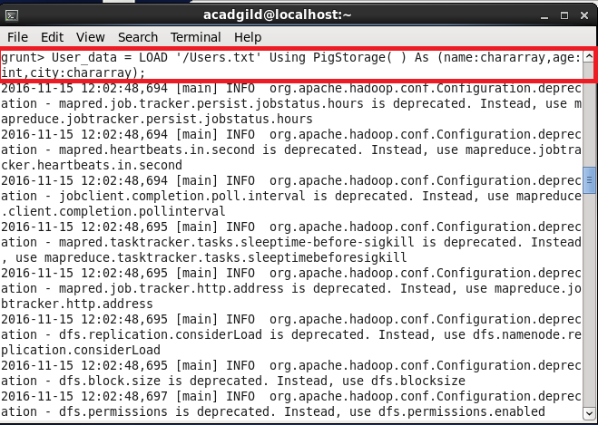

1. Using Store command transfer data to hbase

STORE User_data INTO ‘hbase://user’ USING org.apache.pig.backend.hadoop.hbase.HBaseStorage(‘user_detail:name,user_detail:age,user_detail:city’);

1. If command success than it show success message.

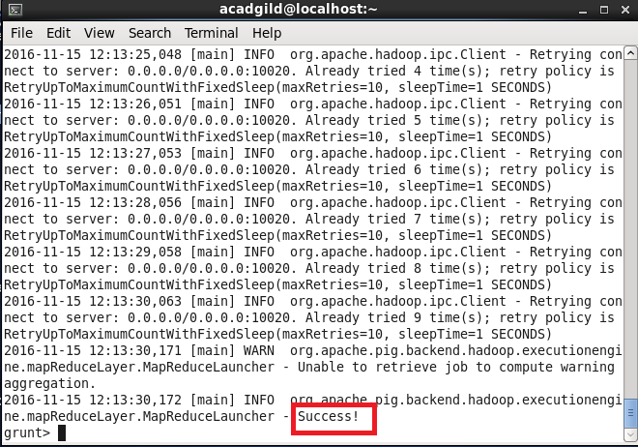

1. Now we can check the output in hbase using **scan command.**

