**Session 1: How to Solve Big Data**

**Assignment 1 :** *Import Acadgild VM into Oracle virtual box by following the document shared in the dashboard.*

**Solution:-**

1. Download the oracle virtual box and install it.

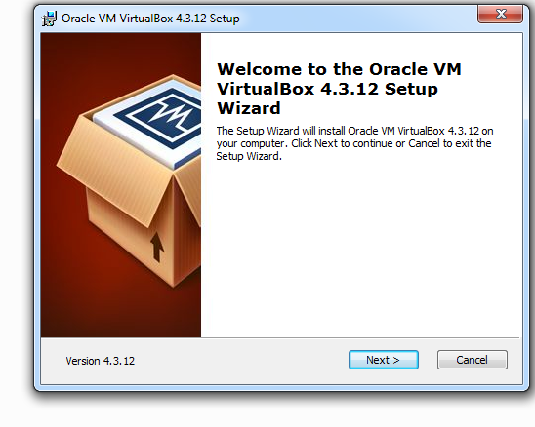

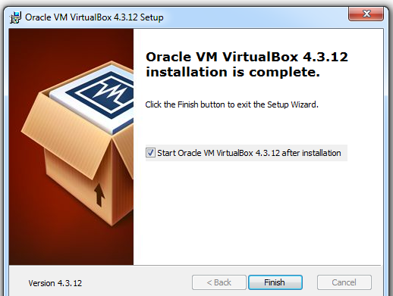

2. Open the virual box.

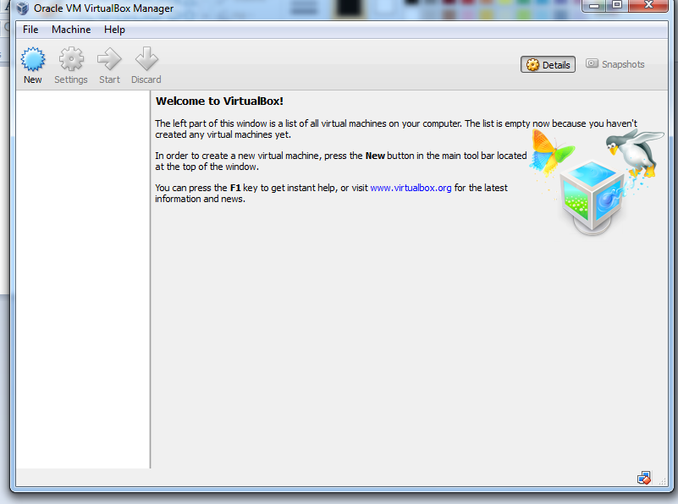

3. Click on file🡪 selects Import Appliance

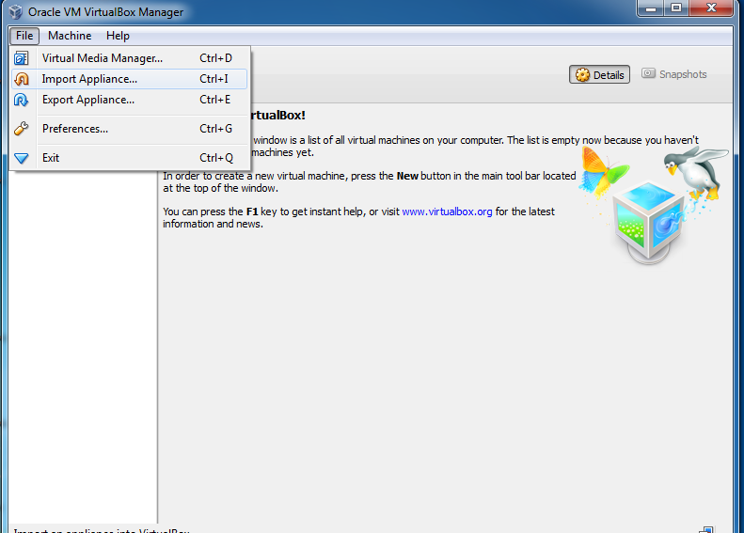

4. Window pop-up 🡪 click on folder 🡪 select path of Acadgild file 🡪Click on next

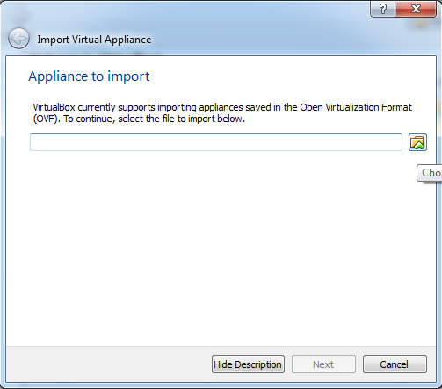

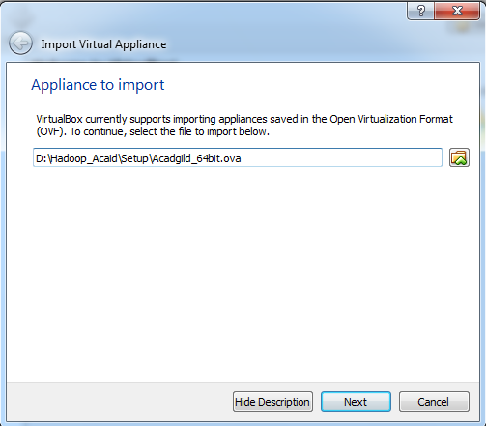

5. Click on Import to start importing VM

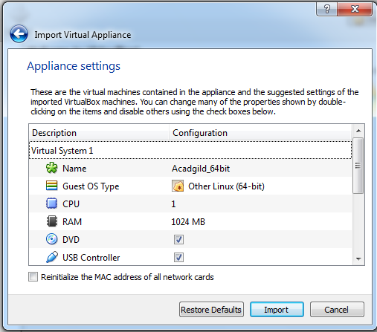

6. As VM start importing it gives prompt window

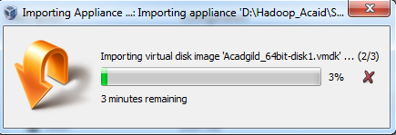

7. Click on start to start the VM

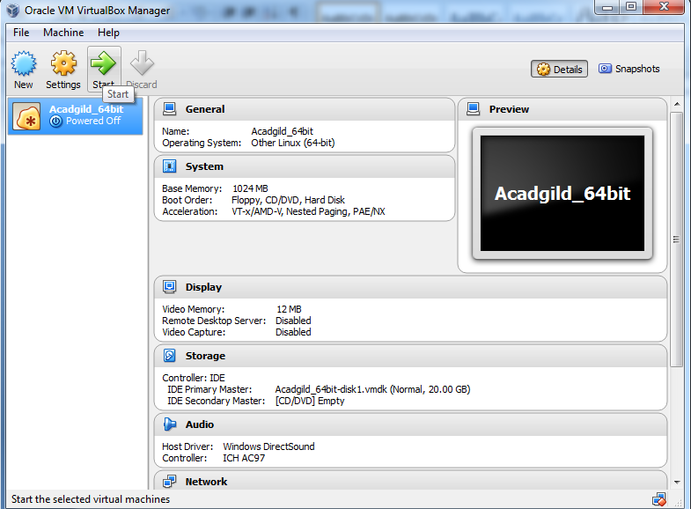

8. Enter the password as accadgild

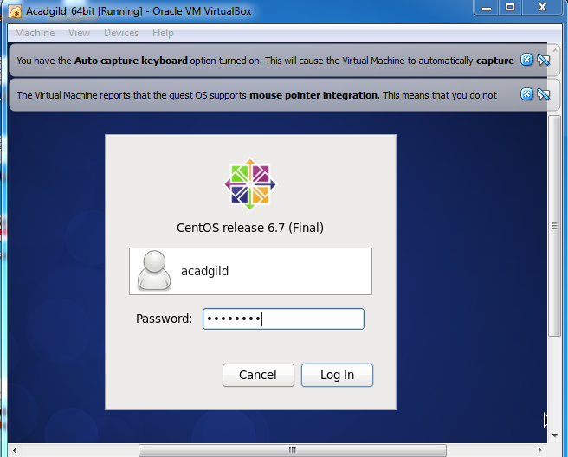

9. Open the terminal and type the command jps to check the list of daemons, we need to start all the daemons for the first time.

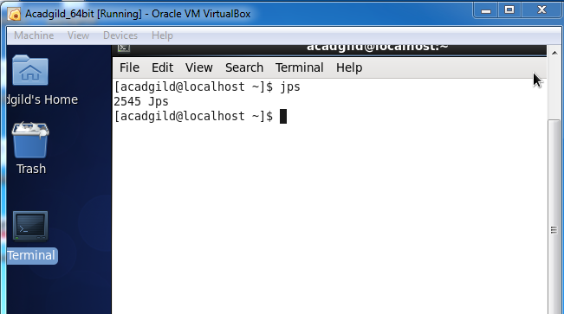

10 Open the terminal and start the ssh server.

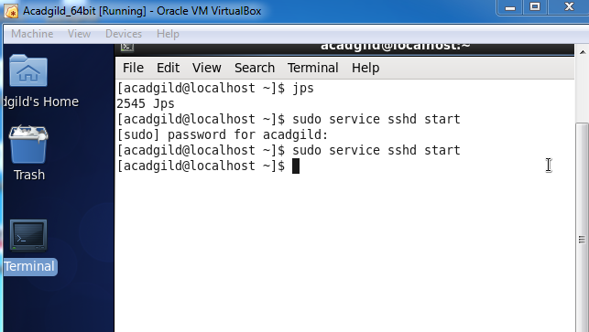

11. Start all the daemons with command start-all.sh

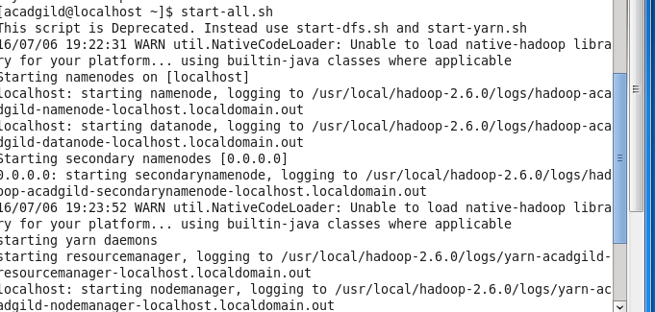

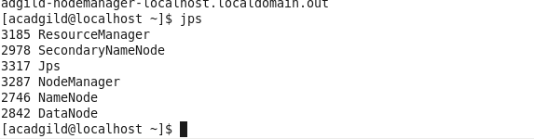

12. Start history server

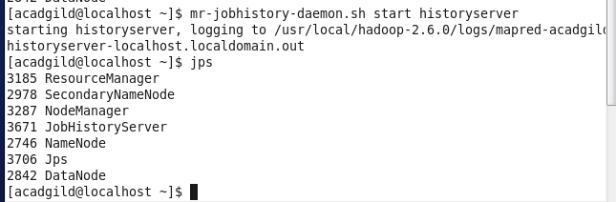

13 To start pig in hdfs mode ,type the command pig in terminal.

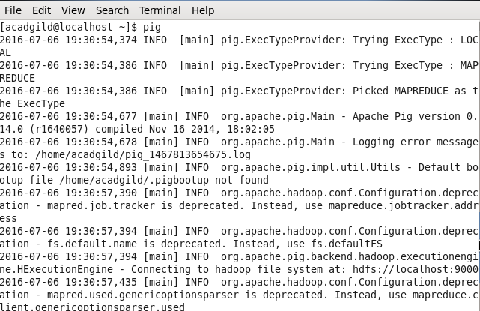

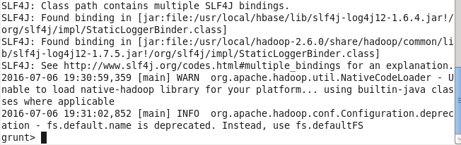

14. To start hive first start mysql service and then type the command hive.

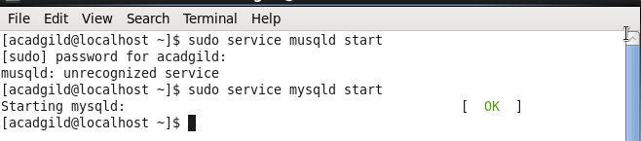

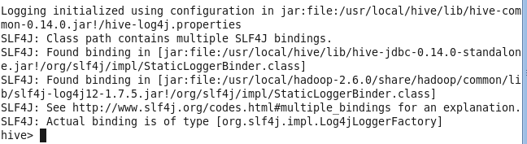

14.Start hbase with command as start-hbase.sh

