**Session 20: Oozie, Sqoop & Flume**

**Assignment 2**

**Files into HDFS Using Flume**

1. Create a property or conf file in flume-ng/conf folder

let named it as spool-to-hdfs.properties





agent1.sources = source1

agent1.sinks = sink1

agent1.channels = channel1

agent1.sources.source1.channels = channel1

agent1.sinks.sink1.channel = channel1

agent1.sources.source1.type = spooldir

agent1.sources.source1.spoolDir = /tmp/spooldir

agent1.sinks.sink1.type = hdfs

agent1.sinks.sink1.hdfs.path = /tmp/flume

agent1.sinks.sink1.hdfs.filePrefix = events

agent1.sinks.sink1.hdfs.fileSuffix = .log

agent1.sinks.sink1.hdfs.inUsePrefix = _

agent1.sinks.sink1.hdfs.fileType = DataStream

agent1.channels.channel1.type = file

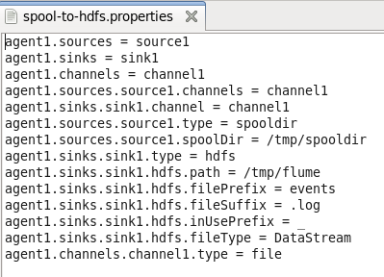

2. Start the flume agent

3. In another terminal create file and store it into spooldir



4. Check in flume terminal

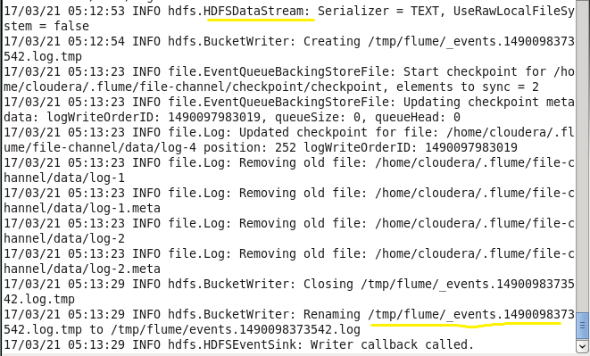

5. check over hadoop

