**Session 5: MapReduce**

**Assignment 3**

String line=”Hadoop is open source frame work ,Hadoop is good framework for handling big data”;

1. Class a sample class with name String_demo and inside the main method perform the following

operation

• Split the line by space and store in a new string array

• Count number of occurrence of word Hadoop in the given string

• Replace the ‘,’with space in the given string

• Create a array list with generic string and store the spitted string inside it

package acadgild;

import java.util.ArrayList;

import java.util.Collections;

import java.util.StringTokenizer;

public class StringExample

{ public static void main(String[] args)) {

String line = "Hadoop is open source frame work ,Hadoop is good framework for handling big data";

String replace = line.replace(","," ");

System.out.println("After replacing String is : " + replace);

String seperator = " ";

String[] t = replace.split(seperator);

System.out.println("After Splitting");

for (int i = 0; i<t.length; i++) {

System.out.print(t[i] + "\t");

}

/*StringTokenizer str1 = new StringTokenizer(replace, " ");

ArrayList<String> a1 = new ArrayList<String>();

System.out.println("*************************");

while (str1.hasMoreTokens()) {

a1.add(str1.nextToken());

}*/

//or by using Arrays.asList method

ArrayList<String> a1 = new ArrayList<String>( Arrays.asList(t));

System.out.println("Contents of al: " + a1);

int count = Collections.frequency(a1, "Hadoop");

System.out.println("count of word Hadoop:" + count);

/*a1.set(6," Hadoop");

System.out.println("Contents of al after replacement: " + a1);*/

} }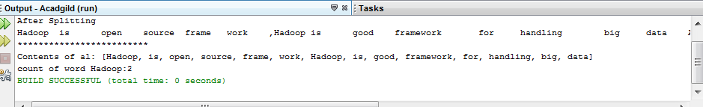

1. The given string is first saved in the ‘line’ string and the ‘space’ is saved in String named as separator.
2. Each word is then saved separately in an array named ‘t’ using split() method of string class.
3. Each word is then displayed in the output using a for loop.
4. Using StringTokenizer, each word is then stored in an ArrayList a1 using the while loop. Or by using Arrays.asList(array)
5. Using the frequency method of Collection class, the appearances of the word ‘HADOOP’ is calculated and stored in a variable count of int type.
6. All of them are then displayed using println() method.