**Session 9: Pig**

**Assignment 1**

**Analysis of Petrol Dataset**

1. Create petrol_dataset separated by ‘,’.

2. Put the dataset into hadoop **using put command**. Here I am putting dataset into my_dir folder present in HDFS

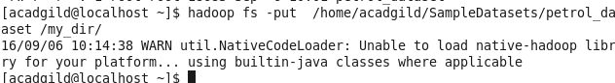

3. Start the pig using command pig –x mapreduce

4. List the files using **ls command** as given below.

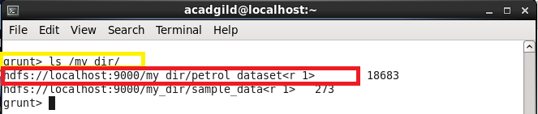

5. Load the data

A = LOAD '/my_dir/petrol_dataset' USING PigStorage(',') as (DistID:chararray,DistributorName:chararray,BuyRate:chararray,Sellrate:chararray,VolumeIN:int,VolumeOUT:int,Year:int);

**Q1. What is the total amount of petrol in volume sold by every distributer?**

B = GROUP A by DistributorName;

TOTALSOLD = FOREACH B GENERATE A.DistributorName,SUM(A.VolumeOUT);

dump TOTALSOLD;

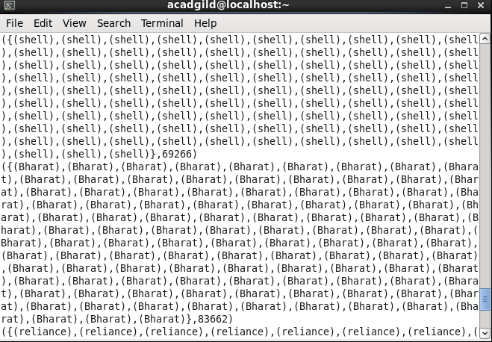

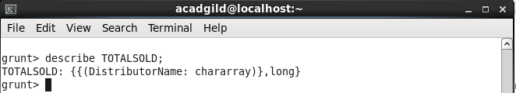

**Q 2. Which are the top 10 distributers ID's for selling petrol? Also display the amount of petrol sold in volume.**

C = ORDER A by VolumeOUT DESC;

D = LIMIT C 10;

DISTRIBUTOT_TOP = FOREACH D GENERATE DistID,VolumeOUT;

dump DISTRIBUTOR_TOP;

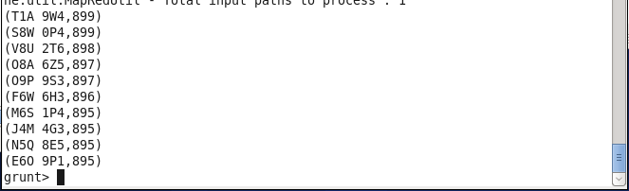

**Q 3. List 10 years where consumption of petrol is more with the distributer id who sold it.**

E = ORDER A by VolumeOUT desc;

Limt_E = LIMIT E 10;

Consumption_detail = FOREACH E GENERATE DistID,VolumeOUT;

dump Consumption_detail;

**Q 4. Find the distributer name who sold petrol in least amount.**

F = ORDER A by VolumeOUT;

Least = LIMIT F 1;

//Least = FOREACH E GENERATE DistributorName

dump Least;

