NORTH SOUTH UNIVERSITY



Project Report

Project Title: MediTrack

Course: Senior Design Project(CSE499A)

**Submitted To**

Mohammad Ashrafuzzaman Khan

**Assistant Professor**

**Submitted by**

**Team Members:**

|  |  |
| --- | --- |
| Name | ID |
| Sazzad Hossain Sabbir | 1612229042 |
| Tahmina Akter Tania | 1611414642 |
| Ria Sarkar | 1620576042 |

**Abstract:** In today’s life, human beings face difficulty to keep in mind the medicines they required to take. For this reason, our application helps to remind medicine taken time. This application can relieve unevenness in taking recommended dosage of pills on time prescribed by the doctor and switch from ways primarily reliant with the memory of the human being insignificant regulation, hence people can be freed doing wrong things due to human error like taking pill at different time with incorrect dosage. We made the Mobile Application using Android Studio IDE and for the development we used java for the back-end code and xml for the design.

Keywords: Android Studio, java, health care etc.

**Acknowledgement:** There are some mobile application program that are found in google play store by which people can manage a clinic or hospital about their stock limits of medicines.

There are some other application program in google play store which provides the service to people that, anybody who will install those application program in their device they can easily know the name of medicines that they will need to get cured from some disease in any emergency situation as a primary treatment.

But the matter of sorrow is, there is not available any application or any software that can look after or maintain the medicine schedule of a particular patient in a day or to remind him/her about that person’s medicine stock or medicine taking time.

i

**Content**

**01. Introduction……………………………….………………………………………………….……………..…….………. 01**

**02. Methodology…………………….………………………................................................................... 01**

**03. Programming Modules:……………………………………………………………………….…….………..……… 03**

**04. Results and Analysis…………………………….………………………………………………………………………. 06**

**05. Conclusion……………………………………………….…………………………………………………………………… 07**

**06. Reference………………………………………………………….…………………………………………………………. 08**

**07. Appendices……………………………..…………….…………………………………………………………………….. 09**

ii

**Introduction:** Every year, thousands of senior citizens are placed in nursing homes because they did not take the right medication at the right time. Medication mix-ups are extremely dangerous. A medication reminder and organizer can help to prevent these life-threatening mistakes. We implemented an android app which can help patients remember and track their medication use are convenient tools for anyone who carries a smart phone. It can keep a complete list of all medications of anyone. He / She can choose to get pill reminders to take his/her meds at a special time, and receive prescription refill reminders right on his/her mobile device. This App even keeps a history of when he / she has (or has not) taken your meds.

You can also add personal notes and get easy access to important information about your medicine online such as [side effects](https://www.drugs.com/sfx/) , [dosage](https://www.drugs.com/dosage/), [drug interactions](https://www.drugs.com/drug_interactions.html) and [safe use during pregnancy](https://www.drugs.com/pregnancy/).

If you like visual clues, you can add photos of your medications for easy reference. Plus, all the data is kept on your personal device only and is fully secure and private, for added peace of mind.

**Methodology :**

Android application development is the booming industry as android apps are being used the most in the market today. Android platform is available for most of the present users use hence while developing any application, company has to make an android version to reach the mobile users on the widest scale.

After log in : 01

1. He/she can check doctor information by clicking “Doctor information” and can check pharmacy by clicking “nearest pharmacy” .
2. For setting medicine notification he/she have to click “add medicine time🡪add quantity 🡪save”
3. After setting notification user can go back to home or can check other things on App. Or just can log out.
4. After setting notification user can go back to home or can check other things on App. Or just can log out.

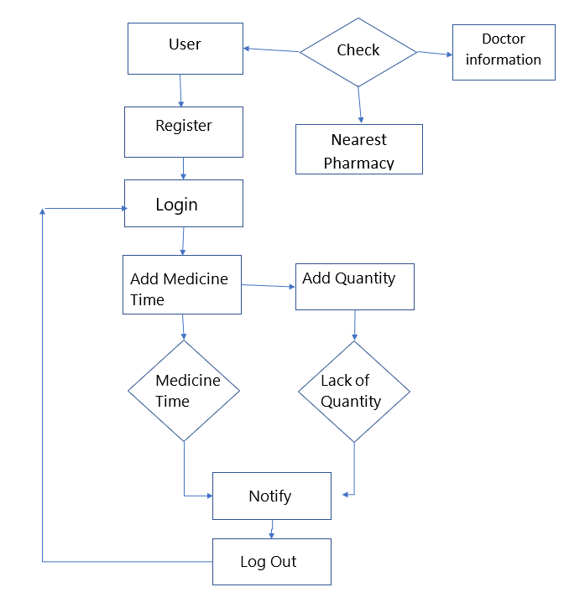

Figure: Medi-track methodology 02

Architectural Design:

Android

Application

**Programming Modules:**

Required Platforms & Programming Language:

* Html
* Xampp
* Android Studio

Using the code the system can be automated and customized in a way that the user needs. The data are stored in the table format. Used Android Studio IDE and for the development we used java for the back-end code and xml for the design.

03

* Login/Signup: User can signup if they are new in the application or they have already an account they can simply login.

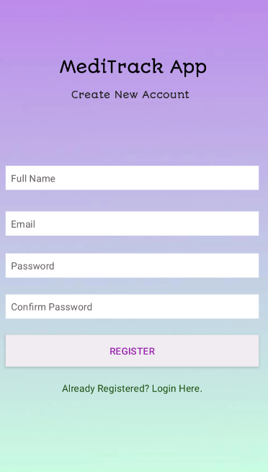

Register Interface

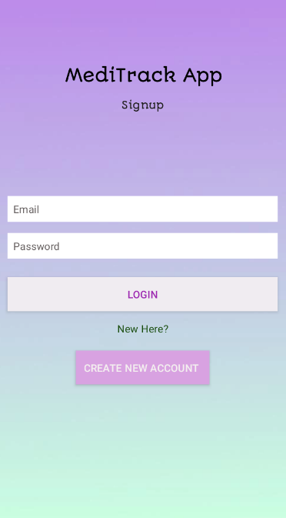

Login Interface

04

* Medicine Details: User can add medicine information.

1. Medicine Name

2. How many times in a day

3. Quantity of medicine

Application will notify user as their inserted Information.

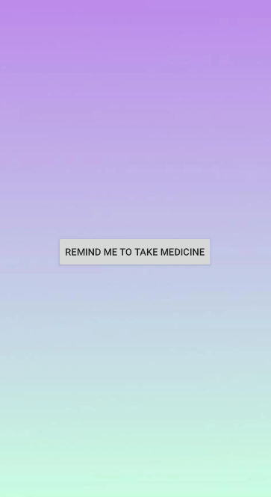

* Doctor information: User can see the doctor name, doctor’s chamber, specialist , visiting hours and contract number of chamber. User can see this information even without login.
* Pharmacy Location: User can find their nearest pharmacy location from the map.

05

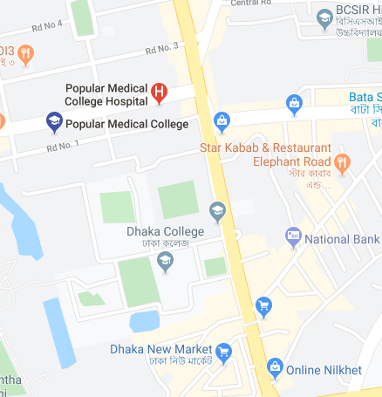

**Result and analysis**

1.When the user starts the application on their Android phone the first screen that saves the login desktop. It is necessary for the user to record the entry of information such as the name of the line and the contact number of the user.

2.After user enter his/her information to register, the authentication code (OTP) will be sent to the user in their contact number.

3.After logging in by the user, a pop-up window will open for the main program, which consists of the following functions :-

**Check:** after clicking this user will pop up with two new option

* + - **Doctor information:** on this user can find doctor’s details. Which we collected from google**. 06**
    - **Nearest pharmacy:** On this user can find his/her nearest pharcacy via google location.

**Add medicine time**: On this user can add his/her medicine time and medicine quantity. According to user’s doctor prescription.

**Add quantity:** user can add his medicin quantity, it’s 1,2 or ½ . and how much medicine he brought before, how much he took. It will be recorded so that when his/her medicine is finishing it will send a massage “lack of quantity” .

**Notification:** On this user can set his medicine notification, when to take or not. And when user should visit doctor. basically here user can add things which he/she might forget.

**Conclusion:**

This android app is an application which contains information regarding medicine details like prescription, appointment, medicine, pharmacy, events from Doctors. Also medicine reminder or medicine notification for user. This information can be accessible from anywhere and anytime using an android device with internet connection.

**07**

**References :**

1.[**https://www.geeksforgeeks.org/project-idea-meditrack/?fbclid=IwAR3V-7BGBlhKrsYhfiFHLO9SAJ8txBnWKHDnjcbHGlMLYG1WM6DCWbMxo1s**](https://www.geeksforgeeks.org/project-idea-meditrack/?fbclid=IwAR3V-7BGBlhKrsYhfiFHLO9SAJ8txBnWKHDnjcbHGlMLYG1WM6DCWbMxo1s)

2.[**https://1000projects.org/projects/android-projects/page/3**](https://1000projects.org/projects/android-projects/page/3)

3.[**https://www.youtube.com/playlist?list=PLgH5QX0i9K3p9xzYLFGdfYliIRBLVDRV5&fbclid=IwAR0BPYGSgcNfUpoFZq77JKZ2rkBRhc1vVKvSIZ6UjC-y2dewUWTfSI5faOU**](https://www.youtube.com/playlist?list=PLgH5QX0i9K3p9xzYLFGdfYliIRBLVDRV5&fbclid=IwAR0BPYGSgcNfUpoFZq77JKZ2rkBRhc1vVKvSIZ6UjC-y2dewUWTfSI5faOU)

4.https://ieeexplore.ieee.org/document/8782349

08

Appendix:

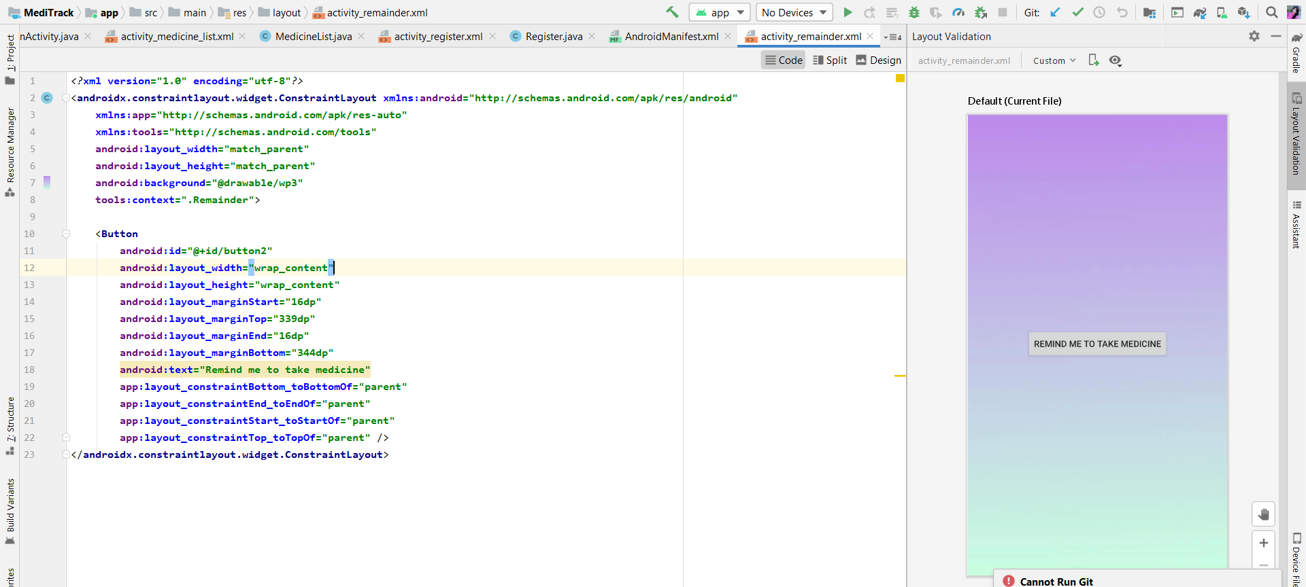

Notification code:

<**manifest xmlns:android="http://schemas.android.com/apk/res/android"  
 package="com.example.meditrack"**>  
  
 <**application  
 android:allowBackup="true"  
 android:icon="@mipmap/ic_launcher"  
 android:label="@string/app_name"  
 android:roundIcon="@mipmap/ic_launcher_round"  
 android:supportsRtl="true"  
 android:theme="@style/AppTheme"**>  
 <**activity android:name=".Remainder"**></**activity**>  
 <**activity android:name=".MedicineList"** />  
 <**activity android:name=".Login"** />  
 <**activity android:name=".Register"**>  
 <**intent-filter**>  
 <**action android:name="android.intent.action.MAIN"** />  
  
 <**category android:name="android.intent.category.LAUNCHER"** />  
 </**intent-filter**>  
 </**activity**>  
 <**activity android:name=".MainActivity"**>  
 <**intent-filter**>  
 <**action android:name="android.intent.action.MAIN"** />  
  
 <**category android:name="android.intent.category.LAUNCHER"** />  
 </**intent-filter**>  
 </**activity**>  
  
  **android:name="preloaded_fonts" 09   
 android:resource="@array/preloaded_fonts"** />  
 </**application**>  
  
</**manifest**>

