Title: Design of adder and comparator circuits.
Abstract: This experiment explores the fundamental principles, design methodologies, and operational behaviors of combinational logic circuits, specifically focusing on adders, subtractors, and magnitude comparators. As the core building blocks of Arithmetic Logic Units (ALUs) in digital electronics, these circuits play a vital role in data processing. In this lab, 1-bit and multi-bit adders and comparators were designed, simulated using software tools, and hardware-implemented on a digital trainer board using standard TTL ICs (e.g., 7408, 7404, 7486). The experimental outputs were thoroughly verified against theoretical truth tables and simulation results, confirming the practical functionality and synchronization of these essential digital components.
Theory: The circuits for adder, subtractor, and comparator are the foundation of many digital systems. They aredesigned to compare the magnitude of two digital signals and perform basic arithmetic operations. Adder circuits: Add binary numbers using an adder circuit. The fundamental component of an adder circuit is a full adder, which adds three binary inputs (A, B, and carry-in) and produces two binary outputs (sum and carry-out). Cascading full adders can be used to add larger binary integers. The binary representation of the arithmetic addition of the input integers is the resultant sum. Comparator Circuit: A comparator circuit compares the magnitude of two binary integers and outputs a binary output indicating which is greater. There are two inputs and one output on the comparator circuit. If the first input is bigger, the output is '1'; otherwise, the output is '0'. The comparator circuit is frequently used in digital systems for sorting, searching, and other applications that need binary number comparison.
Apparatus:
- Digital trainer board
- IC 7408:2 pcs
- IC 7404:2 pcs
- IC 7486:2 pcs
- IC 7431:2 pcs
- IC 7483:1 pcs
- Connecting wires
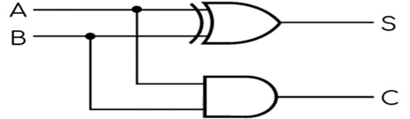
Circuit Design:
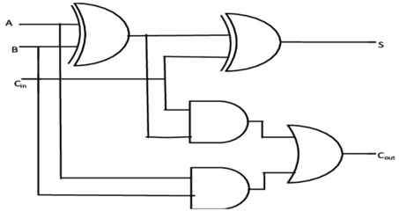
- (b)
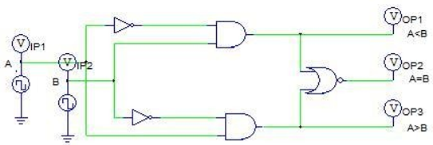
(c)
Figure: (a) Schematics of half Adder circuit; (b) Schematics of Full Adder; (c) 1-Bit Comparator
Theoretical Calculation:
Half Adder:
S = A  B, C_{out} = AB
Table-1: Truth table for half adder.[1]
A | B | C | S
0 | 0 | 0 | 0
0 | 1 | 0 | 1
1 | 0 | 0 | 1
1 | 1 | 1 | 0

Full Adder:
S = A  B  C_{in}
C_{out} = C_{in} (A  B) + AB
Table-2: Truth table for full adder.[1]
A | B | Cin | S | C
0 | 0 | 0 | 0 | 0
0 | 0 | 1 | 1 | 0
0 | 1 | 0 | 1 | 0
0 | 1 | 1 | 0 | 1
1 | 0 | 0 | 1 | 0
1 | 0 | 1 | 0 | 1
1 | 1 | 0 | 0 | 1
1 | 1 | 1 | 1 | 1

For a 1-bit comparator with inputs A and B, the outputs are:
A=B if, A=B=0 or A=B=1;
A>B if A=1 and B=0;
A<B if A=0 and B=1;

Table-3: Truth table for 1-bit comparator.[1]
A | B | A=B | A>B | A<B
0 | 0 | 1 | 0 | 0
0 | 1 | 0 | 0 | 1
1 | 0 | 0 | 1 | 0
1 | 1 | 1 | 0 | 0

Simulation Result:
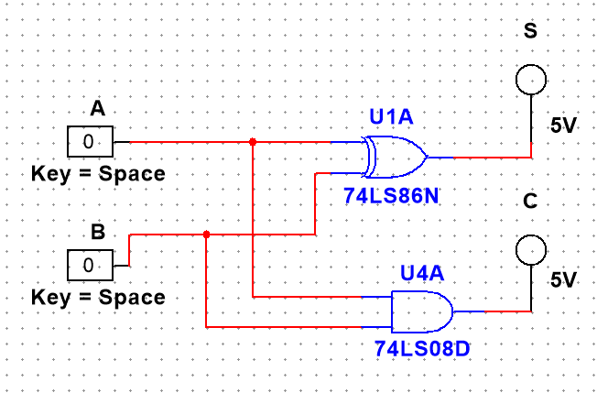
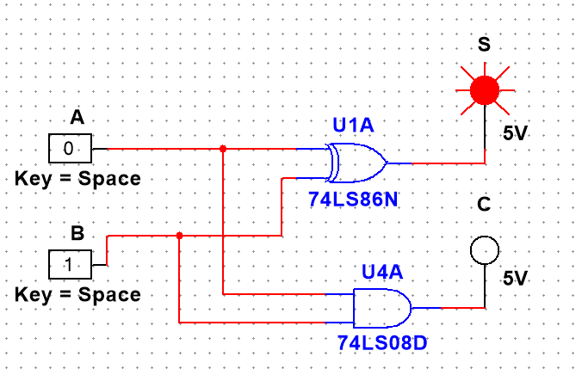
Half Adder :
(a) (b)
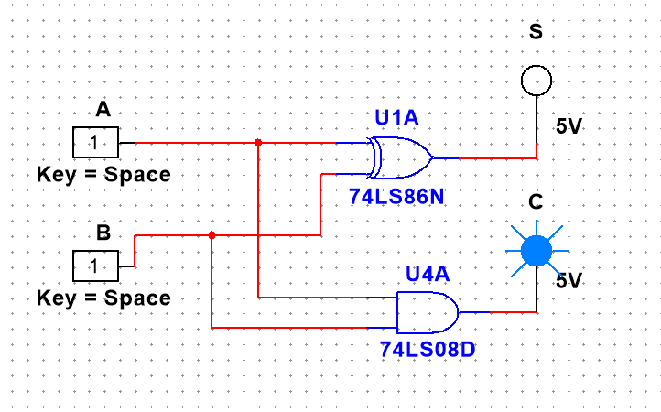
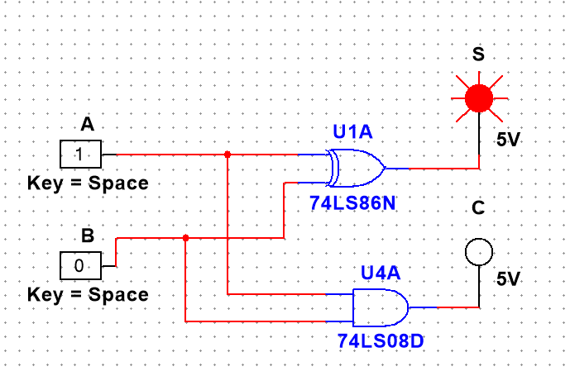
Figure 1 : For half Adder (a) when input is 00 , output carry and sum is 0; (b)when input is 01, output sum is 1 and carry is 0
(c) (d)
Figure 2 : For half Adder (c) when input is 10 , output carry is 0 and sum is 1; (b) when input is 11 , output sum is 0 and carry is 1
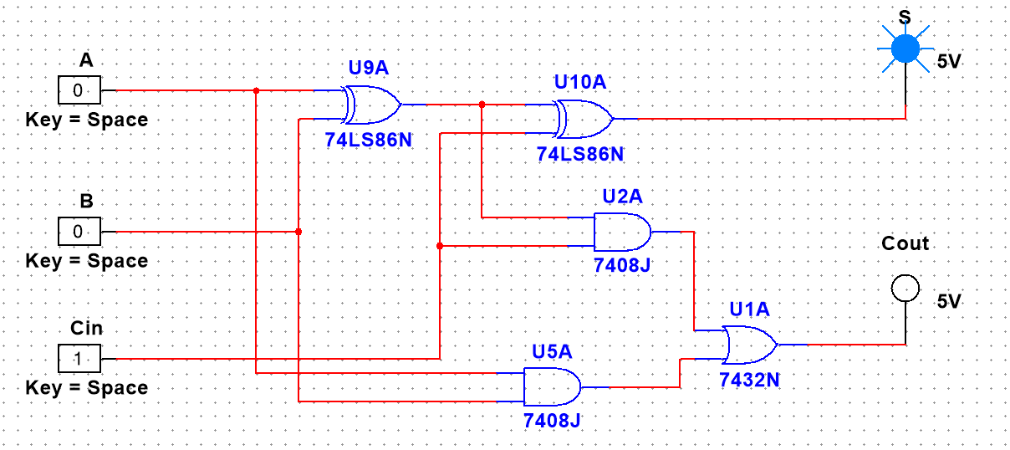
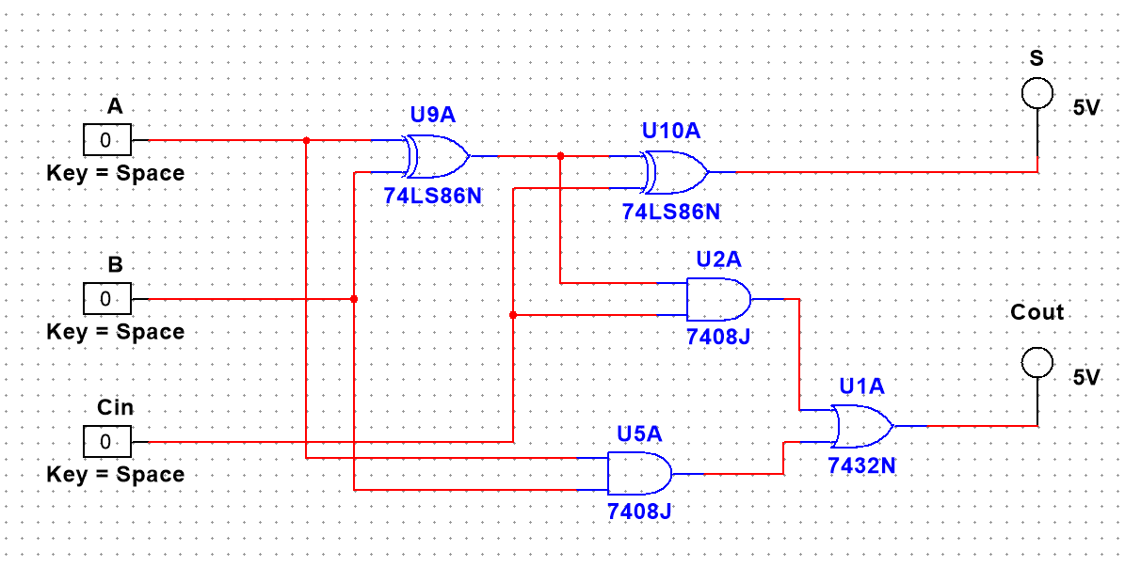
Full Adder :
- (b)
Figure 3 : For Full Adder (a) when input is 000 , output Cout is 0 and sum is 0; (b) when input is 001 , output sum is 1 and carry is 0
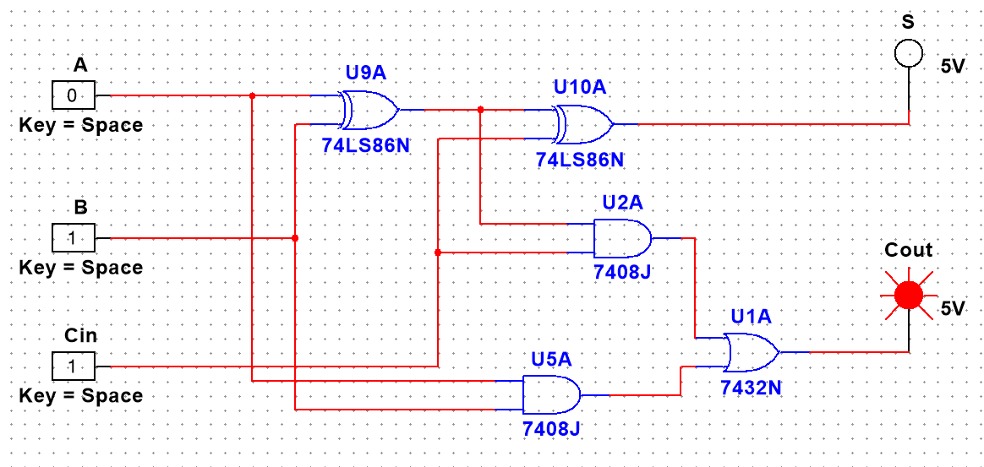
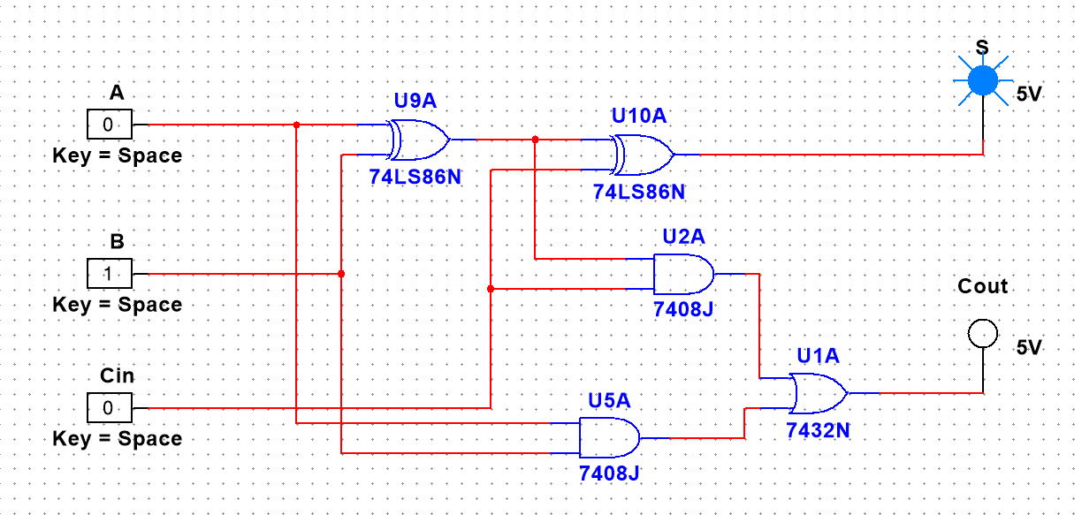
(c) (d)
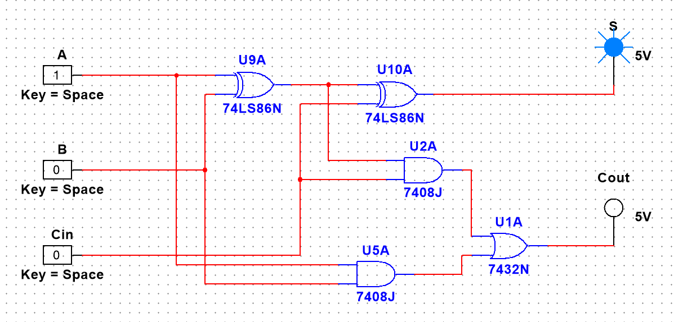
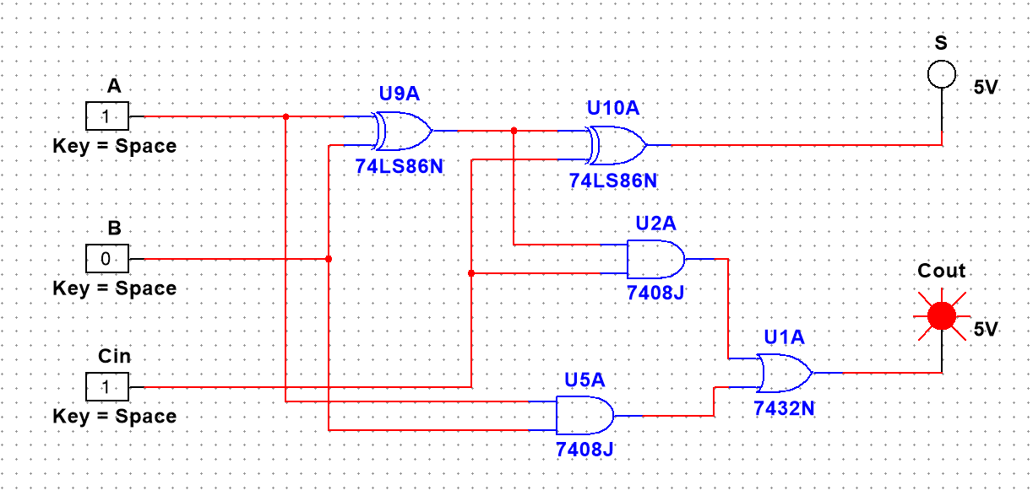
Figure 4 : For Full Adder (c) when input is 010 , output Cout is 0 and sum is 1; (d) when input is 011 , output sum is 0 and carry is 1
(e) (f)
Figure 5 : For Full Adder (e) when input is 100 , output Cout is 0 and sum is 1; (f) when input is 101 , output sum is 0 and carry is 1
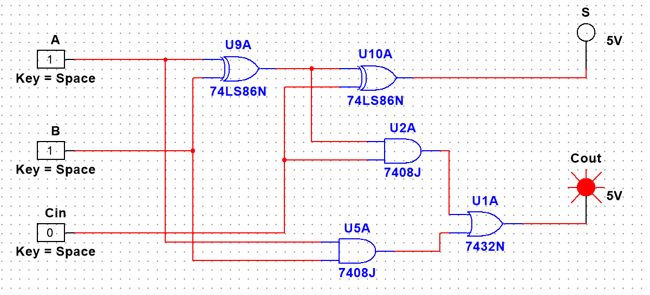
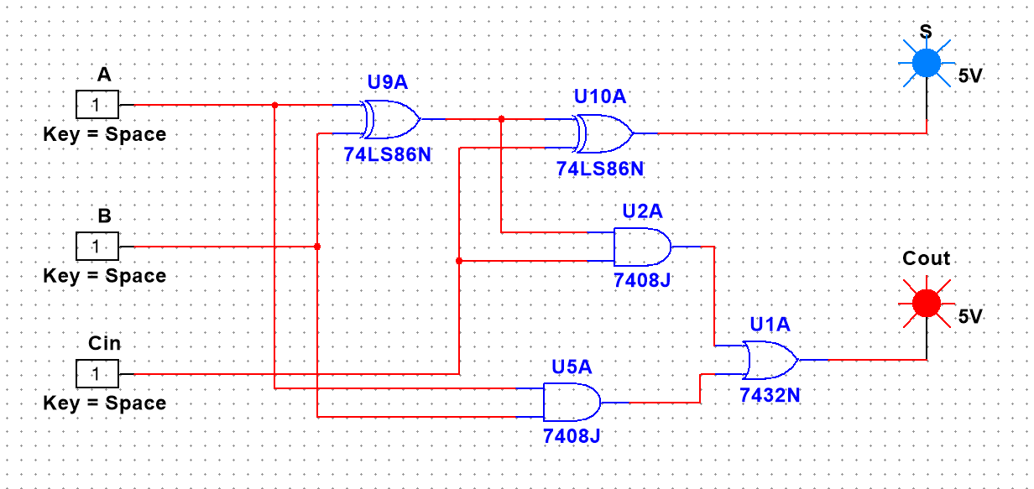
(g) (h)
Figure 6 : For Full Adder (g) when input is 110 , output Cout is 1 and sum is 0; (h) when input is 111 , output sum is 1 and carry is 1
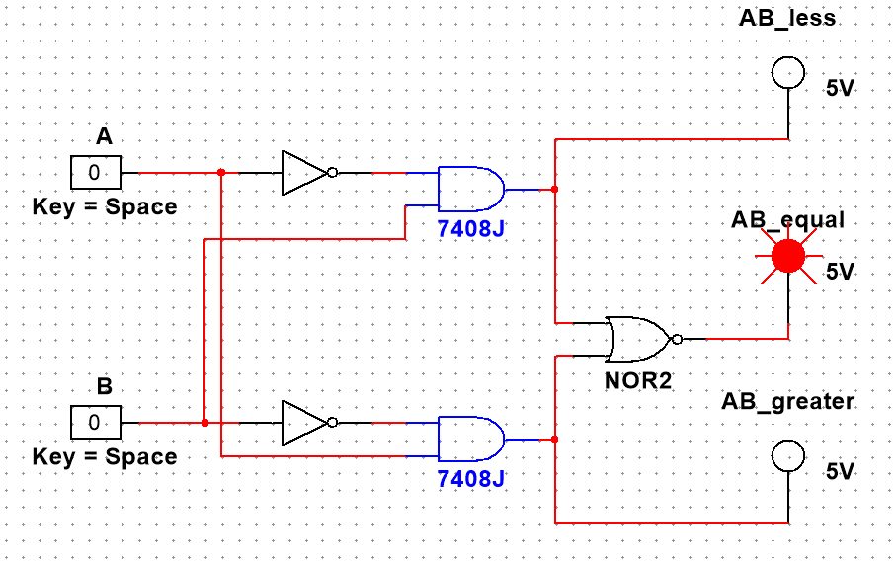
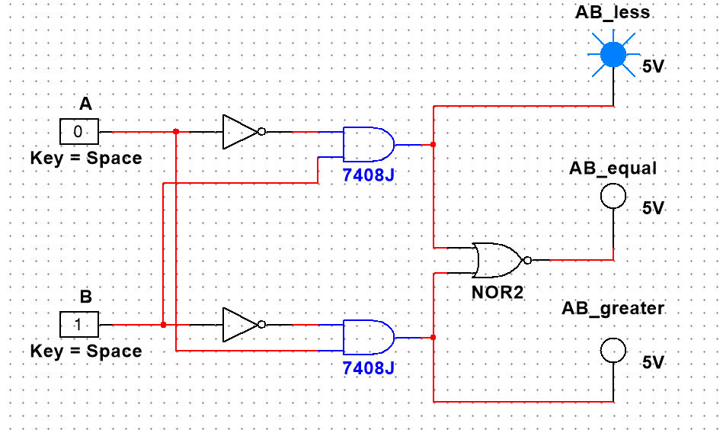
Comparator :
(a) (b)
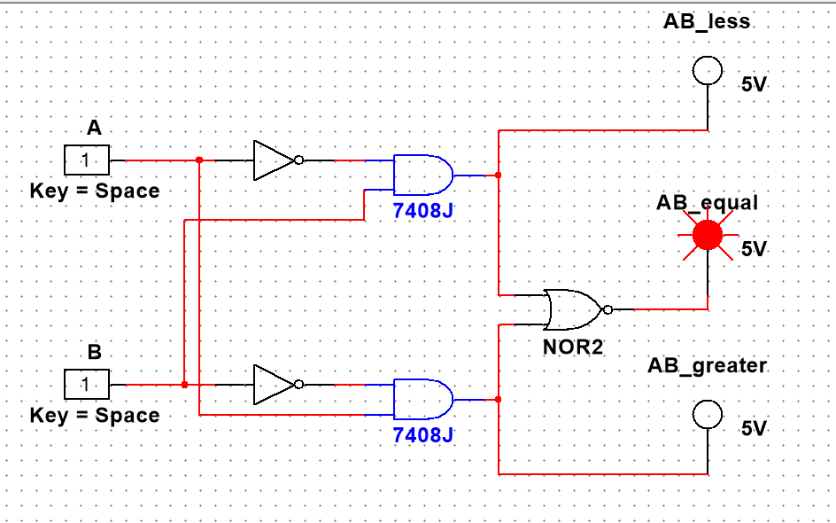
Figure 7 : For Comparator (a) when input is 00 , AB_Less is 0, AB_Equal is 1 and AB_Greater is 0; (b) when input is 01 , output AB_Less is 1, AB_Equal is 0 and AB_Greater is 0
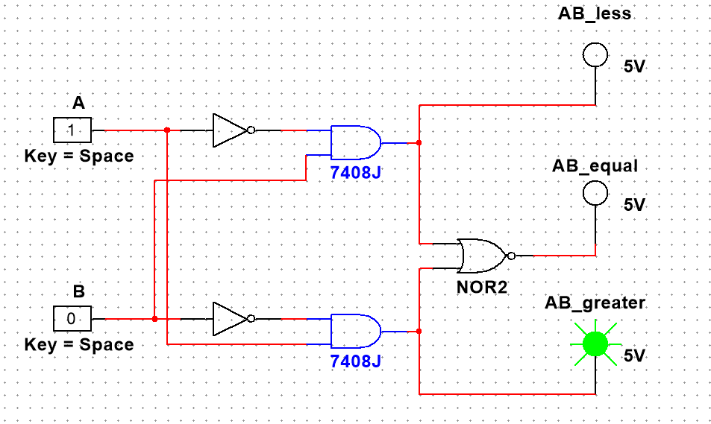
(c) (d)
Figure 8 : For Comparator (c) when input is 10 , AB_Less is 0, AB_Equal is 1 and AB_Greater is 1; (d) when input is 11 , output AB_Less is 0, AB_Equal is 1 and AB_Greater is 0
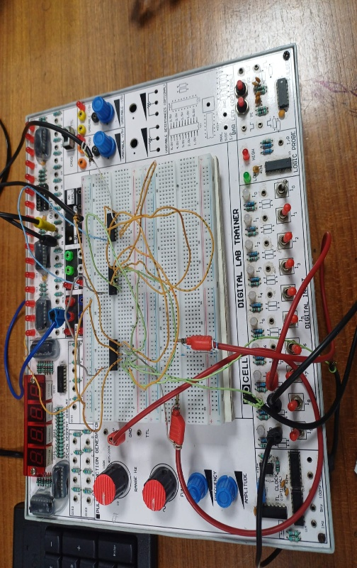
Experimental Setup:
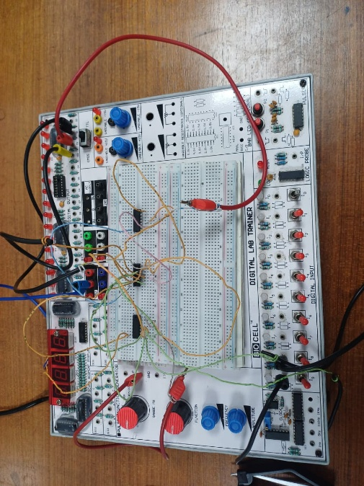
(a) (b)
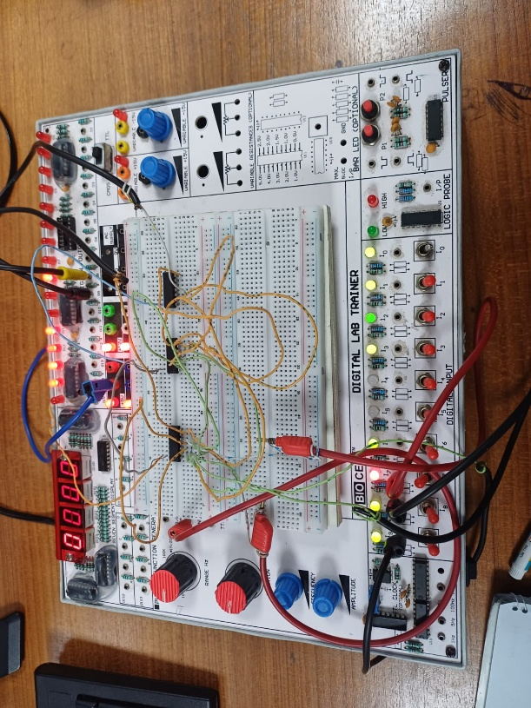
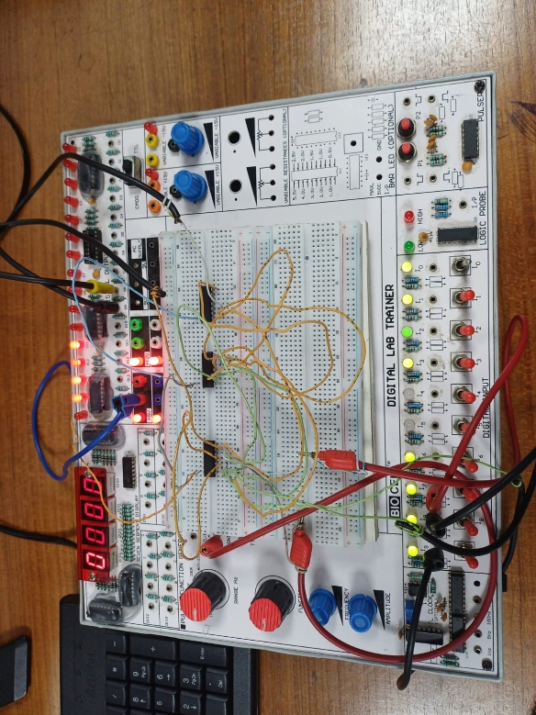
Figure: (a)Setup for Full Adder; (b)Setup for 1-Bit Comparator
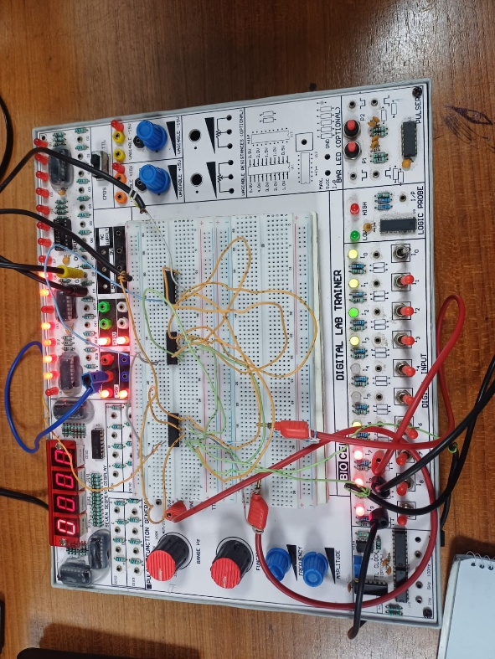
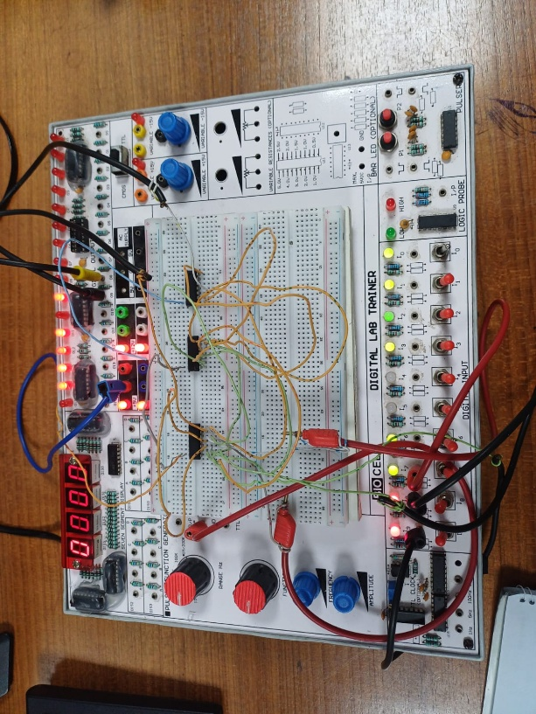
Experimental Result: (for Full Adder)
Figure 2: input(a=0,b=0,c=1); output(s=1,c=0)
Figure 1: input(a=0,b=0,c=0); output(s=0,c=0)
Figure 4: input(a=1,b=1,c=1); output(s=1,c=1)
Figure 3: input(a=1,b=1,c=0); output(s=0,c=1)
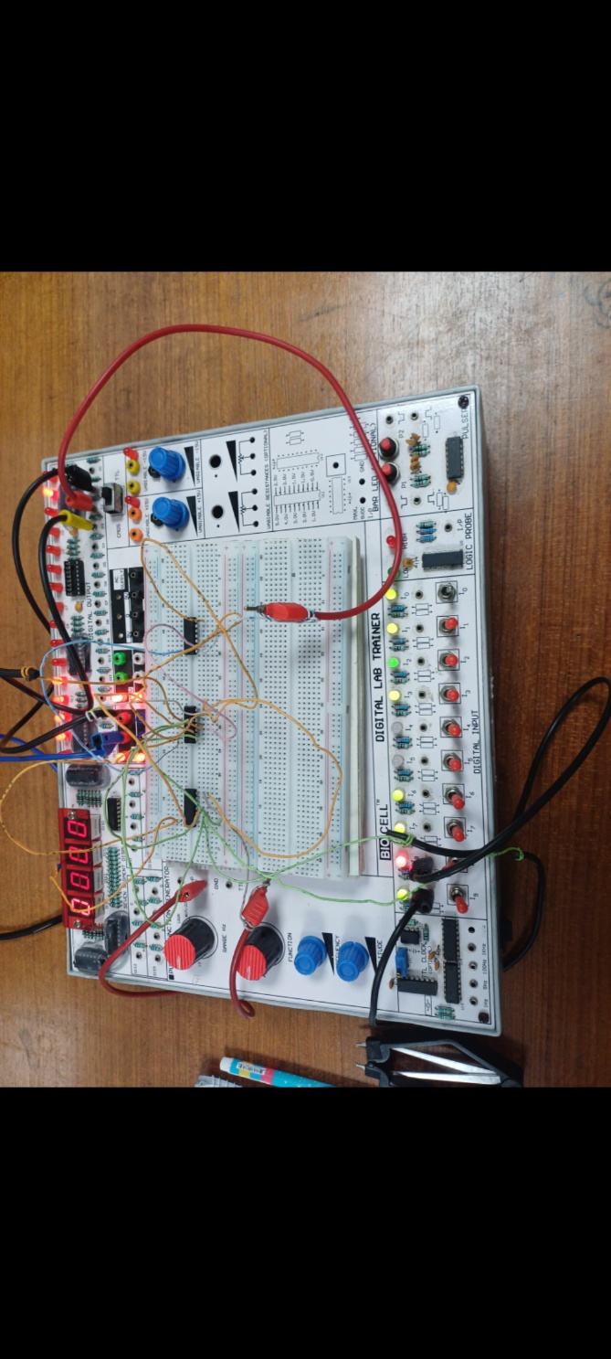
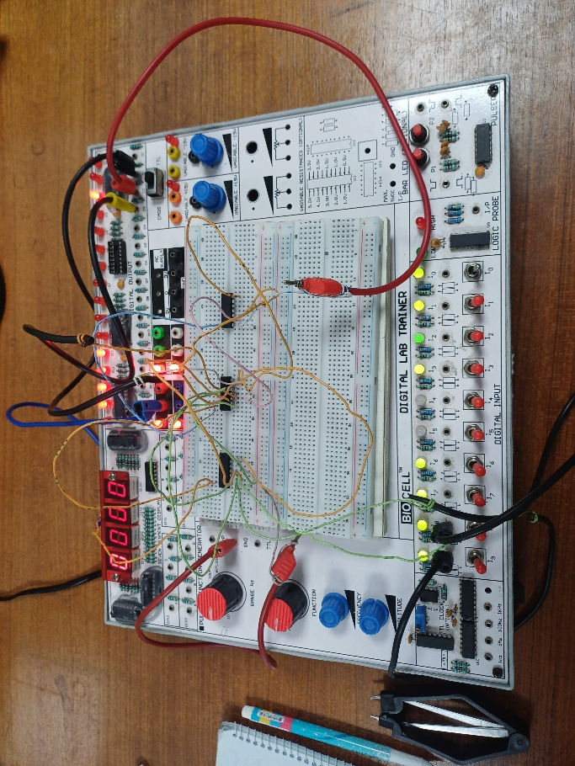
(for 1-Bit Comparator)
Figure 2: input(A=0, B=1);
output(A=B->0, A>B->0, A<B->1)
Figure 1: input(A=0, B=0);
output(A=B->1, A>B->0, A<B->0)
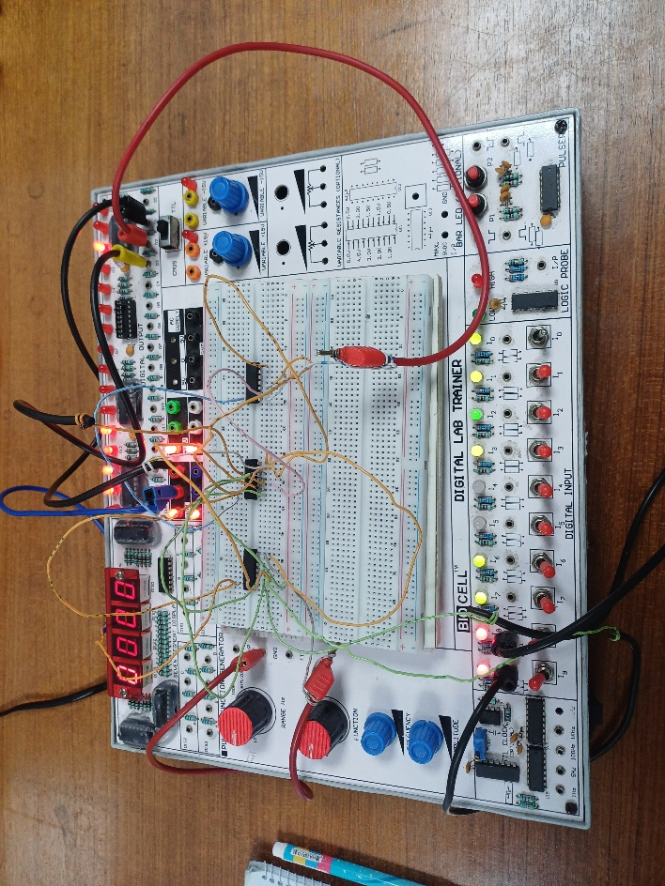
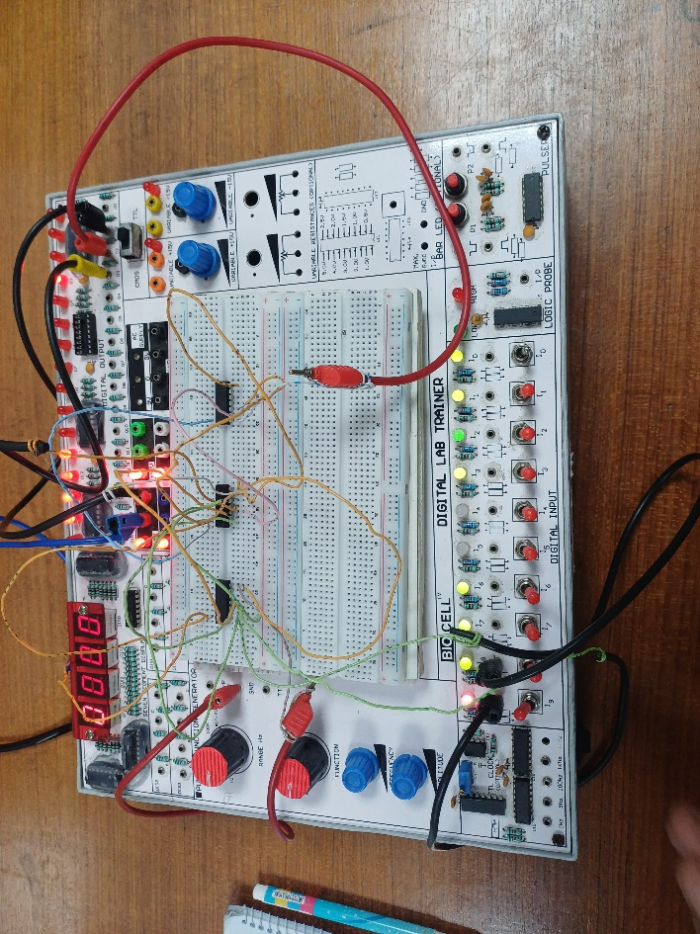

Figure 4: input(A=1, B=1);
output(A=B->1, A>B->0, A<B->0)
Figure 3: input(A=1, B=0);
output(A=B->0, A>B->1, A<B->0)

s

