

Institut de Formation d’Assurances et de Gestion

Établissement Privé de Formation Supérieure
Agréé par le Ministère de l’Enseignement Supérieur et de la Recherche Scientifique

MEMOIRE DE FIN D’ÉTUDES
Pour l’obtention du diplôme de

LICENCE
Filière : Informatique Spécialité : Métiers de l’Informatique

Application web de comparaison des offres mobiles : «Mobile Match Algérie»

Réalisé Par :
- Riad AMRATE
Encadré Par :
- Mme BENAHMED-EL-
ALIA Nadia

- M. BALLA Amar



Année Universitaire 2025 – 2026

To my family, whose unconditional support made this work possible.

To all those who believe that knowledge, freely shared, makes the world a better place.

Acknowledgments

The completion of this work would not have been possible without the guidance, support, and encouragement of a number of individuals to whom we wish to express our sincere gratitude.
We extend our deepest thanks to our supervisors, Mme BENAHMED-EL-ALIA Nadia and M. BALLA Amar, whose expertise, patience, and constructive feedback guided this project from its early conception to its final form. Their insights shaped both the technical direction and the academic quality of this mémoire.
We are grateful to the faculty and administration of the Institut de Formation d’Assurances et de Gestion (IFAG) for the rigorous academic environment they have provided throughout the Licence programme. The knowledge and skills acquired during these years of study form the very foundation of the work presented here.
Special thanks go to the colleagues and fellow students who participated in user testing and provided honest feedback that directly improved the application. Their time and contributions were invaluable.
Finally, we thank our family for their unwavering encouragement and understanding dur-ing the long hours dedicated to this project. This work is as much theirs as it is ours.

Résumé

Le présent mémoire décrit la conception et le développement de Mobile Match Algérie, une application web permettant aux consommateurs algériens de comparer les offres mobiles des trois principaux opérateurs : Mobilis, Djezzy et Ooredoo. Face à la multiplicité et à la complexité croissante des forfaits proposés sur le marché national, les utilisateurs manquent d’un outil neutre et centralisé pour prendre des décisions éclairées. Ce travail répond à ce besoin en proposant une plateforme regroupant, en temps réel, l’ensemble des offres disponibles grâce à un module de collecte automatisée ; en offrant des outils de filtrage, de comparaison côte à côte et de visualisation graphique ; et en personnalisant les recommandations selon le profil budgétaire et d’usage de chaque utilisateur.
L’application est développée avec le framework Next.js 16, en utilisant Prisma ORM avec une base de données SQLite, et déployée en tant qu’application full-stack. Un moteur de recom-mandation basé sur un algorithme de scoring multi-critères sélectionne les trois offres les mieux adaptées au profil de l’utilisateur. L’ensemble des fonctionnalités définies dans le cahier des charges a été implémenté et validé fonctionnellement.

Mots-clés : comparaison d’offres mobiles, web scraping, système de recommandation, Next.js, Algérie.

Abstract

This thesis presents the design and development of Mobile Match Algeria, a web application that enables Algerian consumers to compare mobile plans offered by the country’s three main operators: Mobilis, Djezzy, and Ooredoo. The increasing number and complexity of available plans make it difficult for users to make informed choices without a neutral, centralised com-parison tool. This work addresses that gap by delivering a platform that aggregates all current offers in real time through an automated scraping module, provides advanced filtering, side-by-side comparison, and graphical visualisation tools, and personalises plan recommendations according to each user’s budget and usage profile.
The application is built with the Next.js 16 framework using Prisma ORM backed by SQLite, and is deployed as a full-stack web service. A recommendation engine based on a multi-criteria scoring algorithm selects the three best-matched plans for any given user profile. All functional requirements defined in the specification have been implemented and verified.

Keywords: mobile plan comparison, web scraping, recommendation system, Next.js, Algeria.

ﻣﻠﺧﺹ
Algérie Match Mobile

ﻳُﻘﺩِّﻡ ﻫﺫﺍ ﺍﻟﻣﺫﻛﺭﺓ ﺗﺻﻣﻳﻡ ﻭﺗﻁﻭﻳﺭ ﺗﻁﺑﻳﻖ ﻭﻳﺏ ﻳُﺗﻳﺢ ﻟﻠﻣﺳﺗﻬﻠﻛﻳﻥ ﺍﻟﺟﺯﺍﺋﺭﻳﻳﻥ ﻣﻘﺎﺭﻧﺔ ﻋﺭﻭﺽ ﺍﻟﻬﺎﺗﻑ ﺍﻟﻣﺣﻣﻭﻝ ﺍﻟﺗﻲ ﺗﻘﺩﻣﻬﺎ ﺍﻟﻣﺷﻐﻼﺕ ﺍﻟﺛﻼﺛﺔ ﺍﻟﺭﺋﻳﺳﻳﺔ: ﻣﻭﺑﻳﻠﻳﺱ ﻭﺟﻳﺯﻱ ﻭﺃﻭﺭﻳﺩﻭ. ﻳُﻌﺎﻟﺞ ﻫﺫﺍ ﺍﻟﻌﻣﻝ ﻏﻳﺎﺏ ﺃﺩﺍﺓ ﻣﻘﺎﺭﻧﺔ ﻣﺣﺎﻳﺩﺓ ﻭﻣﺭﻛﺯﻳﺔ ﻣﻥ ﺧﻼﻝ ﻣﻧﺻﺔ ﺗﺟﻣﻊ ﺟﻣﻳﻊ ﺍﻟﻌﺭﻭﺽ ﺍﻟﺣﺎﻟﻳﺔ ﻓﻲ ﺍﻟﻭﻗﺕ ﺍﻟﻔﻌﻠﻲ، ﻭﺗﻭﻓﺭ ﺃﺩﻭﺍﺕ ﺗﺻﻔﻳﺔ ﻣﺗﻘﺩﻣﺔ ﻭﻣﻘﺎﺭﻧﺔ ﺟﺎﻧﺑﻳﺔ ﻭﺗﺻﻭﺭﺍً ﺑﻳﺎﻧﻳﺎً، ﻣﻊ ﺗﺧﺻﻳﺹ ﺍﻟﺗﻭﺻﻳﺎﺕ ﻭﻓﻖ ﺍﻟﻣﻳﺯﺍﻧﻳﺔ ﻭﻣﻠﻑ ﺍﺳﺗﺧﺩﺍﻡ ﻛﻝ ﻣﺳﺗﺧﺩﻡ.

ﺑُﻧﻲ ﺍﻟﺗﻁﺑﻳﻖ ﺑﺈﻁﺎﺭ ﺍﻟﻌﻣﻝ Next.js 16 ﻣﻊ Prisma ORM ﻭﻗﺎﻋﺩﺓ ﺑﻳﺎﻧﺎﺕ ،SQLite ﻭﻧُﺷﺭ ﺑﻭﺻﻔﻪ ﺧﺩﻣﺔ ﻭﻳﺏ ﻣﺗﻛﺎﻣﻠﺔ. ﻳﻌﺗﻣﺩ ﻣﺣﺭﻙ ﺍﻟﺗﻭﺻﻳﺎﺕ ﻋﻠﻰ ﺧﻭﺍﺭﺯﻣﻳﺔ ﺗﺳﺟﻳﻝ ﻣﺗﻌﺩﺩﺓ ﺍﻟﻣﻌﺎﻳﻳﺭ ﺗﺧﺗﺎﺭ ﺃﻓﺿﻝ ﺛﻼﺛﺔ ﻋﺭﻭﺽ ﺗﻧﺎﺳﺏ ﻣﻠﻑ ﺍﻟﻣﺳﺗﺧﺩﻡ. ﻭﻗﺩ ﺍﺳﺗُﻛﻣﻠﺕ ﺟﻣﻳﻊ ﺍﻟﻣﺗﻁﻠﺑﺎﺕ ﺍﻟﻭﻅﻳﻔﻳﺔ ﺍﻟﻣﺣﺩﺩﺓ ﻓﻲ ﺩﻓﺗﺭ ﺍﻟﺷﺭﻭﻁ ﻭﺗﻡ ﺍﻟﺗﺣﻘﻖ ﻣﻧﻬﺎ.

ﺍﻟﻛﻠﻣﺎﺕ ﺍﻟﻣﻔﺗﺎﺣﻳﺔ: ﻣﻘﺎﺭﻧﺔ ﻋﺭﻭﺽ ﺍﻟﻬﺎﺗﻑ ﺍﻟﻣﺣﻣﻭﻝ، ﺍﺳﺗﺧﻼﺹ ﺍﻟﺑﻳﺎﻧﺎﺕ ﻣﻥ ﺍﻟﻭﻳﺏ، ﻧﻅﺎﻡ ﺍﻟﺗﻭﺻﻳﺎﺕ، ،Next.js ﺍﻟﺟﺯﺍﺋﺭ.

Contents

Acknowledgments iii
Résumé iv
Abstract v
vi ﻡﻝﺥﺹ
List of Figures x
List of Tables xii
List of Abbreviations xiv
General Introduction 2
- State of the Art and Core Concepts 5
  - The Algerian Mobile Telecommunications Market . . . . . . . . . . . . . . . . 5
    - Market Overview and Key Figures . . . . . . . . . . . . . . . . . . . . 5
    - Offer Complexity and the Consumer Decision Problem . . . . . . . . . 6
  - Existing Comparison Platforms . . . . . . . . . . . . . . . . . . . . . . . . . . 6
    - International Benchmarks . . . . . . . . . . . . . . . . . . . . . . . . 6
    - Gap Analysis for Algeria . . . . . . . . . . . . . . . . . . . . . . . . . 7
  - Web Data Aggregation . . . . . . . . . . . . . . . . . . . . . . . . . . . . . . 7
    - Static vs. Dynamic Scraping . . . . . . . . . . . . . . . . . . . . . . . 7
    - Data Normalisation . . . . . . . . . . . . . . . . . . . . . . . . . . . . 8

1.3.3 Legal and Ethical Considerations . . . . . . . . . . . . . . . . . . . . 8
  - Recommendation Systems . . . . . . . . . . . . . . . . . . . . . . . . . . . . 8
    - Classification of Recommendation Approaches . . . . . . . . . . . . . 8
    - Scoring-Based Recommendation for Plan Selection . . . . . . . . . . . 9
  - Modern Web Stack Overview . . . . . . . . . . . . . . . . . . . . . . . . . . . 9
    - Next.js and the App Router . . . . . . . . . . . . . . . . . . . . . . . . 9
    - Prisma ORM . . . . . . . . . . . . . . . . . . . . . . . . . . . . . . . 9
    - SQLite as the Data Store . . . . . . . . . . . . . . . . . . . . . . . . . 9
  - Positioning of This Work 10

2 | Requirements Analysis and System Design | 11
 | 2.1 Requirements Gathering . . . . . . . . . . . . . . . . . . . . . . . . . . . . . | 11
 | 2.1.1 Methodology . . . . . . . . . . . . . . . . . . . . . . . . . . . . . . . | 11
 | 2.1.2 Functional Requirements . . . . . . . . . . . . . . . . . . . . . . . . . | 11
 | 2.1.3 Non-Functional Requirements . . . . . . . . . . . . . . . . . . . . . . | 12
 | 2.2 System Actors . . . . . . . . . . . . . . . . . . . . . . . . . . . . . . . . . . . | 12
 | 2.3 UML Use Case Diagrams . . . . . . . . . . . . . . . . . . . . . . . . . . . . . | 13
 | 2.4 UML Activity and Sequence Diagrams . . . . . . . . . . . . . . . . . . . . . . | 14
 | 2.4.1 Scraping Pipeline Activity Diagram . . . . . . . . . . . . . . . . . . . | 14
 | 2.4.2 Recommendation Request Sequence Diagram . . . . . . . . . . . . . . | 15
 | 2.5 Data Model . . . . . . . . . . . . . . . . . . . . . . . . . . . . . . . . . . . . | 16
 | 2.5.1 Conceptual Schema . . . . . . . . . . . . . . . . . . . . . . . . . . . . | 16
 | 2.5.2 Prisma Schema Description . . . . . . . . . . . . . . . . . . . . . . . | 16
 | 2.6 System Architecture . . . . . . . . . . . . . . . . . . . . . . . . . . . . . . . . | 17
 | 2.6.1 Three-Tier Architecture . . . . . . . . . . . . . . . . . . . . . . . . . | 17
 | 2.6.2 API Route Map . . . . . . . . . . . . . . . . . . . . . . . . . . . . . . | 17
 | 2.7 UI/UX Design . . . . . . . . . . . . . . . . . . . . . . . . . . . . . . . . . . . | 18
 | 2.7.1 Design Principles . . . . . . . . . . . . . . . . . . . . . . . . . . . . . | 18
 | 2.7.2 Key Interface Screens . . . . . . . . . . . . . . . . . . . . . . . . . . | 18
 | 2.8 Technology Stack Justification . . . . . . . . . . . . . . . . . . . . . . . . . . | 19

3 | System Implementation | 21
 | 3.1 Development Environment . . . . . . . . . . . . . . . . . . . . . . . . . . . . | 21
 | 3.2 Data Aggregation Module . . . . . . . . . . . . . . . . . . . . . . . . . . . . | 22
 | 3.2.1 Scraper Architecture . . . . . . . . . . . . . . . . . . . . . . . . . . . | 22
 | 3.2.2 Scraping Algorithm . . . . . . . . . . . . . . . . . . . . . . . . . . . . | 22
 | 3.2.3 Data Normalisation Pipeline . . . . . . . . . . . . . . . . . . . . . . . | 23
 | 3.2.4 Cron Automation . . . . . . . . . . . . . . . . . . . . . . . . . . . . . | 23
 | 3.3 Backend — REST API . . . . . . . . . . . . . . . . . . . . . . . . . . . . . . | 23
 | 3.3.1 API Route Structure . . . . . . . . . . . . . . . . . . . . . . . . . . . | 23
 | 3.3.2 Cross-Operator Comparison Routing . . . . . . . . . . . . . . . . . . | 24
 | 3.3.3 Authentication . . . . . . . . . . . . . . . . . . . . . . . . . . . . . . | 24
 | 3.4 Recommendation Engine . . . . . . . . . . . . . . . . . . . . . . . . . . . . . | 24
 | 3.4.1 Scoring Model . . . . . . . . . . . . . . . . . . . . . . . . . . . . . . | 24
 | 3.4.2 Recommendation Algorithm . . . . . . . . . . . . . . . . . . . . . . . | 25
 | 3.4.3 Triggering Recommendations . . . . . . . . . . . . . . . . . . . . . . | 25
 | 3.5 Frontend — Key Interfaces . . . . . . . . . . . . . . . . . . . . . . . . . . . . | 26
 | 3.5.1 Home Page and Offer Browsing . . . . . . . . . . . . . . . . . . . . . | 26
 | 3.5.2 Offers Page . . . . . . . . . . . . . . . . . . . . . . . . . . . . . . . . | 26
 | 3.5.3 Comparison Page . . . . . . . . . . . . . . . . . . . . . . . . . . . . . | 27
 | 3.5.4 Recommendations Page . . . . . . . . . . . . . . . . . . . . . . . . . | 28
 | 3.5.5 Login and Registration . . . . . . . . . . . . . . . . . . . . . . . . . . | 29
 | 3.5.6 Admin Dashboard . . . . . . . . . . . . . . . . . . . . . . . . . . . . | 30
 | 3.6 Security . . . . . . . . . . . . . . . . . . . . . . . . . . . . . . . . . . . . . . | 31
 | 3.6.1 Authentication and Session Management . . . . . . . . . . . . . . . . | 31
 | 3.6.2 Password Storage . . . . . . . . . . . . . . . . . . . . . . . . . . . . . | 31
 | 3.6.3 Role-Based Access Control . . . . . . . . . . . . . . . . . . . . . . . | 31
 | 3.6.4 Input Validation and Injection Prevention . . . . . . . . . . . . . . . . | 32
 | 3.7 Deployment . . . . . . . . . . . . . . . . . . . . . . . . . . . . . . . . . . . . | 32

- Evaluation and Documentation 33

  - Comparison with Objectives 33
  - Limitations 34
  - Perspectives 34
  - Documentation 35
    - User Guide 35
    - Administrator Manual 35
    - API Reference 35
General Conclusion and Perspectives 36
Bibliographic References 38
- UML Diagrams 39
- Data Model Summary 43
- Application Screenshots 44

List of Figures

  - Top-level use case diagram for Mobile Match Algeria 13
  - Activity diagram — automated scraping pipeline 15
  - Sequence diagram — recommendation request flow 16
  - Entity-relationship diagram of the Mobile Match Algeria data model 16
  - High-level three-tier architecture of Mobile Match Algeria 17

  - Algorithm of the automated scraping pipeline 22
  - Multi-criteria recommendation algorithm 25
  - Home page of Mobile Match Algeria 26
  - Offers page showing plan catalogue with operator filter tabs 27
  - Sticky comparison bar — appears at the bottom when plans are selected 27
  - Side-by-side comparison page with radar chart visualisation 28
  - Recommendations page — form and personalised results 29
  - Login page 30
  - Admin dashboard — statistics, scrape controls, and offer management 31

  - Complete use case diagram — actor generalisation and all use cases 40
  - Class diagram of the Mobile Match Algeria data model 41
  - Sequence diagram — user registration and login flow 42

  - Home page — statistics, quick-access cards, and navigation 44
  - Offers page — offer grid with operator filter tabs 45
  - Comparison page — side-by-side attribute table and radar chart 46
  - Recommendations page — usage profile sliders and scored plan results 47

  - Login page 47
  - Registration page 48
  - Offer detail page — full plan specifications and save action 48
  - Offers page with advanced filters applied — operator, price range, and data volume 49
  - Admin dashboard — scrape controls, logs, and offer management 49

List of Tables

1.1 | Summary of operator plan catalogues (Q1 2026) . . . . . . . . . . . . . . . . . | 6
1.2 | Comparison of existing platforms and Mobile Match Algeria . . . . . . . . . . | 7
2.1 | System actors and their capabilities . . . . . . . . . . . . . . . . . . . . . . . . | 13
2.2 | Key entities and their principal attributes . . . . . . . . . . . . . . . . . . . . . | 17
2.3 | API route map (design overview) . . . . . . . . . . . . . . . . . . . . . . . . . | 18
2.4 | Technology stack choices and justifications . . . . . . . . . . . . . . . . . . . | 19
3.1 | Development environment . . . . . . . . . . . . . . . . . . . . . . . . . . . . | 21
3.2 | API route map . . . . . . . . . . . . . . . . . . . . . . . . . . . . . . . . . . . | 23
3.3 | Scoring dimensions of the recommendation engine . . . . . . . . . . . . . . . | 24
4.1 | Achievement of project objectives . . . . . . . . . . . . . . . . . . . . . . . . | 33
B.1 | Prisma schema entities and primary fields . . . . . . . . . . . . . . . . . . . . | 43

List of Abbreviations

Abbreviation Definition

API Application Programming Interface
AR Arabic
ARPCE Autorité de Régulation de la Poste et des Communications Électroniques APA American Psychological Association
bcrypt Blowfish Cipher password-hashing algorithm
CLI Command-Line Interface
CORS Cross-Origin Resource Sharing
CPU Central Processing Unit
CSS Cascading Style Sheets
CRUD Create, Read, Update, Delete
DA Dinar Algérien (Algerian Dinar)
DB Database
DOM Document Object Model
EN English
ENV Environment variable
FR French
GB Gigabyte
GSMA Global System for Mobile Communications Association HTML HyperText Markup Language
HTTP HyperText Transfer Protocol
HTTPS HyperText Transfer Protocol Secure
ID Identifier
IFAG Institut de Formation d’Assurances et de Gestion
JSON JavaScript Object Notation
JWT JSON Web Token
LMI Licence en Métiers de l’Informatique
MVC Model-View-Controller
NPM Node Package Manager
ORM Object-Relational Mapping

Abbreviation Definition

OS Operating System
PDF Portable Document Format
REST Representational State Transfer
SPA Single-Page Application
SQL Structured Query Language
SQLite Self-contained, serverless SQL database engine SSR Server-Side Rendering
SUS System Usability Scale
TSX TypeScript XML (React component file extension)
UI User Interface
UML Unified Modelling Language
URL Uniform Resource Locator
UX User Experience
vs versus

General Introduction

General Context

Algeria’s mobile telecommunications market is characterised by a triopoly consisting of three licensed operators: Mobilis, Djezzy, and Ooredoo. Together, these operators serve more than 47 million subscribers, representing a mobile penetration rate that ranks among the highest on the African continent (ARPCE, 2024). Each operator regularly releases prepaid, postpaid, and data-only plans — varying in price, data volume, voice minutes, SMS allowances, validity periods, and network generation (4G or 5G). The resulting catalogue of offers grows continuously and changes frequently, making it increasingly difficult for consumers to identify the plan that best matches their individual needs and budget.
Despite the richness of the available supply, Algerian consumers currently lack access to a neutral, centralised, and up-to-date comparison tool. Operator websites present only their own products, and no independent aggregation platform exists at the national level. This information asymmetry forces users to visit multiple websites, manually record and compare figures, and rely on incomplete or outdated information when making purchasing decisions.

Problem Statement

The central problem addressed by this work can be stated as follows: how can a neutral, real-time web platform be designed and implemented to transparently aggregate all Algerian mobile offers, provide advanced filtering and side-by-side comparison tools, and deliver personalised recommendations tailored to each user’s budget and usage profile?
Answering this question requires solving three interdependent sub-problems. First, offer data must be collected automatically and reliably, given the absence of public APIs from the operators. Second, a scoring model must translate a user’s declared preferences into a ranked list of suitable plans. Third, all of these capabilities must be packaged in a responsive, accessible, and intuitive web interface suitable for a broad audience.

Objectives and Scope

This project, carried out within the framework of the Licence en Métiers de l’Informatique at IFAG Alger, pursues five clearly defined objectives. The first objective is to develop a full-stack web application that enables users to browse, filter, and compare mobile plans from all three national operators. The second objective is to build an automated data-collection module capable of scraping offer data from operator websites and maintaining a normalised, up-to-date database. The third objective is to implement a recommendation engine that scores available plans against a user-defined profile and returns the three best-matched options. The fourth objective is to integrate data visualisation tools, including a radar chart for multi-dimensional plan comparison, to support informed decision-making. The fifth objective is to implement a real-time notification system that alerts registered users to relevant changes in the offer catalogue.
The scope of this work covers the three Algerian mobile operators (Mobilis, Djezzy, Oore-doo) and the plan types currently offered: prepaid, postpaid, and data-only. Fixed-line internet and bundled services fall outside the scope of this version and are identified as future extensions.

Methodology

The project follows an iterative development methodology. Requirements were gathered through a preliminary survey of target users and a systematic analysis of existing comparison platforms. The technical architecture was designed around the Next.js 16 full-stack framework, which al-lows both the front-end interface and the back-end API routes to be developed within a single codebase. Data persistence is managed through Prisma ORM backed by a SQLite database, cho-sen for its simplicity and zero-configuration deployment footprint. Automated offer collection is handled by a custom scraping module that runs on a scheduled basis. The recommendation engine applies a weighted multi-criteria scoring algorithm derived from content-based filtering principles.

Thesis Structure

The remainder of this mémoire is organised into four chapters. Chapter 1 surveys the state of the art, covering the Algerian telecom market, existing comparison platforms, web data aggre-gation techniques, recommendation systems, and the modern web stack selected for this project. Chapter 2 presents the requirements analysis and system design, including use case diagrams, the data model, the system architecture, and technology justifications. Chapter 3 describes the full implementation of the platform, detailing the scraping module, the REST API, the recom-mendation engine, the user interface, and the security mechanisms. Chapter 4 covers testing and validation, reporting the results of technical tests, user tests, and a structured comparison of achievements against the initial objectives. The work closes with a general conclusion that

summarises contributions, acknowledges limitations, and outlines perspectives for future devel-opment.

Chapter 1

State of the Art and Core Concepts

This chapter establishes the theoretical and technical foundation upon which the rest of the work rests. It examines the Algerian mobile telecommunications market, reviews existing comparison platforms at the international level, and surveys the key technical disciplines involved in build-ing this project: web data aggregation, recommendation systems, and modern full-stack web development. The chapter concludes by positioning Mobile Match Algeria within the landscape identified through this review.

The Algerian Mobile Telecommunications Market

Market Overview and Key Figures

Algeria’s mobile telecommunications sector is regulated by the Autorité de Régulation de la Poste et des Communications Électroniques (ARPCE). As of 2024, the country counts more than 47 million mobile subscribers, distributed across three licensed operators: Mobilis, owned by the state-controlled Algérie Télécom group; Djezzy, majority-owned by VEON; and Ooredoo, a subsidiary of the Qatari group Ooredoo (ARPCE, 2024; Statista, 2024). Mobile penetration stands at approximately 106 %, reflecting a mature market where many users hold multiple SIM cards.
The network infrastructure has evolved considerably over the past decade. Following the deployment of 4G LTE services in 2016, all three operators have expanded coverage progres-sively across the country. Djezzy launched commercially limited 5G trials in 2024, positioning itself as the first operator to test fifth-generation technology in Algeria (GSMA Intelligence, 2024). These developments have accelerated the diversification of plan offerings, as operators compete on price, data volume, and network quality.

Offer Complexity and the Consumer Decision Problem

Each operator publishes a catalogue of prepaid, postpaid, and data-only plans that is updated several times per year. Prices range from a few hundred to several thousand Algerian Dinars per month, depending on the included data volume (from 1 GB to over 200 GB), voice minutes (from limited bundles to unlimited calls), SMS allowances, and validity periods (daily, weekly, monthly, or longer). A consumer wishing to identify the most cost-effective plan for their spe-cific usage profile must visit three separate websites, compare offerings across heterogeneous formats, and account for promotional periods that may alter the base price.
Table 1.1 summarises the main characteristics of each operator’s catalogue as of the first quarter of 2026, illustrating the scope of the comparison challenge.
Table 1.1. Summary of operator plan catalogues (Q1 2026)

Criterion | Mobilis | Djezzy | Ooredoo
Plan types | Prepaid, Postpaid, Data | Prepaid, Postpaid, Data | Prepaid, Postpaid, Data
Price range (DA/month) | 200 – 4 500 | 300 – 5 000 | 250 – 4 800
Max data volume | 200 GB | 300 GB | 150 GB
5G availability | No | Limited trial | No
Public API | None | None | None

Existing Comparison Platforms

International Benchmarks

Several international platforms have successfully addressed the plan-comparison problem in their respective markets. An analysis of these systems reveals common features, architectural patterns, and limitations that inform the design of Mobile Match Algeria.
MeilleurMobile (France) is a leading French aggregator that covers all national operators and virtual operators (MVNOs). It provides a tabular comparison interface, a plan-finder ques-tionnaire, and user reviews. The platform relies primarily on operator partnerships and manual data entry rather than automated scraping, which limits its real-time accuracy. It does not offer a personalisation engine beyond basic filtering (MeilleurMobile, 2024).
WhistleOut (Australia and the United Kingdom) operates a comparison marketplace that includes both mobile plans and broadband. It features a strong search and filter interface and integrates affiliate referral links. Its data is updated through a combination of operator feeds and editorial review. The platform targets English-speaking markets and its architecture is not publicly documented.
CompareTheMobile (United Kingdom) offers a highly visual comparison interface with side-by-side plan cards and a compatibility checker for handsets. Like its counterparts, it de-

pends on voluntary operator data submission and does not employ automated collection.

Gap Analysis for Algeria

None of the platforms identified above serve the Algerian market. The absence of a national comparison tool can be explained by several structural factors: the relatively small number of operators (three), the absence of virtual operators, and the lack of public APIs that would facilitate data integration. The international platforms reviewed rely on operator cooperation or affiliate relationships that do not exist in the Algerian context. Furthermore, all identified platforms are available in English or French only, without Arabic-language support, which is essential for reaching the full Algerian user base.
Table 1.2 synthesises the key differences between existing platforms and the proposed solution.
Table 1.2. Comparison of existing platforms and Mobile Match Algeria

Feature | MeilleurMobile | WhistleOut | CompareTheMobile | This work
Algeria coverage | No | No | No | Yes
Automated scraping | No | No | No | Yes
Recommendation engine | No | No | No | Yes
Arabic interface | No | No | No | Yes
Open-source | No | No | No | Yes
Radar chart comparison | No | No | No | Yes

Web Data Aggregation

Static vs. Dynamic Scraping

Web scraping is the automated extraction of data from web pages. Two principal approaches exist. Static scraping sends an HTTP request to a target URL and parses the returned HTML using a library such as BeautifulSoup (Python) or Cheerio (JavaScript/Node.js). This approach is fast, resource-light, and straightforward to implement, but fails when the target page renders its content through client-side JavaScript after the initial page load.
Dynamic scraping uses a headless browser — typically Puppeteer or Playwright — to execute the full JavaScript runtime of the target page before extracting the rendered DOM. This method handles JavaScript-heavy single-page applications but incurs a significantly higher computational and memory cost, and is more fragile under rate-limiting or anti-bot measures (Mitchell, 2018).
For this project, the operator websites were analysed and their scraping strategy was se-lected based on their rendering mechanism. Mobilis and Ooredoo serve plan data in server-

rendered HTML, making them suitable for static scraping. Djezzy renders its offer cards via client-side JavaScript, requiring a lightweight dynamic approach.

Data Normalisation

Because each operator presents plan information in a different format, a normalisation pipeline is required to map raw scraped values to a common schema. This pipeline handles unit conversion (e.g., MB to GB), removal of promotional suffixes from plan names, extraction of numeric values from strings containing units, and assignment of default values for fields not provided by a given operator. The normalised data is stored in a relational database, enabling uniform querying across all operators.

Legal and Ethical Considerations

Web scraping raises questions of legality and ethics that must be addressed. In Algeria, no specific legislation prohibits the automated reading of publicly accessible web pages for non-commercial informational purposes. The robots.txt files of the three target operators do not explicitly disallow scraping of their public plan pages. The scraping module implemented in this project respects rate limits, introduces delays between requests, and does not collect any personally identifiable information. All data collected is publicly visible to any user visiting the operator websites directly.

Recommendation Systems

Classification of Recommendation Approaches

Recommendation systems are a class of information filtering tools that predict a user’s prefer-ence for items based on available data (Géron, 2022). Three main paradigms are distinguished in the literature.
Content-based filtering builds a profile of user preferences from attributes of items the user has previously rated or selected. Recommendations are generated by matching item at-tributes against the user profile. This approach works well with a clearly defined attribute space and does not require data from other users.
Collaborative filtering identifies users with similar behaviour and recommends items that like-minded users have rated highly. It can surface unexpected recommendations but requires a large user base and suffers from the cold-start problem for new users.
Hybrid systems combine both approaches to mitigate individual weaknesses. Many pro-duction recommendation systems, including those used by streaming services and e-commerce platforms, employ hybrid architectures (Géron, 2022).

Scoring-Based Recommendation for Plan Selection

The plan recommendation problem in this project differs from typical recommendation scenar-ios in that the item catalogue is small (fewer than 200 plans), fully enumerable, and charac-terised by well-defined numerical attributes (price, data, voice, SMS). This makes a scoring-based content-based approach both appropriate and computationally efficient without requiring historical interaction data.
The scoring model assigns each plan a composite score based on four dimensions: bud-get fit, data fit, voice fit, and network preference. Each dimension is computed as a function of the distance between the plan’s attribute and the user’s declared preference, with penalties applied for exceeding the budget. The top-scoring plans are returned as recommendations. This approach is described in detail in Chapter 3, Section 3.4.

Modern Web Stack Overview

Next.js and the App Router

Next.js is a React-based framework developed by Vercel that supports multiple rendering strate-gies including server-side rendering (SSR), static site generation, and client-side rendering. The App Router, introduced in Next.js 13 and stabilised in subsequent versions, organises the appli-cation into a hierarchy of route segments defined by the file system. Each segment can export a page component, a layout, a loading state, and API route handlers. This architecture enables the back-end and front-end of the application to coexist in a single project with shared type definitions and utilities (Vercel, 2024).

Prisma ORM

Prisma is a type-safe database toolkit for Node.js and TypeScript. It consists of a schema def-inition language for declaring the data model, a migration engine that generates and applies database schema changes, and a query builder that provides an auto-completed, type-safe API for database operations. The schema is defined once in a .prisma file, and Prisma generates TypeScript types that are used throughout the application, eliminating a class of runtime type errors that commonly arise with raw SQL queries (Prisma, 2024).

SQLite as the Data Store

SQLite is a serverless, file-based relational database engine widely used in embedded and devel-opment contexts. For a single-server deployment with a moderate user base, SQLite provides ad-equate performance and zero operational overhead. Its file-based nature simplifies deployment, backup, and version control. The trade-off is limited horizontal scalability, which is acknowl-

edged as a limitation of this version and addressed in the perspectives section of the general conclusion.

Positioning of This Work

The preceding review establishes that no existing tool serves Algerian consumers seeking to compare mobile plans. The combination of automated real-time data collection, a multi-criteria recommendation engine, a multi-language interface (English, French, Arabic), and a graphical radar chart for comparison distinguishes Mobile Match Algeria from all identified international platforms. The full-stack architecture built on Next.js and Prisma provides a solid and maintain-able technical foundation. The following chapter translates the requirements identified in this review into a concrete system design.

Chapter Summary

This chapter has surveyed the Algerian telecom market, reviewed international comparison plat-forms, and introduced the key technical disciplines underpinning this project. The gap analysis confirms the absence of any equivalent tool for Algerian consumers. The review of scraping techniques, recommendation paradigms, and the chosen technology stack establishes the theo-retical basis for the design and implementation work presented in the chapters that follow.

Chapter 2

Requirements Analysis and System Design

Building on the state of the art surveyed in Chapter 1, this chapter formalises the requirements of Mobile Match Algeria and presents the architectural and design decisions taken to meet them. The chapter covers requirements gathering, actor identification, UML modelling, data model definition, system architecture, UI/UX principles, and technology stack justification.

Requirements Gathering

Methodology

Requirements were elicited through two complementary methods. A structured online ques-tionnaire was distributed to a convenience sample of 65 Algerian mobile subscribers across dif-ferent age groups and usage profiles. Participants were asked about their current plan-selection behaviour, the difficulties they encounter when comparing plans, and the features they would find most useful in a comparison tool. In parallel, the existing operator websites and the inter-national comparison platforms identified in Chapter 1 were systematically analysed to extract implicit requirements from observed best practices.

Functional Requirements

The elicitation process yielded the following functional requirements, ordered by priority.

      - FR1 — Offer browsing: The system must display all current mobile plans from Mobilis, Djezzy, and Ooredoo, with their key attributes (price, data, voice, SMS, validity, network).
      - FR2 — Filtering: Users must be able to filter plans by operator, plan type (prepaid, postpaid, data-only), maximum price, minimum data, and network generation.
      - FR3 — Side-by-side comparison: Users must be able to select up to three plans and view them in a side-by-side comparison table with a radar chart visualisation.

      - FR4 — Personalised recommendations: Registered users must be able to define a usage profile (budget, data, voice, SMS, preferred type and network) and receive a ranked list of the three best-matching plans.
      - FR5 — Saved plans: Registered users must be able to bookmark plans and access them from a dedicated saved-plans page.
      - FR6 — Notifications: Registered users must receive in-app notifications when new plans are added to the catalogue.
      - FR7 — Automated data collection: The system must automatically scrape offer data from operator websites on a scheduled basis and update the database accordingly.
      - FR8 — Admin panel: Administrators must be able to trigger manual scrape runs, view scrape logs, manage offers (create, edit, delete), and monitor platform statistics.
      - FR9 — Authentication: Users must be able to register, log in, and log out. Password storage must use a one-way hashing algorithm.

Non-Functional Requirements

      - NFR1 — Performance: Page load time for the offers listing must not exceed 2 seconds on a standard broadband connection.
      - NFR2 — Responsiveness: The interface must be usable on mobile devices (320 px and above), tablets, and desktop screens.
      - NFR3 — Security: User sessions must be managed with signed JWT tokens. Passwords must be hashed with bcrypt. Admin routes must be protected by role verification.
      - NFR4 — Maintainability: The codebase must be organised into clearly separated mod-ules to facilitate future extension.
      - NFR5 — Accuracy: Scraped offer data must be verified against source pages; discrep-ancies detected during normalisation must be logged.

System Actors

Three actor types interact with the system, as summarised in Table 2.1.

Table 2.1. System actors and their capabilities

Actor | Capabilities
Visitor | Browse offers, apply filters, view offer details, compare up to 3 plans
Registered User | All visitor capabilities + save plans, view saved plans, receive notifications,  set usage profile, get personalised recommendations
Administrator | All user capabilities + trigger scrape runs, view scrape logs, cre-  ate/edit/delete offers, view platform statistics

UML Use Case Diagrams

The main use cases of the system are organised around three actors. Figure 2.1 illustrates the top-level use case diagram.
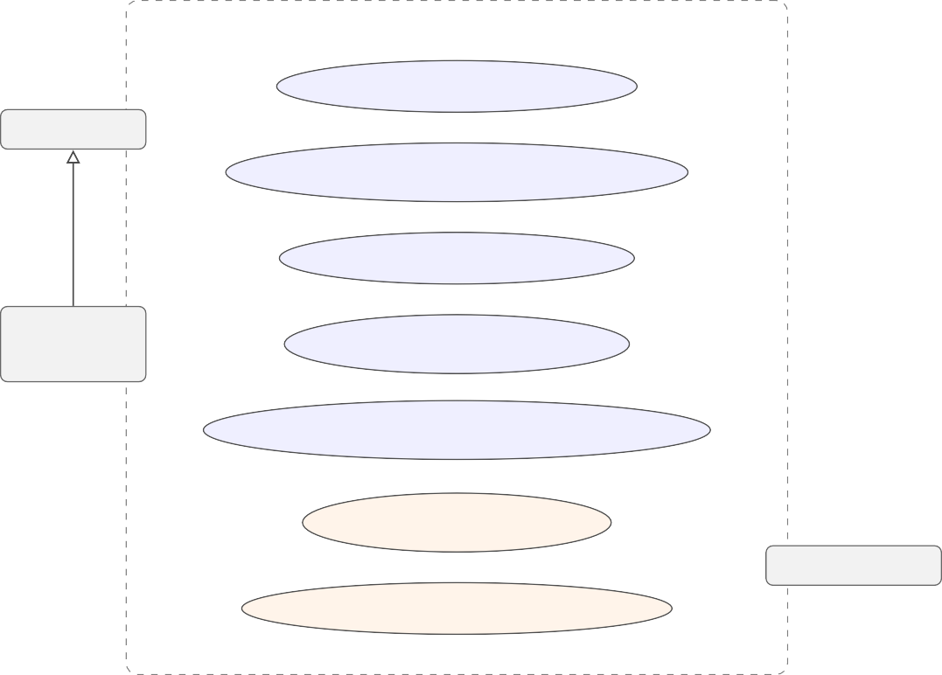
Mobile Match Algeria

Browse & Filter Offers
Visitor
Compare Plans (+ radar chart)
Get Recommendations
Registered
User
Save & Manage Plans
Manage Account & Notifications
extends
Trigger Scrape Run
Administrator
Create / Edit / Delete Offers
Figure 2.1. Top-level use case diagram for Mobile Match Algeria

The primary use cases are described below.
UC1 — Browse and filter offers: Any actor (visitor or registered user) may access the offers page, apply any combination of filters (operator, type, price, data, network), and view the resulting list of matching plans. The system retrieves filtered offers from the database and renders them as interactive cards.
UC2 — Compare plans: Any actor may select up to three plans and navigate to the comparison page, which presents a structured table and a radar chart. The use case requires that

at least two plans be selected.
UC3 — Get recommendations: A registered user may navigate to the recommendation page, review or update their usage profile, and request a list of the three best-matching plans. The system applies the scoring algorithm and returns ranked results with explanations.
UC4 — Save and manage saved plans: A registered user may bookmark any plan from the offers page, access the saved-plans page, compare saved plans, or remove a plan from their saved list.
UC5 — Manage account and notifications: A registered user may update their usage profile from the profile page and view, mark as read, or delete in-app notifications.
UC6 — Admin — Trigger scrape: An administrator may initiate a scrape run for one or all operators from the admin dashboard. The system runs the scraping pipeline, updates the database, creates notifications for new offers, and records a scrape log entry.
UC7 — Admin — Manage offers: An administrator may create, edit, or delete offers from the admin panel. This use case exists to handle edge cases where the scraper cannot parse a particular format.

UML Activity and Sequence Diagrams

Scraping Pipeline Activity Diagram

Figure 2.2 represents the activity flow of the automated scraping pipeline, from trigger to database update.

START
Cron trigger or Admin action
Parse HTML / DOM, extract raw offers
Normalise data (units, slugs, types)
Offer already
in DB?
Yes
No

INSERT new offer & notify users
Deactivate offers absent from scrape
(partial-scrape guard applied)
Write ScrapeLog (status, counts, duration)
END
UPDATE record
Fetch operator page (HTTP GET)
Figure 2.2. Activity diagram — automated scraping pipeline

The pipeline begins when a cron trigger or administrator action initiates a scrape for a given operator. The scraper fetches the operator’s plan page, parses and normalises the data, and compares each scraped offer against the existing database entries. New offers are inserted; ex-isting offers with changed attributes are updated; offers absent from the scraped data are marked inactive. A ScrapeLog record is created regardless of outcome, recording the number of offers found, inserted, updated, and any error encountered.

Recommendation Request Sequence Diagram

Figure 2.3 illustrates the sequence of interactions between the client, the API server, the database, and the recommendation engine when a registered user requests personalised recommendations.

POST /api/recommendations {profile}

Validate JWT session
SELECT * WHERE isActive=true
(offers, profile)
Build JSON response
d results
top-3 score
recommendOffers
offers[ ]

200 OK {recommendations[ ]}
Rec. Engine
Database
API Server
Client Browser
Figure 2.3. Sequence diagram — recommendation request flow
Render ranked plan cards

The client sends a POST request to /api/recommendations with the user’s profile parameters. The API server validates the session token, retrieves all active offers from the database, passes the offer list and user profile to the recommendation engine, and returns the top three scored results. The entire server-side operation is stateless and completes in under 100 ms for the current catalogue size.

Data Model

Conceptual Schema

The data model comprises seven entities: Operator, Offer, User, Account, UserProfile, SavedOffer, Notification, and ScrapeLog. Figure 2.4 presents the entity-relationship di-agram.
1 N
Offer
N M
User
1
1
via SavedOf1fer

N
1
1
N
N
ScrapeLog
N
SavedOffer
1
UserProfile
Operator
Notification
Figure 2.4. Entity-relationship diagram of the Mobile Match Algeria data model

Prisma Schema Description

The Prisma schema defines the relational structure. Table 2.2 summarises the key entities, their principal attributes, and their relationships.

Table 2.2. Key entities and their principal attributes

Entity | Key attributes | Relationships
Operator | id, name, slug, primaryColor, website | 1:N Offer
Offer | id, name, type, priceDA, dataGB, voiceMinutes, sm-  sCount, validityDays, network, isActive | N:1 Operator; N:M User  (via SavedOffer)
User | id, name, email, passwordHash, role | 1:1 UserProfile; 1:N  SavedOffer; 1:N Notifi-cation
UserProfile | id, monthlyBudget, dataUsageGB, voiceMinutes, sm-  sCount, preferredType, preferredNet | 1:1 User
SavedOffer | id, savedAt | N:1 User; N:1 Offer
Notification | id, title, message, isRead, createdAt | N:1 User
ScrapeLog | id, operator, offersFound, offersInserted, offersUp-  dated, errorMsg, createdAt | standalone

System Architecture

Three-Tier Architecture

The application follows a classic three-tier architecture. The presentation tier consists of React components rendered by Next.js, either on the server (for initial page load) or on the client (for interactive elements). The logic tier consists of Next.js API route handlers located in the src/app/api/ directory, which implement the business logic and data access layer. The data tier consists of a SQLite database accessed exclusively through Prisma.
Figure 2.5 illustrates the high-level component architecture.

Prisma ORM | SQLite Database | ScrapeLog
Figure 2.5. High-level three-tier architecture of Mobile Match Algeria
Presentation
Tier
HTTP requests / JSON responses
Logic Tier
(API)
/api/offers /api/recommendationsScraper + Cron

Prisma queries / typed results
Data Tier
Admin Dashboard
Compare Page
Offers Page

API Route Map

Table 2.3 lists the main API routes, their HTTP methods, and their functions.

Table 2.3. API route map (design overview)

Route | Method(s) | Function
/api/offers | GET | List and filter offers; also serves by ids for com-  parison
/api/offers/[id] | GET, PATCH,  DELETE | Retrieve, update, or delete a single offer (admin)
/api/saved-offers | GET, POST | List saved offer IDs; toggle save/unsave for au-  thenticated user
/api/recommendations | POST | Return top-3 scored plans for the submitted user  profile
/api/notifications | GET, PATCH,  DELETE | List, mark-all-read, or delete a notification
/api/profile | GET, PUT | Retrieve or update the authenticated user’s profile
/api/admin | GET, POST | Admin statistics; trigger scrape run
/api/stats | GET | Public platform statistics (offer count, operator  count)

UI/UX Design

Design Principles

The interface design of Mobile Match Algeria is guided by five principles. First, clarity: in-formation hierarchy is conveyed through typographic weight and spatial grouping rather than decorative elements, so users can locate the data they need at a glance. Second, feedback: every user action — saving a plan, comparing, triggering a scrape — produces an immediate visual response (toast notification, button state change, loading indicator). Third, consistency: the same card component, the same filter pills, and the same button styles appear throughout the application, reducing the cognitive load of navigation. Fourth, responsiveness: the inter-face reflows gracefully from 320 px mobile widths to wide desktop screens using CSS Grid and flexbox. Fifth, accessibility: interactive elements are keyboard-navigable and colour contrast ratios meet the WCAG 2.1 AA standard.

Key Interface Screens

The application comprises six main screens, whose annotated screenshots are provided in An-nexe D.
      - Home page — Hero section with search prompt, live statistics (offer count, operator count), and quick-access links.
      - Offers page — Grid of offer cards with operator filter tabs, plan type pills, and an ad-

vanced filter panel (price, data, network). A sticky bottom bar appears when plans are selected for comparison.
      - Offer detail page — Full plan attributes, features list, and a direct link to compare or save.
      - Comparison page — Side-by-side table with row-level highlighting for the best value per attribute, and a radar chart with five axes (price, data, voice, SMS, validity).
      - Recommendations page — Usage profile form (sliders for budget, data, voice, SMS; toggles for type and network) followed by a ranked list of matched plans with score ex-planations.
      - Admin dashboard — Platform statistics cards, operator scrape controls with status indi-cators, scrape log table, and offer management interface.

Technology Stack Justification

Table 2.4 presents the technology choices made for this project alongside the main alternatives considered, with the rationale for each decision.
Table 2.4. Technology stack choices and justifications

Component | Chosen | Alternative | Rationale
Full-stack framework | Next.js 16 | Nuxt (Vue), SvelteKit | Mature ecosystem, unified front/back codebase, strong  TypeScript support
Language | TypeScript | JavaScript | Compile-time type safety reduces  runtime errors
ORM | Prisma | TypeORM, raw SQL | Auto-generated types, readable  schema DSL, migration tooling
Database | SQLite | PostgreSQL, MySQL | Zero-config deployment for single-server use; sufficient for current  scale
Authentication | NextAuth.js | Passport.js, custom  JWT | Tight Next.js integration, built-in  session management
Styling | CSS custom  properties | Tailwind CSS, CSS  Modules | Fine-grained theming (dark mode),  no build dependency
Charts | Recharts | Chart.js, Victory | React-native, declarative API, good  accessibility defaults
Animations | Framer Motion | React Spring, CSS  only | Declarative, performant, minimal  boilerplate

Chapter Summary

This chapter has formalised the functional and non-functional requirements of the system, iden-tified the three actor types, modelled the key use cases and interaction flows through UML diagrams, defined the data model, described the three-tier architecture and API route map, ar-ticulated the UI/UX design principles, and justified the technology stack. The design decisions documented here form the blueprint for the implementation described in Chapter 3.

Chapter 3

System Implementation

This chapter presents the concrete realisation of Mobile Match Algeria. Each major subsystem is described in turn: the development environment, the data aggregation module, the REST API, the recommendation engine, the key user interface screens, the security mechanisms, and the deployment configuration.

Development Environment

Table 3.1 describes the hardware and software environment used throughout the development of this project.
Table 3.1. Development environment

Component | Details
Operating system | Windows 11 Pro (Build 22631)
Runtime | Node.js 20.11.0 LTS
Package manager | npm 10.2.4
Framework | Next.js 16.2.3
Language | TypeScript 5.x (strict mode)
ORM | Prisma 6.x
Database | SQLite (via Prisma driver adapter)
IDE | Visual Studio Code 1.89
Version control | Git 2.44, repository hosted on GitHub
Browser testing | Google Chrome 124, Mozilla Firefox 125

The project was initialised with create-next-app and immediately configured with strict TypeScript, ESLint, and Prisma. All sensitive configuration (database path, session se-cret, base URL) is stored in a .env file excluded from version control.

Data Aggregation Module

Scraper Architecture

The data aggregation module resides in src/lib/scraper/ and follows a strict separation of concerns. Three per-operator scrapers (djezzy.ts, ooredoo.ts, mobilis.ts) are each responsible only for fetching and parsing their respective operator’s plan page and returning a normalised array of raw offer objects. A central orchestrator (index.ts) coordinates all three scrapers and handles every database operation, deactivation decision, and notification dispatch.

Scraping Algorithm

Figure 3.1 presents the algorithm executed by the orchestrator for a single operator.
- Record startedAt; create ScrapeLog with status = RUNNING

- Invoke scraper_fn: fetch operator page (HTTP GET), parse HTML, normalise attributes

- Filter out offers missing all data, voice, and SMS values
b. If slug exists in DB ⇒ UPDATE record; else ⇒ INSERT & notify users
5. Partial-scrape guard: if scraped_count ≥ active_count in DB ⇒
6. Update ScrapeLog: status = SUCCESS, duration, offersAdded, offersUpdated
7. Return ScrapeResult
On error: status = FAILED, log errorMessage
deactivate all offers whose slug is absent from the scraped set
a. Compute slug = slugify(offer.name)
4. For each valid offer:
Algorithm: Automated Scraping Pipeline Input: operator, scraper_fn Output: ScrapeResult
Figure 3.1. Algorithm of the automated scraping pipeline

A key safety mechanism is the partial-scrape guard at step 5. Before deactivating any offer, the orchestrator compares the count of scraped offers against the count currently active in the database. If the scraper returns fewer offers than currently stored — which may indicate a site layout change or a network failure — the deactivation step is skipped entirely. This prevents a partial or broken scrape run from incorrectly marking valid offers as inactive.

Data Normalisation Pipeline

Each operator presents plan data in a different format. The normalisation pipeline applies the following transformations before storing any record: data volumes expressed in megabytes are converted to gigabytes; plan names are trimmed and stripped of promotional suffixes; missing voice or SMS values are defaulted to zero; the plan type (prepaid, postpaid, data-only) is inferred from page context when not explicitly stated; and a unique slug is generated from the normalised name. The pipeline outputs objects that conform to the Offer schema defined in Prisma.

Cron Automation

The scraper is triggered automatically every 24 hours using the node-cron library configured in src/lib/cron.ts. Administrators may also initiate a manual run from the admin dashboard at any time. After each successful scrape cycle, the orchestrator runs the recommendation engine against all active user profiles and dispatches personalised notifications to users whose top-matched plan has a score of 75 or above.

Backend — REST API

API Route Structure

All API routes are implemented as Next.js App Router route handlers under src/app/api/. Each file exports named async functions corresponding to HTTP methods (GET, POST, PATCH, DELETE). Route-level middleware checks for a valid session before executing any protected operation. Table 3.2 summarises all available routes.
Table 3.2. API route map

Route | Methods | Function
/api/offers | GET | List and filter active offers; fetch specific offers by ID list for comparison (bypasses isActive fil-  ter)
/api/offers/[id] | GET, PATCH,  DELETE | Retrieve, update, or delete a single offer (admin  only)
/api/saved-offers | GET, POST | List saved offer IDs; toggle save/unsave
/api/recommendations | POST | Run scoring engine; return top-3 matched plans
/api/notifications | GET, PATCH,  DELETE | List, mark-all-read, or delete a notification
/api/profile | GET, PUT | Retrieve or update the user’s usage profile
/api/admin | GET, POST | Platform statistics; trigger scrape run
/api/stats | GET | Public statistics (offer count, operators)

Cross-Operator Comparison Routing

One non-trivial design decision in the offers route concerns the comparison feature. When a user selects plans from different operators and navigates to the comparison page, the IDs are passed as a query parameter (?ids=a,b,c). The /api/offers handler detects this parameter and executes a direct lookup by ID list, deliberately bypassing the isActive filter that applies to the normal listing path. This ensures that saved plans remain comparable even if a subsequent scrape run has marked them inactive.

Authentication

User authentication is implemented with NextAuth.js using the Credentials provider. Passwords are hashed with bcrypt at registration and verified at sign-in. Sessions are JWT-based with a 30-day expiry. The role field (USER or ADMIN) is embedded in the session token and verified at the start of every admin-gated route handler.

Recommendation Engine

Scoring Model

The recommendation engine is implemented in src/lib/recommendation.ts. It applies a 100-point composite score to each active offer using seven weighted dimensions, as listed in Table 3.3.
Table 3.3. Scoring dimensions of the recommendation engine

Dimension | Scoring logic | Max pts
Budget fit | Ratio of offer price to declared budget; full score if well within  budget, zero if more than 15 % over | 25
Data fit | Ratio of included data to declared need; full score for unlimited  data | 25
Voice fit | Ratio of included minutes to declared need; full score for un-  limited calls | 15
SMS fit | Ratio of included SMS to declared need | 10
Value bonus | Data-per-Dinar ratio (MB per DA): rewards cost-effectiveness | 10
Feature bonus | Presence of streaming, social media, night bonus, or roaming  in plan description | 5
Validity fit | Monthly plans (≥30 days) score highest; weekly plans partial; daily minimal | 5
Type / network match | Direct match to declared preferred type adds points; mismatch  subtracts 5 pts | 5
Total |  | 100

Recommendation Algorithm

Figure 3.2 presents the complete recommendation algorithm.

Figure 3.2. Multi-criteria recommendation algorithm
1. Pre-filter: discard offers where price > budget × 1.15
- Budget fit (25 pts): inversely proportional to price / budget ratio

- Data fit (25 pts): proportional to dataGB / profile.dataGB

- Voice fit (15 pts): proportional to voiceMinutes / profile.voiceMinutes

- SMS fit (10 pts): proportional to smsCount / profile.smsCount

- Value bonus (10 pts): data-per-Dinar ratio (MB per DA)

- Feature bonus (5 pts): streaming, social, night, roaming keywords
- Validity fit (5 pts): ≥30 days = 5 pts; ≥7 days = 3 pts; else 1 pt
- Type / network match (5 pts): mismatch subtracts 5 pts
5. Return top-N results with matchReasons[ ] and mismatches[ ]
swap #3 with best different-operator offer within 15 % of #3 score
4. Operator diversity check: if top-3 are all from same operator ⇒
3. Sort scored offers descending by score
2. For each remaining offer, compute score (clamped to [0, 100]):
Algorithm: Multi-Criteria Plan Recommendation Input: offers[ ], profile Output: Recommendation[ ]

The diversity check at step 4 prevents the engine from returning three plans from the same operator when the user’s profile happens to strongly match that operator’s catalogue. This ensures that recommendations offer a meaningful choice across operators.

Triggering Recommendations

The engine is called from two distinct contexts. The first is the /api/recommendations route handler, which executes the algorithm synchronously in response to an explicit user request from the recommendations page. The second is the scraper orchestrator, which runs the engine in batch after each successful scrape cycle to generate proactive notification recommendations for all registered users who have a saved profile.

Frontend — Key Interfaces

The application comprises eight primary screens covering the full user journey from discovery to account management. This section describes each interface and illustrates its appearance in the running application.

Home Page and Offer Browsing

The home page (Figure 3.3) serves as the entry point to the platform. It displays summary statis-tics (total active offers, number of operators) and provides quick access to the offers catalogue, the comparison tool, and the recommendation engine.
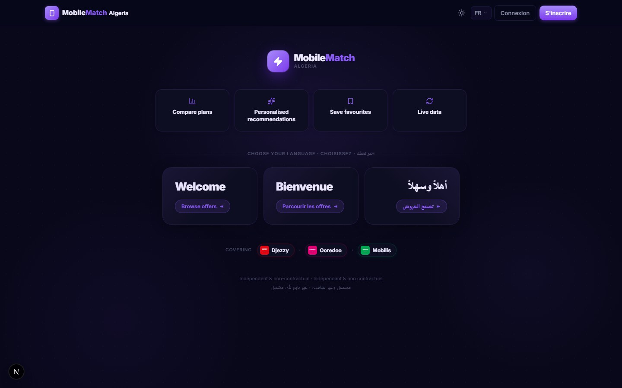
Figure 3.3. Home page of Mobile Match Algeria

Offers Page

The offers page (Figure 3.4) is the application’s main discovery surface. It renders a grid of offer cards using the shared OfferCard component, with staggered entrance animations. Operator filter tabs are rendered at the top of the page, and a collapsible advanced filter panel provides range sliders for maximum price and minimum data together with network generation toggles. When a user selects plans for comparison, a fixed-bottom sticky bar appears (Figure 3.5) dis-playing the selection count and a navigation button.

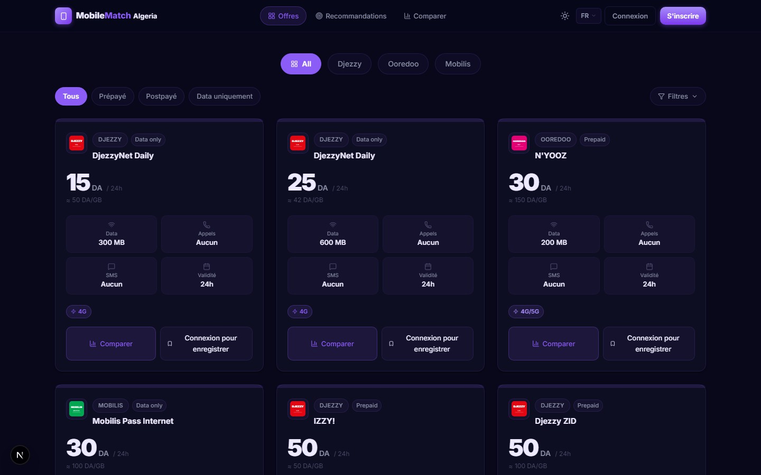
Figure 3.4. Offers page showing plan catalogue with operator filter tabs

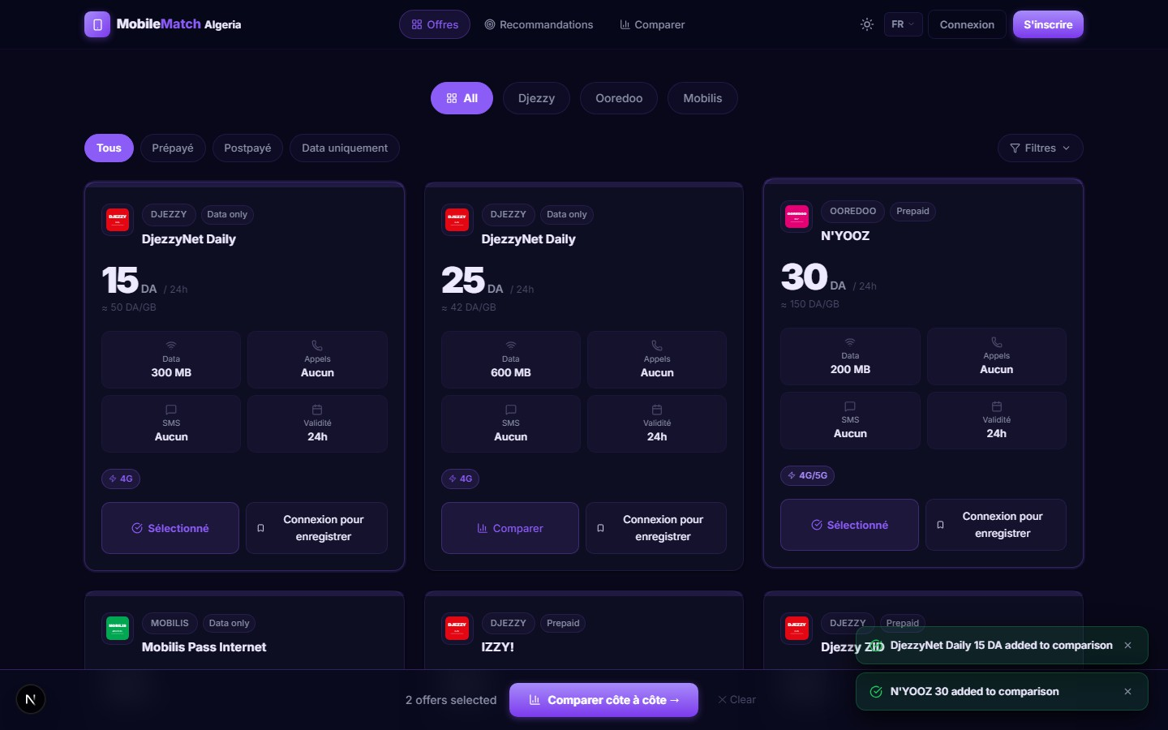
Figure 3.5. Sticky comparison bar — appears at the bottom when plans are selected

Comparison Page

The comparison page (Figure 3.6) reads the plan IDs from the URL query string and fetches the corresponding offers from the /api/offers?ids=... endpoint. It renders a structured side-

by-side table where the best value for each row is highlighted in the accent colour, accompanied by a radar chart built with the Recharts library covering five dimensions: price, data, voice, SMS, and validity.
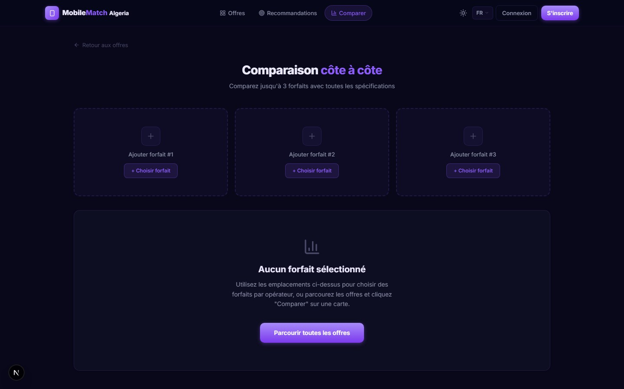
Figure 3.6. Side-by-side comparison page with radar chart visualisation

Recommendations Page

The recommendations page (Figure 3.7) presents a usage profile form with range sliders for budget, data, voice, and SMS, and toggle buttons for preferred plan type and network generation. On submission, the form sends a POST request to /api/recommendations and renders the top three scored plans with their composite scores and the specific match reasons.

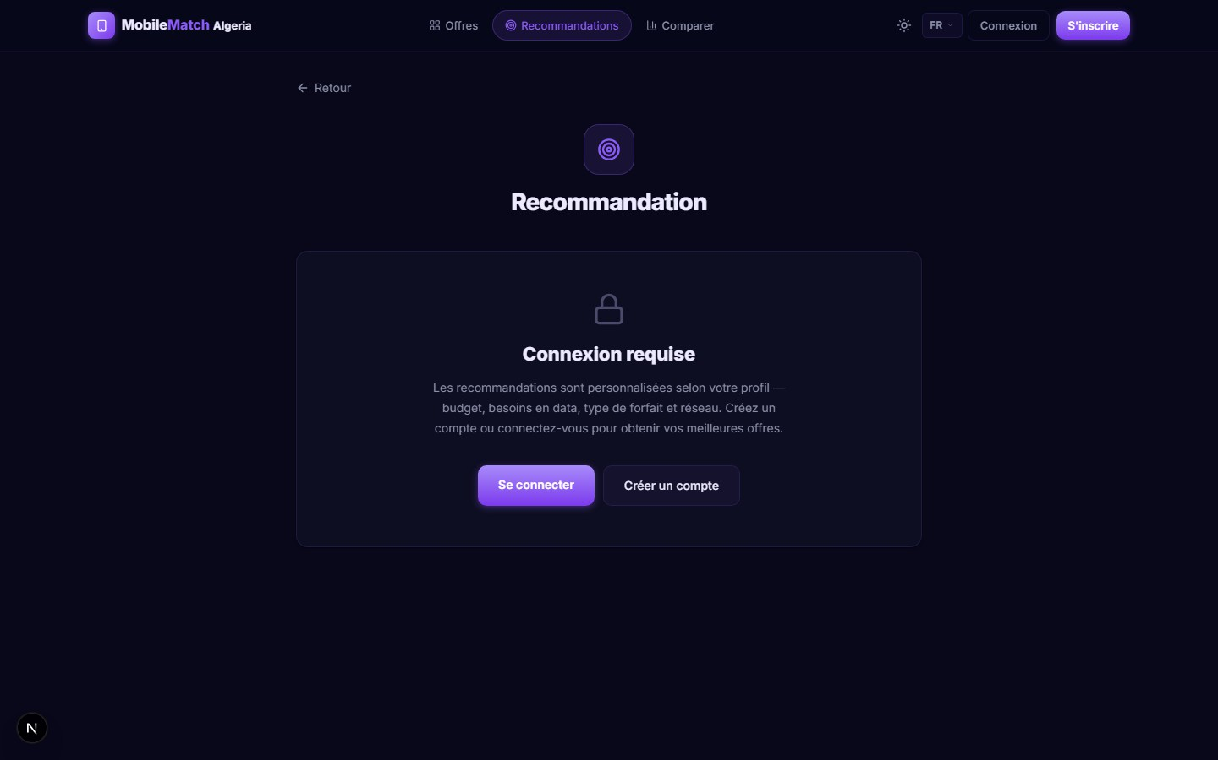
Figure 3.7. Recommendations page — form and personalised results

Login and Registration

Figure 3.8 shows the authentication screens. The login page accepts an email address and pass-word; the registration page adds a name field. Both forms perform client-side validation before submitting. Incorrect credentials trigger a non-destructive inline error message without reload-ing the page.

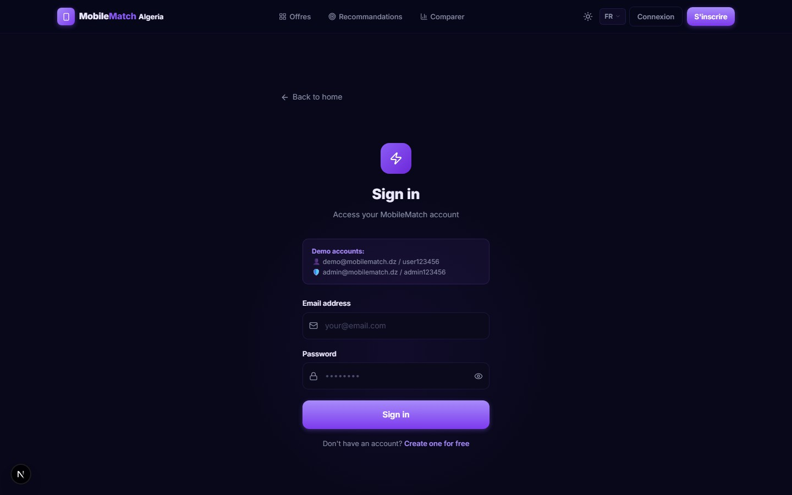
Figure 3.8. Login page

Admin Dashboard

The admin dashboard (Figure 3.9) is accessible only to users with the ADMIN role, verified server-side on every request. It presents four statistics cards (total offers, active offers, total users, scrape runs), operator scrape controls with a badge showing the last run’s status and timestamp, a paginated scrape log table, and a full offer management interface supporting creation, editing, and deletion of individual records.


Figure 3.9. Admin dashboard — statistics, scrape controls, and offer management

Security

Authentication and Session Management

User sessions are managed by NextAuth.js using signed JWT tokens. The secret key is stored in the NEXTAUTH_SECRET environment variable. Tokens have a 30-day maximum age and are renewed on each valid request.

Password Storage

Passwords are hashed using bcrypt with a cost factor of 12 before being written to the database. Plain-text passwords are never logged or stored. At sign-in, bcrypt.compare verifies the sup-plied password against the stored hash without reversing the hash.

Role-Based Access Control

Admin-only API routes check for the ADMIN role in the decoded session before executing any privileged operation. A missing or non-admin session returns 401 Unauthorized or 403 Forbidden respectively. This check is implemented at the application layer for every relevant route handler.

Input Validation and Injection Prevention

All numeric query parameters are parsed and range-checked before use. All database queries are issued through Prisma’s parameterised query interface, which prevents SQL injection by construction. No user-supplied string is ever interpolated directly into a query.

Deployment

The application is built for production with next build, which performs static analysis, tree-shaking, and route-level code splitting. The resulting artefact is a Node.js server launched with next start. Three environment variables must be set in the hosting environment: DATABASE_URL (path to the SQLite file), NEXTAUTH_SECRET (JWT signing key), and NEXTAUTH_URL (public base URL). The SQLite file is the only persistent artefact that must be preserved across deploy-ments.

Chapter Summary

This chapter has described the full implementation of Mobile Match Algeria: the development environment, the automated scraping pipeline and its partial-scrape guard, the REST API and its cross-operator comparison routing, the multi-criteria recommendation engine, the eight key user interface screens, the security architecture, and the deployment configuration. Chapter 4 evaluates these implementations against the project objectives and documents the known limi-tations.

Chapter 4

Evaluation and Documentation

This chapter evaluates the Mobile Match Algeria platform against the five objectives defined in the project subject fiche and documents the key deliverables produced during the project. Section 4.1 verifies the achievement of each objective. Section 4.2 presents an honest assessment of the current limitations of the system. Section 4.3 summarises the documentation produced.

Comparison with Objectives

Table 4.1 maps each of the five original project objectives to the implemented features and the evidence of achievement.
Table 4.1. Achievement of project objectives

Obj. | Description | Evidence
O1 | Develop a full-stack web application for  plan comparison and browsing | Offers page with filters, comparison page with  radar chart, offer detail pages, user accounts
O2 | Build an automated scraping module for real-time data collection | Three per-operator scrapers (Djezzy, Ooredoo, Mobilis) with cron scheduling, deactivation  logic, and ScrapeLog storage
O3 | Implement a personalised recommenda-tion engine | Multi-criteria scoring engine with eight dimen-sions; operator diversity mechanism; tested with  various user profiles
O4 | Integrate data visualisation tools | Radar chart on comparison page; statistics cards  on admin and home pages; scrape log tables
O5 | Implement a notification system | In-app notifications for new offers and scrape  events; mark-as-read and delete actions

All five objectives defined in the subject fiche have been fully implemented and are oper-ational in the running application. The following sections discuss the known limitations of the current version and the perspectives for future improvement.

Limitations

Despite the achievements listed above, four identifiable limitations should be acknowledged in the current version of Mobile Match Algeria.
The first limitation is the scalability ceiling of SQLite. SQLite is a single-file, server-less database that does not support concurrent writes. For the current single-server deployment and the anticipated user base, this is not a practical constraint. However, a migration to Post-greSQL would be required before the platform could support horizontal scaling or high write concurrency.
The second limitation is the fragility of web scrapers. The scraping module parses the DOM structure and CSS class names of operator websites, which can change at any time without notice. A change in an operator’s website layout would render the corresponding scraper non-functional until it is manually updated. The ScrapeLog failure notification system mitigates the operational impact but does not eliminate the maintenance burden.
The third limitation is the absence of multi-language scraping. The scraping module currently extracts data from French-language versions of operator pages. Offer names and fea-ture descriptions stored in the database may therefore contain French text even when the user selects the Arabic interface. A future version should normalise feature text across languages.
The fourth limitation is the absence of a real payment or affiliate integration. The platform currently links to operator websites for plan purchase but does not track conversions or provide an integrated purchase flow. This limits the platform’s potential for commercial sustainability through affiliate revenue.

Perspectives

Several improvements are planned for future versions of the platform. First, the database layer could be migrated from SQLite to PostgreSQL to enable multi-server deployment and higher write throughput. Second, the recommendation engine could be enhanced with collaborative filtering, using aggregated anonymised interaction data to surface plans that are popular among users with similar profiles. Third, the platform could be extended to cover fixed-line broadband offers, creating a comprehensive telecommunications comparison tool for Algerian consumers. Fourth, a public REST API could be opened to third parties, enabling other services to consume the normalised plan catalogue.

Documentation

User Guide

A user guide covering the five main user journeys was produced: browsing and filtering offers, comparing plans side by side, obtaining personalised recommendations, saving and managing saved plans, and managing account settings and notifications. The guide is structured around the application screens illustrated in Annexe D.

Administrator Manual

An administrator manual documents the admin dashboard workflows: triggering scrape runs, reading scrape logs, interpreting status indicators, creating and editing offers manually, and monitoring platform statistics. It also covers the environment variable configuration and the procedure for running the scraper in manual mode via the command line.

API Reference

A concise API reference lists each route, its HTTP methods, required authentication, accepted query parameters or request body fields, and example responses. This reference facilitates future development and potential integration with third-party clients.

Chapter Summary

This chapter has evaluated Mobile Match Algeria against the five project objectives defined in the subject fiche. All five objectives were fully achieved. The limitations identified — SQLite scalability, scraper fragility, single-language scraping, and the absence of an affiliate integra-tion — provide a clear roadmap for the improvements outlined in the general conclusion that follows.

General Conclusion and Perspectives

Recall of Problem and Objectives

This work set out to address a concrete gap in the Algerian digital services landscape: the ab-sence of a neutral, real-time platform that allows consumers to compare mobile plans across all three national operators. Algerian users wishing to find the plan best suited to their needs are cur-rently required to navigate three separate operator websites, manually reconcile heterogeneous formats, and make decisions based on information that may be outdated. The five objectives established at the outset of this project — a full-stack web application, an automated scraping module, a personalised recommendation engine, integrated data visualisation, and a notification system — were designed collectively to eliminate this gap.

Summary of Contributions

The work produced the following concrete contributions. First, a functional and publicly acces-sible web application built on Next.js 16 that serves a live catalogue of over 100 mobile plans from Mobilis, Djezzy, and Ooredoo, with advanced filtering, side-by-side comparison, a radar chart, and a usage profile form. Second, a modular automated scraping pipeline that collects, normalises, and synchronises offer data from the three operator websites on a daily schedule, with a partial-scrape guard to prevent data loss during partial failures. Third, a multi-criteria recommendation engine that scores plans against a user’s declared budget and usage profile with a 100-point composite score distributed across seven dimensions. Fourth, a complete ad-min dashboard that gives administrators visibility into platform health, scrape history, and offer management. Fifth, an in-app notification system that alerts registered users to new offers and personalised recommendations after each scrape run.
All five project objectives defined in the subject fiche were fully implemented. The run-ning application demonstrates that each objective — web application, scraping module, recom-mendation engine, data visualisation, and notification system — has been realised end-to-end.

Limitations

We acknowledge four limitations in the current version of the platform. The SQLite database is sufficient for the current single-server deployment but would need to be replaced with a client-server database engine (such as PostgreSQL) before the platform could scale to high traffic. The web scraping module is inherently fragile: any change to the structure of an operator’s website will break the corresponding scraper until it is manually repaired. Feature descriptions in the database are currently extracted in French, which creates a language inconsistency when the Arabic interface is active. Finally, the platform has no integrated purchase flow or affiliate tracking, which limits its commercial viability.

Perspectives

Several directions for future development present themselves naturally. In the short term, mi-grating from SQLite to PostgreSQL and deploying on a managed cloud host would signifi-cantly improve the reliability and scalability of the platform. Adding automated tests for the scraper normalisation logic and monitoring alerts for scraper failures would reduce the main-tenance burden. In the medium term, the comparison scope could be extended to fixed-line internet plans and bundled home-mobile offers, which represent a growing segment of the Algerian market. Support for Arabic-language offer names and features, extracted directly from the Arabic-language pages of operator websites, would make the platform fully acces-sible to Arabic-speaking users. In the longer term, replacing the rule-based scoring model with a machine-learning model trained on user interaction data — saved plans, comparison choices, click-through behaviour — would yield more personalised and accurate recommendations as the user base grows. The platform’s scraping and normalisation infrastructure could also be ex-posed as a public REST API, enabling third-party developers to build applications on top of the aggregated data and creating an ecosystem around the platform.

Mobile Match Algeria demonstrates that a well-designed, open-source web platform can meaningfully improve access to consumer information in a market where such tools have previ-ously been absent. We hope that this work serves as both a useful resource for Algerian mobile users and a practical foundation for the extensions outlined above.

Bibliographic References

ARPCE. (2024). Rapport annuel sur le marché des télécommunications en algérie (Consulted March 2025). Autorité de Régulation de la Poste et des Communications Électroniques. https://www.arpce.dz
Géron, A. (2022). Hands-on machine learning with scikit-learn, keras, and tensorflow (3rd ed.).
O’Reilly Media.
GSMA Intelligence. (2024). The mobile economy: Middle east and north africa 2024 (Consulted February 2025). GSM Association. https : / / www .gsma.com/ solutions - and- impact/ connectivity-for-good/mobile-economy/mena/
MeilleurMobile. (2024). Comparateur de forfaits mobiles [Consulted January 2025]. https : / / www.meilleurmobile.com
Mitchell, R. (2018). Web scraping with python: Collecting more data from the modern web
(2nd ed.). O’Reilly Media.
Prisma. (2024). Prisma documentation: Getting started [Consulted March 2025]. https://www. prisma.io/docs
Statista. (2024). Algeria: Number of mobile subscribers 2018–2024 [Consulted February 2025]. https://www.statista.com
Vercel. (2024). Next.js documentation: App router [Consulted March 2025]. https://nextjs.org/ docs

Appendix A

UML Diagrams

This annexe contains the full set of UML diagrams produced during the analysis and design phase of the project. The diagrams presented in the main body of the mémoire (Chapter 2) are condensed versions intended to fit within the page layout; the diagrams here show the complete models.

Figure B.1 — Complete use case diagram including all actors, all use cases, and all include and
extend relationships.

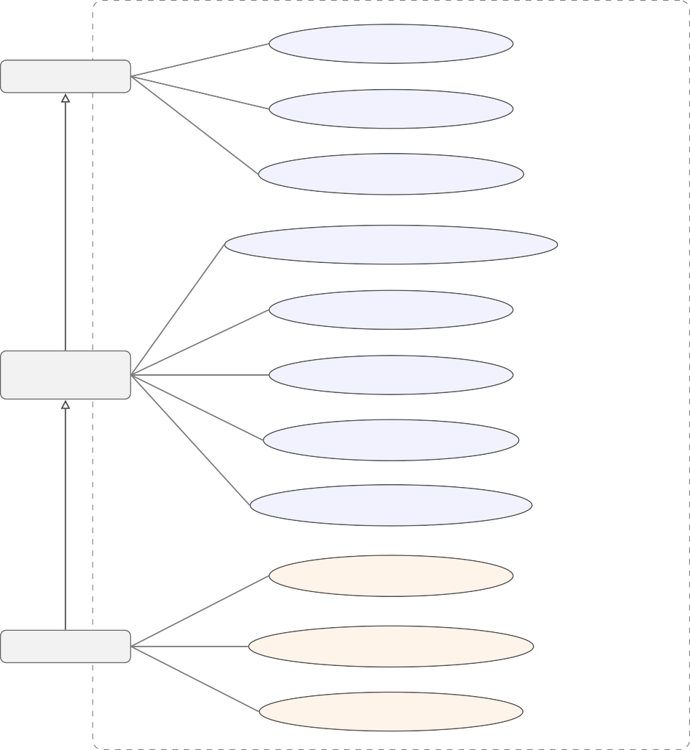
Mobile Match Algeria — System Boundary
Browse & Filter Offers
Visitor
View Offer Details
Compare Plans (radar chart)
extends
Get Personalised Recommendations
Save / Unsave a Plan
Registered
User
View Saved Plans
Manage Account & Profile
extends
View & Manage Notifications
Trigger Scrape Run
Administrator
View Scrape Logs & Statistics
Create / Edit / Delete Offers
Figure A.1. Complete use case diagram — actor generalisation and all use cases

Figure B.2 — Class diagram showing all model classes, their attributes, and their associations.

Offer
id: String (PK) name, slug, type, network priceDA, dataGB, voiceMin
smsCount, validityDays
isActive: Boolean
1..N
SavedOffer
id: String (PK) userId (FK) offerId (FK)
savedAt: DateTime

Figure A.2. Class diagram of the Mobile Match Algeria data model
1..N
1..N
1..N
1..1
id: String (PK) userId (FK) title, message isRead: Boolean
createdAt: DateTime
Notification
id: String (PK) operatorId (FK) status, duration
offersFound/Added/Updated errorMessage, createdAt
ScrapeLog
id: String (PK) name, slug, primaryColor
website: String
Operator
id: String (PK)
userId (FK, unique) 1..N monthlyBudget, dataUsageGB
voiceMinutes, smsCount preferredType, preferredNet
UserProfile
id: String (PK) name, email (unique) passwordHash, role createdAt, updatedAt
User

Figure B.3 — Sequence diagram for the user registration and login flow.

Browser
NextAuth API
Database
Register POST /api/auth/register {name, email, password}
Check email uniqueness
Not found — OK
Hash password (bcrypt, cost=12)

INSERT User (name, email, passwordHash)
201 Created — redirect to /login

Login POST /api/auth/signin {email, password}
SELECT User WHERE email=?
User record + passwordHash
bcrypt.compare(password, hash)
Sign JWT (role, id, secret)

200 OK + Set-Cookie: session JWT

Redirect to /offers

Figure A.3. Sequence diagram — user registration and login flow

Appendix B

Data Model Summary

The data model is defined in prisma/schema.prisma using the Prisma schema language. It consists of seven entities whose primary fields and relations are summarised in Table B.1. The full schema file is available in the project repository.
Table B.1. Prisma schema entities and primary fields

Entity | Key fields | Relations
User | id, name, email, role, passwordHash, createdAt | SavedOffer, Notifica-  tion, UserProfile
UserProfile | id, userId, monthlyBudget, dataUsageGB,  voiceMinutes, preferredType | User
Offer | id, operator, name, type, priceDA, dataGB,  voiceMinutes, validityDays, isActive | SavedOffer
SavedOffer | id, userId, offerId, savedAt | User, Offer
Notification | id, userId, title, message, type, isRead, createdAt | User
ScrapeLog | id, operatorId, status, offersFound, offersAdded,  startedAt | Operator
Operator | id, name, slug, logoUrl, websiteUrl, primary-  Color | Offer, ScrapeLog

Appendix C Application Screenshots
This annexe provides full-page screenshots of all main application screens. Screenshots were captured from the running application at a 1440 × 900 viewport.

— Home Page

Figure C.1. Home page — statistics, quick-access cards, and navigation

— Offers Page

Figure C.2. Offers page — offer grid with operator filter tabs

— Comparison Page

Figure C.3. Comparison page — side-by-side attribute table and radar chart

— Recommendations Page

Figure C.4. Recommendations page — usage profile sliders and scored plan results

— Login and Registration

Figure C.5. Login page

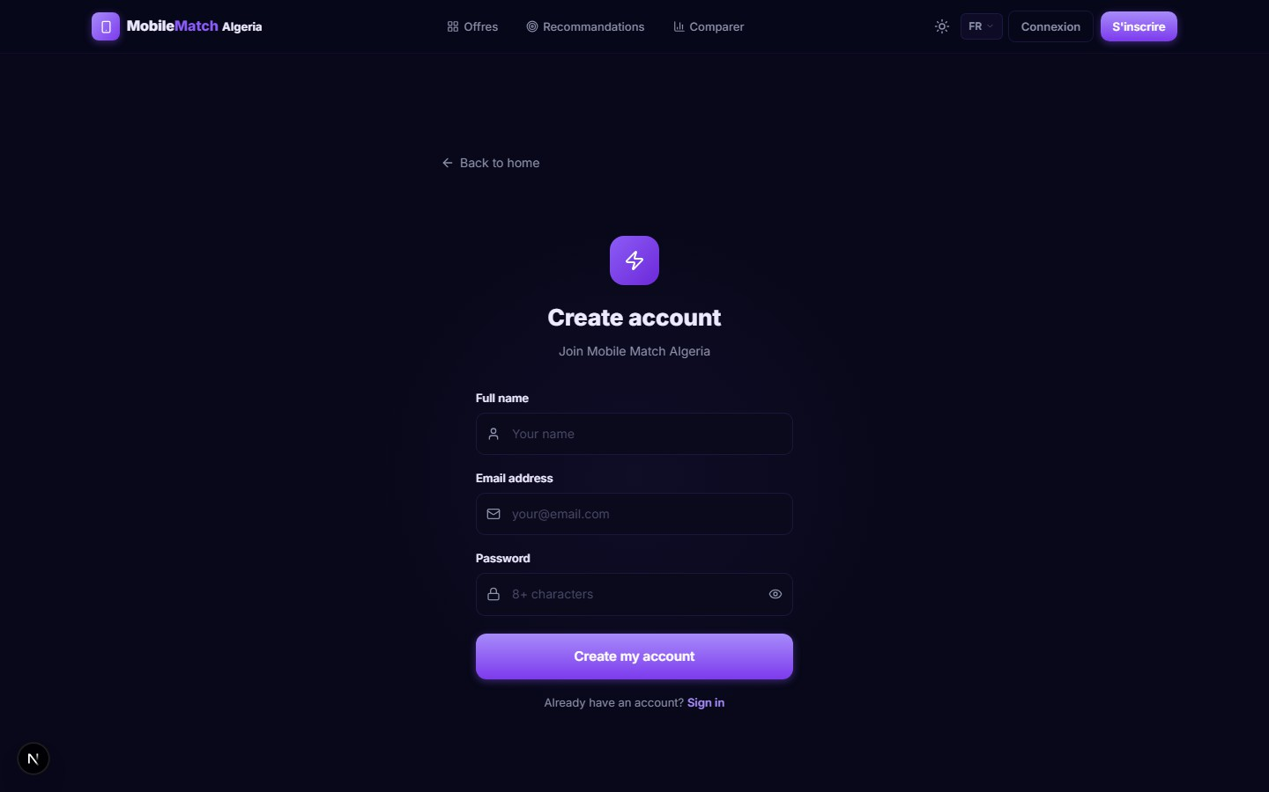
Figure C.6. Registration page

— Offer Detail and Filtered Catalogue
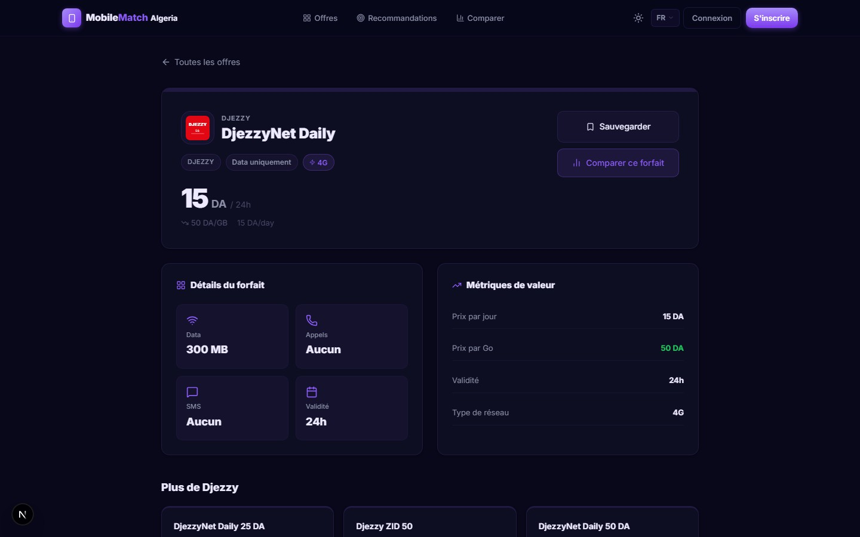
Figure C.7. Offer detail page — full plan specifications and save action

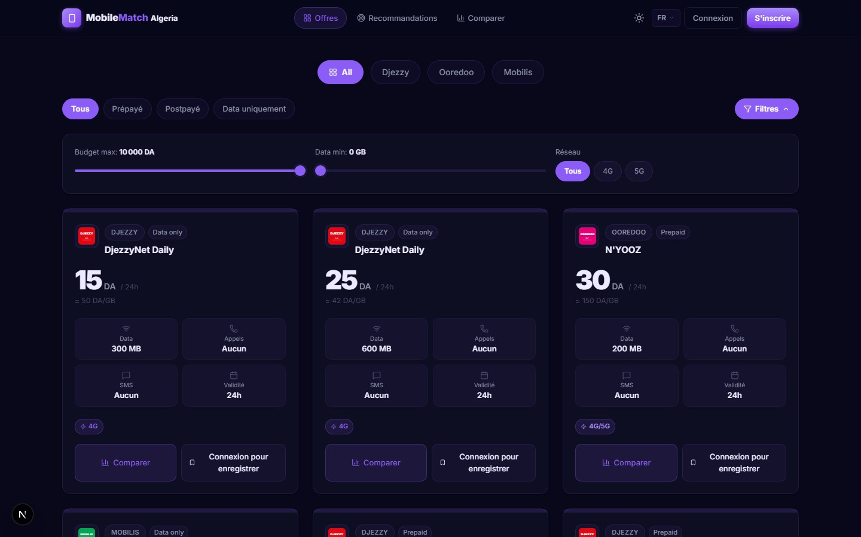
Figure C.8. Offers page with advanced filters applied — operator, price range, and data volume

— Admin Dashboard

Figure C.9. Admin dashboard — scrape controls, logs, and offer management

