Home Page URL: <http://localhost:8080/CustomerRelationshipManagement/customer/list>

1. While There is no DATA in DB.

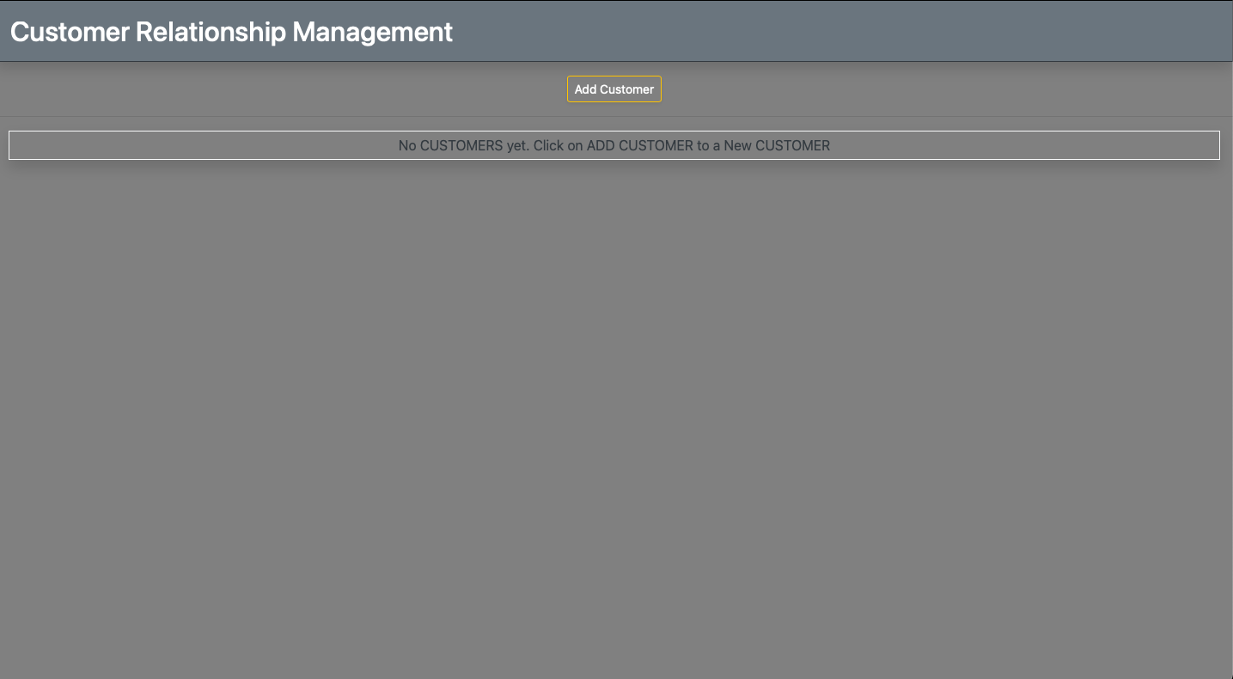

1. Adding Customer details-(RIAJUDDIN).

URL: <http://localhost:8080/CustomerRelationshipManagement/customer/showFormForAdd>

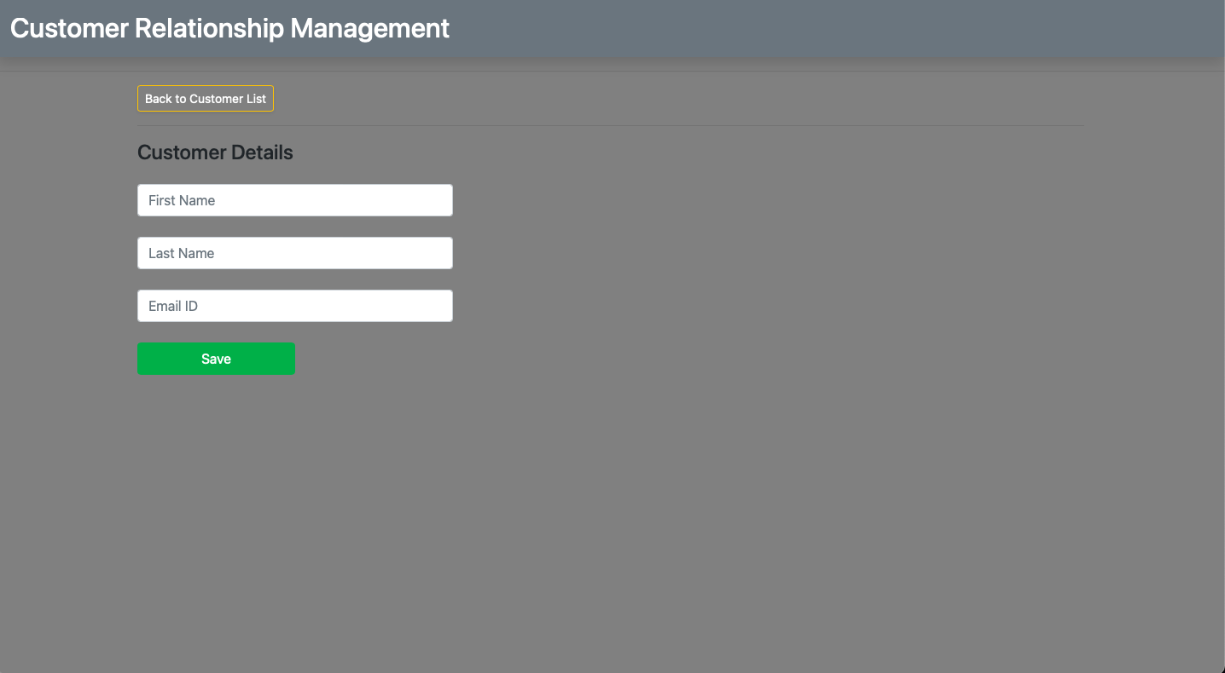

1. After adding Customer details- RIAJUDDIN

<http://localhost:8080/CustomerRelationshipManagement/customer/list>

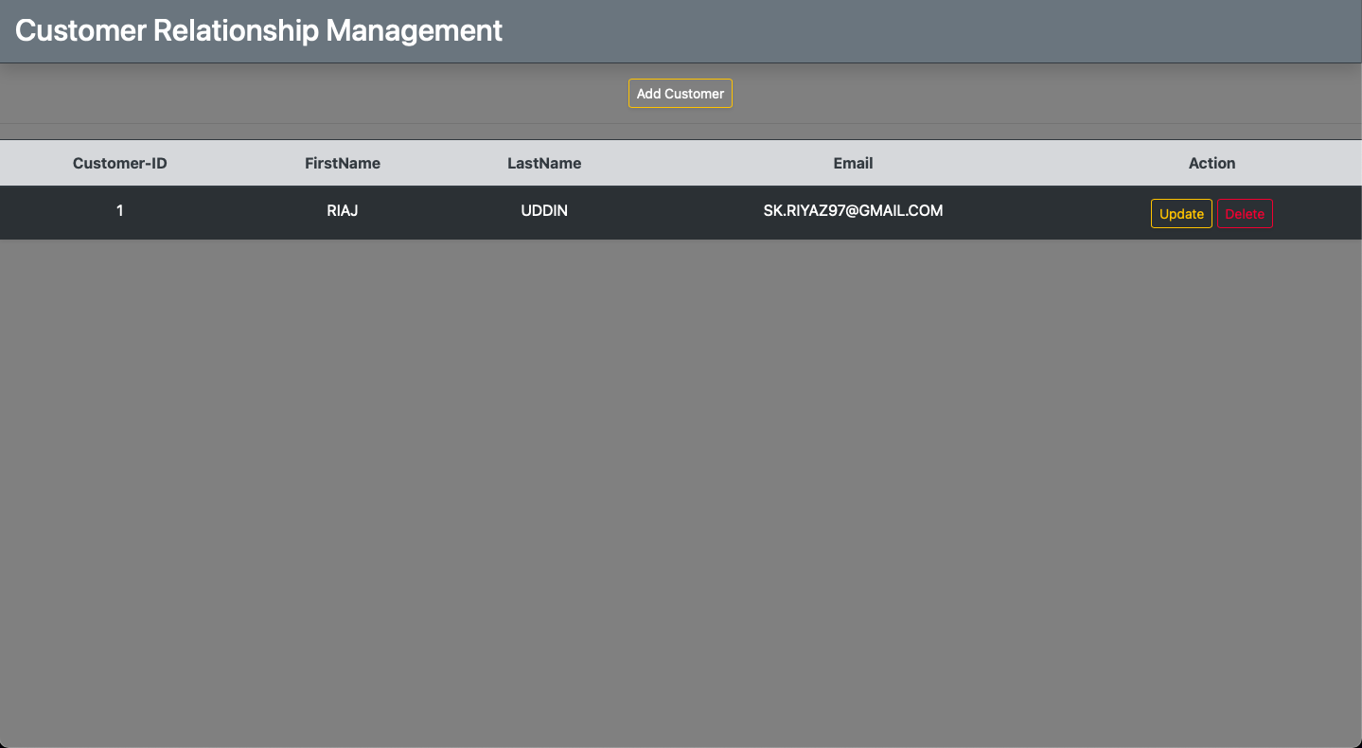

1. DB Screenshot after adding RIAJUDDIN

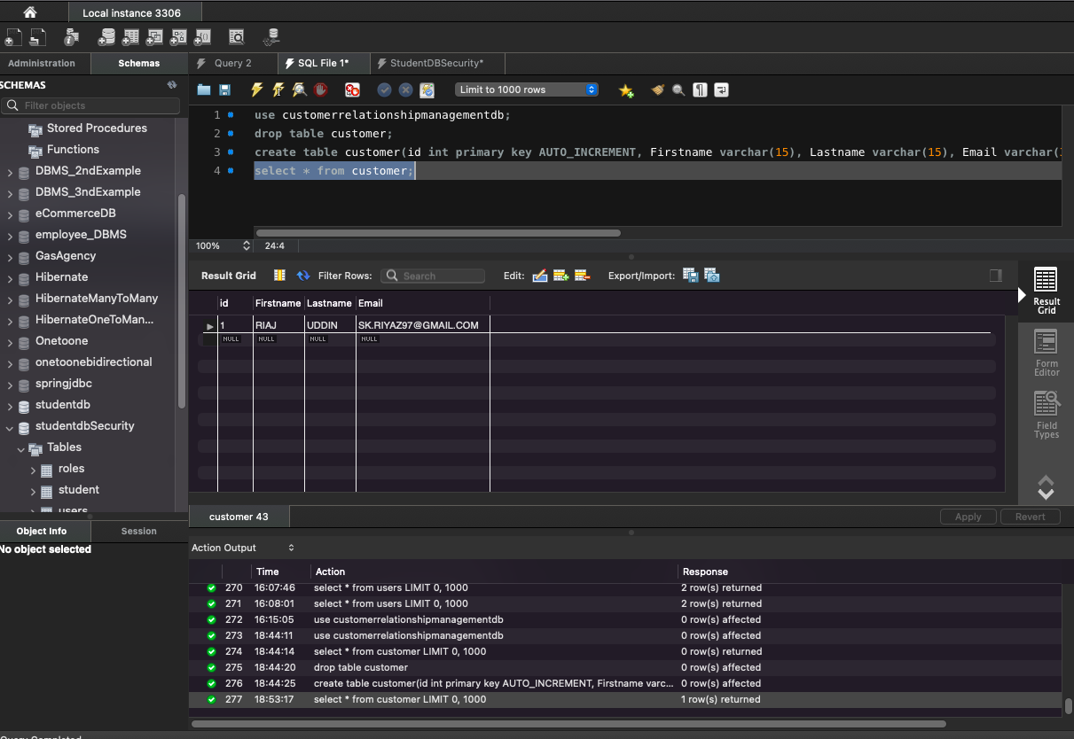

1. Updating Customer details- RIAJ to RIAJUDDIN, Email From [SK.RIYAZ97@GMAIL.COM](mailto:SK.RIYAZ97@GMAIL.COM) TO SK.RIYAZ97@GL.COM

http://localhost:8080/CustomerRelationshipManagement/customer/showFormForUpdate?customerId=1

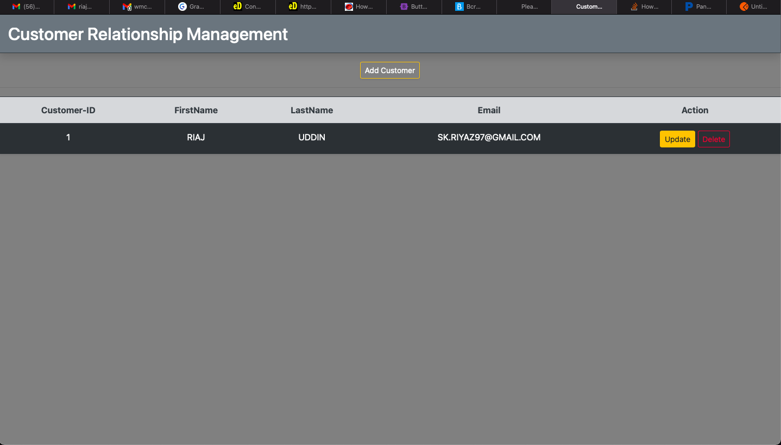

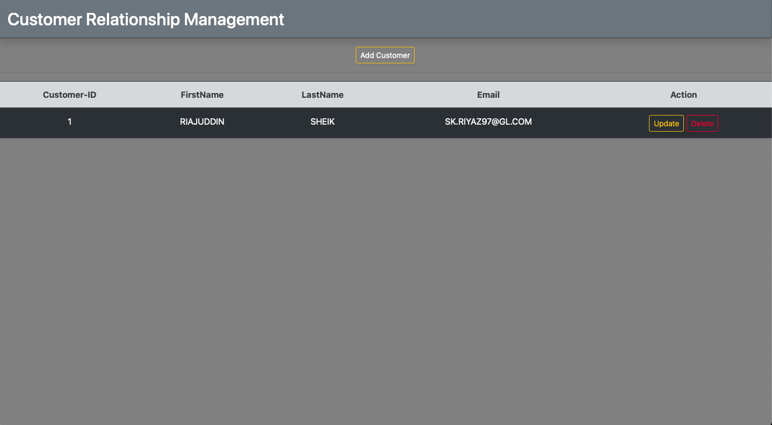

1. Deleting Customer details- RIAJ

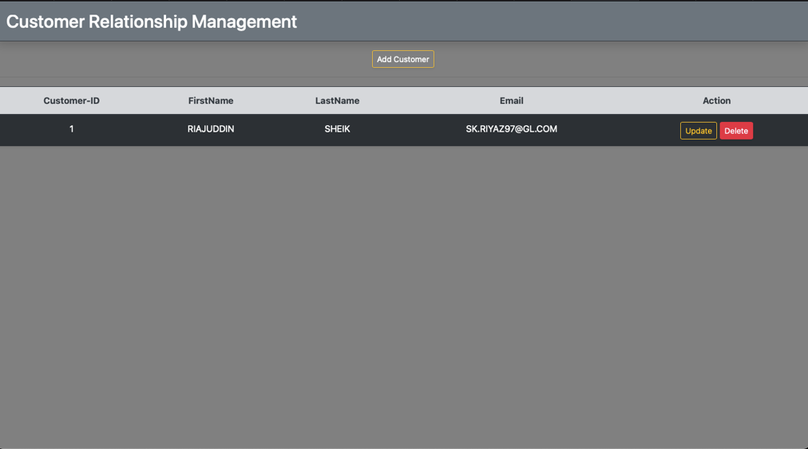

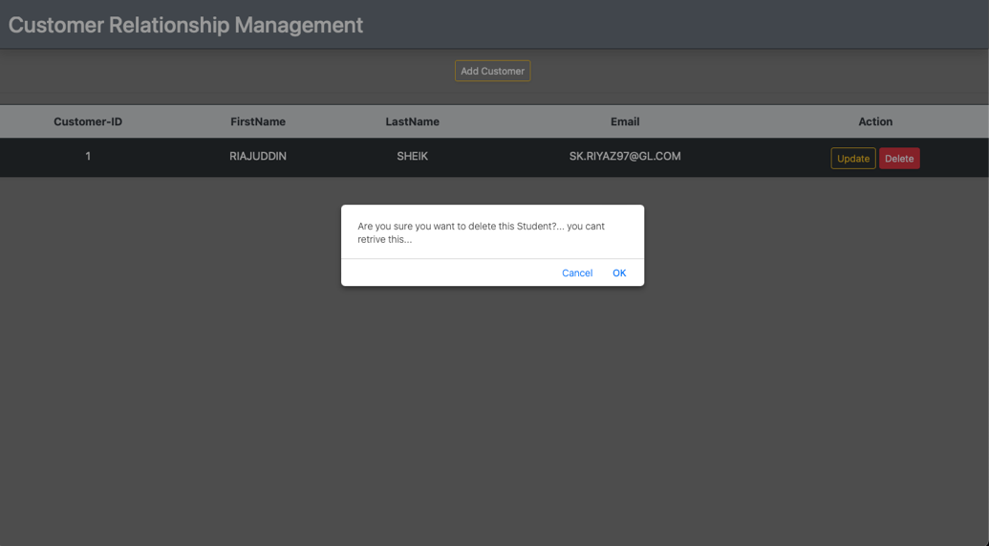

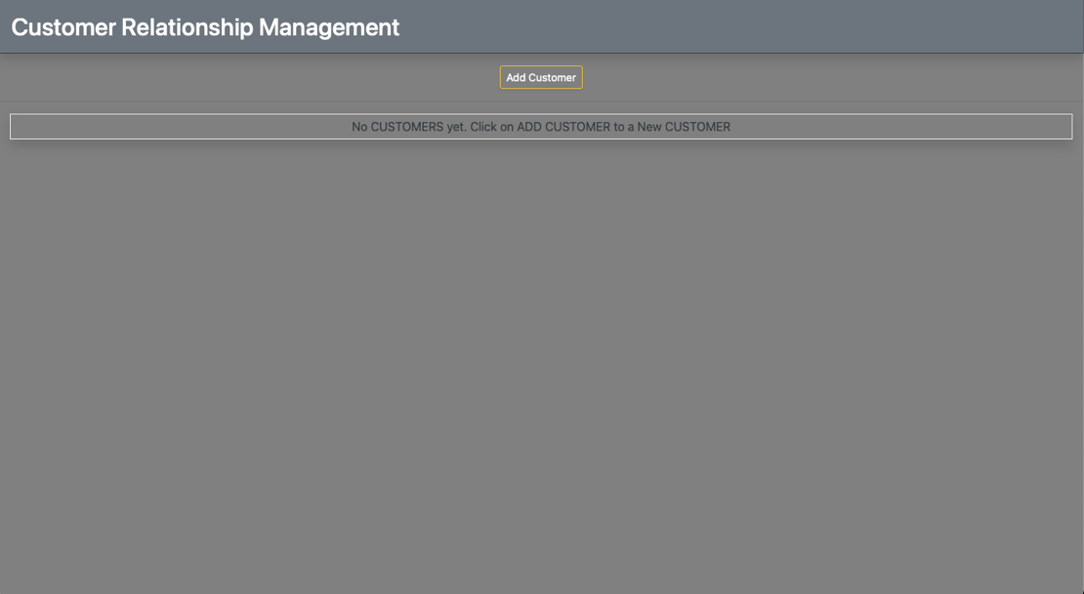

1. Adding a new Customer details from DB- (SEKHAR)

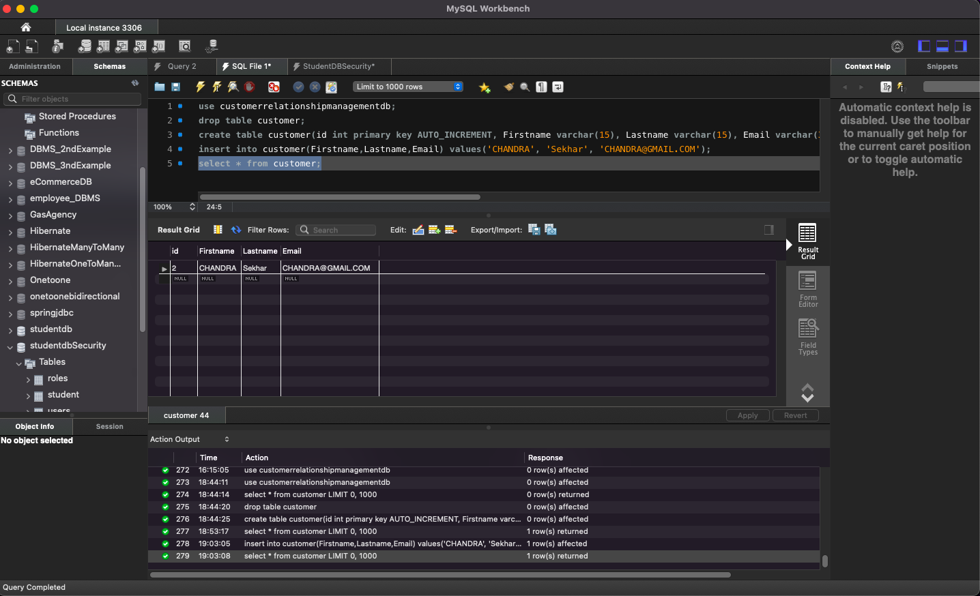

URL after adding customer from DB: <http://localhost:8080/CustomerRelationshipManagement/customer/list>

