

CSE471: System Analysis and Design
Project Report
Project Title: AcademiX

Group No: 3
CSE471 Lab Section: 9
Fall 2024
ID | Name
24141253 | Ahmed Riasat
22101215 | Mustafina Joarder

Submission Date: 13/05/2025

Table of Contents

1. System Request 3
Business need: 3
Business requirements: 3
Business value: 3
Special issues or constraints: 3
2. Functional Requirements 4
3. Technology (Framework, Languages) 4
4. Backend Development 5
5. User Interface Design 11
6. Frontend Development 14
7. User Manual 18
8. Performance and Network Analysis 24
9. Github Repo [Public] Link 27
10. Link of Deployed Project 28
11. Individual Contribution 28
12. References 28

System Request

Business need: Colleges and universities increasingly require digital tools to streamline academic activities. Managing quizzes, assignments, and tracking student progress regardless if it is conducted online or offline - remains a major challenge without a centralized platform. Here we propose “AcademiX” as a solution for this problem.

Business requirements: These are the features that the system must provide:
- Account management:
  - Account creation based on role (Admin, Teacher, Student)
  - Profile and password management
  - Admin control over other users

- Dashboard
  - Custom dashboard based on role
  - Role based view and access from dashboard

- Course management
  - Admin can create courses and assign teachers in that course
  - Amin and teacher can create and control assignment
  - Student can enroll in courses and attend assignment and quizzes
  - Score tracking

Business value: This system will be beneficial for both teacher and students. It will be a centralized platform for keeping track of assignments and quizzes. There will be no need to visit several platforms for different courses. Everything will be under one platform. There will be no last moment searching of quiz questions and assignment questions before exams. It will support both online and offline works.

Special issues or constraints:
- Role based access and view
- Offline quizzes can also be handles
- Score tracking
- Submission of pdf and docs

2. Functional Requirements
- Users can register with a username, valid email, password and role
- User can do successful login logout
- Password and profile can be updated

Admin can control other user’s profile
- Admin can create course and assign teacher
- Admin and Teacher can create assignments and quizzes
- Students can enroll in courses
- Score can be tracked
- Student can view their submitted works

3. Technology (Framework, Languages)
- Backend Language - Golang
- Backend framework - Gin
- Frontend Language - Typescript
- Frontend Library - React
- Frontend Framework - Next js
- Database - PostgreSQL

4. Backend Development
- academix/course ->this route fetches all the course available
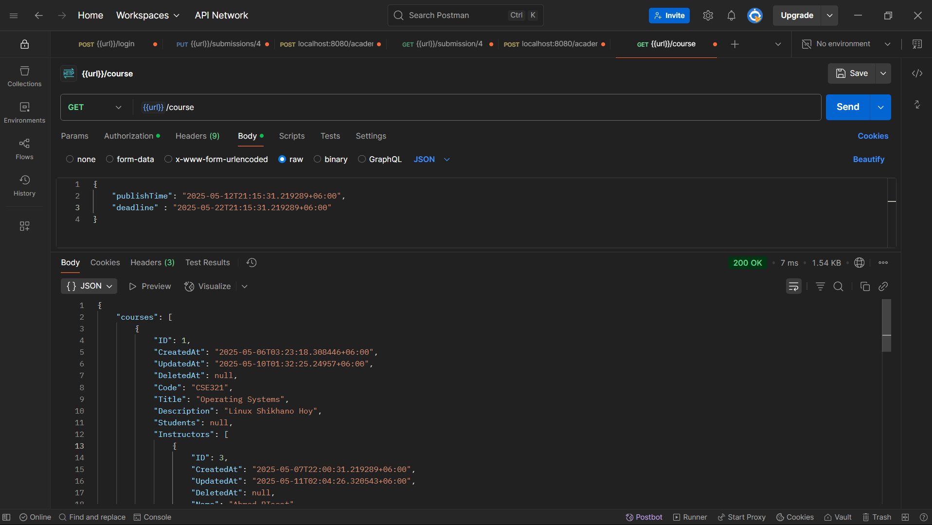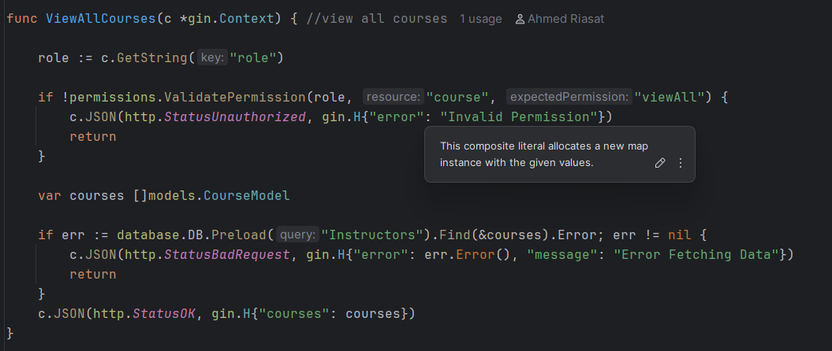
2.academix/own-course -> this route fetches the courses a student is enrolled in or a teacher teaching the course (in this screenshot it’s teacher’s view)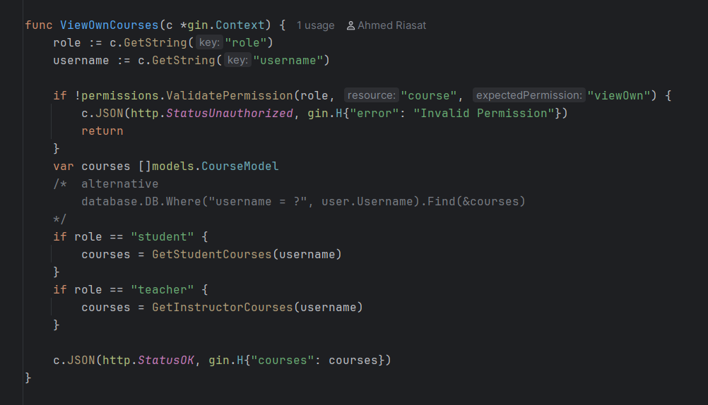
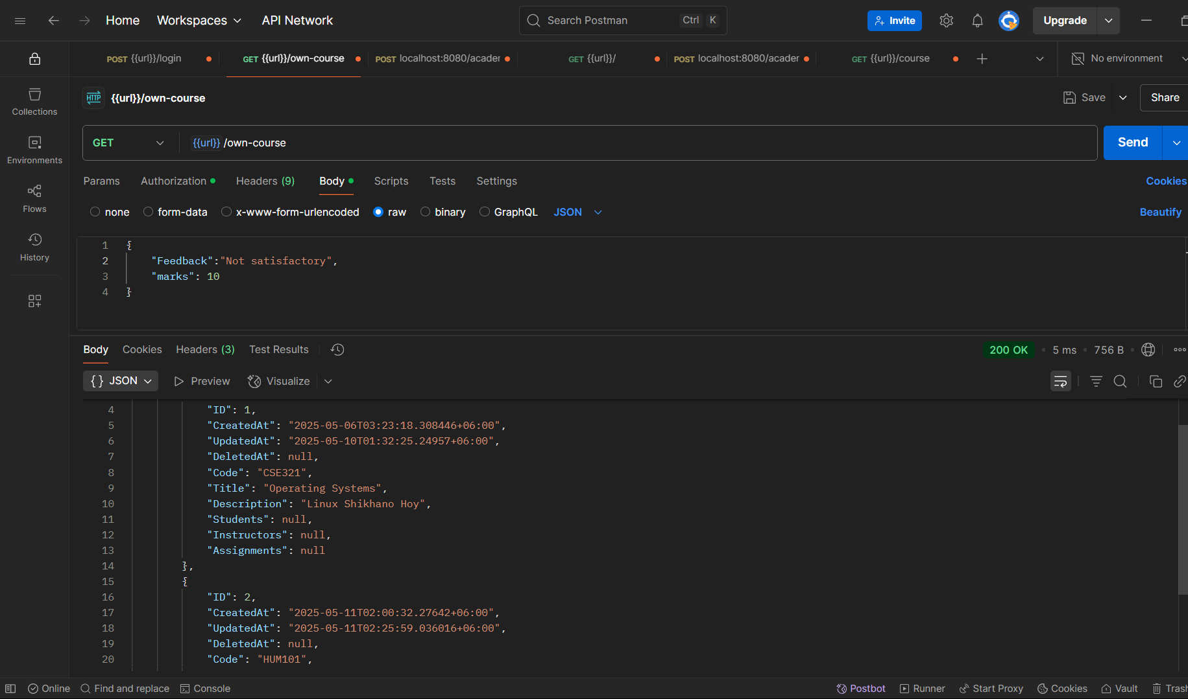

3. /:courseCode/assignments/:assignment_id -> here we get an particular assignment(in this view it was being updated)

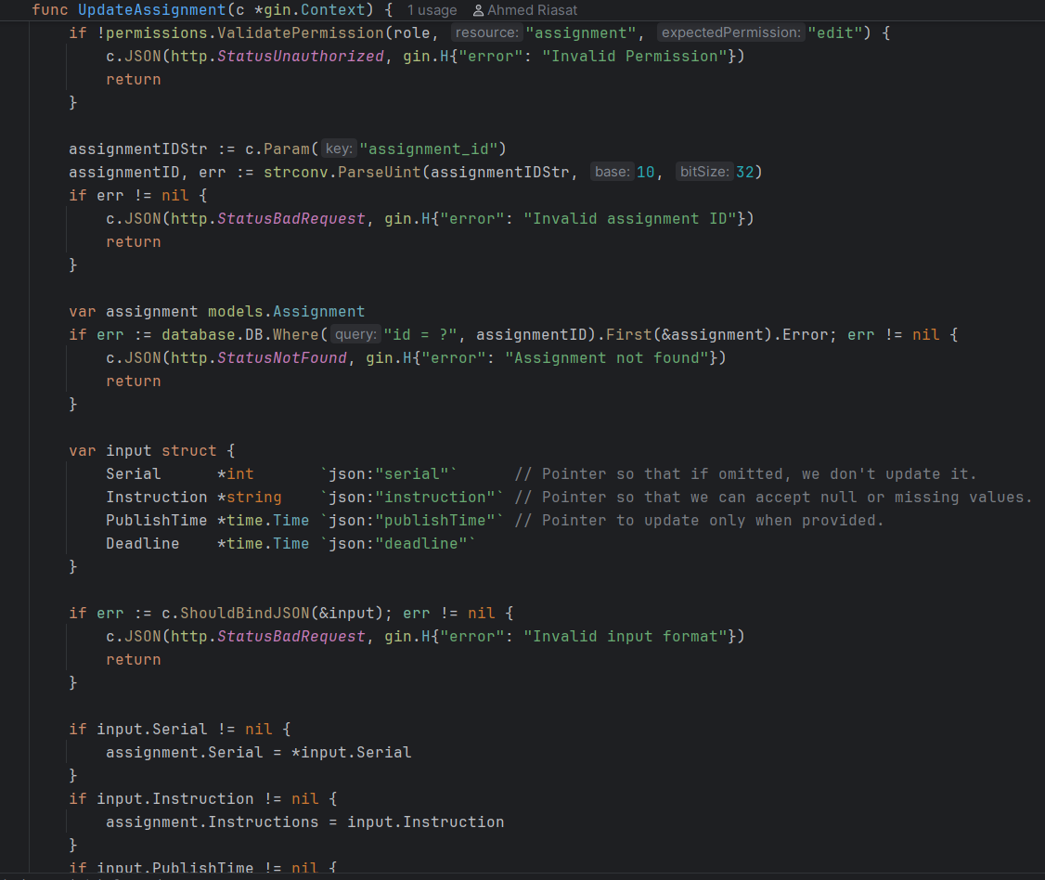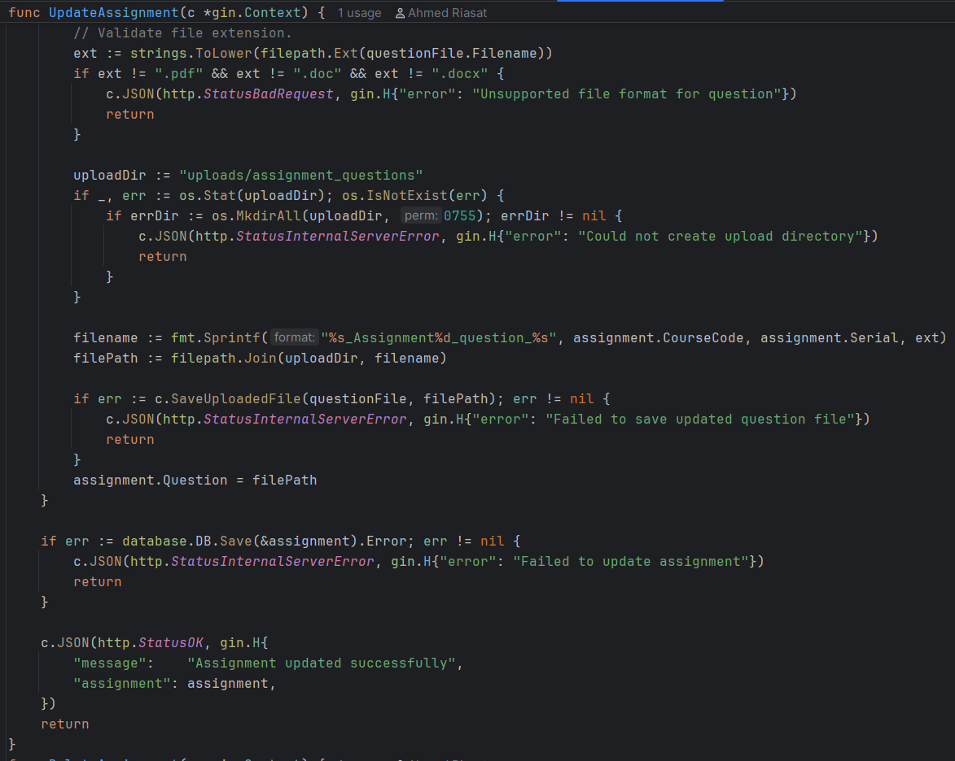

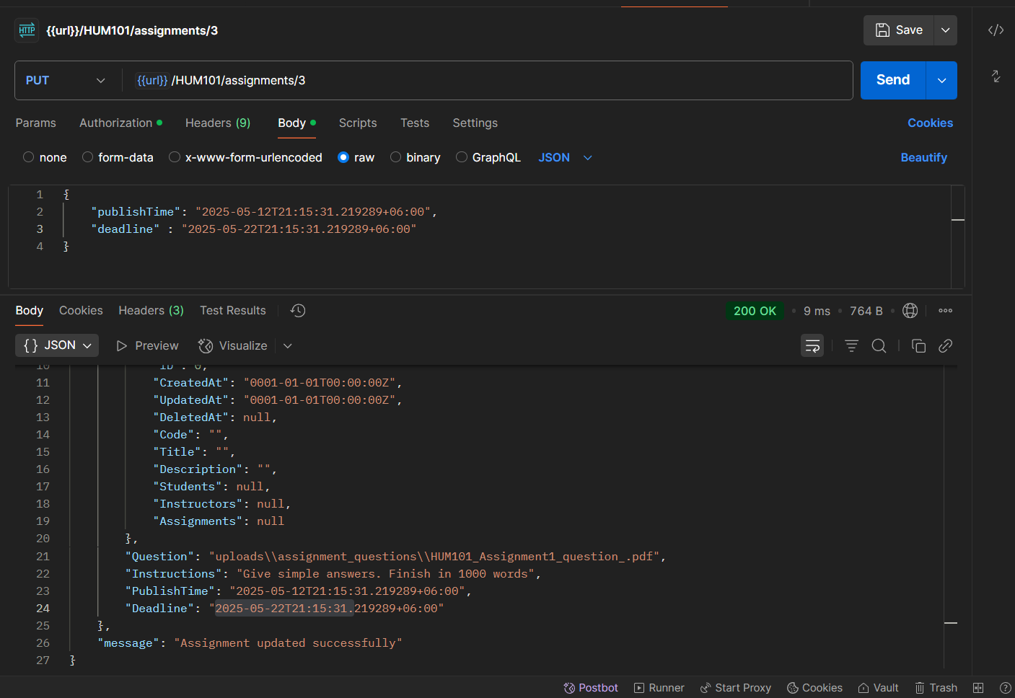

4./admin/student-list -> fetches the studentlist (only for admin view)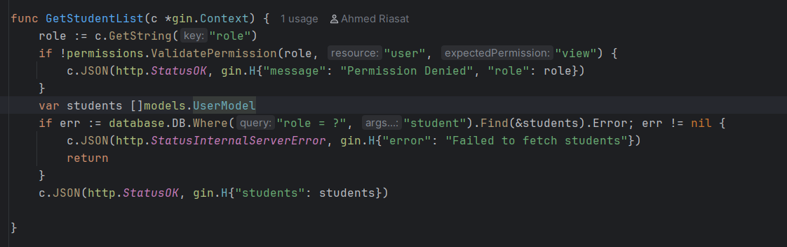
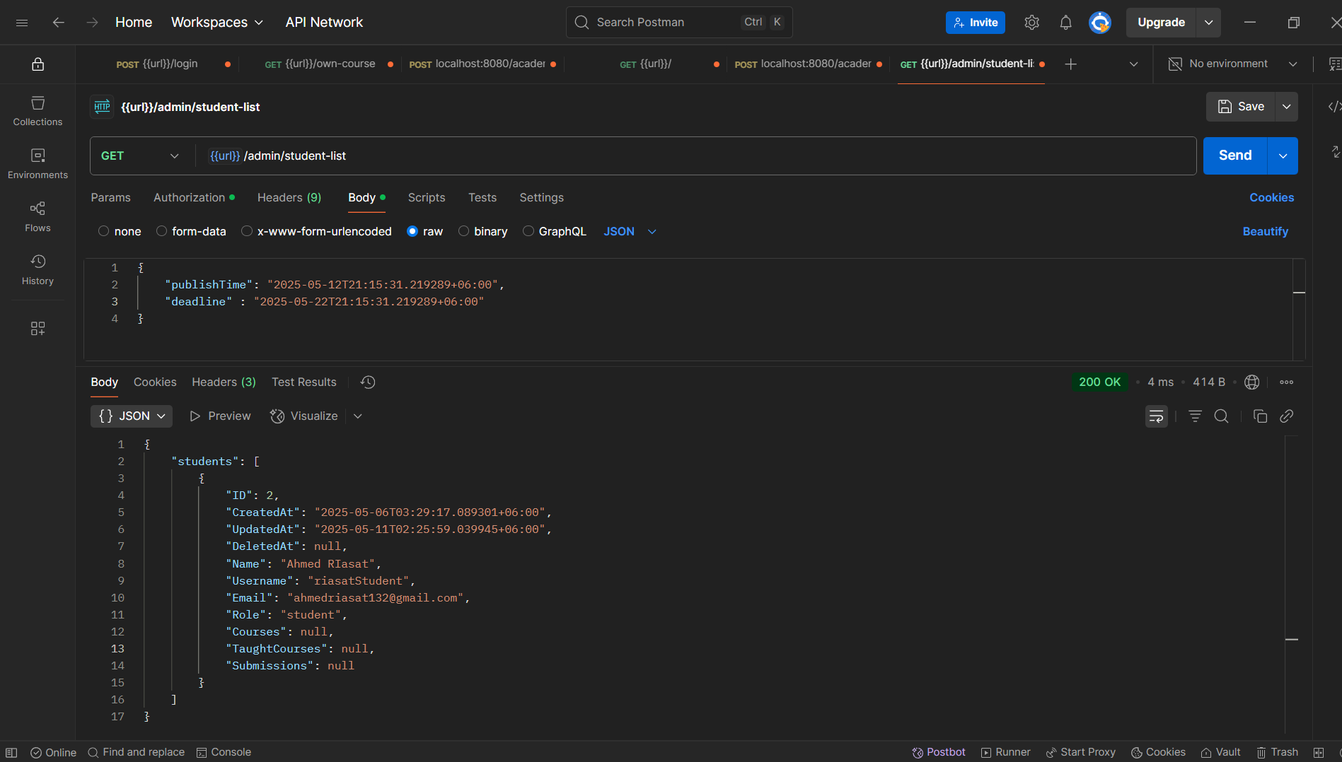

5./submissions/:submission_id -> student receives his received marks and feedback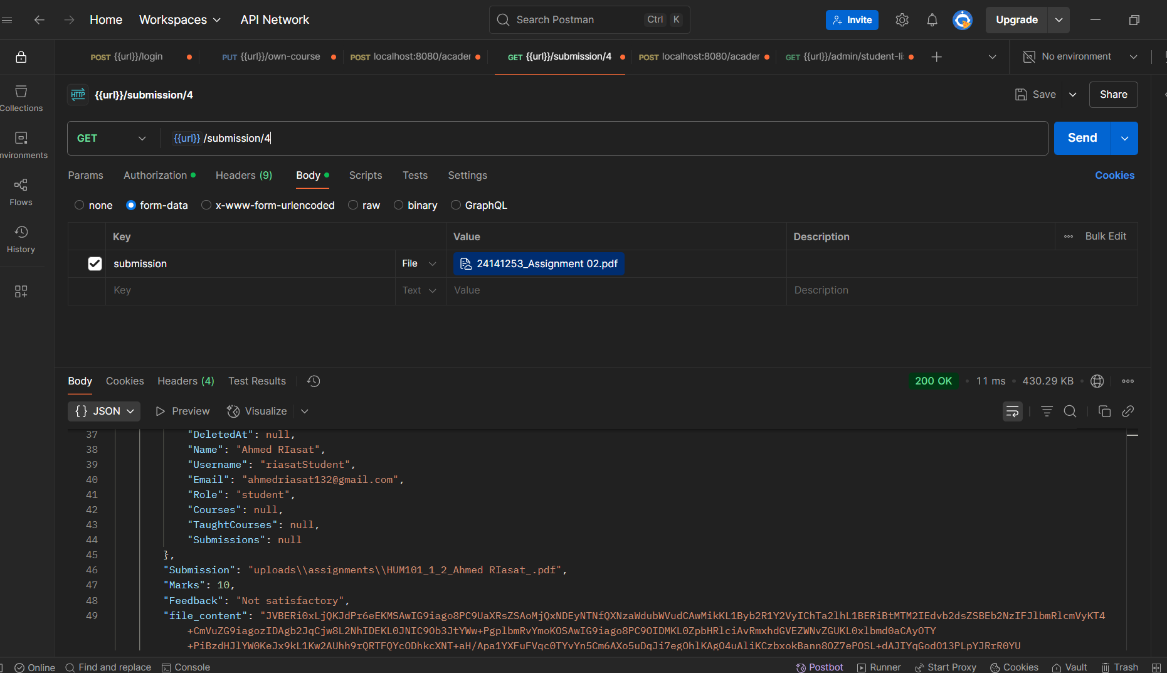
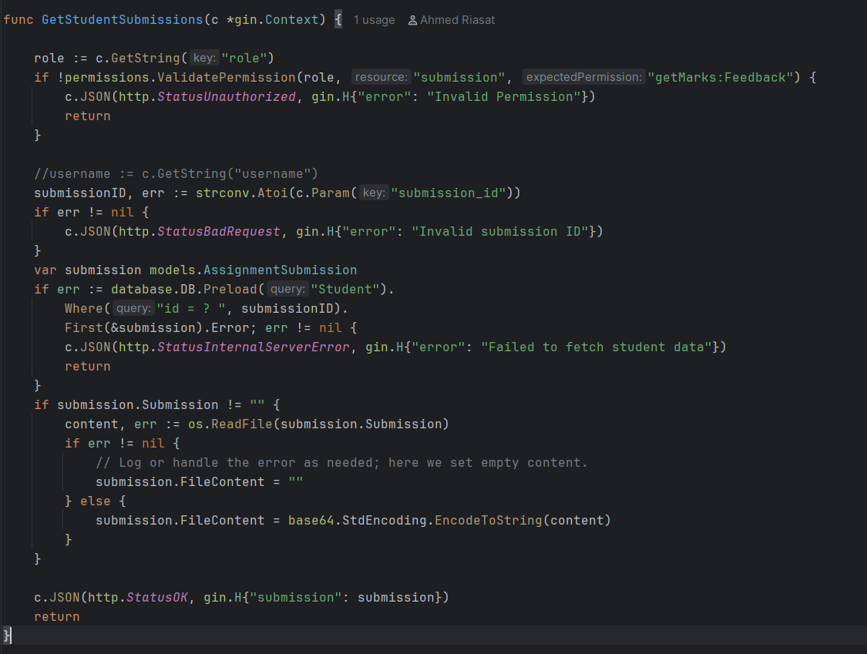

5. User Interface Design
ProjectLink : https://www.figma.com/design/ckABt25cTC58QMxoGrHTxG/Untitled?node-id=0-1&t=34yyaqH1avLgIdYX-1

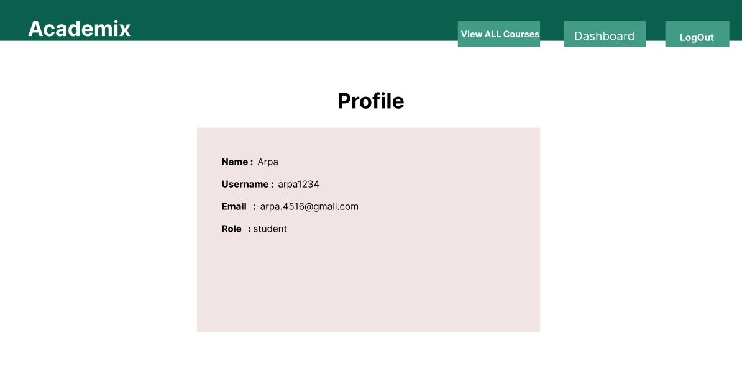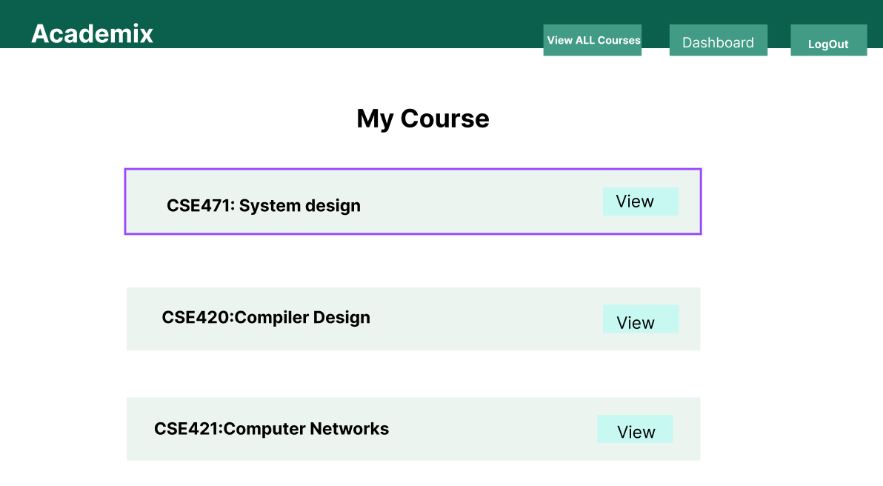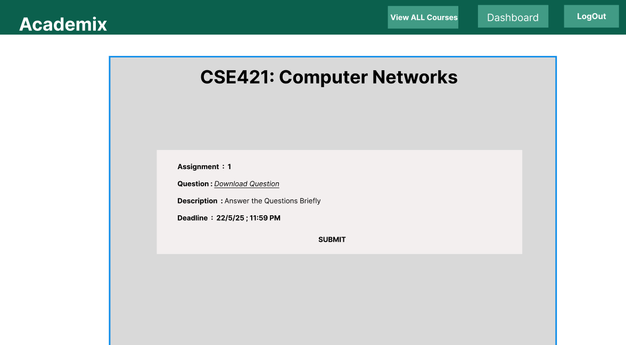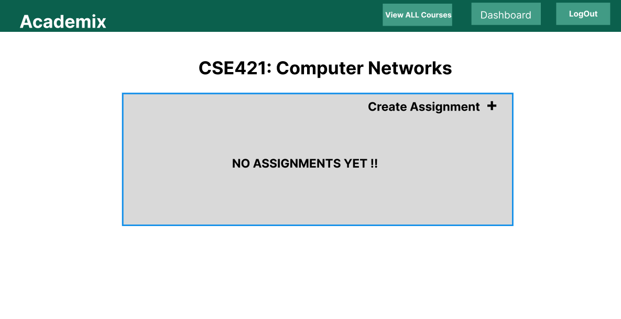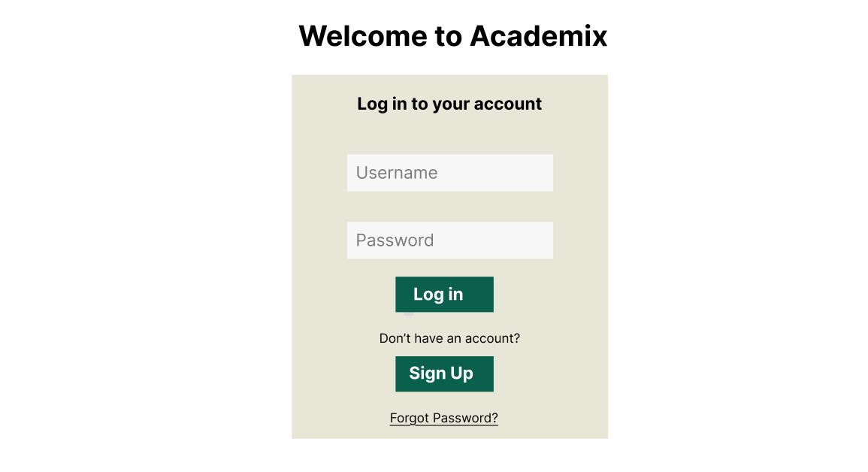

6. Frontend Development
1.Handling login with token

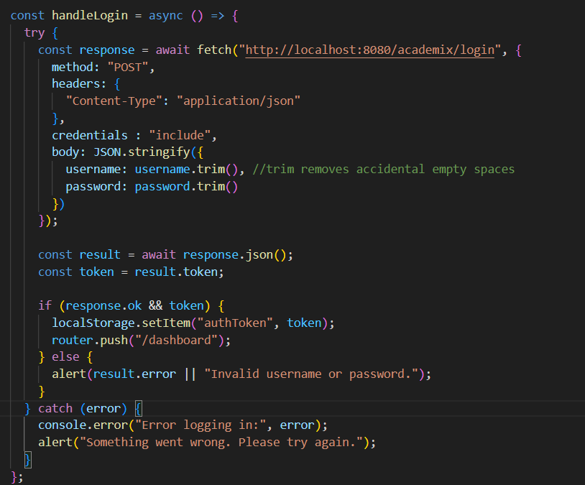
2. Updating email address on profile page
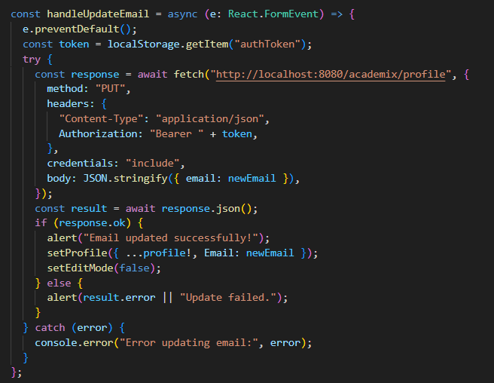

3. Student can enroll in a course
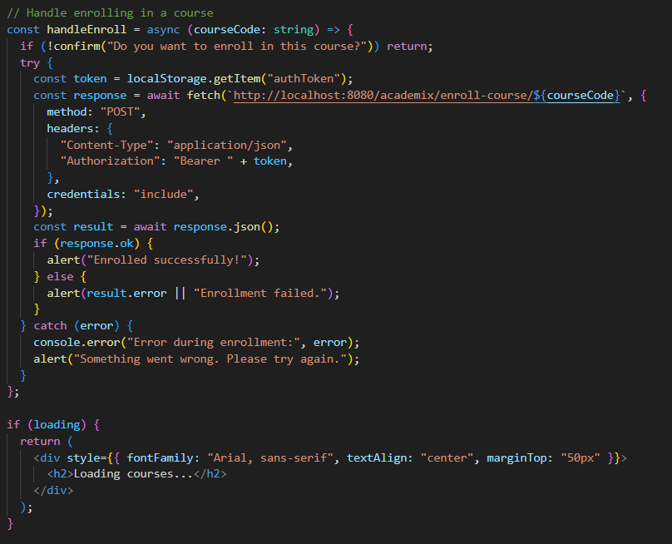

4. Teacher can create an assignment
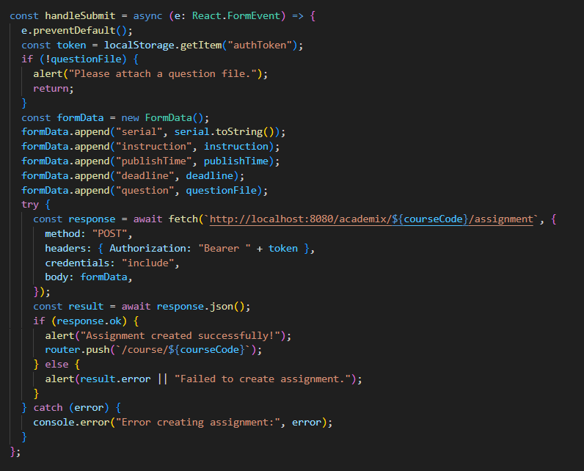
5. Viewing student list as an admin
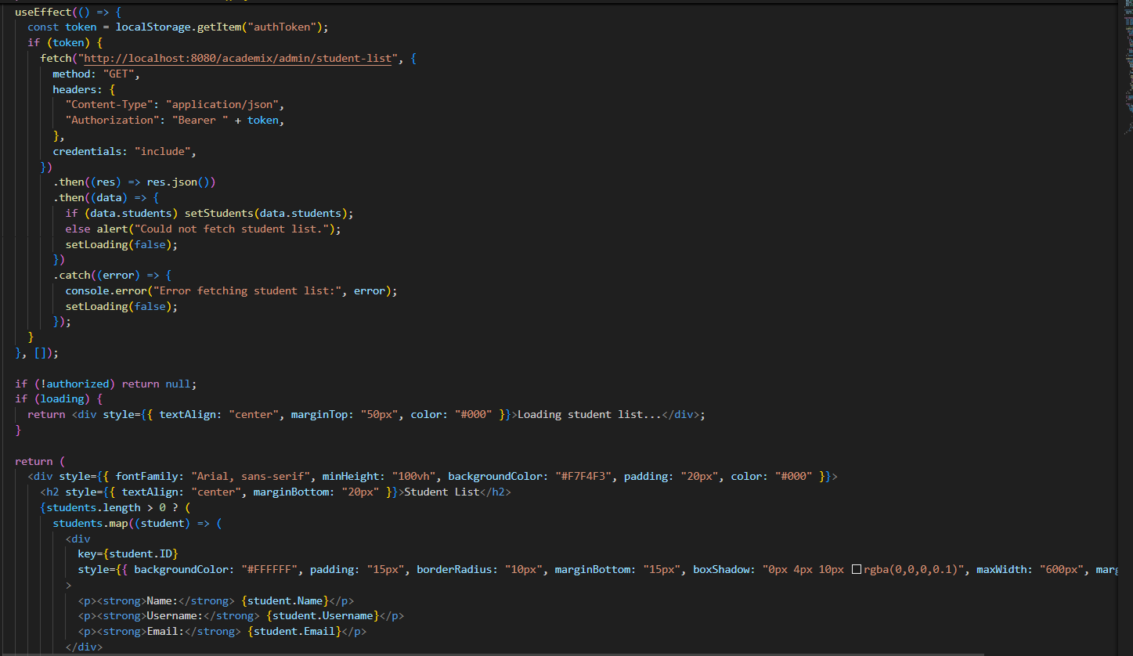

7. User Manual
1. Landing page of the website
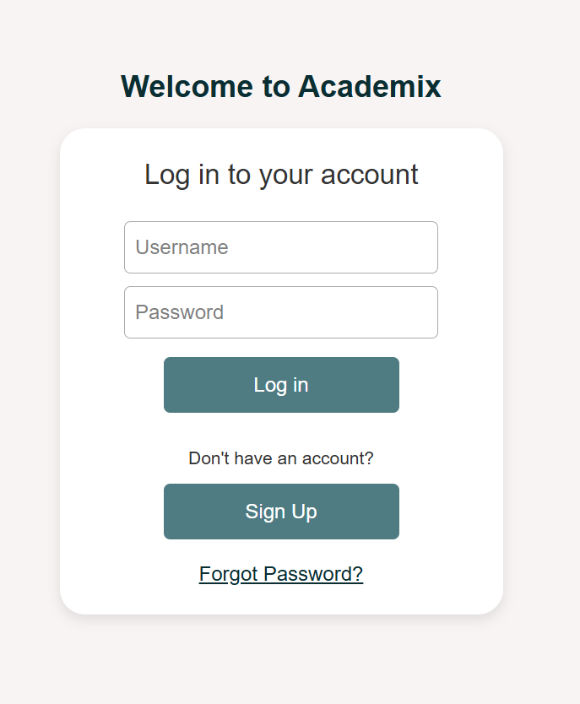

2. After successful login, the student will view this page where he can see the courses he is currently enrolled in. The “View All Courses” button shows the student courses created by admin and he can enroll in them from here.
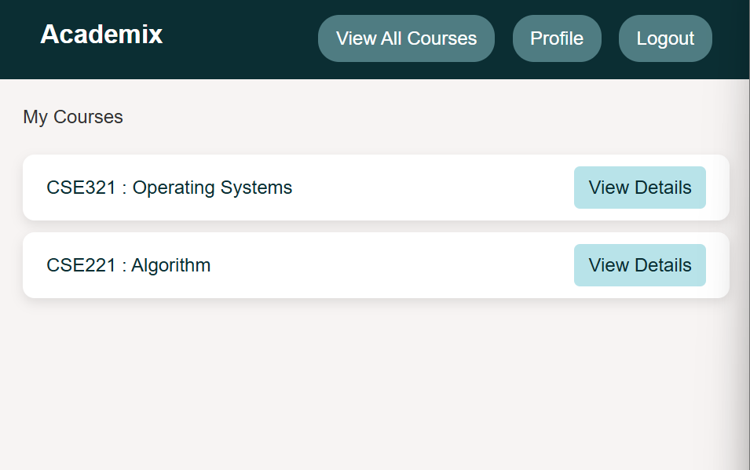

3. Clicking “View Details” takes the student inside the course and he can see the assignments created by teacher and also can submit the assignment.
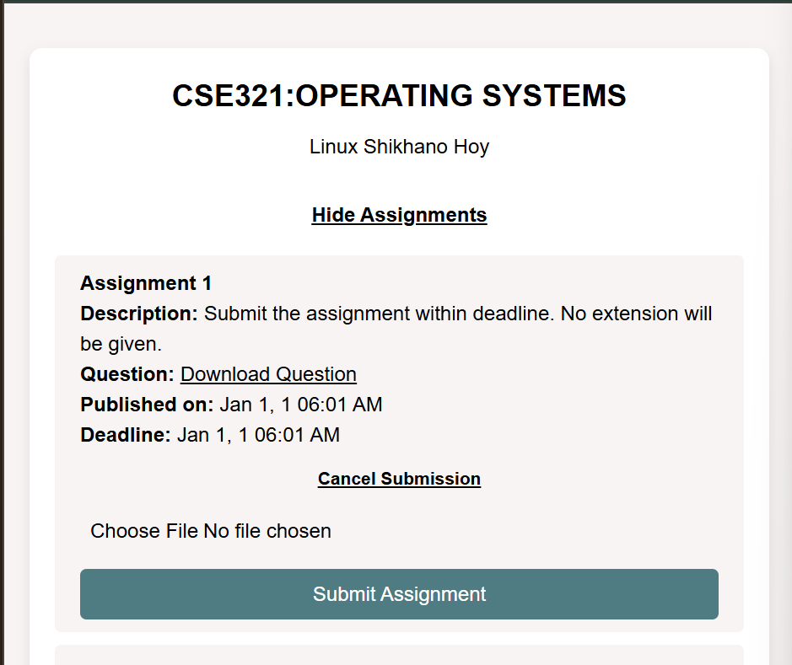
4. If the logged in user is a Teacher, he will see this page inside a course.
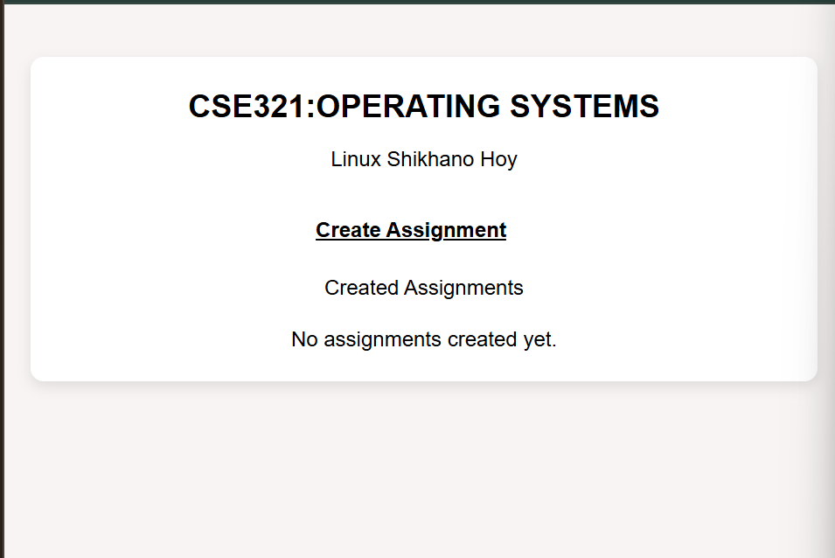

5. Tecaher can create a course
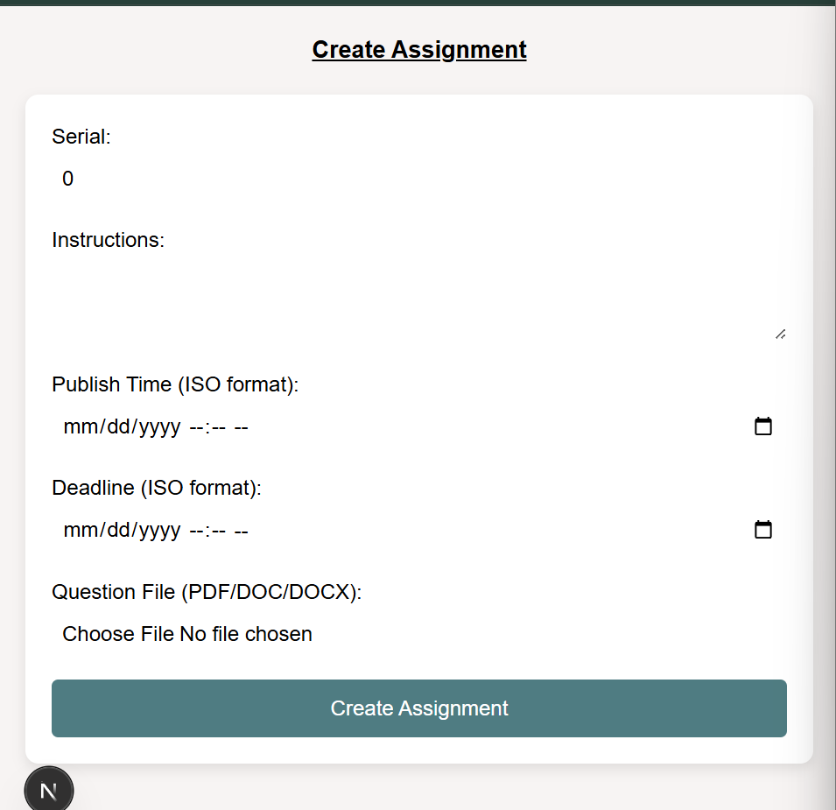

6. If the user is an Admin, he will see this page upon login.
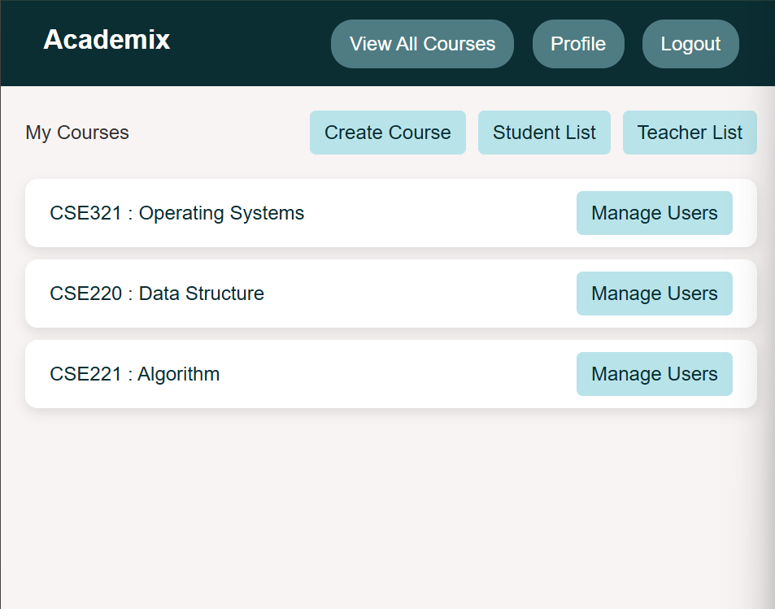
By clicking “Create Course” he can create a course, Student list and teacher list shows the teachers and students of this page.

8. Performance and Network Analysis
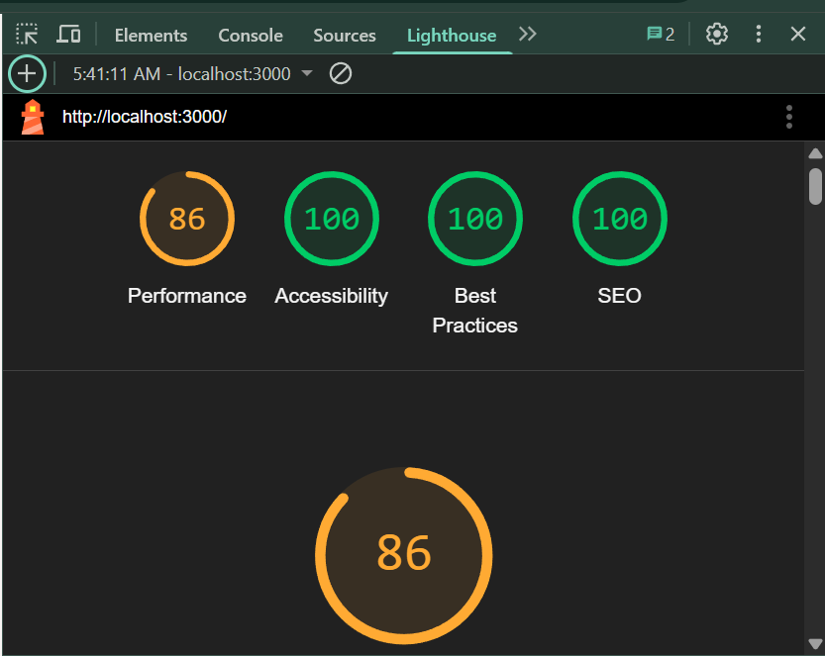
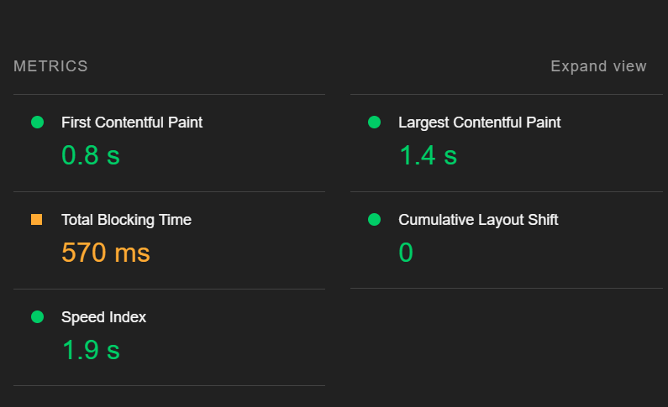
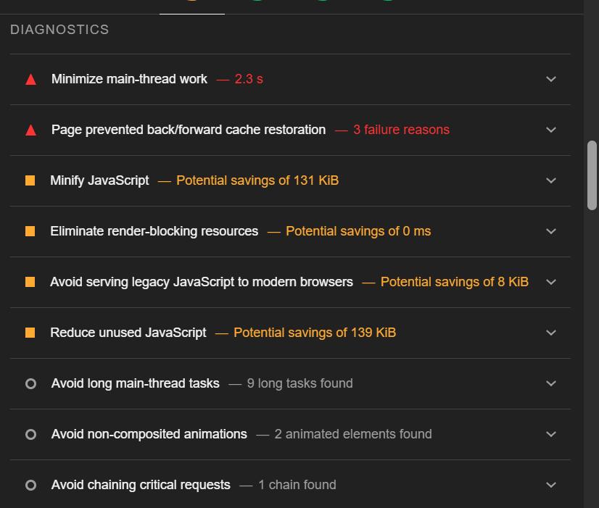
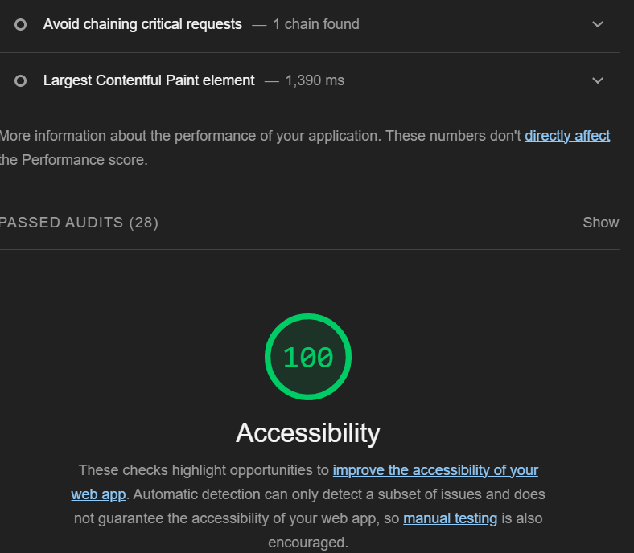
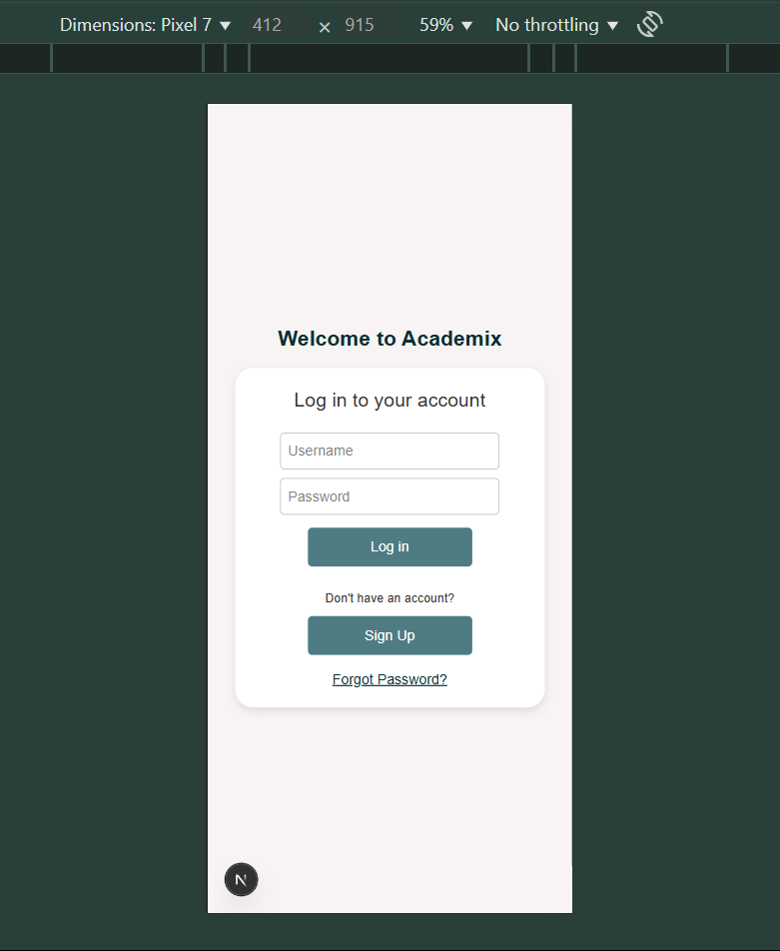

9. Github Repo [Public]
https://github.com/Arpa4517/CSE471_academix

10. Link of Deployed Project

11. Individual Contribution
Group member - 01
Name: Ahmed Riasat | Student ID: 24141253
Functional Requirements which are developed by this member:
- The whole backend part of this project

Group member - 02
Name: Mustafina Joarder | Student ID: 22101215
Functional Requirements which are developed by this member:
- The whole frontend part of this project

12. References

- How to Code : Google’s Go(golan) Programming Language
https://www.udemy.com/course/learn-how-to-code/?couponCode=CP130525
- Go by example
https://gobyexample.com/
- Implementing JWT authentication in Go
https://permify.co/post/jwt-authentication-go/
- Gin Web Framework
https://gin-gonic.com
- Golang official documentation
https://go.dev/doc/tutorial/web-service-gin
- This project benefited from the assistance of GitHub Copilot, an AI pair programmer
- Traversy Media
https://www.youtube.com/watch?v=LDB4uaJ87e0&t=115s&ab_channel=TraversyMedia
- Codevolution
https://www.youtube.com/@Codevolution

Permissions (access control) in web apps
https://dev.to/wasp/permissions-access-control-in-web-apps-j6b

- PostgreSQL Official Documentation
https://www.postgresql.org/
- Knowledge 360
https://www.youtube.com/@Knowledge360Channel/videos

