QUALITY ASSURANCE MANAGEMENT SYSTEM

by
Riasath Arif Prodhan
ID: 122-15-1935
Noor Nabiul Alam Siddiqui
ID: 122-15-1875
Rumia Akter Rumi
ID: 122-15-1836
Albert Rozario
ID: 1222-15-1858

This Report Presented in Partial Fulfillment of the Requirements for the Degree of Bachelor of Science in Computer Science and Engineering

Supervised By

Prof. Dr. Syed Akhter Hossain
Professor and Head
Department of CSE
Daffodil International University


DAFFODIL INTERNATIONAL UNIVERSITY
Dhaka, Bangladesh
APRIL 2016

APPROVAL
This Project titled “Digital QAMS system for daffodil international university”, submitted by Riasath Arif Prodhan, Noor Nabiul Alam Siddiqui, Rumia Akter Rumi and Albert Rozario to the Department of Computer Science and Engineering, Daffodil International University, has been accepted as satisfactory for the partial fulfillment of the requirements for the degree of B.Sc. in Computer Science and Engineering and approved as to its style and contents. The presentation has been held on 16/17/18/19 January 2016.
Board of Examiners

Dr. Syed Akhter Hossain Chairman
Professor and Head
Department of Computer Science and Engineering
Faculty of Science & Information Technology
Daffodil International University

Dr. Sheak Rashed Haider Noori Internal Examiner
Assistant Professor
Department of Computer Science and Engineering
Faculty of Science & Information Technology
Daffodil International University

Narayan Ranjan Chakraborty Internal Examiner
Assistant Professor and Associate Head
Department of Computer Science and Engineering
Faculty of Science & Information Technology
Daffodil International University

Nazmun Nessa Moon Internal Examiner
Assistant Professor
Department of Computer Science and Engineering
Faculty of Science & Information Technology
Daffodil International University

Dr. Mohammad Shorif Uddin External Examiner
Professor and Chairman
Department of Computer Science and Engineering
Jahangirnagar University
DECLARATION

We hereby declare that, this project has been done by us under the supervision of Prof. Dr. Syed Akhter Hossain, Department Head, and Department of CSE Daffodil International University. We also declare that neither this project nor any part of this project has been submitted elsewhere for award or any kind of degree.

Supervised by:

Prof. Dr. Syed Akhter Hossain
Professor and Head
Department of CSE
Daffodil International University

Submitted by:

Riasath Arif Prodhan
ID: 122-15-1935
Department of CSE
Daffodil International University

Noor Nabiul Alam Siddiqui
ID: 122-15-1875
Department of CSE
Daffodil International University

Rumia Akter Rumi
ID: 122-15-1836
Department of CSE
Daffodil International University

Albert Rozario
ID: 122-15-1858
Department of CSE
Daffodil International University

ACKNOWLEDGEMENT

First we express our heartiest thanks and gratefulness to almighty Allah for His divine blessing makes us possible to complete this project successfully.

We fell grateful to and wish our profound our indebtedness to Prof. Dr. Syed Akhter Hossain, Professor and Head, Department of CSE Daffodil International University, Dhaka. Deep Knowledge & keen interest of our supervisor influenced us to carry out this project .His endless patience ,scholarly guidance ,continual encouragement , constant and energetic supervision, constructive criticism, valuable advice ,reading many inferior draft and correcting them at all stage have made it possible to complete this project.

We would like to express our heartiest gratitude to the Head, Department of CSE, for his kind help to finish our project and also to other faculty member and the staff of CSE department of Daffodil International University.

We would like to thank our entire course mate in Daffodil International University, who took part in this discuss while completing the course work.

Finally, we must acknowledge with due respect the constant support and patients of our parents.

Abstract
In 21st century, advantage of the technology and digitalization efforts. The use of technology all of our life has been evolved. In academic activities of today studding from school till university. Due to this wider application of ICT in education and growing demand of quality human resources worldwide .The quality assurance has become a very important area to work with. In this project we looked at the quality assurance process of the universities. The requirement from the quality assurance cell of the universities. Based on the requirement comparative study of different quality assurance system to understand the design and implementation a quality assurance management system. The project is implemented using Codeigniter framework based on PHP and MYSQL as backend Database. The different users for this quality assurance system was tested and found satisfactory. In the future this system will be further enhanced to incorporate extended business process based on internet of things and other process.

TABLE OF CONTENTS
CONTENS | PAGE
Approval | ii
Board of examiners | ii
Declaration | iii
Acknowledgements | Iv
Abstract | V
CHAPTER
CHAPTER 1: INTRODUCTION | 10
1.1 Objective | 10
1.2 Motivation | 11
1.3 Expected Outcome | 11
1.4 Report Layout | 12
CHAPTER 2: LITERATURE | 13
2.1 Introduction | 13
2.2 Quality Assurance in Higher Education | 13
2.3 Related Works | 14
2.4 Proposal System Requirement | 14
2.4.1 User Interface Requirements | 14
2.4.2 Functional Software Requirements | 16
2.5 Challenges | 16
CHAPTER 3: REQUIRMENT SPECIFICATION | 17
3.1 Use case model | 17
3.2 Logical data model | 19
3.2.1 Teacher’s workflow | 20
3.2.2 Department Head workflow | 22
3.2.3 Dean workflow | 23
3.2.4 QAMS Head workflow | 24
3.3 Implementation requirement | 25
CHAPTER 4: DESIGN & IMPLEMENTATION | 28
4.1 Design of GUI | 28
4.1.1 Teachers Login Panel | 29
4.1.2 Teachers panel | 30
4.1.3 Teachers QAMS form | 31
4.1.4 Department Head Login Panel | 32
4.1.5 Department Head Panel | 33
4.1.6 Dean Login Panel | 34
4.1.7 Dean Panel | 35
4.1.8 Dean Verification | 36
4.1.9 QAMS Head Panel | 37
4.1.10 IQAC Head Verification | 38
4.2 Database ERD | 39
4.3 Database schema | 40
4.4 Functionality testing | 41
4.4.1 Unit Test | 41
4.4.2 System test | 41
4.4.3 Usability Test | 41
4.4.4 Compatibility Testing | 42
4.5 Discussion summary | 42
CHAPTER 5: CONCLUTION & FUTURE SCOPE | 43
5.1 Discussion & conclusion | 43
5.2 Outcome | 43
5.3 Limitations | 43
5.4 Future scope | 43
REFERENCE | 45

LIST OF FIGURES
FIGURES | PAGE
Figure 3.1: Use case model for QAMS Management System | 18
Figure 3.2: Workflow diagram of the proposed system | 20
Figure 3.3: Workflow diagram for the teacher’s panel | 21
Figure 3.4: Workflow diagram for the Dept. Head panel | 22
Figure 3.5: Workflow diagram for the Dean panel | 23
Figure 3.6: Workflow diagram for the QAMS Head panel | 24
Figure 4.1: UI for Teachers Login Panel | 29
Figure 4.2: UI for Teachers Panel | 30
Figure 4.3: UI for Teachers QAMS form | 31
Figure 4.4: UI for Head Login Panel | 32
Figure 4.5: UI for Head Panel | 33
Figure 4.6: UI for Dean Login Panel | 34
Figure 4.7: UI for Dean Panel | 35
Figure 4.8: UI for Dean Verification | 36
Figure 4.9: UI for QAMS Head Panel | 37
Figure 4.10: UI for IQACMS Head Verification | 38
Figure 4.11: Database ERD | 39
Figure 4.12: Database Schema | 40

CHAPTER 1
Introduction
This project is about “QAMS Management System”. Our project introduce a digital version or the QAMS submission and validation system. Which is currently continuing in paperwork in the whole university.

In the current system submission and validation of the QAMS form is done by the paperwork. The teachers submit the QAMS form to the department head which contain the student’s details information about their course such as attendance, number of class test, number of presentation and assignment etc. Our project digitalize the whole process including the student’s course information input and validation. This digital QAMS system is much more time and space efficient than the previous system. All of the document will be computerized so searching of the specific documents will be an easy task. Majority of the information in the QAMS form will be drop down list which will help the user to complete it without any difficulties.

After implementation of all functions, the system is tested in different stages and it works successfully as a prototype.

1.1 Objective
The aim of the Digital QAMS system is to build up a better user accessibility and efficient way of using the QAMS form and validation by the respected teachers, department head, university DEAN and QAMS head.
The primary objective of QAMS is
1. To ensure the best quality of teaching of an educational institution.
2. To maintain and assure the management quality of the institution.
3. Help to improve the academic and administrative performance of the institution.
4. To improve the internal communication between teachers and administration of the institution members.

1.2 Motivation
QAMS plays a vital role for developing better performance in teaching area and improving the working process of the teachers. The system motivate them to provide their best and help them to find their limitation and how to overcome them. QAMS also motivate the flexibility of the administration procedure to increase the academic and administration performance by developing a better communication skill between the teachers and the administration members. The QAMS system allows the teachers to do their duty efficiently and moderately as well as gaining new experience on the way of teaching.
A digital management system like this can reduce a lot of paper work that can take a lot of time. In that point of view QAMS management system saves a huge amount of time and complete the task with just a click.

1.3 Expected Outcome
The most anticipated outcome of QAMS is to improved student academic performance, improved the working process of the institution and help teachers to get their job done more efficiently and accurately. Right now the only way to submit the student data like attendance sheet, information about exam, presentation, assignment, class test are done by manually. But with our digital QAMS management system all the manual paper work will be computerized. It all can be completed with just a couple of mouse click. In one way this system saves a lot of time and it also maintaining the academic quality of the institution as well.
These are the commonly expected outcome from the QAMS management system
1. Improve the academic performance
2. Improve the working process of the institution
3. Develop a better communication skill between teachers and the administration members.
4. Complete the student data sheet accurately and efficiently and with online submission.
5. Perfect validation of the data sheet provided by the teachers.
6. Increase the learning environment of the institution to compete with other institutions globally.

1.4 Report Layout
Our report for the final project of our bachelor course in computer science & engineering contains the abstract, which describe the key point of our project followed by the acknowledgement of our respected supervisor and the co-supervisor. The table of content has several parts with flow chart diagram and description which has been researched and implemented to finalizing the product successfully. The most important part of the report is the layout and the validity of the content which need to be verified by the respected supervisor and the co-supervisor. Our project report describe the whole project development step by step. Starting by the system requirement, related works in this part of technology in the world, proposed a final system requirement confirmed by the respected supervisor and the challenges for developing the project and the final part of this project was design several logical data model that meet the requirements and implement the whole thing successfully.

CHAPTER 2
Literature
2.1 Introduction
QAMS is a well versed management system for educational institute to assure the quality of their academic and management performance. Now a day’s most of the reputed educational institute are working with QAMS management system to improve their overall performance. The topics “Internal quality assurance cell” has been researched many time and there are so many publication about this topics are published on the internet. Still now new technology regarding measuring the quality of the higher education are being researched and published by some of the well-known universities around the world.

2.2 Quality Assurance in Higher Education
Higher education refers different meaning that varies people to people. Generally higher education state that achieving the highest degree possible on the country. In present universities represent the higher educational qualification for any student. That including the privet and public institutions with the quality of their teaching process. The difficulties now a days in the education field is that, it’s becoming a field of business instead of a place for learning and teaching and that’s why the quality assurance takes place. Determining the best quality for the educational institutions is one of the most essential part for developing a country. Thus quality assurance in higher education is mandatory for any educational institutions [1].
Every educational institutions must maintain the standard quality for their services or teaching processes. The core material for any university are the students and teacher, stuffs and the managing members of the university. Quality assurance can be effective when it is the core of the university teaching system [2].
Validation is one of the most vital part of the quality assurance in higher education. From the book of “Quality Assurance in Higher Education” by Alma Craft “The process of approving of a new program, or allowing an existing program to continue, is described as validation.” Whatever the rules and regulations defines in the quality control division of a university, it does not take effect unless the responsible authority validate every one of the rules and regulation because the key point of the quality assurance in higher education system is to improve the overall performance of every aspect of a university [3].
2.3 Related Works
There are so many universities and organization that are already have QAMS managements system or currently developing something related to QAMS. Since the prime goal of QAMS is to assure the internal quality of the institution overall performance, so most universities has a division for QAMS department. The main task of the QAMS department is to check the annual improvement of the institution and make some necessary decision to increase the academic and administration performance. The QAMS committee publish an annual report for all the improvement and problems that should be maintained for assure the internal quality of the institutions. The limitation for most of the QAMS management system is imperfect validation. There is absolutely no way to validate all the data on the QAMS annual report perfectly. This leads a huge gape to maintain proper quality in the overall performance of the institutions. It’s quite impossible to validate every bit of information acquired from a survey. So the QAMS management system still have areas that need to be developed further for secure the quality of the education field even more for the better developed country because education is the backbone of a country [4].

2.4 Proposed System Requirements
The Quality Assurance Management System maintain the quality specific for any institute or organization. To check and validate all the information of the institution by the authorities and after validation, all the information will be stored in the archive. We are developing a Quality Assurance Management System for Daffodil International University as our final project and Thesis. As for the system requirement the validation will be divided into all the user of the system. The user interface requirements and software functional requirements are described below.

2.4.1 User Interface Requirements
All the user of the system must go through the login panel by using their email address and password. There should be a change password option available. There must me several drop down menu for user to select specific panel to enter such as user type, semester, year, select department, select faculty etc. The login should be perfectly verified that without a username or email and password, no user will pass through the login panel. All the input field must be required to login into the system. All the user must have their own user panel to input or validate all the information.
The teacher panel has the required information as given name of program, faculty, and name of teacher, department, semester, year, and Designation and employee id. The teacher can input the information in the QAMS form. The QAMS form contain course name, section as given input. The Drop down menu contains course outline given, Google classroom link, number of class taken, number of class test taken, midterm exam taken, final term exam taken, number of assignment, and number of presentation. The student attendance, mid-term exam question and final term exam question will be uploaded as a pdf file format. Teacher will submit the QAMS form to the Department Head by clicking the submit button.
The department head panel must contain the required information as like teacher panel and also contain the QAMS form that the teacher has sent. The QAMS form will have all the information filled and if the department head find any incorrect information, he will click the revert button to send the form back to the teacher for correcting all the information. If the Head revert the QAMS forms, the teacher have to correct all the incorrect information in the form and then submit it again to the department head for validation.
The Dean panel contain all the specific given information and QAMS form validate by the department head. The Dean have to validate all the information again and if any incorrect information found the dean will revert the form back to the head and the process will continue until the teacher correct all the information.
The QAMS Head panel will also contain all the required information given and the QAMS form validate by the department head and the dean. The same process will happen again if the QAMS Head find any incorrect information the he will revert the form back and if all the information is correct, the QAMS Head will finally validate the information and store the form into the archive.
2.4.2 Functional Software Requirements
All the user have different functional requirements for developing the Quality Assurance Management System for the Institutions. Our software has four type of user group Teacher, Department Head, Dean, and IQAC Head. All the user have their different functionality. As for the login user interface the user should provide the correct email addresses and password to successfully log in into the QAMS system. If the provided information doesn’t match with the database information then an error massage will occur and the user have to try again with correct email address and password. There have to be an option for if the use forget the email address and password. All the dropdown information on the login panel for specific user will be automatically selected and if the user provide wrong information, after the error massage only the wrong information whether it is the email address or the password or both will be empty and all the other information will not be required again.
All the user except teacher must have a specific option as a button for revert the submission of the IQAC form back to the previous user. For example if the IQAC head revert the submission the Dean will have to validate the IQAC form again by reverting it back to the Department Head and as on the Department Head will revert it back to the Teacher to Correct the information and submit the IQAC form again to the Department Head. After all the validation the IQAC Head will save the IQAC form in the database.

2.5 Challenges
This project has several challenging parts for us. The most challenging parts of this project are
- Database normalization
- Reduce the redundancy
- Implement all the features for the user panels
- Complete the project before deadline

CHAPTER 3
Requirement specification
3.1 Use case
In software and systems engineering, a use case is a list of actions or event steps, typically defining the interactions between a role and a system, to achieve a goal. The actor can be a human or other external system. In systems engineering, use cases are used for representing missions or stakeholder goals [5].
The use case diagram which defines the interactions between external actors and the system under consideration to accomplish a goal. Actors must be able to make decisions, but need not be human: "An actor might be a person, a company or organization, a computer program, or a computer system—hardware, software, or both." Actors are always stakeholders, but not all stakeholders are actors, since they "never interact directly with the system, even though they have the right to care how the system behaves [5].
The use case diagram of our project contains four actors which are teacher, department head, dean and QAMS Head. The use case model gives a bird eye look of the overall project features. As for the actors, the teachers have to login in to the system with correct username and password to get access in the QAMS form. The change password feature will also be available. Teachers can create new record including attendance, exam mark and questions and other student information’s. The teachers have to complete the QAMS form and then send it to the department head for validation. If the department head revert the submission back then the teachers have to correct all the incorrect information and send it to the department head again for further validation.
The Department Head will also have to login to the system with correct username and password to get access in the department head panel and QAMS form to check the information and sent it to the Dean. The change password feature will also be available for the department head. If the Dean revert the submission for incorrect information, the department head will also revert to the teacher for correcting all the incorrect information and finally sent it again to the Dean for validation.
The Dean will also have to go through the login panel with correct username and password to get access to the Dean panel and QAMS form for validate the information and sent it to the QAMS Head. The change password feature will also be available for The Dean. Figure 3.1 demonstrate the use case diagram of our software.

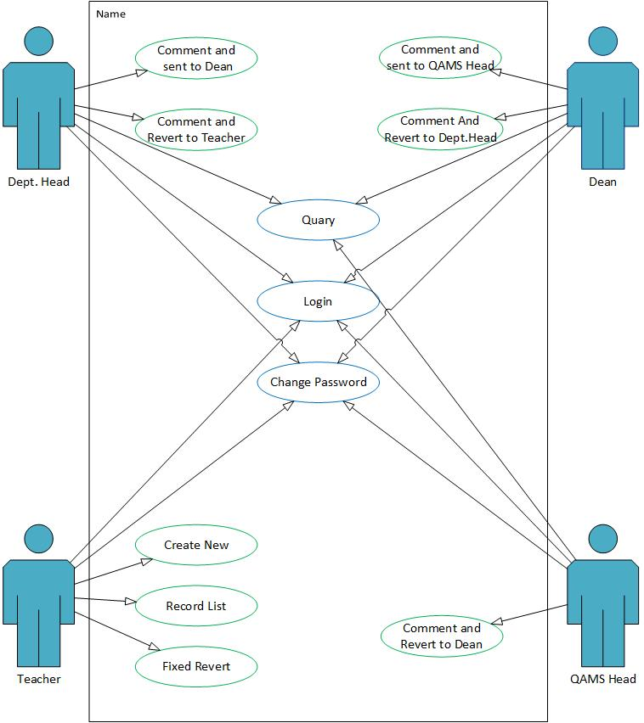

Figure 3.1: Use case model for QAMS Management System
If the QAMS Head find any incorrect information and revert it back to the Dean, the dean have to revert it back to Department Head and then to the teacher for correction and again sent it to the Department Head to Dean to the QAMS Head.
The QAMS Head will also have to go through the login panel with the correct username and password to get access to the QAMS panel and the QAMS form for validate the information. The change password feature will also be available for the QAMS Head. If there is any incorrect information the QAMS Head will revert it to Dean to Department Head to Teacher and the Teacher will correct the information and sent it back to the QAMS Head by following the same process again. If all the information is successfully validate by the QAMS Head then he will sent the document in the server and save it into the database.

3.2 Logical data model
We are proposing a QAMS management system for educational institutions that will benefit the student, teacher and the management authorities of the educational institutes. Our proposed system contains the QAMS form and the validation form to get input from the teacher and to validate the information by the QAMS members including department head, Dean and QAMS head. On the QAMS form the teachers should input the following data- Attendance copy, no of classes taken, assignment, presentation, midterm exam, final exam, course outline covered in classes. The teacher should upload the Attendance copy, final and midterm question copy, course outline in PDF file format.
For the validation part of the system the teacher will submit the QAMS form to the Dept. Head and the Dept. Head will validate all the information and submit the QAMS validation form to the Dean and eventually the document will be submit to the QAMS head by the Dean. The QAMS head validate the information and save it in the database. If the teacher submit any invalid information than he/she must make a resubmission request to the Dept. Head and if the Dept. Head approved the request, the revert option for the submission will be activated again for the teachers to correct the information on the QAMS form and then resubmit the document again.

Our proposed QAMS management system have four module Teacher, Dept. Head, Dean and QAMS Head. The teacher have to fill-up the QAMS form and scanned the attendance sheet and other document and submit on the system. The document will be sent to the Dept. Head for Proper validation and if the content information is false then the Dept. Head will reject the submission and notify the teacher to resubmit the document again. If the Dept. Head validate the document properly then the document will sent to the Dean for more validation. The same process will take effect if any false information occurs otherwise the documentation will be sent to the QAMS Head for final validation. The same process will happen if any false information occurs and if every bit of information is correct and validate properly then the QAMS Head will save the information on the database.
The figure 3.2 is the main working flow diagram for our proposed system
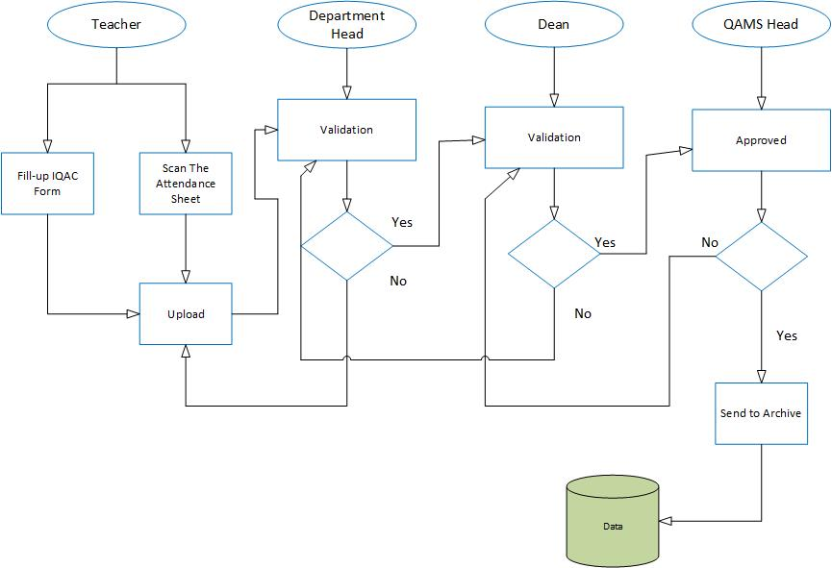
Figure 3.2: Workflow diagram of the proposed system
3.2.1 Teacher’s workflow
Figure 3.3 explain teacher’s workflow where the teachers should have to login correctly to get access to the QAMS form. There is a forget password option in case of the teacher can’t login to the QAMS form. If the teacher submit the form previously then the normal submission menu won’t be available. In that case apply for revert option will be available, to request a resubmission to the Dept. Head. If the teacher submitting the QAMS Form for the first time of the semester, after inputting all the necessary information into the QAMS form, the teacher can submit the document to the Dept. Head. The QAMS form requirements are Course code, Learning feedback system link, no of the classes taken, midterm, final term, assignment, presentation and Course outline, Midterm question, final term question, attendance copy will submitted as PDF file format.
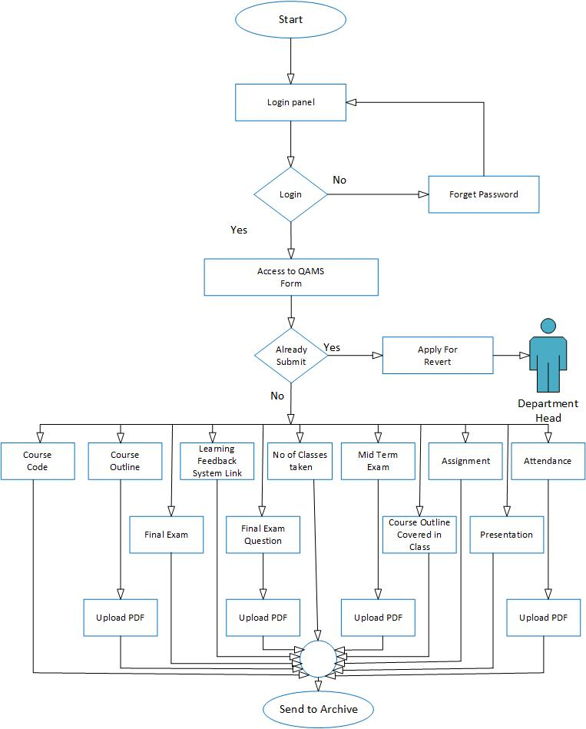

Figure 3.3: Workflow diagram for the teacher’s panel
3.2.2 Department Head workflow
The following figure 3.4 explains the Dept. Head Panel who also have to login through the login panel to access to the QAMS validation form. There is a forget password option for login error. The Dept. Head have to ensure all the information and verify the validation form. If the Dept. Head never submit the QAMS validation form of that semester before, the submission option will be available. Else apply for revert option will be available instead of submission. The Dept. Head have to request a resubmission to the Dean by applying the revert option. If the Dean approve the resubmission request, the submission option will be available again for the Dept. Head to resubmit the QAMS validation form.
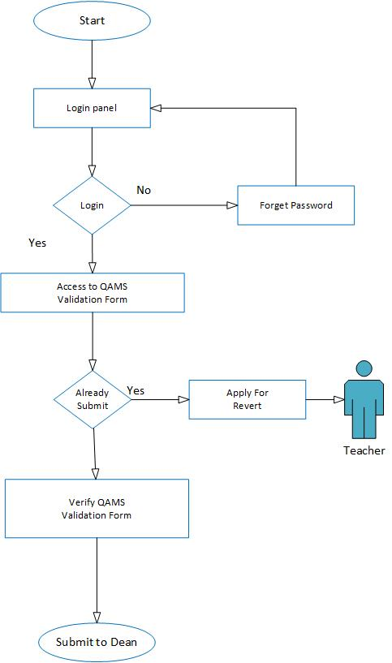

Figure 3.4: Workflow diagram for the Dept. Head panel
3.2.3 Dean workflow
In the following figure 3.5 explain the workflow diagram of the Dean panel, like the previous panels the Dean also have to login through the login panel. In case the password is forgotten, the forgotten password option will be available for creating a new password. After getting access to the QAMS validation form, the Dean will verify the QAMS validation form and submit the document to the QAMS Head. If the Dean never submit the QAMS validation form of that semester before, the submission
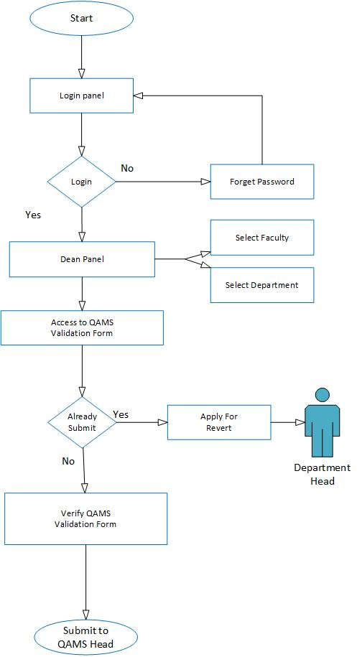

Figure 3.5: Workflow diagram for the Dean panel
option will be available. Else apply for revert option will be available instead of submission. The Dean have to request a resubmission to the QAMS Head by applying the revert option. If the QAMS Head approve the resubmission request, the submission option will be available again for the Dean to resubmit the QAMS validation form.
3.2.4 QAMS Head workflow
In the following Figure 3.6 explain the workflow diagram of the QAMS Head panel, like the previous panels the QAMS Head also have to login through the login panel. In case the password is forgotten, the forgotten password option will be available for creating a new password.
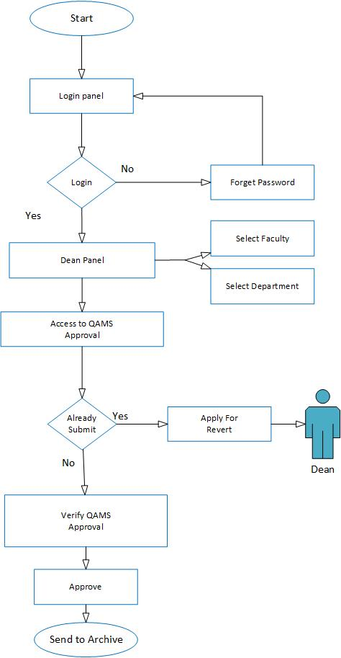
Figure 3.6: Workflow diagram for the QAMS Head panel
Before get access to the QAMS validation form the QAMS Head have to select the specific faculty and department from the drop down menu. After getting access to the QAMS approval, the QAMS Head will verify the QAMS approval. The QAMS Head will approve the document and sent it to the database. There will be not revert option for the QAMS Head because the QAMS Head is the prime authority for QAMS management system. If the Dean apply for a resubmission request, the QAMS can approve the request to resubmission the document again.

3.3 Implementation Requirement
The QAMS has been developed by some professional and resourceful web developing tools & technologies. The development was divided into two parts, front end developing and back end developing. The tools we used for developing the QAMS are the following
- HTML5, CSS3 with Bootstrap framework
- PHP with Codeigniter framework, jQuery
- Apache Server 5
- Database: MySQL
The font end developing required mostly HTML5, CSS3 bootstrap etc. For using HTML5 is the reason that it has constant improving capabilities with better accessibility. But HTML5 is best known for its cross platform capabilities. Compatibility with different platforms is the main attractive feature of this technology. A HTML5 app can work in different operating systems of mobile devices including Android, iOS, Blackberry or Windows Phone. Creating mobile apps using HTML5 is also easy. There are also many HTML5 apps that are easily available and they can be used in any device that supports this technology.
The CSS3 provide the best user friendly interface for any web application or design. The bootstrap framework is filled with simple and attractive design module to use. The using pattern was also very efficient form any other design pattern. The fundamental structure and design plays a vital role of any web based application. The first card of the game has to make the product attractive to the target group of people. Then amaze them by the user friendly backend developing where the application meet all the requirement of the client.
CodeIgniter is one of the most popular PHP frameworks around. It uses the Model-View-Controller Architectural design pattern and it’s considered by lots of PHP developers as one of the best framework solution for small to medium projects. CodeIgniter uses Model-View-Controller pattern which is the most used architectural design pattern in web application. It can also be turned into supporting the more advanced Hierarchical Model View Controller (HMVC) pattern by installing the popular CodeIgniter HMVC Extension. Since performance has been a major concern for each web developer, CodeIgniter is optimized to boost the code performance. Also codeIgniter contains wide variety of helper functions that were created to help for writing cleaner code and save time and effort doing repetitive tasks.
Angular JS makes use of the original MVC (Model-View-Controller) software architectural pattern, but not in the traditional sense. Two-way data binding, which automatically updates the view as soon as any change occurs in the model and vice-versa, is certainly one the most unique and powerful features in Angular JS. Angular takes full advantage of Dependency Injection (DI) to deal with how an application should be wired. That means, it is no longer required to use the un-maintainable main () method in order to execute the code.
We have tested this system in Linux and Windows operating system. We used Apache Web server and NetBeans IDE.
As for our database we use MySQL which is the world most used open source relational database management system that runs as a server providing multi-user access to a number of database. MySQL is a popular choice of database for user in web application, and it is a central component of the widely used LAMP open source web application. For the commercial use, several paid edition are available, and offer additional functionality. MySQL is also in many high-profile large scale worldwide web products [6]. Google has used MySQL in their Adword project [7]. MySQL is also used in world’s biggest networking site Facebook [8].
In this chapter we have discussed about the platform and the technical requirement that we have used in our entire project. Basically we used Codeigniter and Angular JS to develop this project. With the help of Bootstrap framework and CSS we’ve designed and align our website’s Text content and we also connect this project to MySQL database for storing and retrieving data. The overall project is based on PHP, JavaScript, HTML5, CSS3 and MySQL which are very popular platform and efficient for developing web based application.

CHAPTER 4
Design & implementation
4.1 Design of GUI
The design of our software interfaces was based on all the implementation requirements and we also developed the product as much user friendly as possible. As for the software requirement, we developed at least one user panel for the user to communicate with the system. For the security and data protection every single user have to go through the log in panel with the correct user name and password. Every user have their own user panel and some validation panel to validate the inputted data regarding the quality assurance of the educational institute for improving the overall performance. For that in mind we attached every single user interface that we developed with details explanation. So that the user can easily maintain and communicate with the system and properly understand and use all of the available function of this software.

We design the entire software for specifically four user that are the Teachers, Department Head, Dean, and IQAC Head. All the user have their different login panel as for the software functional requirement where different type of data have to be inputted to successfully log on into the system. The Teacher will have access to the teacher panel and the IQACMS form panel log in with correct email address and password. There the teachers will input all the quality assurance data and submit the IQACMS form to the Department Head for further validation. The Department Head will get access to the Head panel by log in to the system and validate all the quality assurance data and submit it to the Dean for more validation. The Dean will also has a Dean panel and a Dean Validation panel to submit all the verified information to the IQAC Head for final validation of the data. The IQAC Head have two user panel like the Dean which is IQAC panel and IQAC validation panel for validate all the student information before saving it on the archive.

The following figures are the snapshot of all the user interface of our developed product with details explanation so that the users can easily understand and use all of the available function and maintain the system properly with maximize output.
4.1.1 Teachers Login Panel
In the following figure 4.1 describe the user interface for teachers login panel. In this panel the teacher have to input the required information to get access into the teacher panel and the IQACMS from. The required information for the teachers to successfully log in into the system are user email and a password. Then the teacher also have to provide dropdown information such as the user type which is teacher, the semester such as spring, summer and fall and for the last dropdown menu is select the year like 2014 or 2015 etc. After providing the correct information the teacher have to click the login button in the bottom down on the interface. If all the information provided by the teacher is correct then the teacher will successfully logged in to the system and get access to the teachers panel and the IQACMS form.

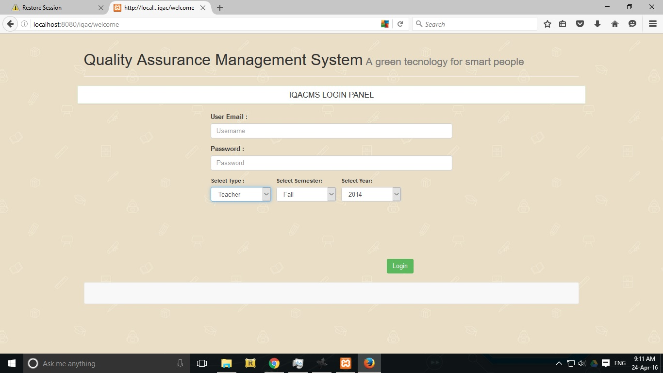
Figure 4.1: UI for Teachers Login Panel

4.1.2 Teachers panel
In the following figures 4.2 describe the user interface for teacher’s panel. Where the teachers panel shows varies information such as Name of the teacher, faculty name, name of the program, semester, year, designation and employee id. Bottom down the menu will display all the course taken by that teacher and the QAMS form submit option will be available here to check the submission. In the bottom right corner is the save button to save all the changes done by the teacher.

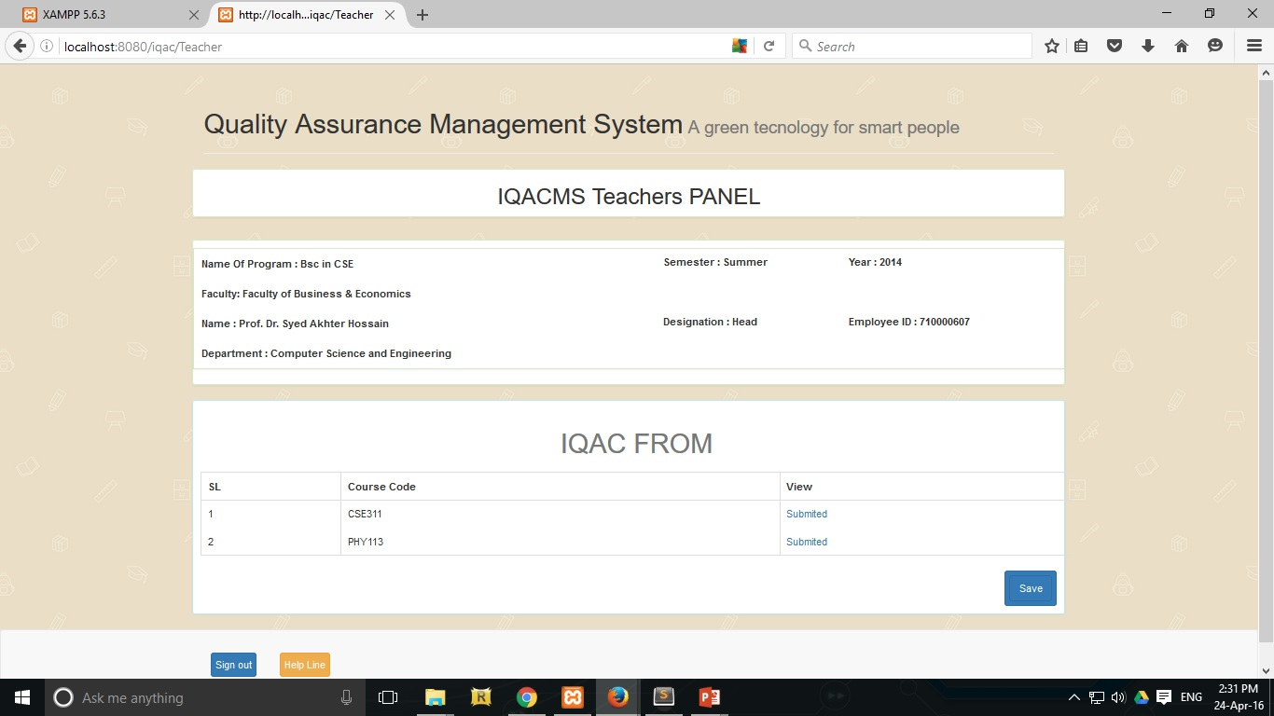
Figure 4.2: UI for Teachers Panel

4.1.3 Teachers QAMS form
In the following figures 4.3 describe the user interface for Teachers QAMS form. Where the teachers will input all the quality assurance data regarding the specific course. The following information will be given automatically on the upper side of the page which are Course name, Section and the rest will be drop down menu and input option for the teacher’s to give the required information for the validation. Such as Google Classroom Link and Number of class take. For the dropdown menu the options are Number of class test taken, Midterm exam test taken, Final term exam taken, Number of assignment, Number of presentation. The Attendance, Midterm exam question and the Final term exam question will be upload manually be the teachers in PDF format. There is a submit button for submitting all the information that is correct and verified by the teachers. After the teacher submit the form, there is no way to resubmit the same form again unless revert button is activate which will let the teacher’s allow to modify the IQAC form again. There is also three more button to back to the previous page, to sign out from the system and the help line button which describe all the function of that specific page.
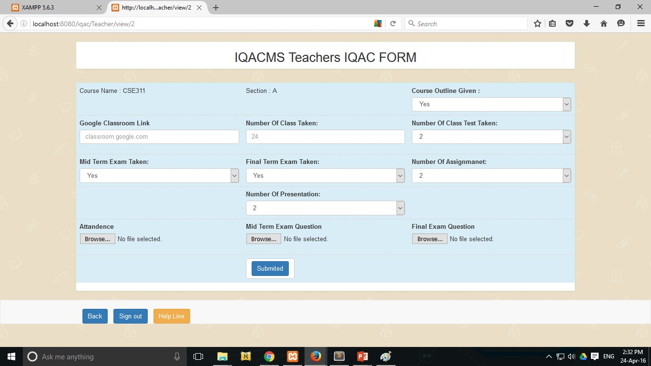
Figure 4.3: UI for Teachers QAMS form

4.1.4 Department Head Login Panel
In the following figure 4.4 describe the user interface for Head Login Panel. In this panel the Department Head have to input the required information to get access into the Department Head panel. The required information for the Department Head to successfully log in into the system are user email and a password. Then the Department Head also have to provide dropdown information such as the user type which is Head, the semester such as spring, summer, select the year like 2014 or 2015 and select specific department such as Computer Science & Engineering etc. After providing the correct information the Department Head have to click the login button in the bottom down on the interface. If all the information provided is correct then the Department Head will successfully logged in to the system and get access to the Department Head Panel.

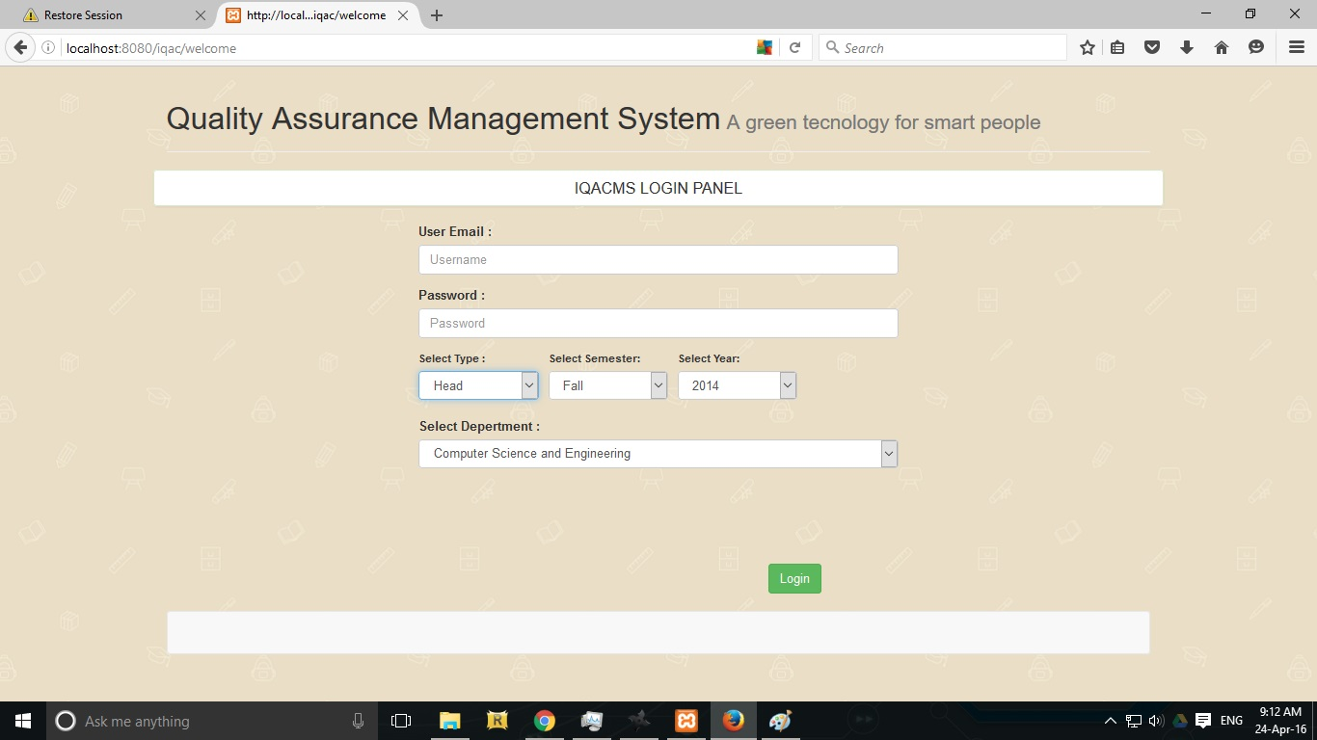
Figure 4.4: UI for Head Login Panel

4.1.5 Department Head Panel
In the following figures 4.5 describe the user interface for Department Head Panel. Where the Department Head Panel shows varies information such as Name of the Department Head, faculty name, name of the program, semester, year, designation and employee id. Bottom down the menu will display the teacher’s name and their submitted IQAC form. There is option available to view every single submission and revert button if the Department Head find any incorrect information in the IQAC form. If the Department Head press the revert button then the specific teacher will be allowed to correct the incorrect information and resubmit the IQAC form again to the Department Head. In the bottom right corner is the save button to save all the changes done by the Department Head. There is also two more button to sign out from the system and the help line button which describe all the function of that specific page.

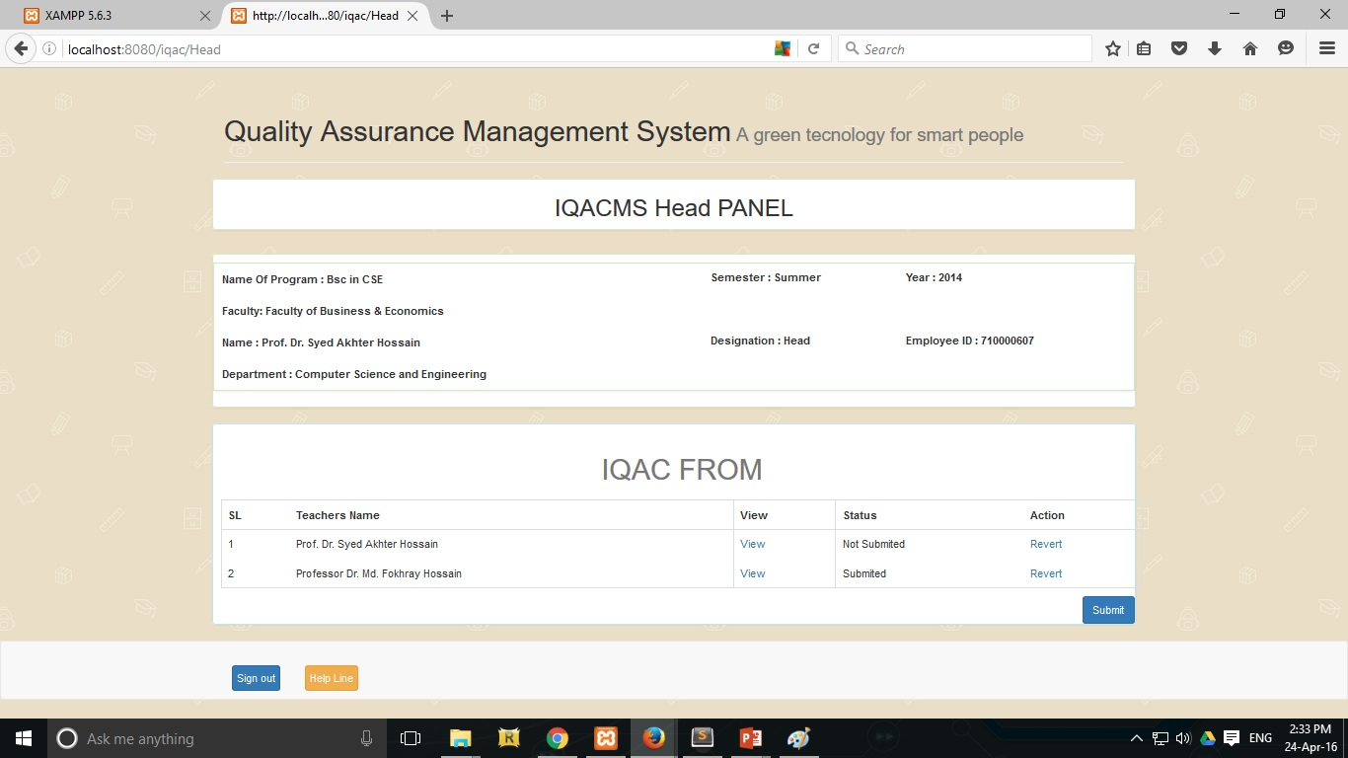
Figure 4.5: UI for Head Panel

4.1.6 Dean Login Panel
In the following figure 4.6 describe the user interface for Dean Login Panel. In this panel the Dean have to input the required information to get access into the Dean panel. The required information for the Dean to successfully log in into the system are user email and a password. Then the Dean also have to provide dropdown information such as the user type which is Dean, the semester such as spring, summer, select the year like 2014 or 2015 and select specific faculty such as Faculty of Business & Economics etc. After providing the correct information the Dean have to click the login button in the bottom down on the interface. If all the information provided is correct then the Dean will successfully logged in to the system and get access to the Dean Panel.

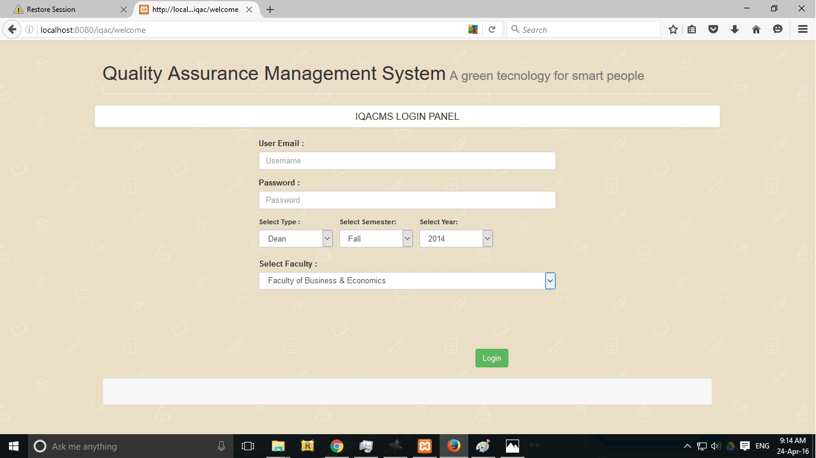
Figure 4.6: UI for Dean Login Panel

4.1.7 Dean Panel
In the following figures 4.7 describe the user interface for Dean Panel. Where the Dean Panel shows varies information such as Name, faculty name, name of the program, semester, year, designation and employee id. Bottom down the menu will display the Department Head names and their submitted IQAC form with submission status. There are option available to view every single submission and revert button if the Dean found any incorrect information in the IQAC form. If the Dean press the revert button then the specific Department Head will be allowed to correct the incorrect information and resubmit the IQAC form again to the Dean for further validation. In the bottom right corner is the save button to save all the changes done by the Dean. There is also two more button to sign out from the system and the help line button which describe all the function of that specific page.

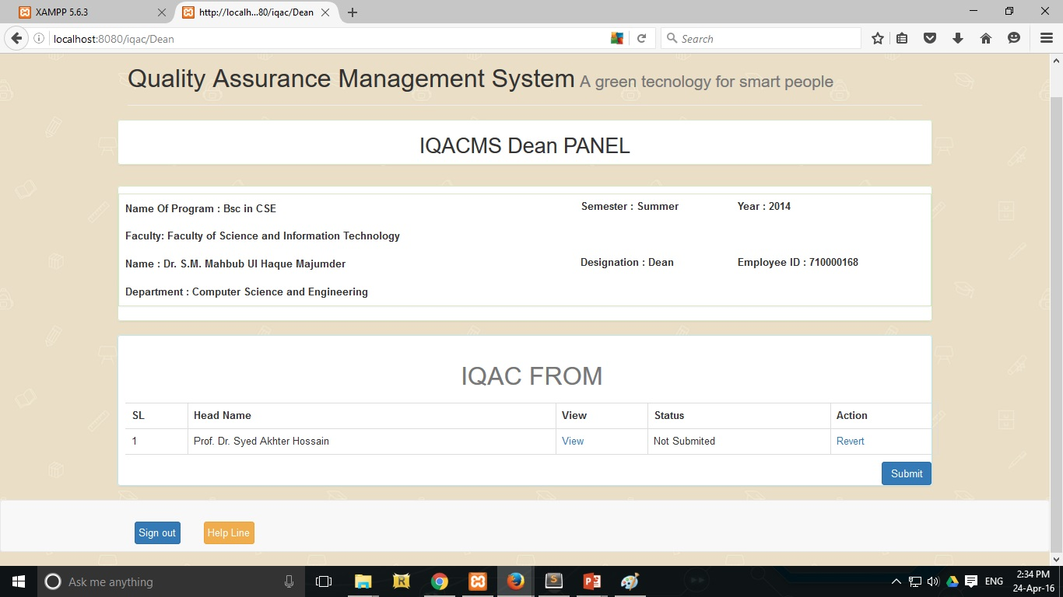
Figure 4.7: UI for Dean Panel

4.1.8 Dean Verification
The following figure 4.8 explain the Dean Verification panel where varies information are given such as Name, faculty name, name of the program, semester, year, designation and employee id. It also contain the IQAC verification form for the Dean to verify all the data and submit it to the IQAC Head for further validation. The IQAC form contain Teachers name, the view option for the review the main IQAC form filled by the teacher’s and the submission status. There is also three more button to back to the previous page, to sign out from the system and the help line button which describe all the function of that specific page.

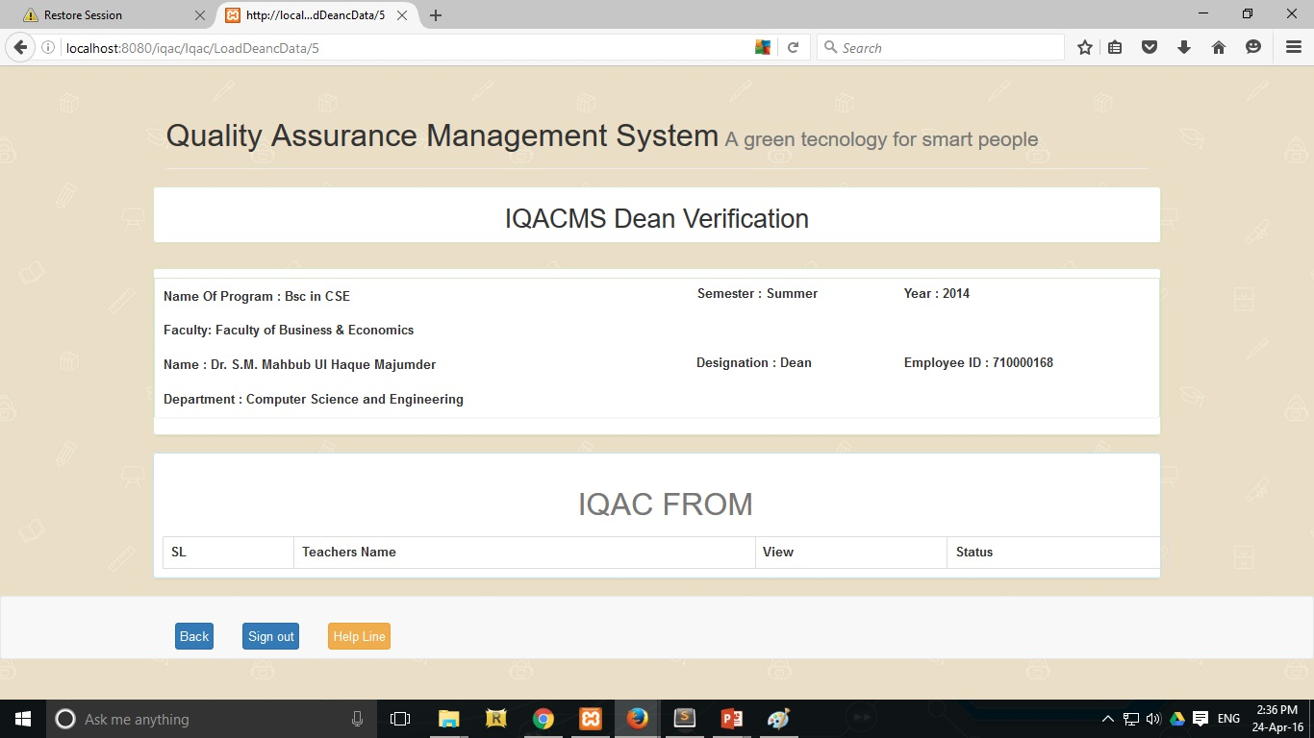
Figure 4.8: UI for Dean Verification

4.1.9 QAMS Head Panel
In the following figures 4.9 describe the user interface for QAMS Head Panel. Where the QAMS Head Panel shows varies information such as Name, faculty name, name of the program, semester, year, designation and employee id. Bottom down the menu will display the Dean names and their submitted IQAC form with submission status. There are option available to view every single submission and revert button if the Dean found any incorrect information in the IQAC form. If the QAMS Head press the revert button then the specific Dean will be allowed to correct the incorrect information and resubmit the IQAC form again to the QAMS Head for further validation. There is also two more button to sign out from the system and the help line button which describe all the function of that specific page.

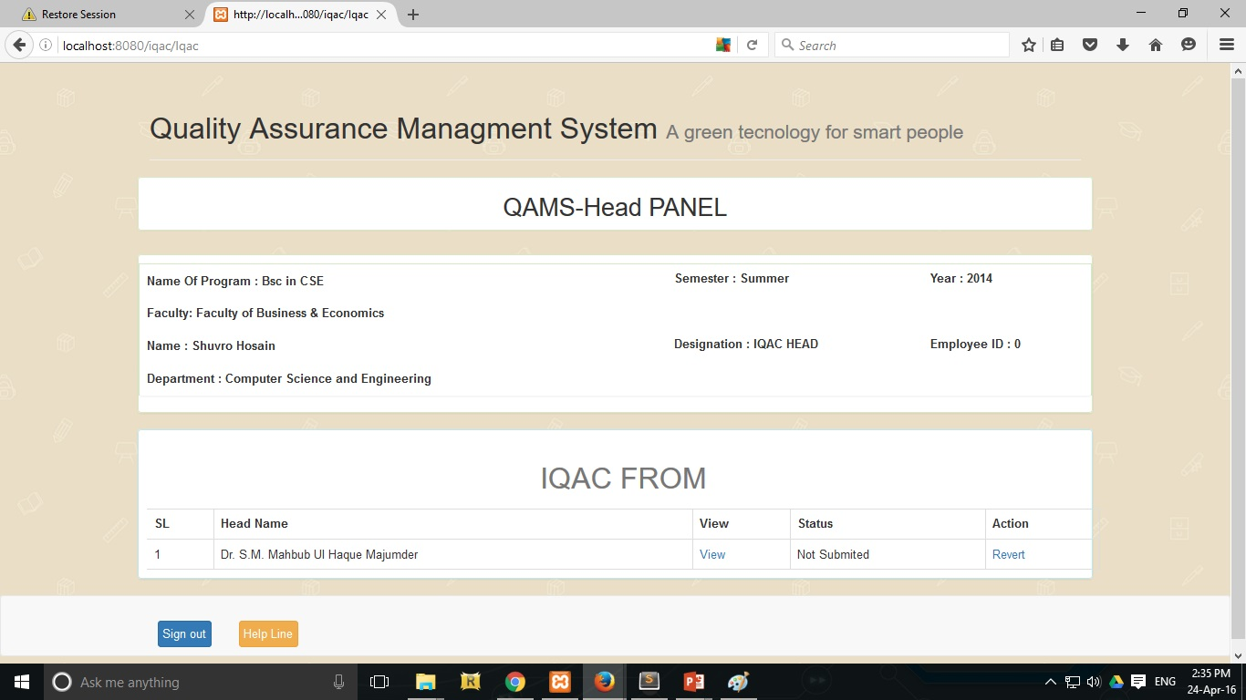
Figure 4.9: UI for QAMS Head Panel

4.1.10 IQAC Head Verification
The following figure 4.10 explain the QAMS Head Verification panel where varies information are given such as Name, faculty name, name of the program, semester, year, designation and employee id. It also contain the IQAC verification form for the QAMS Head to verify all the data. The IQAC form contain Teachers name, the view option for the review the main IQAC form filled by the teacher’s and the submission status. In the bottom right corner is the save button to save the IQAC form into the archive for future scope. There is also three more button to back to the previous page, to sign out from the system and the help line button which describe all the function of that specific page.

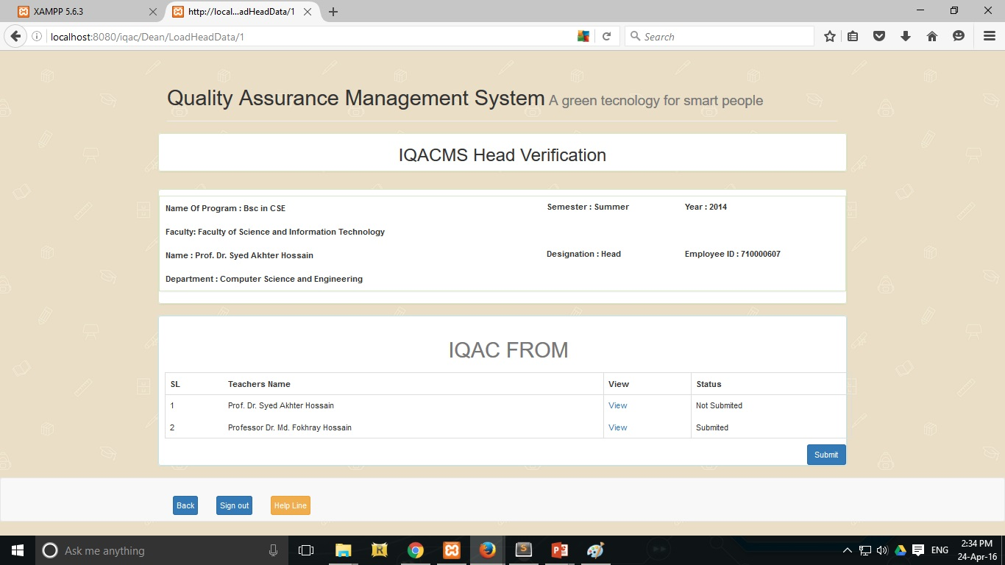
Figure 4.10: UI for IQACMS Head Verification

4.2 Database ERD
In our Database ERD model, there are fourteen tables which are connected each other by their primary keys. Every table has its own attribute. Store table has thirteen attribute, this table mainly store the QAC all data.
In User table we store all user data and all kind of user type store in user type table. Which user which type we only can find out checking UserTypeRelationship table.
Status table control the Teachers submission and the administration table control the Head, Dean and QAC submission. Faculty table store all the faculty details, Department table store department all details.
Figure 4.11 demonstrate the ERD model of our Software database.

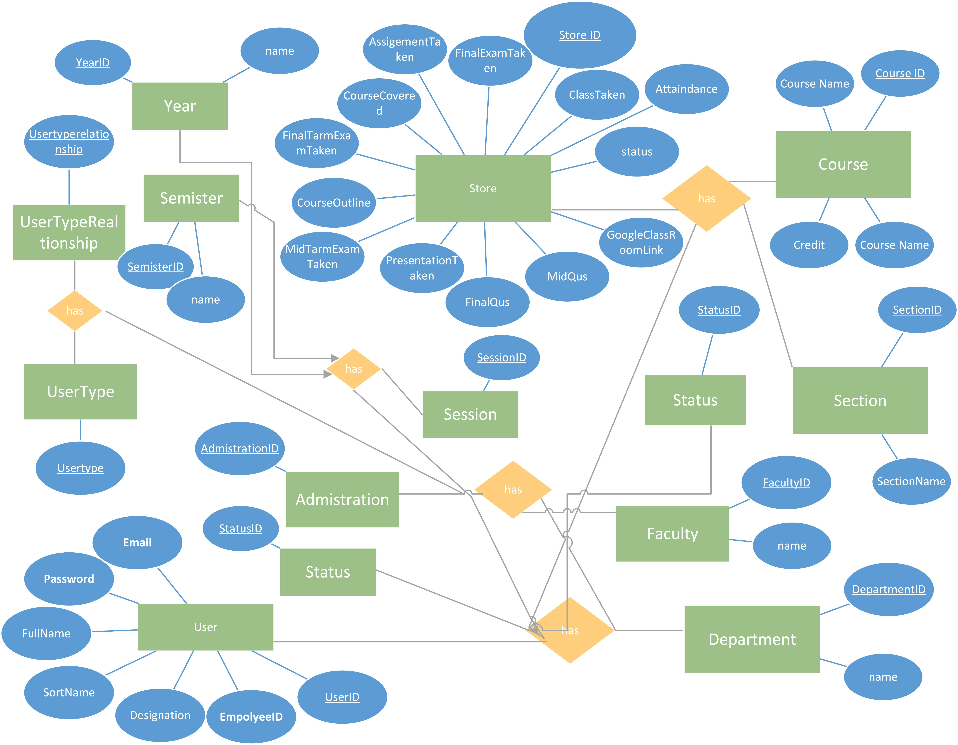
Figure 4.11: Database ERD
4.3 Database Schema
Figure 4.12 explain the connectivity of our product database Schema. The schema model stores data that is retrieved according to commands from the controller. Here we indicate all the models which we use to talk to the tables.
Preload
LoadType(),LoadSemester(),LoadDepertment(),Loadyear(),LoadFaculty().
User
Login_check($username,$password),LoginTypeCheck($userid,$UserTypeId),GetSession($YearId,$SemesterId),VelidationSession($SessionId,$userid),UserDetails($userid),GetFaculty($FacultyId),GetYear($YearId),GetSemester($semester),CheckDepartment($userid,$departmentid),CheckFaculty($userid,$departmentid,$FacultyId),DeanVarification($userid,$DepertmentId,$FacultyId),SubmissionTest($userid,$SessionId,$UsertypeId),HeadScrach($departmentid,$SessionId),DeanScrach($FacultyId,$SessionId),DepertmentDeanList($SessionId),Revert($id,$data),RevartHead($id,$FacultyId,$SessionId,$data),RevartDean($id,$SessionId,$data)
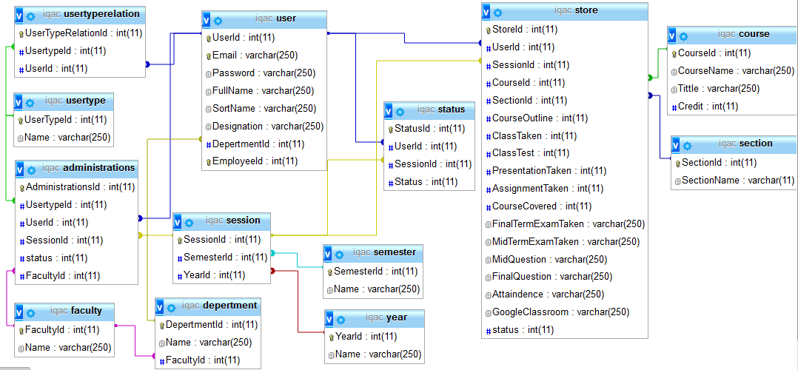
Figure 4.12: Database Schema
Storage
GetTeachersResult($userid,$SessionId),IqacFormDetails($value),_update($id, $data),StatusUpdate($id, $data).
Administrations
HaadSubmittion($userid,$UserTypeId,$SessionId,$data),DeanSubmittion($userid,$UserTypeId,$SessionId,$data),IqacHeadSubmittion($userid,$UserTypeId,$SessionId,$data)
4.4 Functionality testing
Reviewing the testing code is another basic of software engineering that is often overlooked in web development. Testing is an integral part of the system development process. The main standard for software testing is contained in the ANSI/IEEE slandered 829/1983-standard for software testing documentation. Some software testing may be performed by CAST (Computer Aided Software Testing). The Whole application must be tested and result documented. It is not only the software that is evaluated during the system testing process, it is also important to test operating procedure.
4.4.1 Unit Test
Each part of the application is tested to ensure that the detailed design is correctly implemented. It has been carried out to ensure that each part of the system works as per requirement.
4.4.2 System test
System testing has been carried out prior to installation and it is observed that the system works according to requirement and there is no functional errors.
4.4.3 Usability Test
Usability test were carried out by the users. These verify that the system provide the required functionality. Firstly we selected few users to test out system for usability test. By doing the usability test, it is sure that the users do not face any difficult problems while using the application.
4.4.4 Compatibility Testing
Compatibility resting, part of the software nonfunctional test, is testing conducted on the application to evaluate the application’s compatibility with the computing environment
Browser compatibility testing can be more appropriately referred to as user experience testing. This requires that the web alienation are tested on different web browser.
4.5 Discussion summary
The codes are reviewed, whenever they are produced each part of the whole project was tested by the local server. Necessary test were carried out to ensure that the system of the web application are error free and all the operating processor work as per requirement. The stages of testing also correspond to the whole web application development. Problems of illogical data, unclear field, inconsistent movement and performance were detected, tackled and eliminated through different test.

CHAPTER 5
Conclusion and future scope
5.1 Discussion & Conclusion
From the developer point of view the project “Quality Assurance Management System” is successfully developed and can be implemented for increasing the quality of the process of any institution in real life. But there is always chance for upgrading the system for further more in the future. In this chapter we like to discuss the goal of the project development, project limitation and specialty of the web based application and further improvement ideas of project.

5.2 Outcome
- Learn how to developed a web based application step by step
- How to corporate as a team for developing
- Using the latest technology possible to create a dynamic web application

5.3 Limitations
- The UI step is too much long process to execute the whole system that need to be update.
- Admin panel is not user friendly.
- Some of the requirement features cannot be implemented for limited resources.
- Coding redundancy.

5.4 Future Scope
The system has been developed with future development possibilities in consideration. We hope that we could improve the system and reduce the limitation of the system in a short period of time. The developers of the system wished to continue their involvement contribution to the system for further development operation.

The developer wants to design and implement an image recognition system for the QAMS forms in the Quality Assurance Management System [9] [10]. The developers implies that the image recognition system will read the pdf upload such as student attendance, mid-term exam and final term exam question and try to compare the pdf information with the teacher inputted information. If the difference in the information has been found the teacher will be notify about this and have to correct all the information as soon as possible. For example if the number of classes taken in the attendance sheet and the input number class in the QAMS form are different, then the incorrect information can be found by comparing between these information [11]. As for the exam question, sometimes the teacher make the repeat question again. By comparing the pdf information’s of multiple exam questions, the repetitive percentage of the question can be obtained easily. We also like to implement Data Mining in our future implementation for improving the accuracy of the submitting information and from the data more important information may occur that can greatly enhance the academic performance [12] [13].

Our main aim is to build a complete, extended and integrate with order systems to participate in a broader scope of “Quality Assurance Management System” successfully which will be fully automated if further implementation has been implies and developed in the future.

References:
[1] Helena Stimac, Sendi Katic, “Quality Assurence In Higher Education”, 2015, Page 94-96.
[2] Yas Abbas Alsultanny, “Quality Assirence in Higher Education”, Page 45-50.

[3] Alma Craft, “Quality Assurence in Higher Eucation”, 1992, Page 1-12.

[4] Dayalbagh Educational Institute, “Internal quality assurance cell” [Online].
Available: http://www.dei.ac.in/dei/index.php/QAMS, [Last accessed: 31 March 2016, 11.00 pm].
[5] Wikipedia, “Use case” [Online]. Available: https://en.wikipedia.org/wiki/Use_case,
[Last accessed: 23 April 2016, 11.00 pm].
[6] Wikimedia Foundation, “Wikimedia servers –System Architecture” [Online]. Available: http://meta.wikimedia.org/wiki/Wikimedia_servers, (2008), [Last accessed: 23 April 2016. 11.00 pm].
[7] Urlocker, M.Zack,”Google Runs MySQL, AdWord was built using the MySQL database” [Online]. Available: http://Planet.mysql.com/?offset=350&tag_search=173, (2005), [Last accessed: 23 April 2016, 11.00 pm].
[8] Callaghan Mark, “MySQL at Facebook”, [Online]. Avilable: https://www.facebook.com/notes/facebook-engineering/mysql-and-database-engineering-mark-callaghan/10150599729938920, (2010), [Last accessed: 23 April 2016, 11.00 pm].
[9] How Artificial Intelligence Reconstruct Our Mind and Lives Using Our Photos [Online]. Available: http://petapixel.com/2013/08/25/how-artificial-intelligence-reconstructs-our-minds-and-lives-using-our-photos/
[10] Artificial intelligence and swarm intelligence. [Online]. Available: http://www.roboshoal.com/featured-items/advanced-intelligence-and-swarm-intelligence/
[11] Designing artificial intelligence. [Online]. Available:
https://software.intel.com/en-us/articles/designing-artificial-intelligence-for-games-part-3

[12] Data mining. [Online]. Available:
http://en.wikipedia.org/wiki/Data_mining
[13] Data mining and analysis in the engineering field. [Online]. Available: http://www.igi-global.com/book/data-mining-analysis-engineering-field/99890

