**Practical Assignment**

Class : Bca(AI\ML) 1B

NAME=Riaz Mohd

Group:1

Q1= **Create a simple html tag using basic tags?**

<HTML>

<HEAD>

<TITLE> HELLO WORLD </TITLE>

</HEAD>

<body>

<H1> Your Name </h1>

</Body>

</html>



Q2= **Create a web page that displays your name to the screen?**

**Ans=**

**<HTML>**

**<HEAD>**

**<TITLE> HELLO WORLD </TITLE>**

**</HEAD>**

**<body>**

**<H1> RIAZ MOHD </h1>**

**</body>**

**</html>**

 = output

**Q3= Create a web page and show the output from 1 to 10 in separate lines?**

<HTML>

<HEAD>

<TITLE> HELLO WORLD </TITLE>

</HEAD>

<body>

1<br> 2<br> 3<br> 4<br> 5<br> 6<br> 7<br> 8<br> 9<br> 10<br>

</body>

</html>

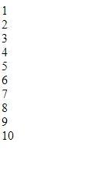 **=OUTPUT**

**Q4= Create a webpage and show the output from 1 to 10 in separate lines, each number being in different color?**

<HTML>

<HEAD>

<TITLE> HELLO WORLD </TITLE>

</HEAD>

<body>

<font color="red"> 1 </font><br>

<font color="blue"> 2 </font><br>

<font color="green"> 3 </font><br>

<font color="black"> 4 </font><br>

<font color="brown"> 5 </font><br>

<font color="pink"> 6 </font><br>

<font color="orange"> 7 </font><br>

<font color="purple"> 8 </font><br>

<font color="grey"> 9 </font><br>

<font color="yellow"> 10 </font><br>

</body>

</html>

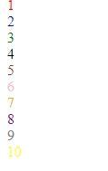  **=OUTPUT**

**Q5= how to make a picture as a background on my web pages?**

ANS= <HTML>

<HEAD>

<TITLE> HELLO WORLD </TITLE>

</HEAD>

<body>

<body background="C:\Users\student\Downloads/download.jpg">

</body>

</html>



**= OUTPUT**

**Q6=Create a web page to print a paragraph with 4-5 sentences, each sentences shall have a different font?**

**Ans=** **<html>**

**<head>**

**<title> BCA IB </title>**

**</head>**

**<body>**

**<h1>Riaz Mohd</h1>**

**<P>**

**<B>My name is riaz mohd.</B><br>**

**<I>I am Currently studing in manav rachna international institute of research and science. It is situated in**

**Badkhal, Faridabad. </I>**

**<br> <U> My course that i am pursuing right now is BCA(AI/ML) </U>.**

**<br><B> My Hobbies are playing games and watching movies and sometimes i go to play**

**Football with My friends.</B><br>**

**</p>**

**</body>**

**</html>**

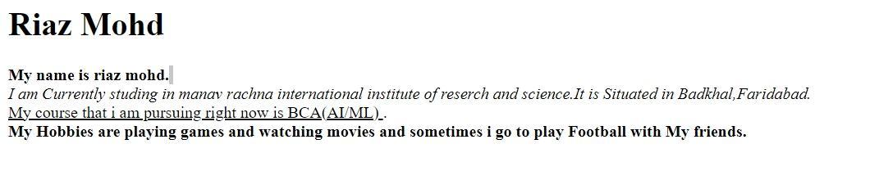

**= OUTPUT**

**Q7=write HTML code to print a paragraph that is described of a book, it shall include the title should be underlined and all adjectives shall be bold and italics?**

<HTML>

<HEAD>

<TITLE>BOOK </title>

</head>

<Body>

<H1><u><b> Title Of The Book: Harry potter</b></u></H1>

<p><i> Author Name: J.K Rowling <br></i>

<i>Harry Potter is a series of novels by British author J. K. Rowling. The novels follow Harry Potter,

an 11-year-old boy who discovers he is the son of famous wizards and will attend Hogwarts School of Witchcraft and Wizardry.

Harry learns of an entire society of wizards and witches. He befriends several Hogwarts students and teachers along his journey.

Each novel chronicles one year in Harry's life and

his adventures discovering the events that led to his parents' deaths at the hands of Lord Voldermort, a dark wizard believed long dead.</i></P>

</p>

</body>

</html>

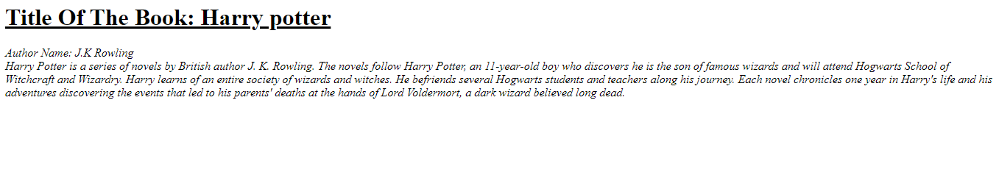

**Q8: Write HTML code to print your name using heading tag, every letter shall be of different heading size?**

**<HTML>**

**<HEAD>**

**<Title> RIAZ </Title>**

**</HEAD>**

**<BODY>**

**<H1> R</h1>**

**<H2> I</h2>**

**<H3> A</h3>**

**<H4> Z</h4><br>**

**<H5> M</h5>**

**<H6> O</h6>**

**<H1> H</h1>**

**<H2> D</h2>**

**</body>**

**</html>**

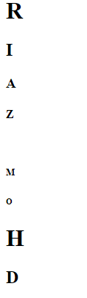

**Q9:Write Html code to print the sequence of number 1-20. each no shall be in different line with number 2 next to it as subscript, an equal sign and the result?**

**Ans:** <html>

<head>

<title>Number Sequence</title>

</head>

<body>

<p>1<sub>2</sub> = 1</p>

<p>2<sub>2</sub> = 4</p>

<p>3<sub>2</sub> = 9</p> <p>4<sub>2</sub> = 16</p> <p>5<sub>2</sub> = 25</p> <p>6<sub>2</sub> = 36</p> <p>7<sub>2</sub> = 49</p> <p>8<sub>2</sub> = 64</p> <p>9<sub>2</sub> = 81</p>

<p>10<sub>2</sub> = 100</p> <p>11<sub>2</sub> = 121</p> <p>12<sub>2</sub> = 144</p> <p>13<sub>2</sub> = 169</p> <p>14<sub>2</sub> = 196</p> <p>15<sub>2</sub> = 225</p> <p>16<sub>2</sub> = 256</p> <p>17<sub>2</sub> = 289</p> <p>18<sub>2</sub> = 324</p> <p>19<sub>2</sub> = 361</p> <p>20<sub>2</sub> = 400</p> </body>

</html>

Output:

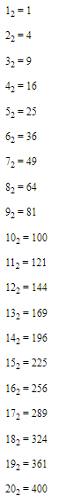

Q10. wtrite an html code to display an image with border of size with width 200 height 200 pixels , leaving Hspace and Vspace of your choice with image hanging in the right side on the screen.

Ans: <HTML>

<head>

<title>Image Display</title>

<style>

img {

border: 2px solid black;

width: 250px;

height: 250px;

display: block;

margin-left: auto;

margin-right: 0;

margin-top: 20px;

margin-bottom: 20px; }

</style>

</head>

<body>

<img src="C:\Users\student\Downloads/jerry-zhang-nxu_VUcBVdA-unsplash.jpg" alt="Sample Image">

</body>

</html>

Output:



Q11: write a html code to create a web page with heading. the heading shall be displayed at the top-centre of the page and the image shall be at the centre , just below the heading .

INPUT- <html>

<head>

<title>Centered Heading and Image</title>

<style>

body {

margin: 0;

font-family: Arial, sans-serif;

text-align: center;

justify-content: center;

align-items: center;

</style>

</head>

<body>

<h1>The Triumph of India 2024</h1>

<img src="C:\Users\Riaz\Downloads/riaz.jpg" alt="scenery" height="450" , width='450'>

</body>

</html>

Output:



Q12. Write HTML code using Multimedia tags.

<html>

<head>

<title> multimedia tags</title>

</head>

<body>

<h1> multimedia tags: </h1>

<h1>img</h1>

<center>

<img src="C:\Users\Riaz\Downloads/riaz.jpg" alt="scenery" height="450" , width="450"/>

<h1> audio </h1>

<audio src="C:\Users\Riaz\Downloads/ringtone.mp3" controls/>

</body>

</html>

Output:

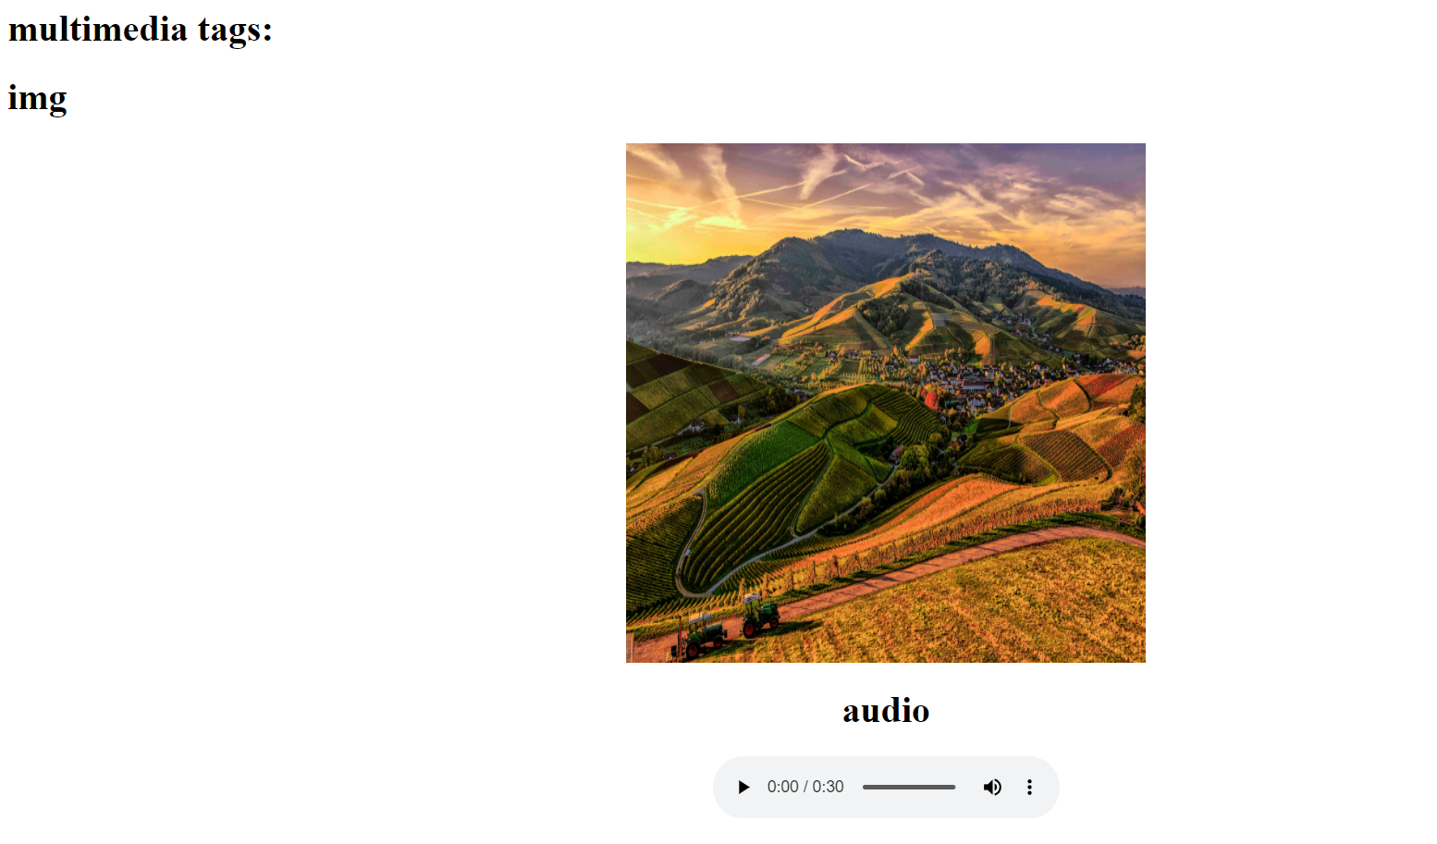

**Video tag:**

**<html>**

**<head>**

**<title> multi media tags</title>**

**</head>**

**<body>**

**<video src="C:\Users\Riaz\Downloads/vidio.mp4" width="720" heigth="480" alt="vidio" controls="control">**

**</video>**

**</body>**

**</html>**

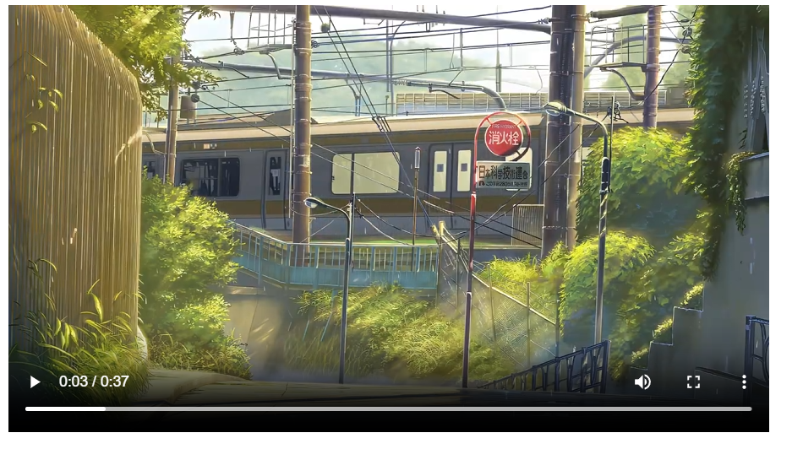

**Q13:** **Create a Table using Rowspan and Colspan taking example of student Record?**

**Ans:**

1. **rowspan**

**<html>**

**<head>**

**<title> my world </title>**

**</head>**

**<body>**

**<h1> table </h1>**

**<table border="2">**

**<tr>**

**<th> name</td>**

**<th> roll no</td>**

**</tr>**

**<tr>**

**<td >riaz</td>**

**<td rowspan="2">23</td>**

**</tr>**

**<tr>**

**<td> astitva</td>**

**</tr>**

**</table>**

**</body>**

**</html>**

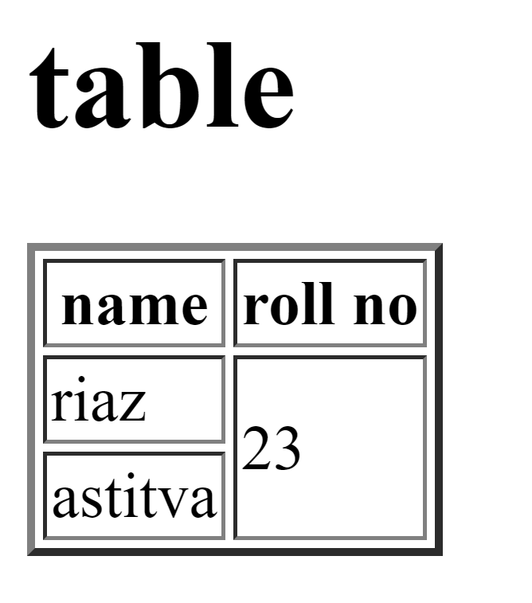

Colspan:

<html>

<head>

<title> my world </title>

</head>

<body>

<h1> table </h1>

<table border="2">

<tr>

<th> name</td>

<th> roll no</td>

<th> class</th>

</tr>

<tr>

<td >riaz</td>

<td colspan="2">23</td>

</tr>

<tr>

<td> astitva</td>

<td> 24</td>

<td> bca </td>

</tr>

</table>

</body>

</html>

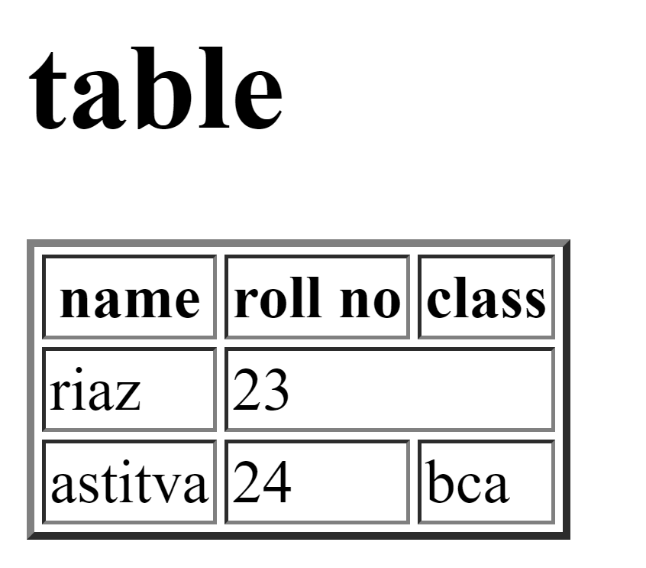

**Q14: Write HTML code using table tag <table> and cellpadding and cellspacing as its attributes**?

<html>

<head>

<style>

table, th, td {

padding : 15;

Spacing : 15;

}

</style>

</head>

<body>

<table border="1">

<tr>

<th> Name </th>

<th> Class </th>

<th> Roll No. </th>

</tr>

<tr>

<td> Riaz </td>

<td> 1B </td>

<td> 39 </td>

</tr>

<tr>

<td> Sahil </td>

<td> 1B </td>

<td> 40 </td>

</tr>

</table>

</body>

</html>

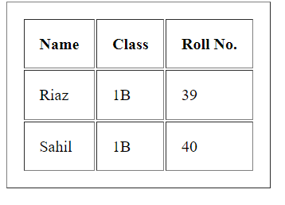

Q15: Create unordered, ordered and definition Lists taking example of your subjects in MCA IST, IInd and IIIrd Semester?

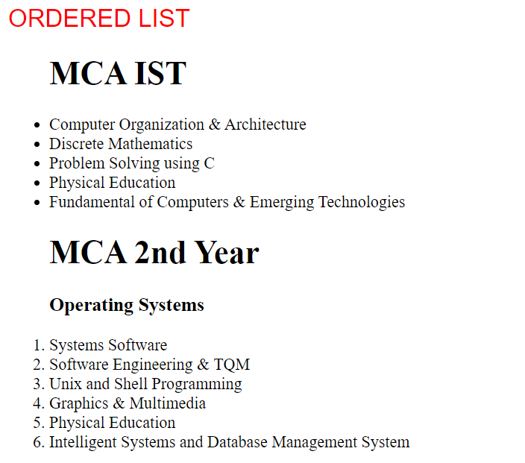

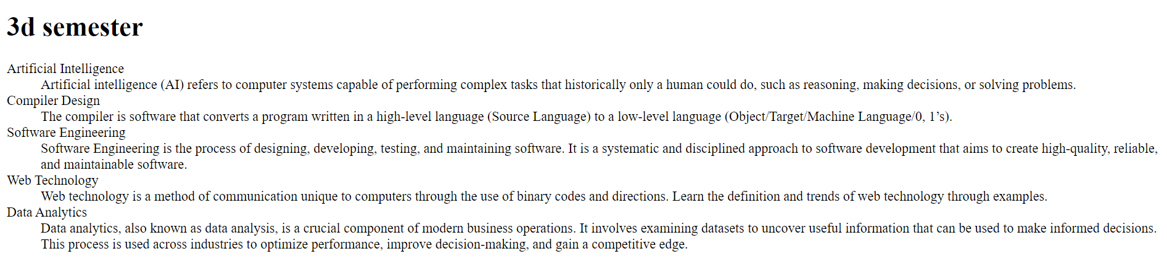

Q17:Write HTML code to design a form in HTML using controls and buttons such as Textbox , Text area,

password, submit button, browse button, drop-down menu?

Ans: <html>

<body>

<h1> FORM </h1>

<fieldset>

<label for="name">Name:</label>

<input type="text" id="name" name="name" required/>

<br><br>

<label for="name">Name:</label>

<input type="text" id="name" name="name" required/>

<br><br>

<label for="Password">Password:</label>

<input type="Password" id="Password" name="Password" required/>

<br><br>

<label for=”file">File</label>

<input type="file" id=" file " name=" file " required/>

<br><br>

<h3> text area</h3>

<textarea cols="50" rows="5"/></textarea><br><br>

<button type="submit">Submit</button>

<button type="reset">Reset</button><br><br>

<select id="cars" name="cars">

<option value="Creta" id="cars" name="cars">Creta</option>

<option value="Brezza" id="cars" name="cars">Brezza</option>

<option value="Mustang" id="cars" name="cars">Mustang</option>

</select>

</fieldset>

</form>

</body>

</html>

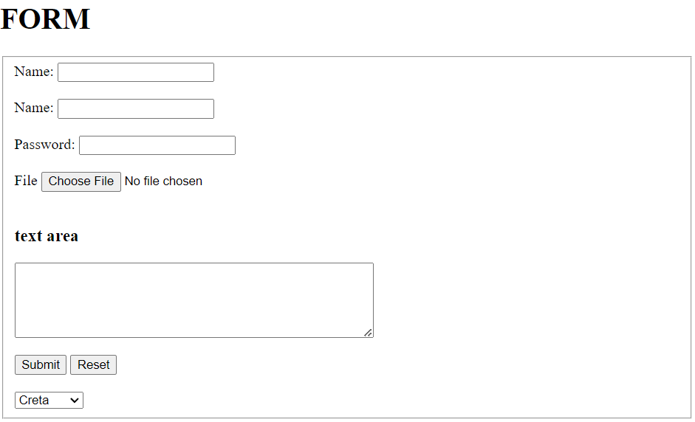

Q18: Write HTML code to design a Registration Form in HTML?

Ans: <html>

<head>

<title> Form </title>

</head>

<body bgcolor="silver">

<h1>FORM</h1>

<form>

<fieldset>

<legend><font color="red" size="5" face="arial"><b>COLLEGE FORM</b></font></legend>

<label for="fname" id=name><b>Name:</label><br>

<input type="text" required>

<label for="12th Marks" id="name"><b> 12th Marks (%): </b></label>

<input type="number" max="100" min="33" required/>

<b> Upload here</b>

<input type="file"/><br>

<label for="Email" id=name required>Email:</label><br>

<input type="Email"/>

<label for="10th Marks" id="name" required ><b>10th Marks (%): </b></label>

<input type="number" max="100" min="33"/>

<b> Upload here</b>

<input type="file" name="mark sheet"/><br>

<label for="Name" id=name>Father's Name:</label><br>

<input type="text"/>

<font color="red">Character certificate</font>

<input type="file" required/><br>

<label for="Course Name" id=name>Course Name:</label><br>

<input type="text"/>

<font color="red">Migration certificate</font>

<input type="file"/><br><br>

<b>Phone No:</b>

<input type="text" size="9" maxlength="10" required/>

<hr>

<b><font size="2" color="red" face="arial"><u> gender</u></font></b><br>

<input type="radio" name="gender"/>

<label for="gender" name="gender">Male</label>

<input type="radio" name="gender"/>

<label for="gender" name="gender">female</label>

<input type="radio" name="gender"/>

<label for="gender" name="gender">others</label><br>

<b><font size="2" color="red" face="arial" ><u>Subject</u></font></b><br>

<input type="Checkbox"/>

<label for="Subject" name="subject">Wt</label>

<input type="Checkbox"/>

<label for="Subject" name="subject">Dbms</label>

<input type="Checkbox"/>

<label for="Subject" name="subject">ITPC</label>

<input type="Checkbox"/>

<label for="Subject" name="subject">Eng</label>

<input type="Checkbox"/>

<label for="Subject" name="subject">History</label><br>

<font color="red" size="2" face="arial"><u>Section</u></font>

<select id="section" name="section" required>

<option value="A">A</option>

<option value="B" selected>B</option>

<option value="C">C</option>

<option value="D">D</option>

</select><br>

<hr>

<lable for="date" name="birth">DOB:</lable>

<input type="date" max="2007" min="2003" required/><br><br>

<lable for="date" name="birth">Date of joining</lable>

<input type="month" id="joining" required/><br>

<br>

<textarea rows="5" cols="40">Review:</textarea><br><br>

<button>Submit</button>

<button>Cancel</button>

</fieldset>

</form>

</body>

</html>

OUTPUT:

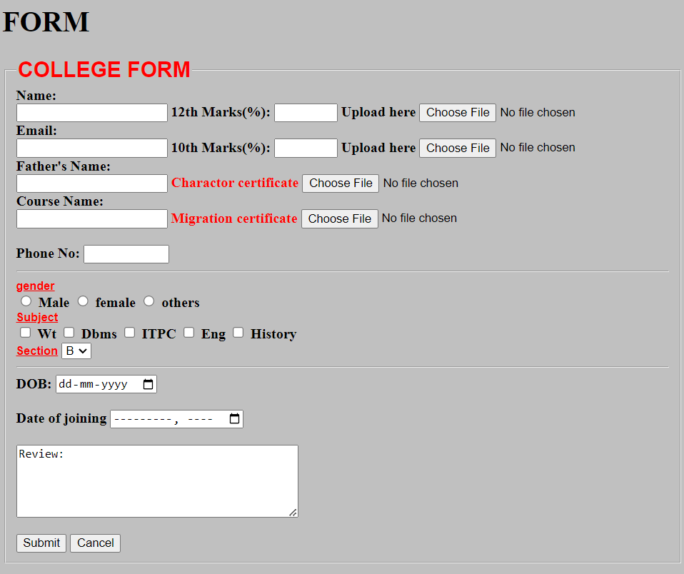

Q19. Write HTML code to design a student admission Form in HTML?

Ans:

<html>

<head>

<title> Form </title>

</head>

<body bgcolor="silver">

<h1>FORM</h1>

<form>

<fieldset>

<legend><font color="red" size="5" face="arial"><b>REGISTRATION FORM</b></font></legend>

<label for="fname" id=name><b>Name:</label><br>

<input type="text" required>

<label for="12th Marks" id="name"><b> 12th Marks (%): </b></label>

<input type="number" max="100" min="33" required/>

<b> Upload here</b>

<input type="file"/><br>

<label for="Email" id=name required>Email:</label><br>

<input type="Email"/>

<label for="10th Marks" id="name" required ><b>10th Marks (%): </b></label>

<input type="number" max="100" min="33"/>

<b> Upload here</b>

<input type="file" name="mark sheet"/><br>

<label for="Name" id=name>Father's Name:</label><br>

<input type="text"/>

<font color="red">Charactor certificate</font>

<input type="file" required/><br>

<label for="Course Name" id=name>Course Name:</label><br>

<input type="text"/>

<font color="red">Migration certificate</font>

<input type="file"/><br><br>

<b>Phone No:</b>

<input type="text" size="9" maxlength="10" required/>

<hr>

<b><font size="2" color="red" face="arial"><u> gender</u></font></b><br>

<input type="radio" name="gender"/>

<label for="gender" name="gender">Male</label>

<input type="radio" name="gender"/>

<label for="gender" name="gender">female</label>

<input type="radio" name="gender"/>

<label for="gender" name="gender">others</label><br>

<b><font size="2" color="red" face="arial" ><u>Subject</u></font></b><br>

<input type="Checkbox"/>

<label for="Subject" name="subject">Wt</label>

<input type="Checkbox"/>

<label for="Subject" name="subject">Dbms</label>

<input type="Checkbox"/>

<label for="Subject" name="subject">ITPC</label>

<input type="Checkbox"/>

<label for="Subject" name="subject">Eng</label>

<input type="Checkbox"/>

<label for="Subject" name="subject">History</label><br>

<font color="red" size="2" face="arial"><u>Section</u></font>

<select id="section" name="section" required>

<option value="A">A</option>

<option value="B" selected>B</option>

<option value="C">C</option>

<option value="D">D</option>

</select><br>

<hr>

<lable for="date" name="birth">DOB:</lable>

<input type="date" max="2007" min="2003" required/><br><br>

<lable for="date" name="birth">Date of joining</lable>

<input type="month" id="joining" required/><br>

<br>

<textarea rows="5" cols="40">Review:</textarea><br><br>

<button>Submit</button>

<button>Cancel</button>

</fieldset>

</form>

</body>

</html>

OUTPUT:

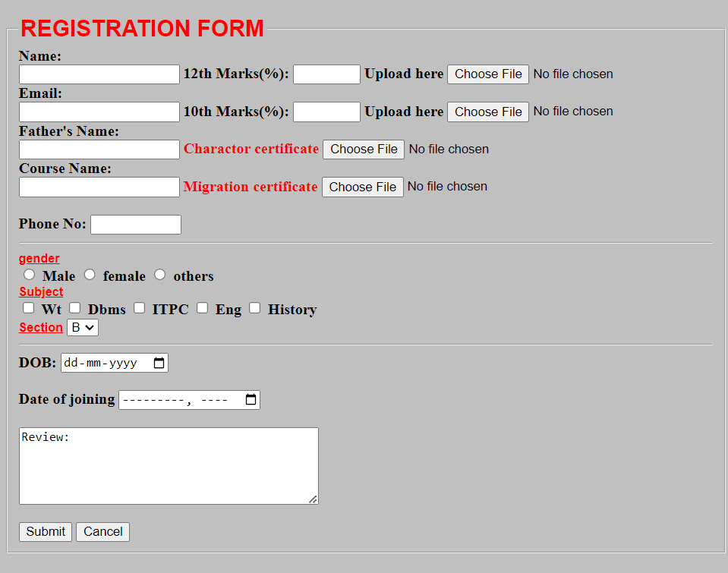

Q20: Create a proper home page of your own using any components and styles?

Ans: <html>

<head>

<style>

/* different styles of heading */

H1, h2, h3 {

text-align: center;

color: Red;

}

#para1 {

text-align: center;

color: Blue;

font-size:15;

}

.center{text-align: center;

color: Green;

font-size:25;

font-family: sans-serif;

}

</style>

</head>

<body bgcolor="pink">

<H1> Drop Box</h1>

<h2> Work Better, safer, together </h2>

<p id="para1">Dropbox business simplifies your work, with a central place to access and share files </p>

<p class="center"> try Dropbox for free</p>

<hr>

</body>

</html>

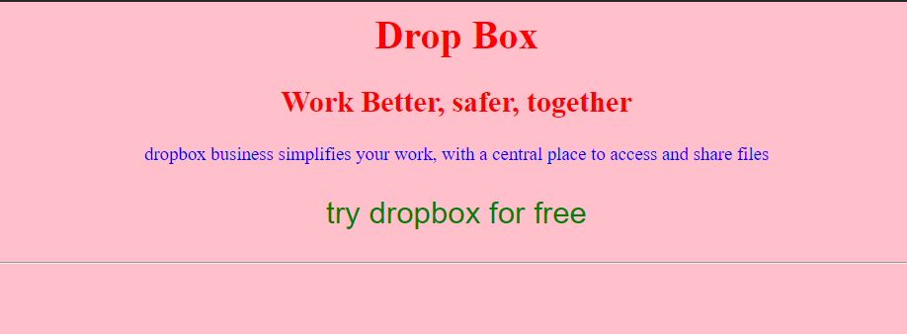

Q21. Write HTML code for including Local hyperlinking in a web page.

Input:

<html>

<body>

<h1>Local Hyperlinking</h1>

<p>HTML code for including Local hyperlinking in a web page.</p>

<a href="#Riaz">Jump to page 2</a>

<h2 id="Riaz">Section 2</h2>

<p>This is the page 2.</p>

</body>

</html>

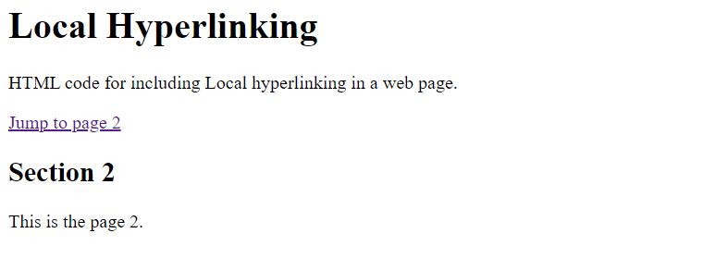

Q22. Write HTML code for including Inter hyperlinking in a web page.

<html>

<body>

<h1>Inter Hyperlinking</h1>

<p>This is a sample paragraph. </p>

<a href="page2.html">Go to Page 2</a>

</body>

</html>



Q23. Write HTML code for including External hyperlinking in a web page. ?

<html>

<body>

<h1>External Hyperlinking</h1>

<p>This is a sample paragraph.</p>

<a href="https://www.example.com">Visit Example Website</a>

</body>

</html>



Q24. Write code to show External CSS with HTML code.

<html>

<head>

<title>External CSS</title>

<link rel="stylesheet" href="styles.css">

</head>

<body>

<h1>Hello,World!</h1>

<p>This is a paragraph.</p>

</body>

</html>



Q25. Write code to show Internal CSS with HTML code.

<html>

<head>

<style>

body {

font-family: Arial;

background-color:blue;

}

h1 {

color:green;

text-align:center;

}

p {

color: red;

font-size: 18px;

}

</style>

</head>

<h1>Hello World!</h1>

<p>This is a paragraph styled with internal CSS to show styled sheet.</p>

</body>

</html>



Q26. Write code to show Inline CSS with HTML code?

<html>

<body>

<h1 style="color: blue; text-align: left;">Hello World!</h1>

<p style="color: red; font-size: 15px;">This is a paragraph styled with inline

CSS. </p>

</body>

</html>

