**Guideline**

1. Install package using cmd: composer require spatie/laravel-database-mail-templates
2. Publish migration: php artisan vendor:publish --provider="Spatie\MailTemplates\MailTemplatesServiceProvider" --tag="migrations"
3. Create 2 Mailable Class using cmd: php artisan make:mail WelcomeMail and do as below  
   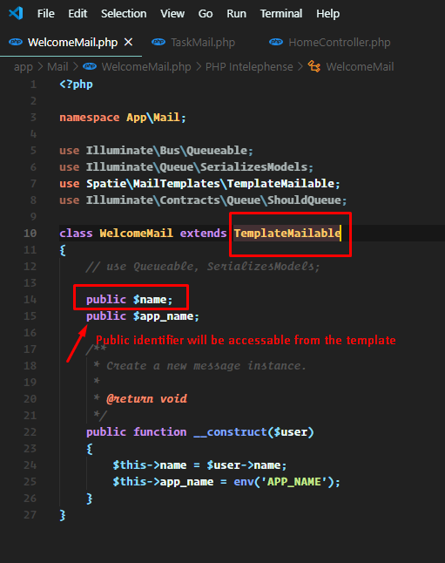  
   and php artisan make:mail TaskMail   
   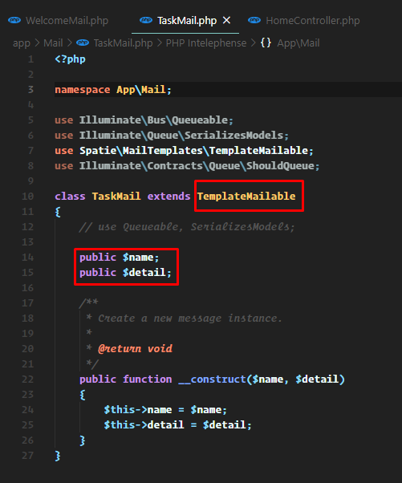
4. Now the template needs to create. I am creating the templates from the seeder. You can add it from **form** also.  
   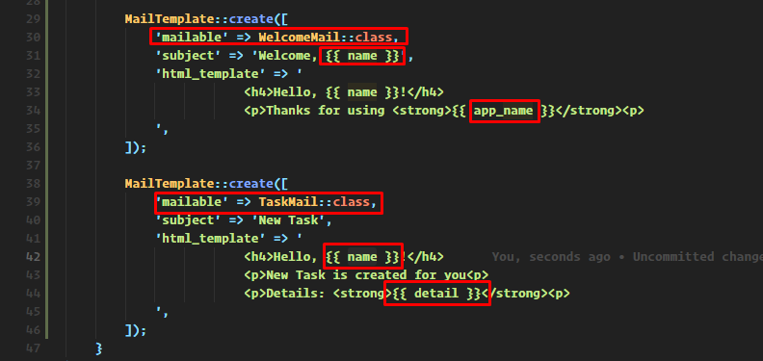
5. Then run migrate using cmd: php artisan migrate --seed
6. Then edit the register method for sending welcome email. As below  
     
   and send after creating task send mail as below



1. Configure email in env file  
   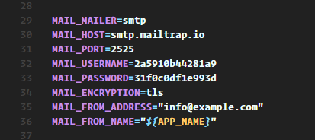
2. Now test it.