**Square Integration:**

1. Install nikolag/laravel-square pkg using cmd: composer require nikolag/laravel-square
2. Publish config using cmd: php artisan vendor:publish --tag=nikolag_config
3. Add square token, id, sandbox, location id in .env  
   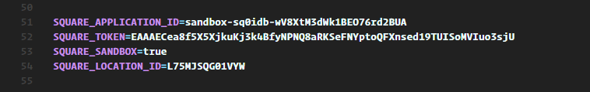
4. Create controller SquarePaymentController:   
   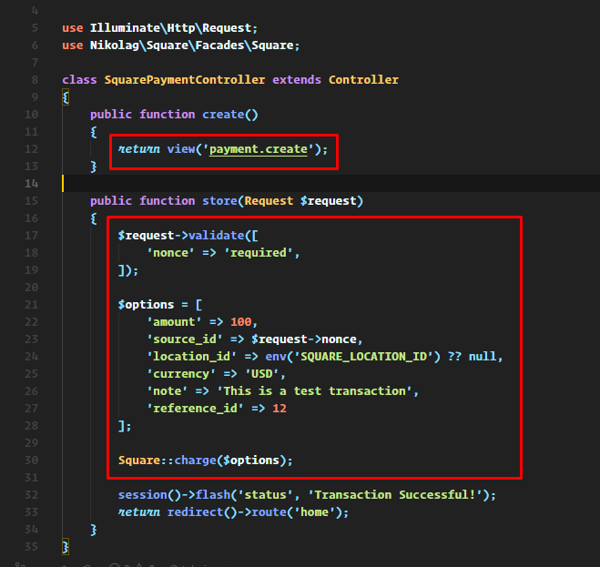
5. Create the resources/views/payment/create.blade.php file: see my file
6. Paste the js, css script in public/square  
   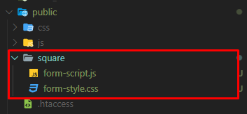
7. Login in to the system and from home controller click the payment btn and test it.