FlexiSpace Boardroom Booking System
Project Plan

1. Introduction
This document sets out our plan for building the FlexiSpace boardroom booking system: a centralised platform allowing staff and centre managers to book meeting rooms across your locations, with real-time synchronisation to Microsoft Outlook calendars.
We're sharing this so you know exactly what to expect from us over the coming weeks — what we're building, in what order, and when you'll see working progress. We'll check in with you at each phase boundary below, and welcome feedback at any point in between.
In short: you'll have a fully working system by week 10 (29 September) — in line with the 10-11 week estimate in your original plan — followed by final testing, documentation, and formal handover shortly after.

2. How the system fits together
The diagram below shows the key parts of the system and how they communicate.
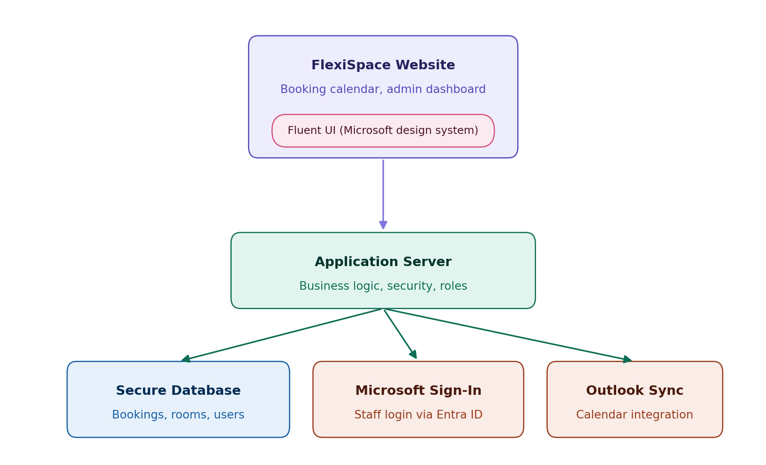
The website is what your team will use day to day. Behind it, an application server handles all the booking logic and security, a secure database stores all booking and user records, and the system connects to Microsoft's sign-in and Outlook services so staff can use their existing accounts and calendars.

3. Project phases
We're working in three phases, each ending in a milestone. At every milestone, we'll give you feedback on progress and show you what's been built — so you're never waiting long without an update.

Phase | Sub-phase | Dates | What happens
1. Design & Prototype | 1.1 Discovery | 20 Jul – 24 Jul(week 1) | Requirements confirmed, room/location list finalised, system architecture agreed
 | 1.2 Design | 27– 31 Jul (week 2) | Database and screen designs finalised; security and integration approach confirmed
 | 1.3 Prototype | 3 – 14 Aug (week 3-4) | Early working prototype of the core booking flow built and demoed
 | 1.4 Submission & Demo | 17 Aug (Mon) | Task 1 submission; prototype demoed to you
2. Core Build | 2.1 Foundation | 18 – 31 Aug (weeks 5–6) | Sign-in, booking engine, and Outlook calendar sync built
 | 2.2 Website | 1 – 14 Sept (weeks 7–8) | Booking calendar, admin dashboard, and core screens built and connected
 | 2.3 Hosting & Integration | 15 – 21 Sept (week 9) | System deployed to secure hosting; all parts connected and tested together
 | 2.4 System Demo | 22 – 28 Sept (week 10) | Final polish; working system demoed to you; Task 2 submitted
3. Finalisation & Handover | 3.1 Testing | 29 Sept onward | Full testing of all features and the Outlook sync
 | 3.2 Documentation | TBC | User guide and final documentation completed
 | 3.3 Handover | TBC | Final walkthrough, training, and formal handover

This keeps us on pace with the 10–11 week estimate in your original plan — a fully working system by week 10, with final polish and handover following shortly after.

4. Feedback and check-ins
We'll come to you for feedback at the end of every phase above, not just at the very end of the project — so if anything needs to change, we can adjust early rather than late. If you'd like a shorter, regular check-in on top of this, we're happy to set that up too.

