FlexiSpace Boardroom Booking System
Team Working Plan — Website & Mobile
Internal document — course INSY7315, week starting 20 July 2026

1. Purpose of this document
This is our shared reference for who's building what, how we avoid stepping on each other's code, and what's due when. If you're unsure what to work on or how your piece connects to someone else's, check here first before pinging the group chat.

2. System architecture
One backend serves both the website and the mobile app. Neither app talks to the database directly — everything goes through the API.
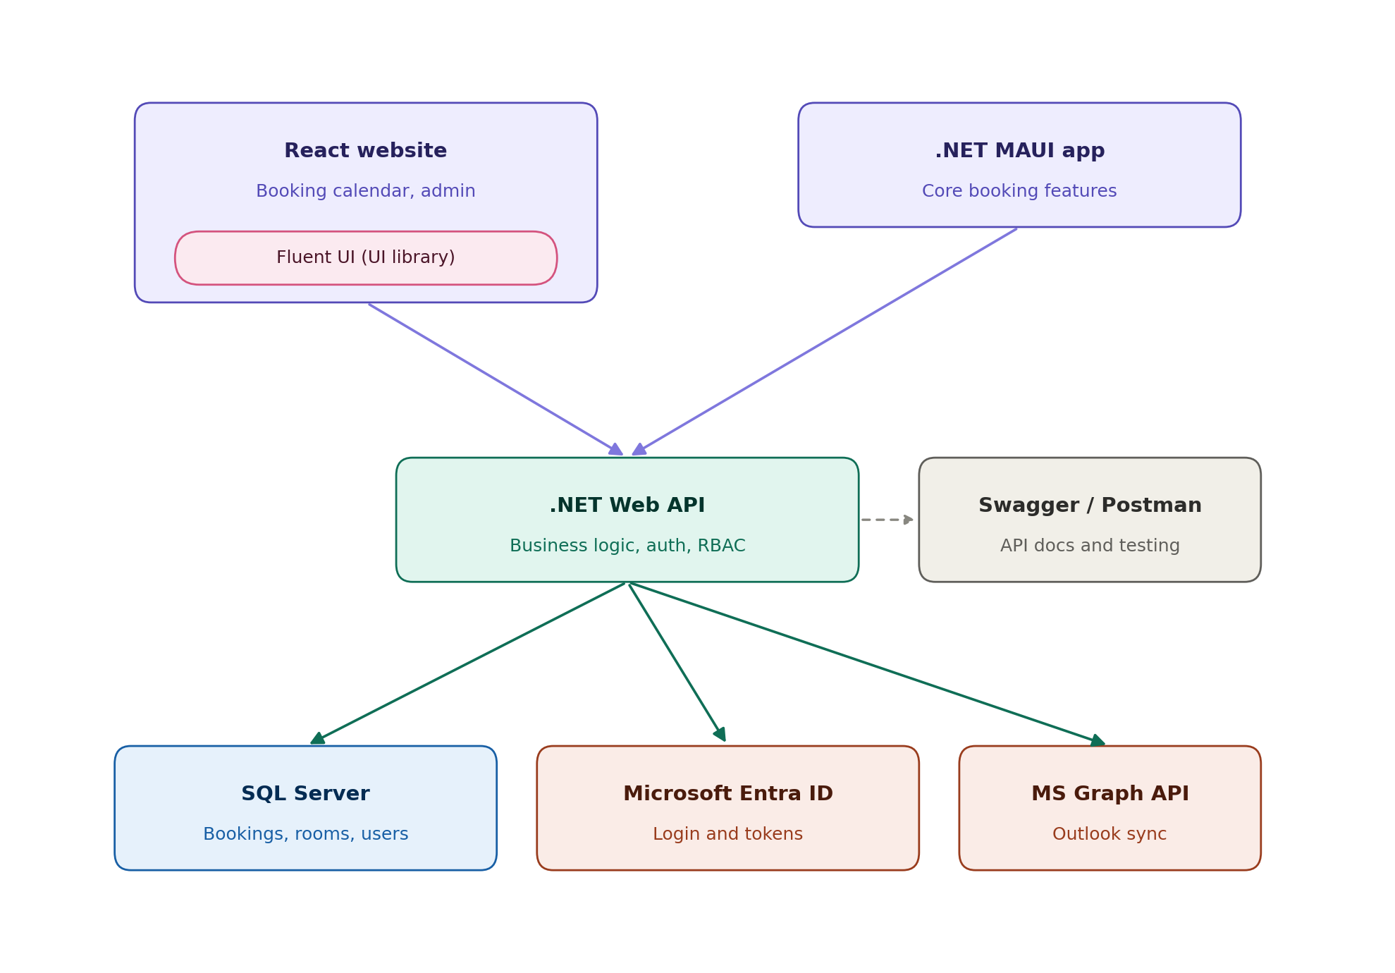

3. Roles and responsibilities
Person | Owns | Specific tasks
Khensani | Database, authentication, calendar integration, chatbot | Database schema and EF Core models · Entra ID login and token handling · Microsoft Graph / Outlook calendar sync · Teams meeting links · Chatbot/AI feature
Tino | Business logic — bookings | Booking CRUD (create/view/edit/cancel) · Conflict detection · Search, filter, pagination on bookings · Unit tests for booking logic
Denzel | Business logic — roles, admin, notifications | RBAC enforcement · Admin/user management endpoints · Audit trail · Notifications (email/in-app) · Reporting/export logic
Khumo | Website UI | React + Fluent UI screens · Login, booking calendar, booking forms · Admin dashboard UI · Connecting screens to the API as endpoints land
Riba | Mobile UI | .NET MAUI screens · Login, view availability, book/cancel · Notifications on mobile · Connecting screens to the API as endpoints land

5. How we're using GitHub
- Repo structure: separate top-level folders — /Backend (Kim, Tino, Denzel, split into /Backend/Data, /Backend/Bookings, /Backend/Users), /Website (Khumo), /Mobile (Riba).
- GitHub Projects board: columns To do / In progress / In review / Done. Every task is an issue, assigned to one person, tagged by area (backend / website / mobile).
- Milestones matching the phases in section 6 below, so progress is visible at a glance.
- Branch naming: feature/short-description (e.g. feature/booking-conflict-check). One branch per issue.
- Never commit directly to main. Every branch merges via a pull request with at least one teammate's review.
- Commit messages reference the issue number so history is traceable.
- .env.example committed for each component (Backend, Website, Mobile); real secrets never committed.
- README kept current with setup steps for all three components as they're built.
- Attendance: team leader/secretary (Kim) logs weekly lecturer session attendance, in addition to the lecturer's own tracking.

6. Phases and sub-phases
Dates are fixed by the INSY7315 assessment schedule (Task 1: 17 Aug, Task 2: 28 Sept, Task 3: Exam Week 1, TBC). This week (20-24 July) is week 1.

Phase 1 — Task 1: Documentation & Prototype (25%, due Mon 17 Aug)
Sub-phase | Dates | Khensani | Tino & Denzel | Khumo & Riba
1.2 Design | 27–31 Jul (wk2) | Finalise schema, EF Core models, migration; Entra ID login spike | Draft business rules (conflict logic, roles) against the schema | Wireframes; Fluent UI / MAUI project scaffolding
1.3 Prototype build | 3–14 Aug (wk3–4) | Working login; basic booking table in DB | Stub booking create/view endpoints against mock or early real data | Build login + one core screen against mock data  Depends on you
1.4 Submit | 17 Aug (Mon) | Architecture, security, DevOps doc sections | Requirements, analysis artifacts, data schema doc sections | Prototype demo screens; documentation review

Phase 2 — Task 2: Build (50%, due Mon 28 Sept)
Sub-phase | Dates | Kim | Person 2 & 3 | Person 4 & 5
2.1 Foundation | 18–31 Aug (wk5–6) | Finish Entra ID; start Graph/Outlook sync | Real booking CRUD + conflict detection against live DB | Connect login screens to real auth endpoint
2.2 Core features | 1–14 Sept (wk7–8) | Finish Graph sync; start chatbot feature | RBAC enforcement; admin endpoints; notifications | Booking calendar (website) / availability + book screens (mobile), connected to real API
2.3 Hosting & integration | 15–21 Sept (wk9) | Azure hosting setup; Teams links | Audit trail; reporting/export; integration testing | Admin dashboard (website) / notifications (mobile)
2.4 Polish & submit | 22–28 Sept (wk10) | Finish chatbot; bug fixes | Bug fixes; unit tests finalised | UI polish; connect any remaining screens; submit by 28 Sept

Phase 3 — Task 3: Final Submission (25%, Exam Week 1 — TBC)
- Combine Task 1 + Task 2 documentation into one updated document — whoever owns a section updates their own part.
- Write the user guide (split website/mobile sections between website and mobile owners).
- Prepare the EXPO presentation — everyone presents their own component.
- Each person completes the peer-evaluation form individually.

7. Essentials for both website and mobile — don't skip these
- Both apps consume the same API — never build a feature into one UI's logic that should live in the backend (e.g. don't calculate booking conflicts separately in React and in MAUI).
CORS = Cross-Origin Resource Sharing.
It's a browser security rule that controls whether a website running on one domain is allowed to make a request to an API running on a different domain.

- CORS must be configured on the backend for the website's domain, or the React app won't be able to call the API from the browser.
- Mobile auth tokens go in secure device storage (Keychain/Keystore) — never in plain app storage.
- Keep API response shapes consistent — if a field changes for the website, it changes for mobile too, at the same time, communicated in the group chat.
- Both UIs need to handle the same error cases (booking conflict, network failure, expired session) — check with each other that you're not handling errors inconsistently.
- Environment config (.env) is separate per component but should point to the same backend URL during testing.
- Test on a real or emulated device for mobile before assuming a feature works — the emulator and a real phone can behave differently, especially for notifications and secure storage.

8. Security — built in from the start

Backend & API
- Role checks enforced server-side on every endpoint — never trusted from the front end alone.
- Passwords/tokens never logged or stored in plain text.
- Parameterised queries / EF Core only.
- Rate limiting and lockout on login, registration, password reset.
- No stack traces or raw database errors returned to clients.
- Audit log recording who did what and when.

Mobile app
- Tokens stored in secure device storage, never plain text.
- No API keys or secrets hardcoded into the app bundle.
- HTTPS only for all API communication.

General
- All secrets in environment variables, never committed to Git.
- POPIA awareness documented: what personal data is stored, why, and how it's protected.

9. Future enhancements worth adding
Enhancement | Why it's easy for us | Effort
Microsoft Teams meeting links | Reuses the Graph integration already built for Outlook sync | Low
QR code check-in | Reuses an existing booking ID plus a status-update endpoint similar to cancel/confirm | Low
Catering request notifications | Reuses the same notification pipeline built for booking confirmations | Low

10. Things easy to forget
- AI feature — a real, working feature (e.g. suggesting the best available room/time), not decorative. Free-tier API only.
- Minimum two user roles with separate dashboards.
- Soft delete/archiving on bookings, not permanent hard-delete only.
- Pagination, search, filtering, sorting on all list views.
- ER diagram, architecture diagram, and UML class + sequence diagrams.
- Unit tests covering core business logic.
- Professional Conduct in the Workplace Programme (Annexure E) — individual, due week 1, unmarked but mandatory for everyone.

11. Next check-in
Weekly lecturer session, every week. Team sync outside of that as needed — flag blockers in GitHub issues, not just verbally, so they're tracked.

