ALEXANDER RYBAK  Odessa, Ukraine  Contact: 048 787-08-77;  E-mail: ribakalexander@gmail.com | 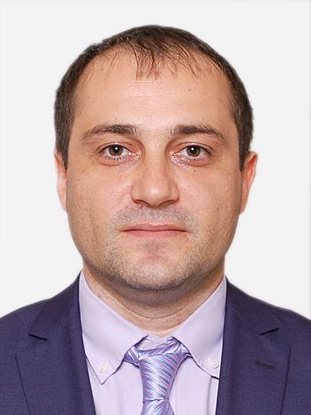

Core skills:

- Basic knowledge HTML, CSS, JavaScript, PHP, MySQL, Adobe Photoshop;
- My portfolio: ar-portfolio.inf.ua; my project: multigrushki.com
- Languages: English – intermediate (IELTS: 6.5); Russian, Ukrainian - native;
- Strong communication with excellent interpersonal skills at all levels of experience.

Education
1998-2003 | Odessa State Economic University | M.A. Economic of Organization
2004-2007 | Odessa State Agrarian University, Faculty of Postgraduate Education | M.A. Accounting

Employment History:

October, 2014 – at the present time | “Intertelecom LCD”  Head of the economic security department | - Organization and control of experts in department in accordance with the company's business objectives;  - Training specialists of the department;  - Ensure effective implementation of changes in the internal company’s procedures;  - Verification of all prepared documents:  - Preservation of confidential company information;  - Identifying violations of international traffic routing by using specialized software;  - Planning and implementation of preventive measures for the protection of company revenue losses;  - Control over the development and acquisition of software and hardware systems to counter FRAUD;  - Look for signs of fraud on the part of subscribers;  - Development of algorithms for the detection of low-quality connectivity and abuse during service:  - zero traffic;  - lack of reinforcements;  - subscriber data changes;  - Development of measures to minimize incorrect connections;  - Collection schemes identified violations when connecting subscribers to the network;  - Identification of those responsible for the violation of internal rules and procedures of the company.
December, 2012 – October, 2014 | “Intertelecom LCD”  Head of Customer Care Center | - Coordination and building of effective department work (44 employees in hand);  - Ensuring the implementation of the monthly plan for sales of goods and services;  - Development of measures to promote the company's services;  - Control over the safety of trade premises and inventory items, maintaining in proper condition;  - Interviewing for staff, training new staff members of the Department, coordinating their further work;  - Bookkeeping in the department (preparation of all financial statements);  - Maintaining of all administrative and economic activities;  - Document storage, management of cash discipline, budget management;  - Prompt resolution of unusual situations;  - Work with VIP clients and the settlement of conflict situations.
November, 2009 – December, 2012 | “Intertelecom LCD”  Corporate Account Manager | - Searching for potential customers and partners;  - Conducting commercial negotiations with customers in the interests of the company;  - Planning and analysis of the demand for telecommunications services;  - Preparing and compiling monthly sales plan;  - Statistical analysis of sales data;  - Providing work reports in accordance with the regulations of the department and the company;  - Carry out marketing research on the demand for the company's services, the price level of competitors, sales prospects for the development of the market;  - Information support of clients;  - Interaction with the company's units in order to fulfill its tasks, participation in the workshops;  - Participate in the consideration of the incoming claims and complaints of customers;  - Ensuring the planned sales;  - Monitoring the timely receipt of funds for the sold services.
June 2008 – June, 2009 | “UkrSibbank BNP Paribas Group”  Department Director | - Ensuring the implementation of the business plan entrusted to the department;  - Organization involvement and customer service;  - Providing quality customer service;  - Work with a personal client portfolio and its high-quality support;  - Organization of banking operations and internal control operations;  - Assessing and monitoring the status of the client portfolio;  - Participation in the credit committee;  - Distribution of functional responsibilities of staff offices, monitoring their daily work;  - Provide adequate and prompt repayment of loans in past due status.
August, 2006 – June, 2008 | “Ukrsibbank”  Financial Advisor SME | - Attracting and advising clients of small and medium business lending, deposit, integrated banking services;  - Assessment of the customers solvency, preparation of conclusions on the financial condition of the borrower and report to the credit committee, credit issuance;  - After-sales service: to verify compliance with its obligations borrowers to the bank (compliance with loan repayment schedules and target use of credit resources);  - Fulfillment of tasks and responsibilities for the performance in the segment of small and medium businesses.

