# Lab 1 - Write a C# Program print your Name and Address.

## Source Code:

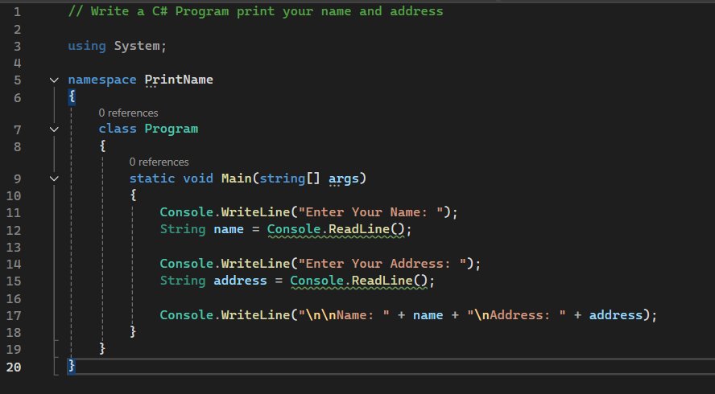

## Output:

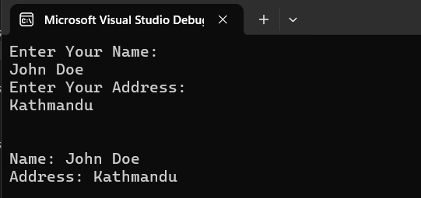

# Lab 2 - Write a C# Program to Print an Integer Entered by User.

## Source Code:

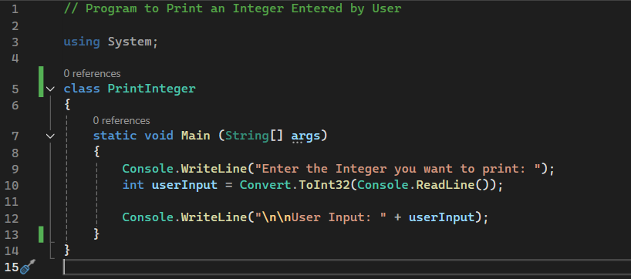

## Output:

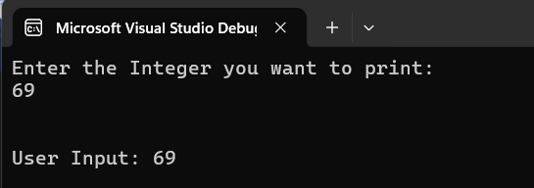

# Lab 3 - Write a C# Program to Multiply two Floating Point Numbers Entered by User.

## Source Code:

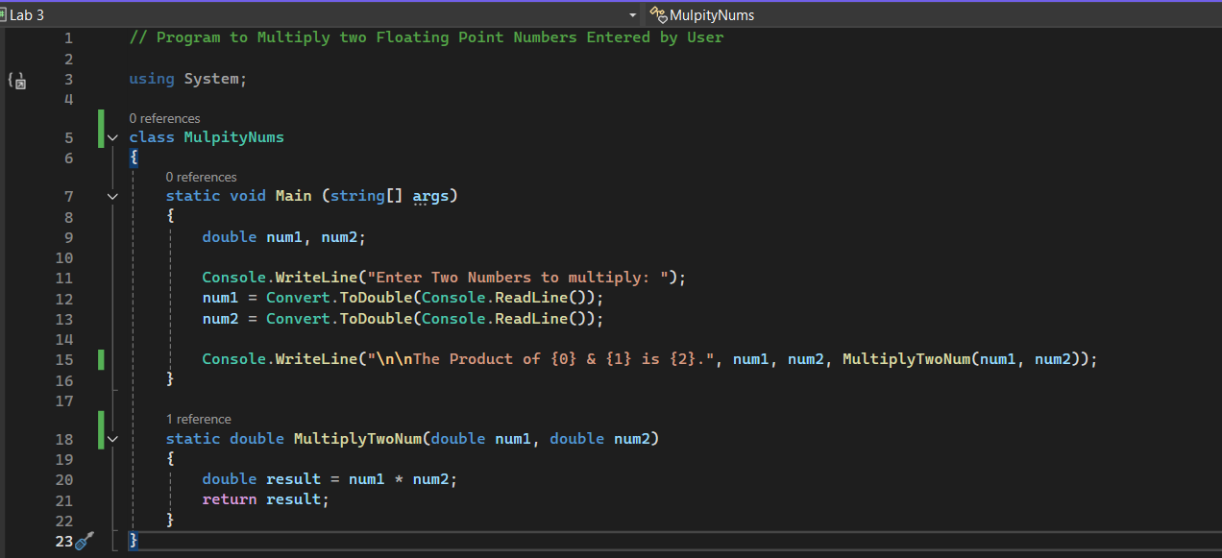

## Output:

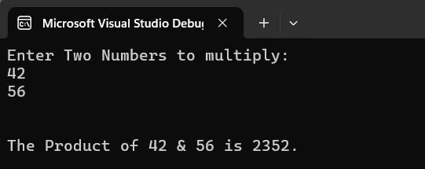

# Lab 4 - Write a C# Program to Calculate the Simple Interest.

## Source Code:

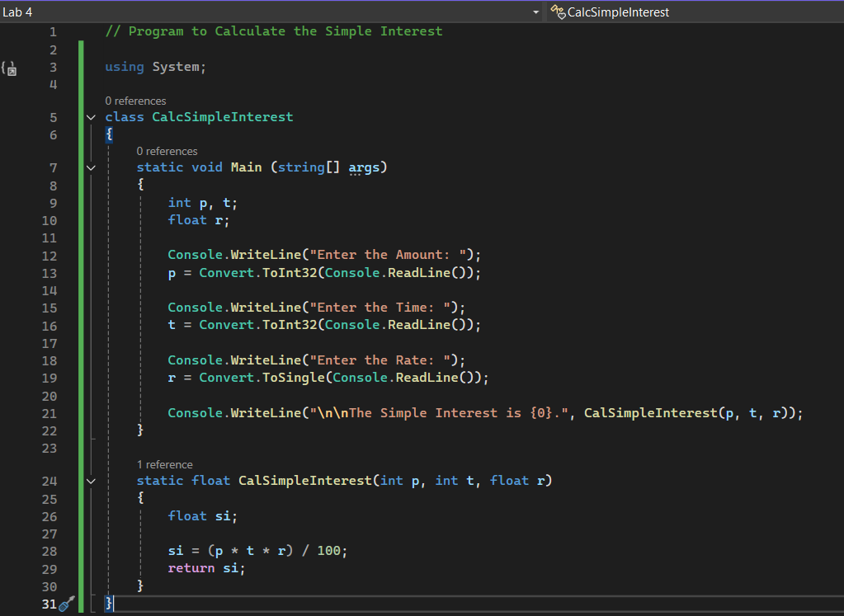Output:

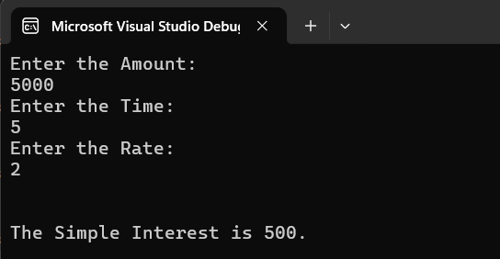

# Lab 5 - Write a C# Program to Calculate Area and Perimeter of Circle.

## Source Code:

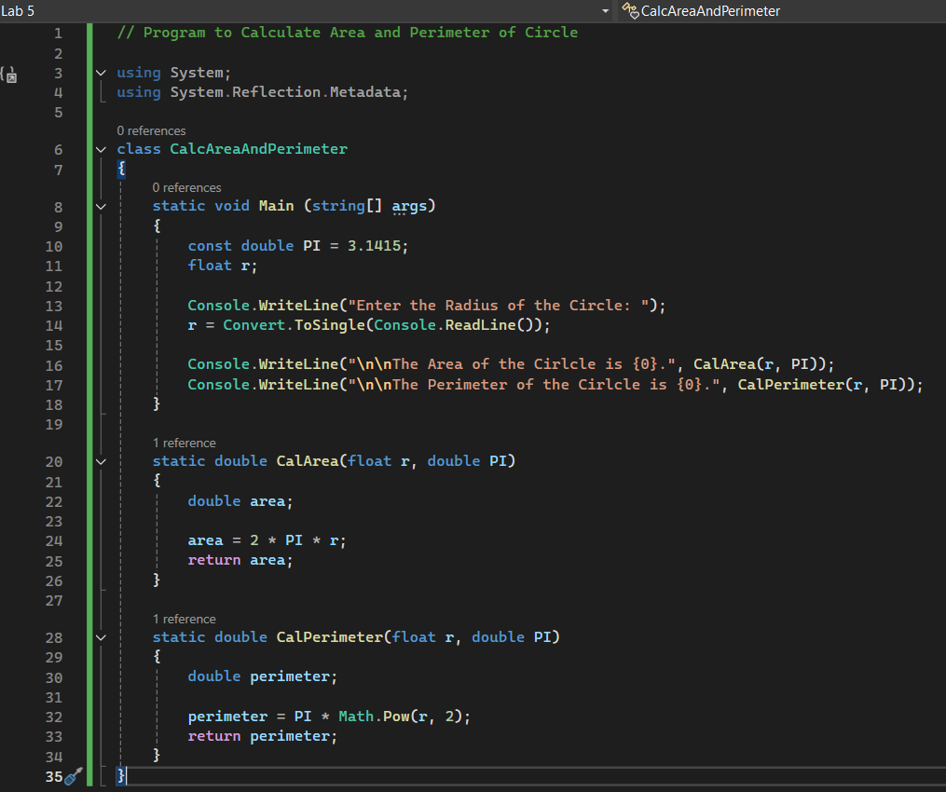

## Output:



# Lab 6 - Write a C# Program to Count Number of Words in a String.

## Source Code:

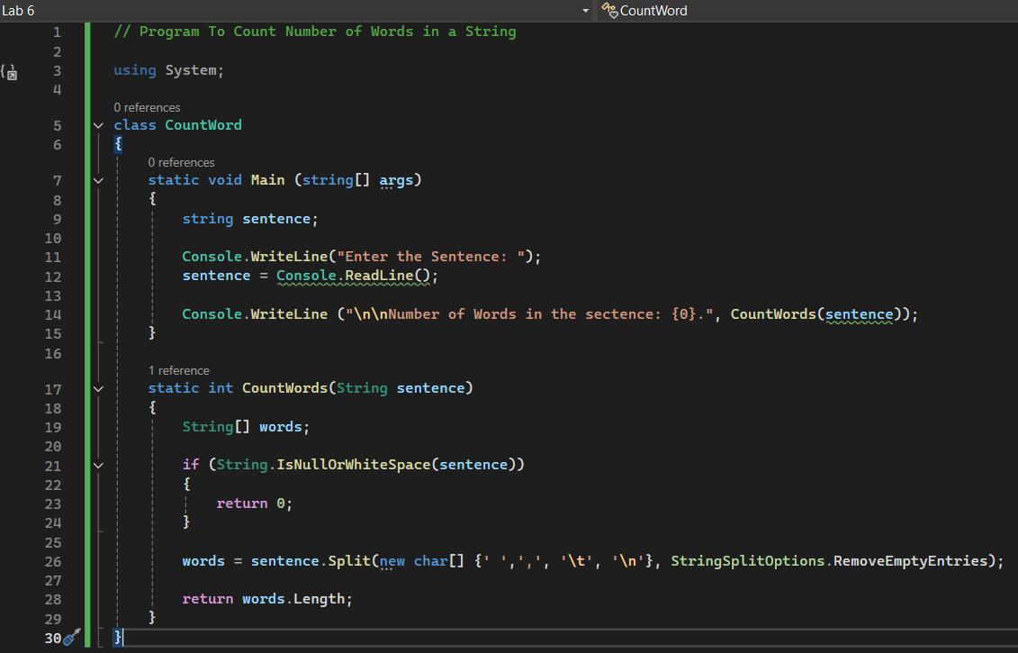

## Output:

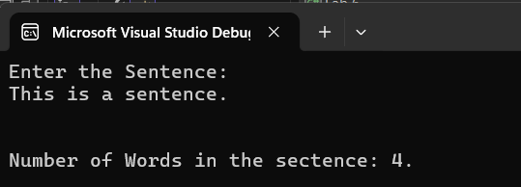

# Lab 8 - Write a C# Program to Print all prime numbers in an interval (i.e. from 5 to 20).

## Source Code:

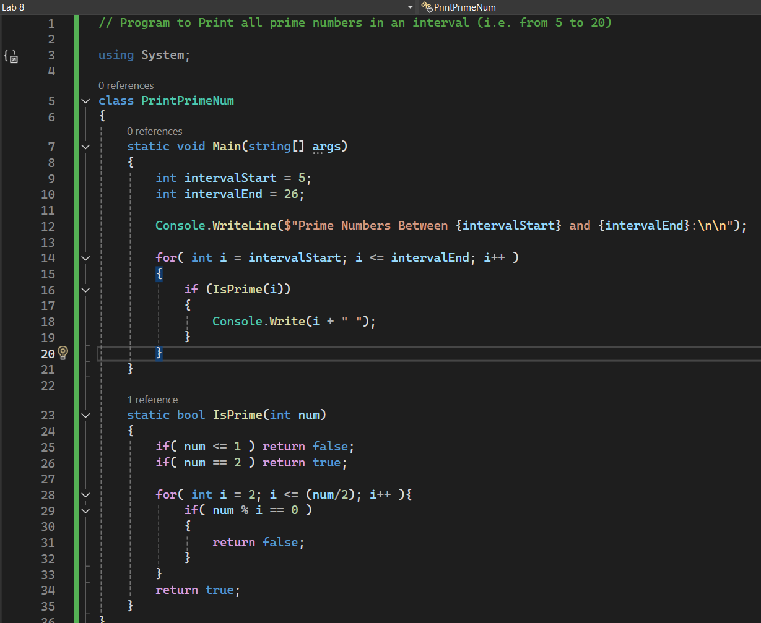

## Output:

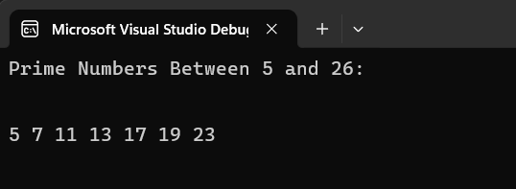

# Lab 9 - Write a C# Program to Find greatest number among 3 numbers using conditional operator.

## Source Code:

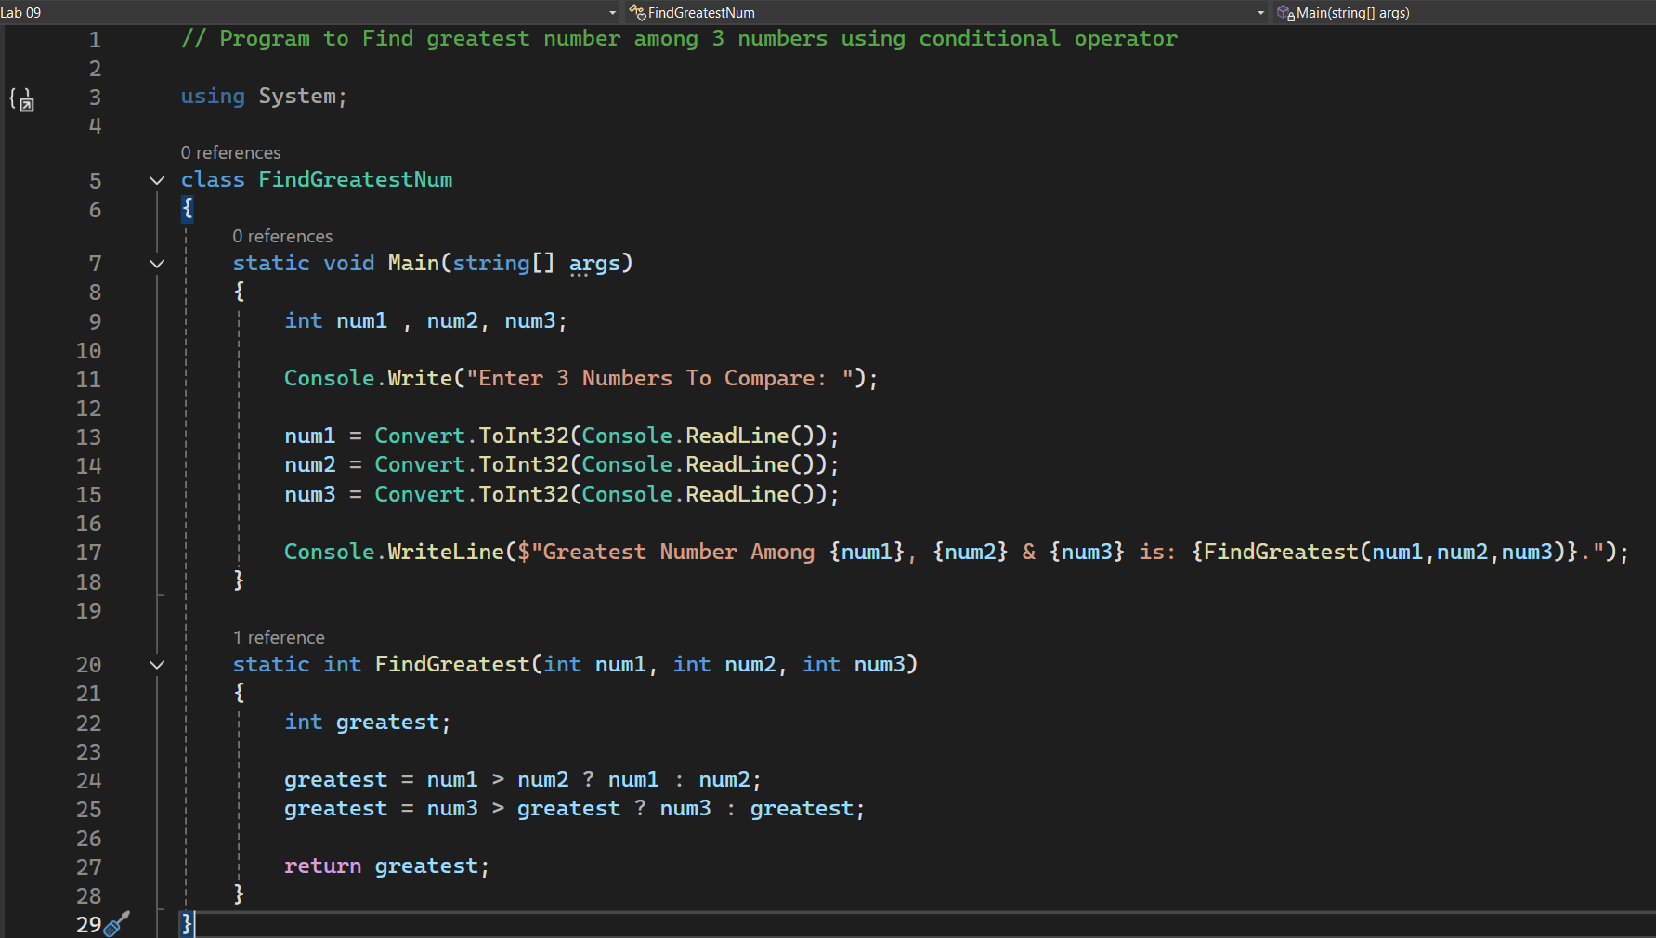

## Output:

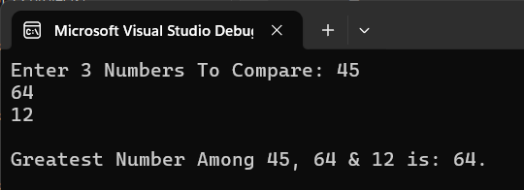

# Lab 10 - Write a C# Program to calculate library fine.

## Source Code:

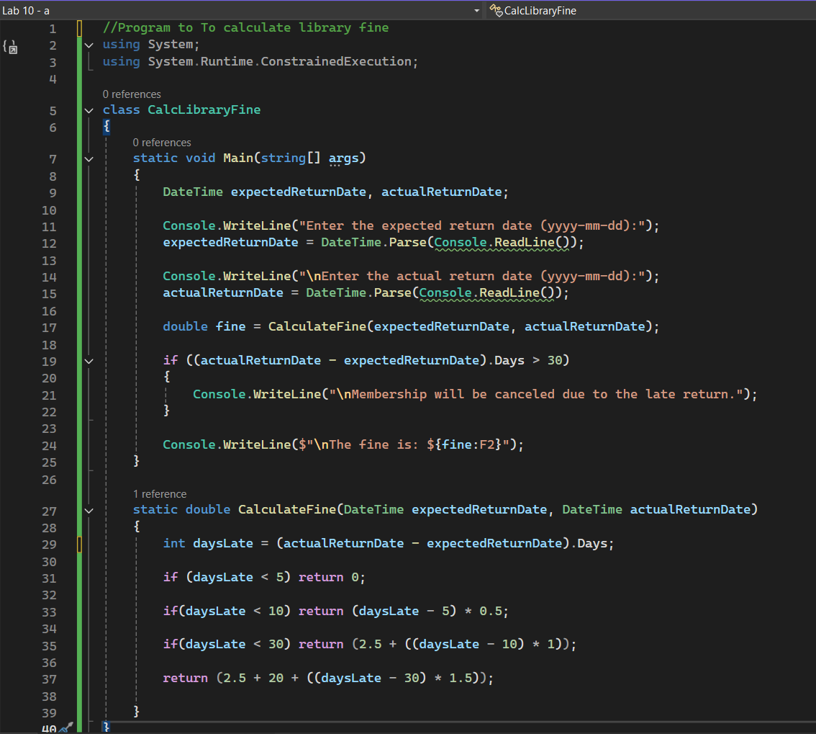

## Output:

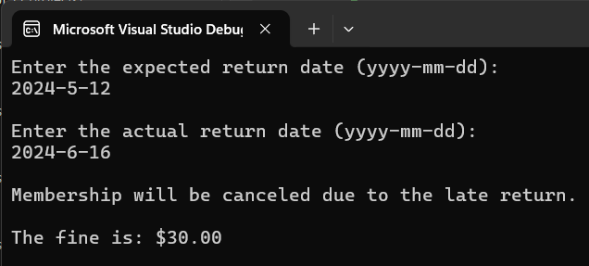

# Lab 11 - Write a C# Program to Find min and max number in an array.

## Source Code:

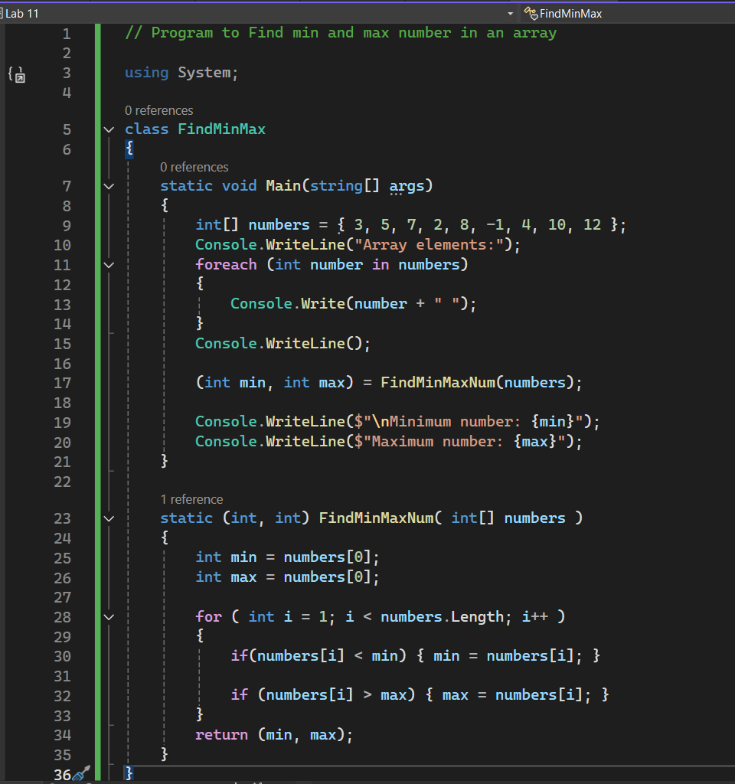

## Output:

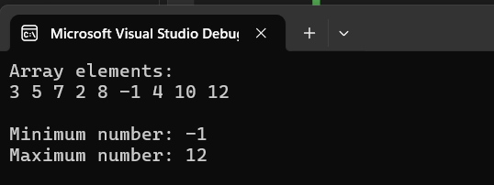

# Lab 12 - Write a C# Program to Find the factorial of a number.

## Source Code:

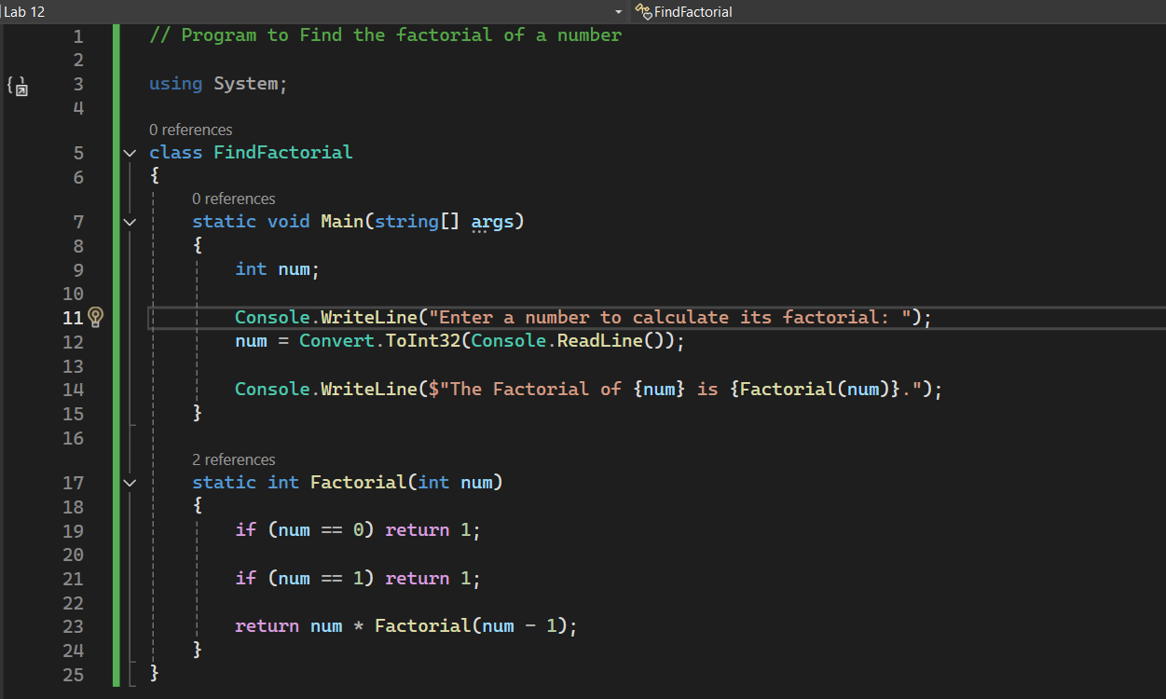

## Output:

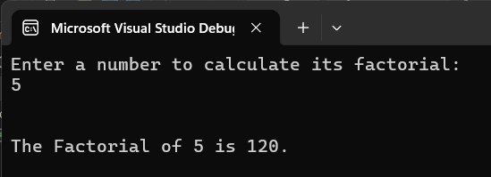

# Lab 13 - Write a C# Program to Find the longest word in a string array.

## Source Code:

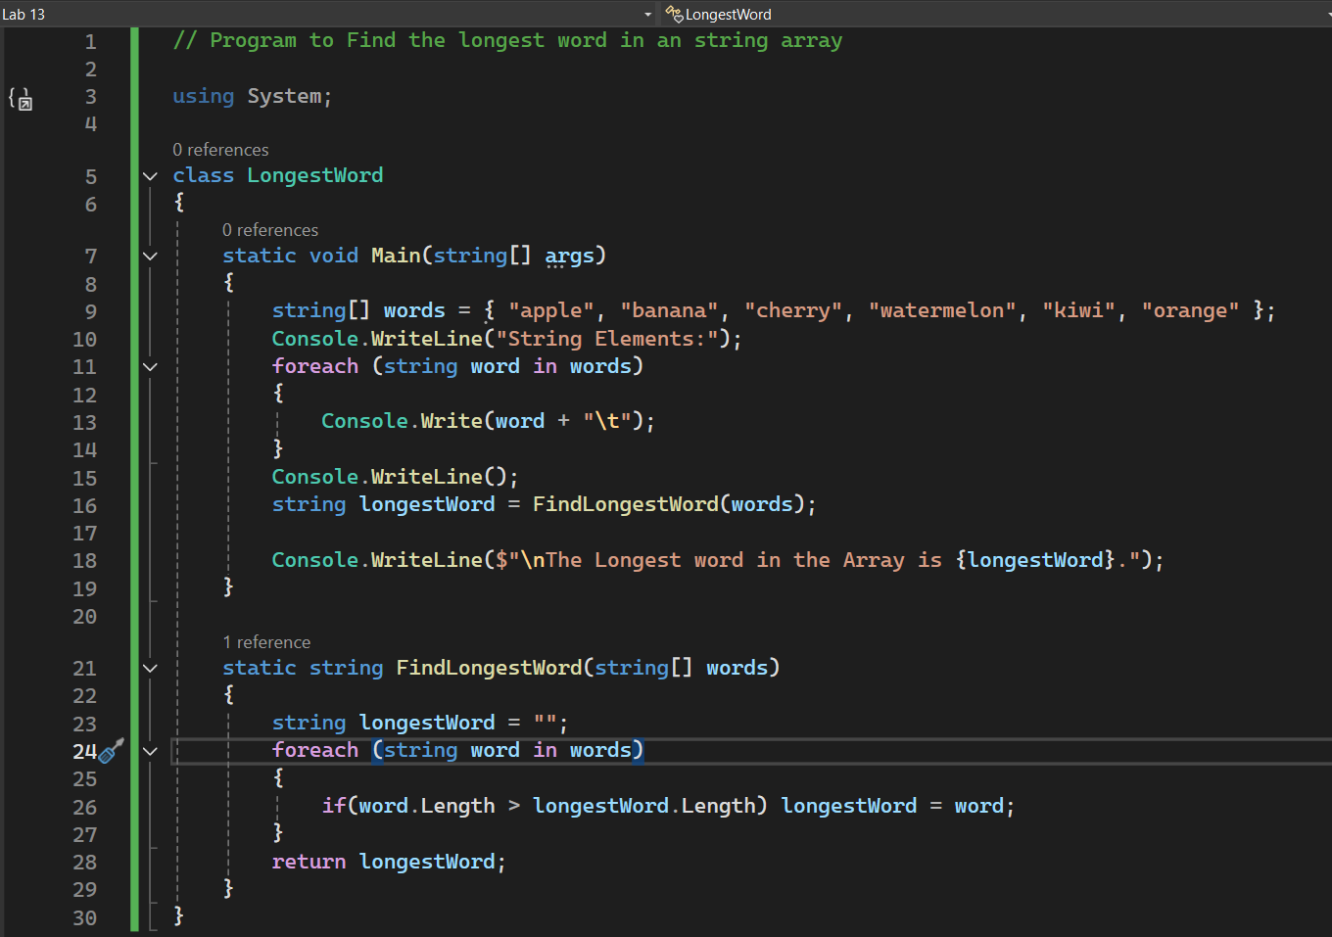

## Output:

