
TRIBHUVAN UNIVERSITY FACULTY OF HUMANITIES AND SOCIAL SCIENCE

A Project Report
On
“MedVault: A Modern Approach to Pharmacy Management”

Submitted to
Department of Computer Application
National College of Computer Studies

In partial fulfillment of the requirements for Bachelor Degree in Computer Application

Submitted by:
Name: Ribesh Maharjan
Roll: 6-2-551-38-2021
Name: Rijan Bajracharya
Roll: 6-2-551-39-2021

07/12/2024

Under the Supervision of
Mr. Radha Krishna Gajurel


Tribhuvan University
Faculty of Humanities and Social Sciences
National College of Computer Studies

Supervisor’s Recommendation

It is my pleasure to recommend that a report on “MedVault: A Modern Approach to Pharmacy Management System” has been prepared under my supervision by Ribesh Maharjan and Rijan Bajracharya in partial fulfillment of the requirements for the degree of Bachelor of Computer Application (BCA). Their report is satisfactory to process for the final evaluation.

……………………………….
SIGNATURE
Radha Krishna Gajurel
SUPERVISOR
Faculty Member
Department of Computer Application
National College of Computer Studies



Tribhuvan University
Faculty of Humanities and Social Sciences National College of Computer Studies

LETTER OF APPROVAL

This is to certify that this project prepared by Ribesh Maharjan and Rijan Bajracharya entitled “MedVault: A Modern Approach to Pharmacy Management System” in partial fulfillment of the requirements for the degree of Bachelor in Computer Application has been evaluated. In our opinion it is satisfactory in the scope and quality as a project for the required degree.

SIGNATURE of Supervisor  Radha Krishna Gajurel  Faculty Member  Department of Computer Application  National College of Computer Studies Paknajol, Kathmandu | SIGNATURE of HOD/ Coordinator  Rajan Poudel  Faculty Member  Department of Computer Application  National College of Computer Studies Paknajol, Kathmandu
SIGNATURE of Internal Examiner | SIGNATURE of External Examiner

ABSTRACT
“Med-Vault” is a web base application used to automate pharmacy workflow. This project was built on Waterfall Methodology with the help of HTML, CSS, JS and PHP. This includes feature like keeping record of medication in the store, update medication records, purchase medicine. It enables tracking of medication stock levels, price, and quantity. This system helps to reduce wastage, ensuring the availability of medications when needed. The primary objective of this application is to enhance efficiency, accuracy, and safety in the management of pharmaceutical processes. It can be used by any pharmacist to keep track of medicine quantity and how much it is sold or purchased. The user can update the medicine record if they want to change or add new medicine.

Keywords: record keeping, inventory, Waterfall methodology

ACKNOWLEDGMENT
I would like to thank my supervisor Mr. Radha Krishna Gajurel for his valuable guidance who gave me great encouragement for this work and helpful suggestions. His encouragement and practical advice were instrumental in helping us complete this project successfully.
I would also like to thank our Vice Principal sir, Mr. Santosh Maskey who monitored, guided and motivated us throughout all the phases of this project. I appreciate the support from all the supervisors, friends and family to help make this project successfully.
Ribesh Maharjan
Rijan Bajracharya
TABLE OF CONTENTS
ABSTRACT iv
ACKNOWLEDGMENT v
LIST OF ABBREVIATIONS viii
LIST OF FIGURES ix
LIST OF TABLES x
Chatpter 1 Introduction 1
1.1 Introduction 1
1.2 Problem statement 1
1.3 Objectives 1
1.4 Scope And Limitation 2
1.4.1 Limitation 2
1.4.2 Scope 2
1.5 Report Organization 2
Chatpter 2 Background Study And Literature Review 3
2.1 Background Study 3
2.2 Literature Review 3
Chatpter 3 System Analysis and Design 4
3.1 System Analysis 4
3.1.1 Requirement Analysis 4
3.1.2 Feasibility Study 6
3.1.3 Data Modeling 7
3.1.4 Process Modeling 7
3.2 System Design 10
3.2.1 Flow Chart for Admin 10
3.2.2 Architectural Design 11
3.2.3 Database Schema Design 11
3.2.4 Interface Design 16
Chatpter 4 Implementation And Testing 17
4.1 Implementation 17
4.1.1 Tools Used 17
4.1.2 Implementation Details of Modules 18
4.2 Testing 27
4.2.1 Testing cases for unit testing 27
4.2.2 Testing case for unit testing of admin page 27
4.2.3 Testing case for System testing 28
Chatpter 5 Conclusion And Future Recommendations 29
5.1 Conclusion 29
5.2 Lesson leant/Outcome 29
5.3 Future Recommendations 29
REFERENCES 30
APPENDIX 31

LIST OF ABBREVIATIONS
CSS |  | Cascading Style Sheet
DFD |  | Data Flow Diagram
ER |  | Entity Relationship
FAQ |  | Frequently Asked Question
HTML |  | Hyper Text Markup Language
PHP |  | Hypertext Preprocessor
SQL |  | Structured Query Language
VSCode |  | Visual Studio Code

LIST OF FIGURES
Figure 3.1 Waterfall Methodology 4
Figure 3.2 Use-Case Diagram of MedVault 5
Figure 3.3 ER diagram of MedVault 7
Figure 3.4 DFD Level 0 of MedVault 8
Figure 3.5 DFD Level 1 of MedVault 8
Figure 3.6 DFD Level 2 of MedVault 9
Figure 3.7 Flowchart for Admin of MedVault 10
Figure 3.8 Architectural Diagram of MedVault 11
Figure 3.10 Interface Diagram of MedVault 16

LIST OF TABLES
Table 3.1 Medicine Schema 11
Table 3.2 Pharmacy Schema 12
Table 3.3 Admin Schema 12
Table 3.4 User Order Schema 12
Table 3.5 Cart Schema 13
Table 3.6 User Medicine Schema 13
Table 3.7 User Sales Schema 13
Table 3.8 Role Schema 14
Table 3.9 Order Pending Schema 14
Table 3.10 Order Completed Schema 14
Table 3.11 Order Address Schema 15
Table 4.1 Tools Used 17
Table 4.2 Test cases of unit testing for login and logout operation 27
Table 4.3 Test cases of unit testing of admin page 27
Table 4.4 Test cases of System testing 28

Introduction

Introduction
Med-Vault is a web-based application used in a pharmacy that helps automate the pharmacy workflow. This includes keeping records of medications, managing the orders and sales and handling bills. Generally, the humans are not able to provide each and every specific detail about stock, sales and many more. So, it plays a vital role to fulfill all these circumstances.
Med-Vault is a crucial tool for integrates multiple functionalities into a centralized platform, enhancing efficiency and accuracy. It enables pharmacy to monitor stock levels, reorder processes, and track medication expiration dates, prices and its purpose.
The project is developed using HTML, CSS and Java Script for frontend and PHP for the backend. In this project, the pharmacy can sign in their own account and can order and manage the medicines according to their requirements.

Problem statement
Record keeping is considered as one of the difficult tasks in a pharmacy because most of the record keepings were done manually which led to a lot of misplacements of medicines. The record of fresh batches couldn’t be kept in a safe manner. There was no proper record of medications purchase and sold. Different problem like improper records of medicine and stock, miscalculation, inefficient inventory improper record of data might occur while using manual file system. While online platforms boast a wider selection, the inability to physically interact with the product or receive expert advice can create uncertainty for buyers, especially those unfamiliar with PC components.

Objectives
- To provide a system that keeps track of medicine in systematic way which lead to faster access of medicine and resolve miscalculation of bills
- To develop an online store that allows pharmacies to explore and purchase medicine.

Scope And Limitation

Limitation
- Admin needs to approve the request of the pharmacy in order to sell the medicine.

Scope
- Users can register, login, and order medicine, while admins can manage medicines and order requests.
- Users can manage their stock in the inventory.
- User can complete their transaction with online payment.

Development Methodology
The development of MedVault was carried out using the Waterfall Methodology. The Waterfall model is a linear and sequential software development approach where each phase must be completed before moving to the next phase. This methodology was chosen because it provides a systematic and well-structured process for developing the system.
The development process of MedVault was divided into different phases which are requirement analysis, system design, implementation, testing, and maintenance. In the requirement analysis phase, information regarding the pharmacy management system was collected and analyzed. In the system design phase, the overall architecture, database schema, ER diagram, DFD, and interface designs were prepared.
After completing the design process, the implementation phase was carried out using HTML, CSS, JavaScript, PHP, and MySQL. Different modules such as login system, inventory management, medicine management, and order management were developed during this phase. After implementation, testing was performed to identify and remove errors from the system. Unit testing and system testing were conducted to ensure that the system functions correctly and meets the project objectives.
The Waterfall methodology helped in maintaining proper documentation, systematic development, and easier management of the project throughout the development lifecycle.

Report Organization
Chapter 1: Introduction
Chapter one introduces the concept of this project. It describes the problems that has been existing and how its objective can tackle it. It also presents the scope and limitations of the project.
Chapter 2: Background study and literature review
This chapter focuses on the basic ideology of how this project will be build. It traces out the study of different platforms and their workings.
Chapter 3: System analysis and design
This chapter describes the requirements gathering, feasibility study, and designing of the project. It includes diagrams, functionality analysis, requirement gathering technique and process model.
Chapter 4: Implementation and testing
This chapter is designed to give information about how the project has been implemented, what kind of software and tools has been used and the type of testing that the project has gone through.
Chapter 5: Conclusion and future recommendation
This chapter includes the possible outcome of this project, conclusion and future recommendations.

Background Study and Literature Review

Background Study
Pharmacy Management System is a software application designed to manage and automate the daily operations of a pharmacy. It helps in maintaining medicine records, managing stock levels, handling sales and purchases, generating bills, and monitoring medicine availability. Traditional pharmacy systems often rely on manual record keeping, which can lead to errors, miscalculations, and inefficient inventory management. A computerized pharmacy management system helps to reduce these problems by providing accurate and efficient data handling.
Inventory Management System is an important part of a pharmacy management system. It is used to track medicine quantity, stock availability, expiry dates, and medicine details. Proper inventory management helps pharmacies maintain sufficient stock levels and reduce medicine wastage caused by expired products.
MedVault is developed as a web-based application. A web-based application is software that runs on a web server and can be accessed through a web browser using the internet or local network. Web applications are platform independent and provide easier accessibility and management compared to traditional desktop applications.
The system uses a relational database management system (RDBMS) to store and manage data. MySQL is used as the database in this project for storing medicine records, user details, orders, and inventory information. Databases help in organizing large amounts of data efficiently and securely.
For the frontend development of the project, HTML, CSS, and JavaScript are used. HTML is used to create the structure of web pages, CSS is used for styling and designing the interface, and JavaScript is used to make the system interactive and dynamic. PHP is used as the backend programming language to handle server-side operations, process requests, and communicate with the database.
The project follows the Waterfall Software Development Methodology. Waterfall methodology is a sequential development approach where each phase such as requirement analysis, design, implementation, testing, and maintenance is completed one after another in a structured manner. This methodology helps maintain proper documentation and systematic project development.

Literature Review
The development of MedVault was carried out after studying various existing pharmacy management systems and online pharmaceutical platforms. Several pharmacy websites and inventory management systems were analyzed to understand their functionalities, advantages, and limitations. This study helped in identifying the essential features required for an effective pharmacy management system.
Existing platforms such as epharmacy.com.np [2] and mobimeds.com.np provide online medicine purchasing services with features like medicine browsing, online ordering, inventory handling, and customer management. These systems offer user-friendly interfaces and efficient medicine searching facilities that improve the customer experience. They also provide better inventory tracking and order management compared to traditional manual systems.
Similarly, pharmacy management projects developed using PHP and CodeIgniter framework [3] were also reviewed during the development of this project. These systems demonstrated functionalities such as medicine stock management, billing systems, order processing, sales tracking, and database handling. The study of these systems provided ideas regarding database design, user authentication, and inventory management techniques.
Although existing systems provide many useful features, some systems are complex to use and lack proper inventory tracking and management facilities for small pharmacies. MedVault aims to overcome these limitations by providing a simple, user-friendly, and efficient web-based pharmacy management system. The system integrates inventory management, medicine management, and order handling into a single platform to improve operational efficiency and reduce manual errors.
The literature review helped in understanding current technologies, identifying system requirements, and designing a better solution for pharmacy inventory and sales management.

System Analysis and Design

System Analysis
The Waterfall methodology also known as the Waterfall model is a sequential development process that flows like a waterfall through all phases of a project (analysis, design, development, and testing, for example), with each phase completely wrapping up before the next phase begins.
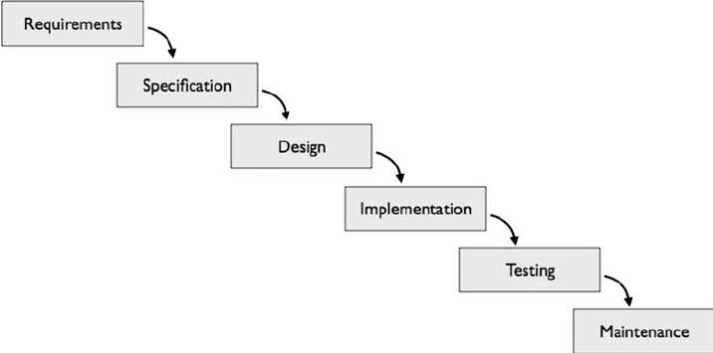
Figure 3.1 Waterfall Methodology
The waterfall model is a traditional software development approach with a sequential, phase-based structure. Each phase, like requirements gathering or testing, must be completed entirely before moving on. This structured approach offers clear planning, predictable timelines, and ease of understanding. However, it can be inflexible for adapting to changing requirements or incorporating user feedback. The waterfall model is most suitable for smaller projects with well-defined needs and established technologies

Requirement Analysis
Requirement analysis is the gathering of relevant requirement that will be used to develop a system. Different methods have been adopted to gather requirement for this project.

Functional Requirements
The system will enable users to securely log in and navigate the platform, providing access to essential features. Users will have the capability to search for medicines based on various parameters such as name, category, or prescription, and proceed with secure purchases online. Additionally, the system will incorporate a robust inventory management module, allowing users to track stock levels, monitor expiry dates, and manage purchase orders.
Some of the functional requirements for this system are as follows:
- User can register.
- User can login to the system.
- User can be able to view the medicine.
- User can be able to purchase the medicine.
- Admin can view medicine.
- Admin can manage medicine.
- Admin can manage the orders of Users.
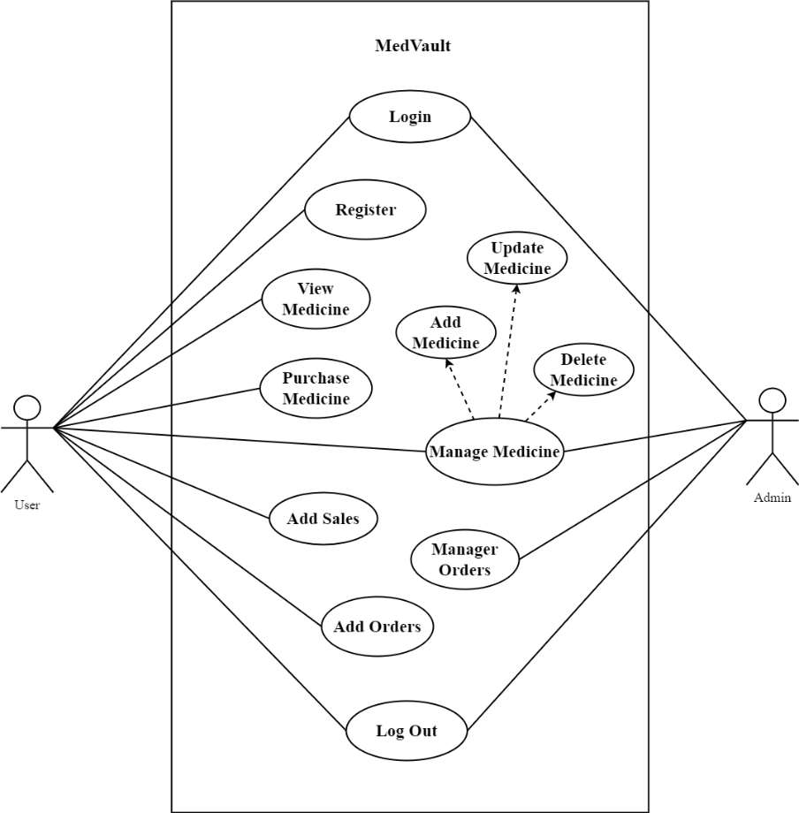
Figure 3.2 Use-Case Diagram of MedVault
In the figure, the figure depicted a pharmacy management system where Customers were able to place medicine orders, while Administrators managed the medicine. Lines connected the user to the use cases they could perform. For example, the line connecting the User to "View Medicine" indicated that a user could view medicine in the system.

Non-Functional Requirements
The non-functional requirements for Med-Vault focus on the website's performance and user experience. This includes software qualities such as performance, security, usability, reliability, and maintainability.
Some of the non-functional requirements of system are:
- The system must be designed for a user-friendly environment.
- The system must be secured.
Since the data is only accessible by authorized individuals, the system is safe from outside threats. The system operates precisely and quickly because of its standardized database, which facilitates quick operations.

Feasibility Study
It is the study of how well the system will function under the given constraints. It studies about how easy is it to build a system under given constraints. The constraints include operational feasibility, economic feasibility, and technical feasibility.

Technical Feasibility:
This system meets the technical feasibility as it will be using existing technologies like HTML, CSS, JavaScript, PHP and MYSQL etc. as well as simple hardware specifications.

Economic Feasibility:
Med-Vault will be feasible economically as the only needed will be a laptop, internet connection and electricity.

Operational Feasibility:
Since the system promises to provide easier and understandable user interface as well as responsiveness when used in another device. Thus, the proposed system will be operationally feasible.

Schedule Feasibility:
This project was assigned a specific duration for completion and it was successfully accomplished within the designated timeframe. affirming its feasibility within the planned timeline.

Data Modeling
A data model is a mechanism that provides this abstraction for database application. Data modeling is used for representing entities and their relationship in the database. E-R (Entity Relationship) Model can be referred to as a Data Model. E-R Model is a popular high level conceptual data model. This model and its variations are frequently used for the conceptual design of database application and many database design tools employ its concept. A database that confirms an E-R diagram can be represented by a collection of tables in the relational system.
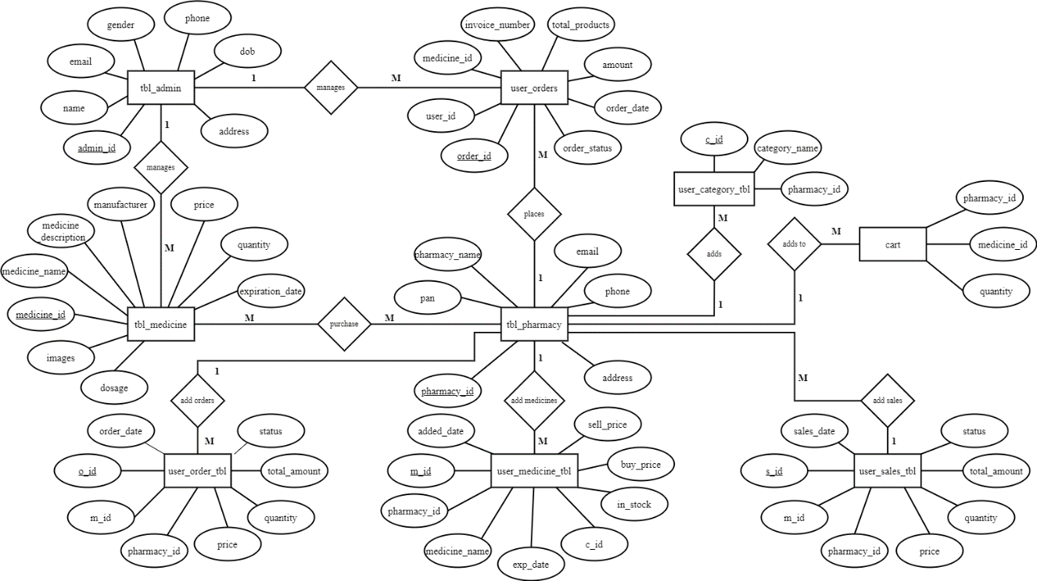
Figure 3.3 ER diagram of MedVault
The diagram illustrates a pharmacy management system comprising entities such as Pharmacy, Medicine, Admin, and many more. Additionally, it includes Order (reflecting customer requests). Relationships between these entities are depicted with symbols indicating the nature of the relationship, including one-to-many (e.g., one pharmacy can stock many medicines), many-to-one (e.g., each medicine is stocked by only one pharmacy). These connections elucidate how the entities interact within the system, facilitating understanding of its functional dynamics.

Process Modeling
A DFD can be referred to as a Process Model. A data-flow diagram (DFD) is a graphical representation of the "flow" of data through an information system. DFDs can also be used for the visualization of data processes (structured design). A data flow diagram (DFD) is a significant modeling technique for analyzing and constructing information processes. DFD illustrates this flow of information in a process based on the inputs and outputs.

DFD 0 Level
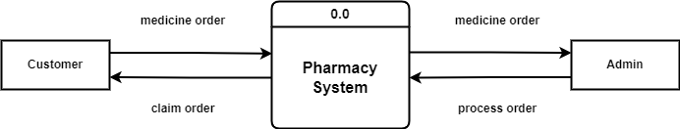
Figure 3.4 DFD Level 0 of MedVault
In above figure, we can see that the arrows show how information flows between these parts of the system. For instance, the customer places a medicine order, which is sent to the pharmacy system. The admin processes the order, and then the claim order is sent to the customer, likely meaning their medication is ready for pickup.

DFD 1 Level
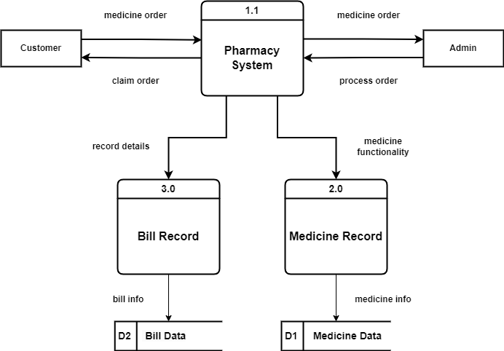
Figure 3.5 DFD Level 1 of MedVault
In above diagram, it’s a data flow diagram (DFD) of a pharmacy management system. It shows how information flows through the system between different parts. In this 1 level DFD, Customers initiate medication orders, while the Pharmacy System handles tasks like managing inventory, processing orders, and storing customer details. Admins oversee system operations, including adding new medications and processing orders.Together, these elements outline the workflow of medication procurement and fulfillment within the system, defining roles and processes for efficient pharmacy management

DFD 2 Level
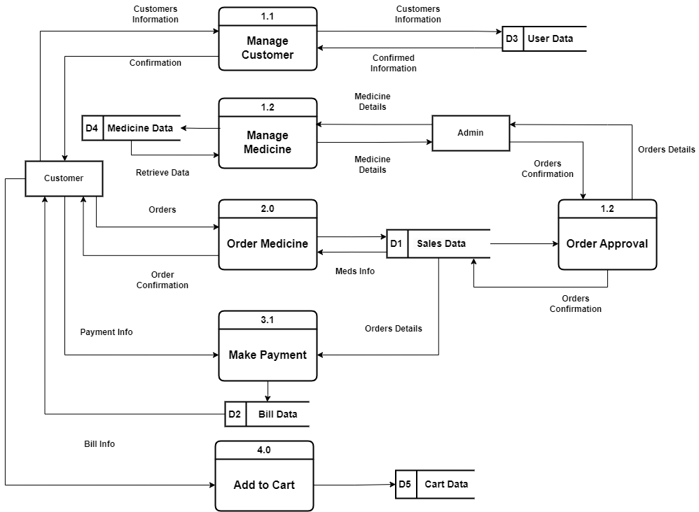
Figure 3.6 DFD Level 2 of MedVault
In above figure, we can see that it’s a level 2 DFD in which it illustrates how data flows throughout the system. For instance, the customers create orders, which are confirmed upon receiving the service. This triggers customer information and order details to be sent to the billing system, along with data from external databases on users, sales, and medicine. The billing system then updates sales data based on these details.

System Design

Flow Chart for Admin

Start

Enter Username and Password

Admin Authentication

Invalid

Valid

Home Page

Browse for options

Stop

Figure 3.7 Flowchart for Admin of MedVault
The figure outlines the process within a pharmacy management system. Initially, the admin logs in using their credentials, and the system checks if the login is successful. If successful, the system identifies the admin; otherwise, it prompts the admin to retry. Once identified, the admin is redirected to Home Page where admin can access all the functionality.

Architectural Design
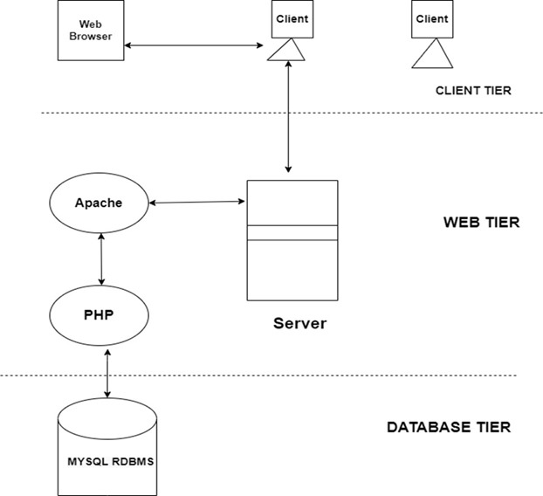
Figure 3.8 Architectural Diagram of MedVault
This diagram depicts a three-tier web application architecture. The Client Tier involves web browsers sending requests. The Web Tier has a server using Apache to handle these requests, with PHP processing dynamic content. The Database Tier comprises a MySQL RDBMS managing data. The server processes requests, interacts with the database, and sends responses back to the client, ensuring scalability and manageability.

Database Schema Design
Table 3.1 Medicine Schema
medicine_id | int(11)
medicine_name | varchar(10)
medicine_description | varchar(1000)
manufacturer | varchar(100)
price | int(11)
quantity | int(11)
expiration_date | date
dosage | varchar(50)
images | varchar(255)
Table 3.2 Pharmacy Schema
pharmacy_id | int(11)
pan | int(11)
pharmacy_name | varchar(100)
email | varchar(50)
phone | varchar(10)
address | varchar(255)

Table 3.3 Admin Schema
admin_id | int(11)
name | varchar(100)
email | varchar(50)
gender | varchar(10)
phone | varchar(10)
dob | date
address | varchar(50)

Table 3.4 User Order Schema
o_id | int(11)
m_id | int(11)
pharmacy_id | int(11)
price | int(11)
quantity | int(11)
total_amount | int(11)
status | varchar(20)
oder_date | date

Table 3.5 Cart Schema
pharmacy_id | int(11)
medicine_id | int(11)
quantity | varchar(50)

Table 3.6 User Medicine Schema
m_id | int(11)
pharmacy_id | int(11)
medicine_name | varchar(100)
image | varchar(100)
medicine_desc | varchar(1000)
c_id | int(11)
in_stock | int(11)
buy_price | int(11)
sell_price | int(11)
added_date | timestamp
exp_date | date

Table 3.7 User Sales Schema
o_id | int(11)
m_id | int(11)
pharmacy_id | int(11)
price | int(11)
quantity | int(11)
total_amount | int(11)
status | varchar(20)
oder_date | date

Table 3.8 Role Schema
user_id | int(11)
name | varchar(100)
email | varchar(50)
password | varchar(50)
role | varchar(10)

Table 3.9 Order Pending Schema
order_id | int(11)
user_id | int(11)
medicine_id | int(11)
invoice_number | int(255)
total_products | int(255)
amount | int(11)
order_status | varchar(255)

Table 3.10 Order Completed Schema
order_id | int(11)
user_id | int(11)
medicine_id | int(11)
invoice_number | int(255)
total_products | int(255)
amount | int(11)
order_status | varchar(255)

Table 3.11 Order Address Schema
order_id | int(11)
city | varchar(50)
province | varchar(50)
street | varchar(50)
postal | int(11)

Interface Design
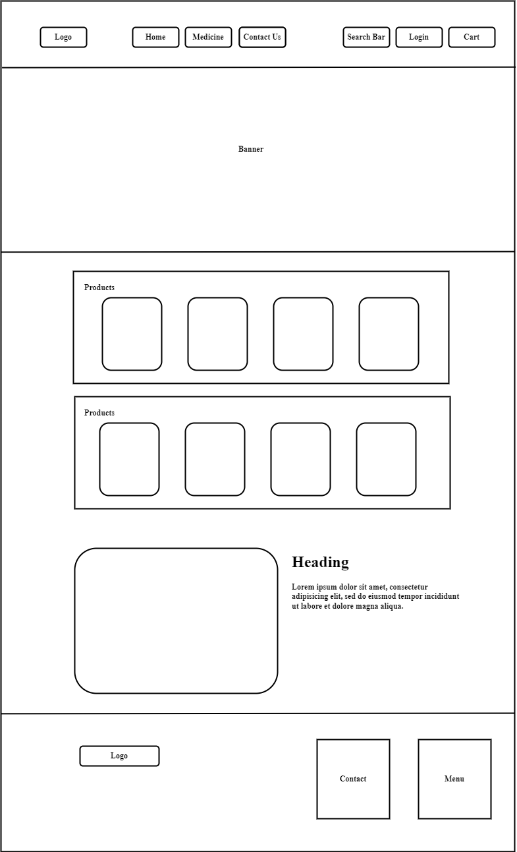
Figure 3.10 Interface Diagram of MedVault

Implementation And Testing

Implementation

Tools Used
Different tools are used during different software development phases. As, for the frontend, we used HTML, CSS, and JavaScript to create interactive user interface. And for the backend, PHP is used to handle server-side operation and database interaction. To manage and store data, MySQL is used. Microsoft word is used for writing report, proposal and Visual Studio Code (VSCode) is used for writing the code.
Table 4.1 Tools Used
Frontend | HTML, CSS, JavaScript
Backend | PHP
Database | MySQL
Server | Apache

Frontend:
- HTML: HTML is used here to create the structure and content of web pages and to define the layout, headings, paragraphs, images, and other elements that make up our webpage.
- CSS: CSS is used here to control the presentation and appearance of the web pages. Also to define the fonts, colors, layouts, and styles, ensuring consistent and visually appealing designs.
- JavaScript: JavaScript is used her to make the website interactive and handle user events.
Backend:
- PHP: PHP is used in MedVault to handle server-side operations and database interaction. PHP a server–site scripting language has been used to connect html files into database in this system.

Database:
- MYSQL: MYSQL an open-source relational database management system is used for storing the database in this system.
Server:
- Apache: The Apache HTTP Server is a free and open-source cross-platform web server software, released under the terms of Apache License 2.0.

Implementation Details of Modules
The different modules provided are:
Module 1: View Product
This module provides an interface that allows users to view product. This module also provides different product recommendation.
<div class="row bg-white py-4 px-3 gy-4 rounded">
<div class="row px-3">
<?php
alertmessage();
?>
</div>
<h1 class="h3 m-0 fw-bold">Products</h1>
<?php
$result = getAllProducts('tbl_medicine');
while ($row=mysqli_fetch_assoc($result)){
$product_id= $row['medicine_id'];
$product_name=$row['medicine_name'];
$product_description=$row['medicine_description'];
$product_image=$row['images'];
$product_price=$row [ 'price'];
?>
<div class="col">
<div class="card" style="width: 15rem;">

Module 2: Login
<img src="<?=$product_image?>" class="card-img-top" style="height: 250px;" alt="<?=$product_name?>">
<div class="card-body h-100 ">
<div class="product-card " role="button" data-href="product.php?medicine_id=<?= $product_id ?>">
<a href="product.php?medicine_id=<?= $product_id ?>"><h5 class="card-title h6"><?=$product_name?></h5></a>
<p class="card-text h5 text-danger fw-semibold mb-4 ">Rs. <?=$product_price?>.00</p>
</div>
<a href="php/add-to-cart.php?add_to_cart=<?=$product_id?>" class="btn btn-danger w-100 py-2">Add to cart</a>
</div>
</div>
</div>
<?php
}
?>
</div>
This module is responsible for validating the type of user and displaying options according to the role of users.
if(isset($_POST['signIn']))
{
$emailInput = validate($_POST['email']);
$passwordInput = validate($_POST['password']);
$email = filter_var($emailInput,FILTER_SANITIZE_EMAIL);
$password= filter_var($passwordInput,FILTER_SANITIZE_STRING,FILTER_FLAG_STRIP_HIGH);
if($email != '' && $password != ''){
$query = "SELECT * FROM $admin_table WHERE email = '$email'";
$result = mysqli_query($conn,$query);

if($result)
{
if(mysqli_num_rows($result) == 1)
{
$row = mysqli_fetch_array($result, MYSQLI_ASSOC);
if(password_verify($passwordInput, $row['password'])) {
if($row['role'] == 'admin')
{
$_SESSION['auth'] =true;
$_SESSION['loggedInUserRole'] = $row['role'];
$_SESSION['loggedInUser'] = [
'name' => $row['name'],
'user_id' => $row['user_id'],
'email' => $row['email']
];
redirect('../proj-back/admin.php','Logged In Successfully');
} else{
$_SESSION['auth'] =true;
$_SESSION['loggedInUserRole'] = $row['role'];
$_SESSION['loggedInUser'] = [
'name' => $row['name'],
'user_id' => $row['user_id'],
'email' => $row['email']
];
redirect('home.php','Logged In Successfully');
}
}
else
{
redirect ('login.php','Invalid Email or Password');
}
}

else
{
redirect('login.php','Invalid Email or Password');
}
}
else
{
redirect('login.php','Invalid Email');
}
}
}
Module 4: Add Product
This module allows admin to add product.
if(isset($_POST['add-medicine'])){
$medicine_name = $_POST['name'];
$manufacturer_name = $_POST['manufacturername'];
$price = $_POST['price'];
$quantity = $_POST['quantity'];
$exp_date = $_POST['exp_date'];
$formatted_Date = date("Y-m-d", strtotime($exp_date));
$dosage = $_POST['dosage'];
$imagename = $_FILES['images']['name'];
$fileExt = explode('.',$imagename);
$fileActualExt = strtolower(end($fileExt));
$fileNameNew = uniqid('', true).".".$fileActualExt;
$fileError = $_FILES['images']['error'];
$fileSize = $_FILES['images']['size'];
if (!preg_match("/^[a-zA-Z-' ]*$/",$medicine_name)) {
redirect('medicine-create.php','Only letters and white space allowed');
}
if (!preg_match("/^[a-zA-Z-' ]*$/",$manufacturer_name)) {
redirect('medicine-create.php','Only letters and white space allowed');
}
if(!is_numeric($price)) {
redirect('medicine-create.php','Invalid Price Number');
}
$allowed = array('jpg', 'jpeg', 'png');
if (!in_array($fileActualExt, $allowed)) {
redirect('medicine-create.php','You cannot upload files of this type!');
}
if ($fileError === 0) {
if ($fileSize < 1000000) {
$upload_dir = "../uploaded_img/";
// Create the directory if it doesn't exist
if (!file_exists($upload_dir)) {
mkdir($upload_dir, 0777, true);
}
$file_tmp = $_FILES['images']['tmp_name'];
$fileDestination = $upload_dir.$fileNameNew;
if(move_uploaded_file($file_tmp, $fileDestination)){
echo "Image $file_name uploaded successfully!<br>";
} else {
redirect ('medicine-create.php','Error uploading image');
}
$query="INSERT INTO tbl_medicine (medicine_id,medicine_name,manufacturer,price,quantity,expiration_date,dosage, images) VALUES('','$medicine_name','$manufacturer_name','$price','$quantity','$formatted_Date','$dosage','../uploaded_img/$fileNameNew')";
$data = mysqli_query($conn,$query);
if($data) {
redirect('medicine-create.php','Medicine Added Successfully');
else{
redirect('medicine-create.php','Could Not Add Medicine');
}
}else {
redirect('medicine-create.php','Your file is too big!');
}
}
else{
redirect('medicine-create.php','Could Not Add Medicine');
}
}
Module 5: Update Product
This module allows admin to update product.
if(isset($_POST['update-medicine'])){
$medicine_id = $_POST['update_id'];
$medicine_name = $_POST['name'];
$manufacturer_name = $_POST['manufacturername'];
$price = $_POST['price'];
$quantity = $_POST['quantity'];
$exp_date = validate($_POST['exp_date']);
$formatted_Date = date("Y-m-d", strtotime($exp_date));;
$dosage = $_POST['dosage'];

if (!preg_match("/^[a-zA-Z-' ]*$/",$medicine_name)) {
redirect('medicine-create.php','Only letters and white space allowed');
}
if (!preg_match("/^[a-zA-Z-' ]*$/",$manufacturer_name)) {
redirect('medicine-create.php','Only letters and white space allowed');
}
if(!is_numeric($price)) {
redirect('medicine-create.php','Invalid Price Number');
}
if(!empty($_FILES['images']['tmp_name'])) {
$imagename = $_FILES['images']['name'];
$fileExt = explode('.',$imagename);
$fileActualExt = strtolower(end($fileExt));
$fileNameNew = uniqid('', true).".".$fileActualExt;
$fileError = $_FILES['images']['error'];
$fileSize = $_FILES['images']['size'];
$allowed = array('jpg', 'jpeg', 'png');
if (!in_array($fileActualExt, $allowed)) {
redirect('medicine-create.php','You cannot upload files of this type!');
}
if ($fileError === 0) {
if ($fileSize < 1000000) {
$imagequery = "UPDATE tbl_medicine SET
images = '../uploaded_img/$fileNameNew'
WHERE medicine_id='$medicine_id'";
$imagedata = mysqli_query($conn,$imagequery);
$upload_dir = "../uploaded_img/";
if (!file_exists($upload_dir)) {
mkdir($upload_dir, 0777, true);
}
$file_tmp = $_FILES['images']['tmp_name'];
$fileDestination = $upload_dir.$fileNameNew;
if(move_uploaded_file($file_tmp, $fileDestination)){
echo "Image $file_name uploaded successfully!<br>";
} else{
redirect('medicine-display.php','Error uploading image!');
}
}else {
redirect('medicine-display.php','Your file is too big!');
}
}else {
redirect('medicine-display.php','Could Not Update Image');
}
}
$query = "UPDATE tbl_medicine SET
medicine_name ='$medicine_name',
manufacturer ='$manufacturer_name',
price ='$price',
quantity ='$quantity',
expiration_date = '$formatted_Date',
dosage = '$dosage'
WHERE medicine_id='$medicine_id'";
$data = mysqli_query($conn,$query);
if($data){
redirect('medicine-display.php','Medicine Added Successfully');
}
else{
redirect('medicine-display.php','Could Not Update Medicine');
}
}

Module 5: Delete Product
This module allows admin to delete product.
if(is_numeric($paraResult)){
$medicine_id = validate($paraResult);
$medicine = getById('tbl_medicine','medicine_id', $medicine_id);
if($medicine['status'] == 200){
$medicinedelete = deleteQuery('tbl_medicine','medicine_id', $medicine_id);
if($medicinedelete){
redirect('medicine-display.php','Medicine Removed Successfully');
}else{
redirect('medicine-display.php','Something Went Wrong!');
}
}else{
redirect('medicine-display.php','Medicine Not Found');
}
}else{
redirect('medicine-display.php', $paraResult);
}

Testing
Testing includes unit testing to ensure individual components function correctly, system testing to validate overall system behavior, and various test cases to cover functionality, performance, and user experience.

Testing cases for unit testing
Testing Scenario: Login and Logout Process
Table 4.2 Test cases of unit testing for login and logout operation
Test Case | Steps | Expected Results | Status
1 | Enter valid username and password, then press login button | User should be redirected to the dashboard | Pass
2 | Enter invalid username or password | User should stay on the login page with an error message | Pass
3 | Leave username or password field blank | Alert box should appear indicating blank fields | Pass
4 | Press logout button | User should be redirected to the login page | Pass

Testing case for unit testing of admin page
Testing Scenario: Admin Login
Table 4.3 Test cases of unit testing of admin page
Test Case | Steps | Expected Results | Status
1 | Login as an admin | User should be redirected to the admin dashboard | Pass
2 | Add a new product with all required details | Product should be added to the system and displayed in the product list | Pass
3 | Add a new user with all required details | User should be added to the system and displayed in the User list | Pass
4 | Approve the user order | Order should be approved and displayed in the order completed list. | Pass

Testing case for System testing
Table 4.4 Test cases of System testing
Test Case | Steps | Expected Results | Status
1 | Login as valid email and password | The user should be taken to home page with all the set of option provided as per their role | Pass
2 | Click on a product | The user should be taken to product page with all its details. | Pass
3 | Type on the search bar | The search bar should asynchronously load all the video with the provided keyword from the database | Pass
4 | Cart function | The user should be able to add products in their cart | Pass

Conclusion And Future Recommendations

Conclusion
This project aims to deliver an intuitive and efficient inventory management system specifically designed for pharmacies. MedVault will address common challenges in inventory management by providing stock tracking. The user-friendly interface ensures that pharmacy staff can easily navigate and utilize the system, enhancing overall operational efficiency. By streamlining the inventory management process, MedVault will help pharmacies maintain optimal stock levels, reduce costs associated with manual errors, and improve the availability of medications. This project not only meets its objectives but also overcomes the drawbacks observed in traditional pharmaceutical inventory systems, ensuring a more reliable and effective solution for modern pharmacies.

Lesson leant/Outcome
Throughout this project, we've honed essential skills in teamwork, problem-solving, writing, and time management. Working collaboratively, we effectively divided tasks among Frontend, Backend, and Documentation roles, utilizing tools like GitHub and social media for seamless communication with partners and supervisors.
Our problem-solving skills flourished as we tackled various errors, seeking guidance from supervisors to resolve issues promptly. We also enhanced our writing proficiency through drafting proposals and detailed project documentation, utilizing case tools for diagrams like use case, schema, data flow, and ER-diagrams to refine our technical communication.
Managing time efficiently was crucial, especially in prioritizing tasks based on system complexity. Despite challenges, including holidays, we maintained productive communication through social media, ensuring consistent progress and effective collaboration throughout the project.

Future Recommendations
Med-Vault can be further improved by widening the target user base to ordinary people. The users should have functionality to upload their prescription can also have subscriptions as well as notification facility.

REFERENCES

[1] | C. F. Inventory, "CFBlog," 16 September 2023. [Online]. Available: https://cashflowinventory.com/blog/inventory-discrepancies/.
[2] | "ePharmacy," [Online]. Available: https://www.epharmacy.com.np.
[3] | oretnom23, "sourcecodester," June10 2022. [Online]. Available: https://www.sourcecodester.com/php-codeigniter-pharmacy-sales-and-inventory-management-system-project.

APPENDIX
Homepage:
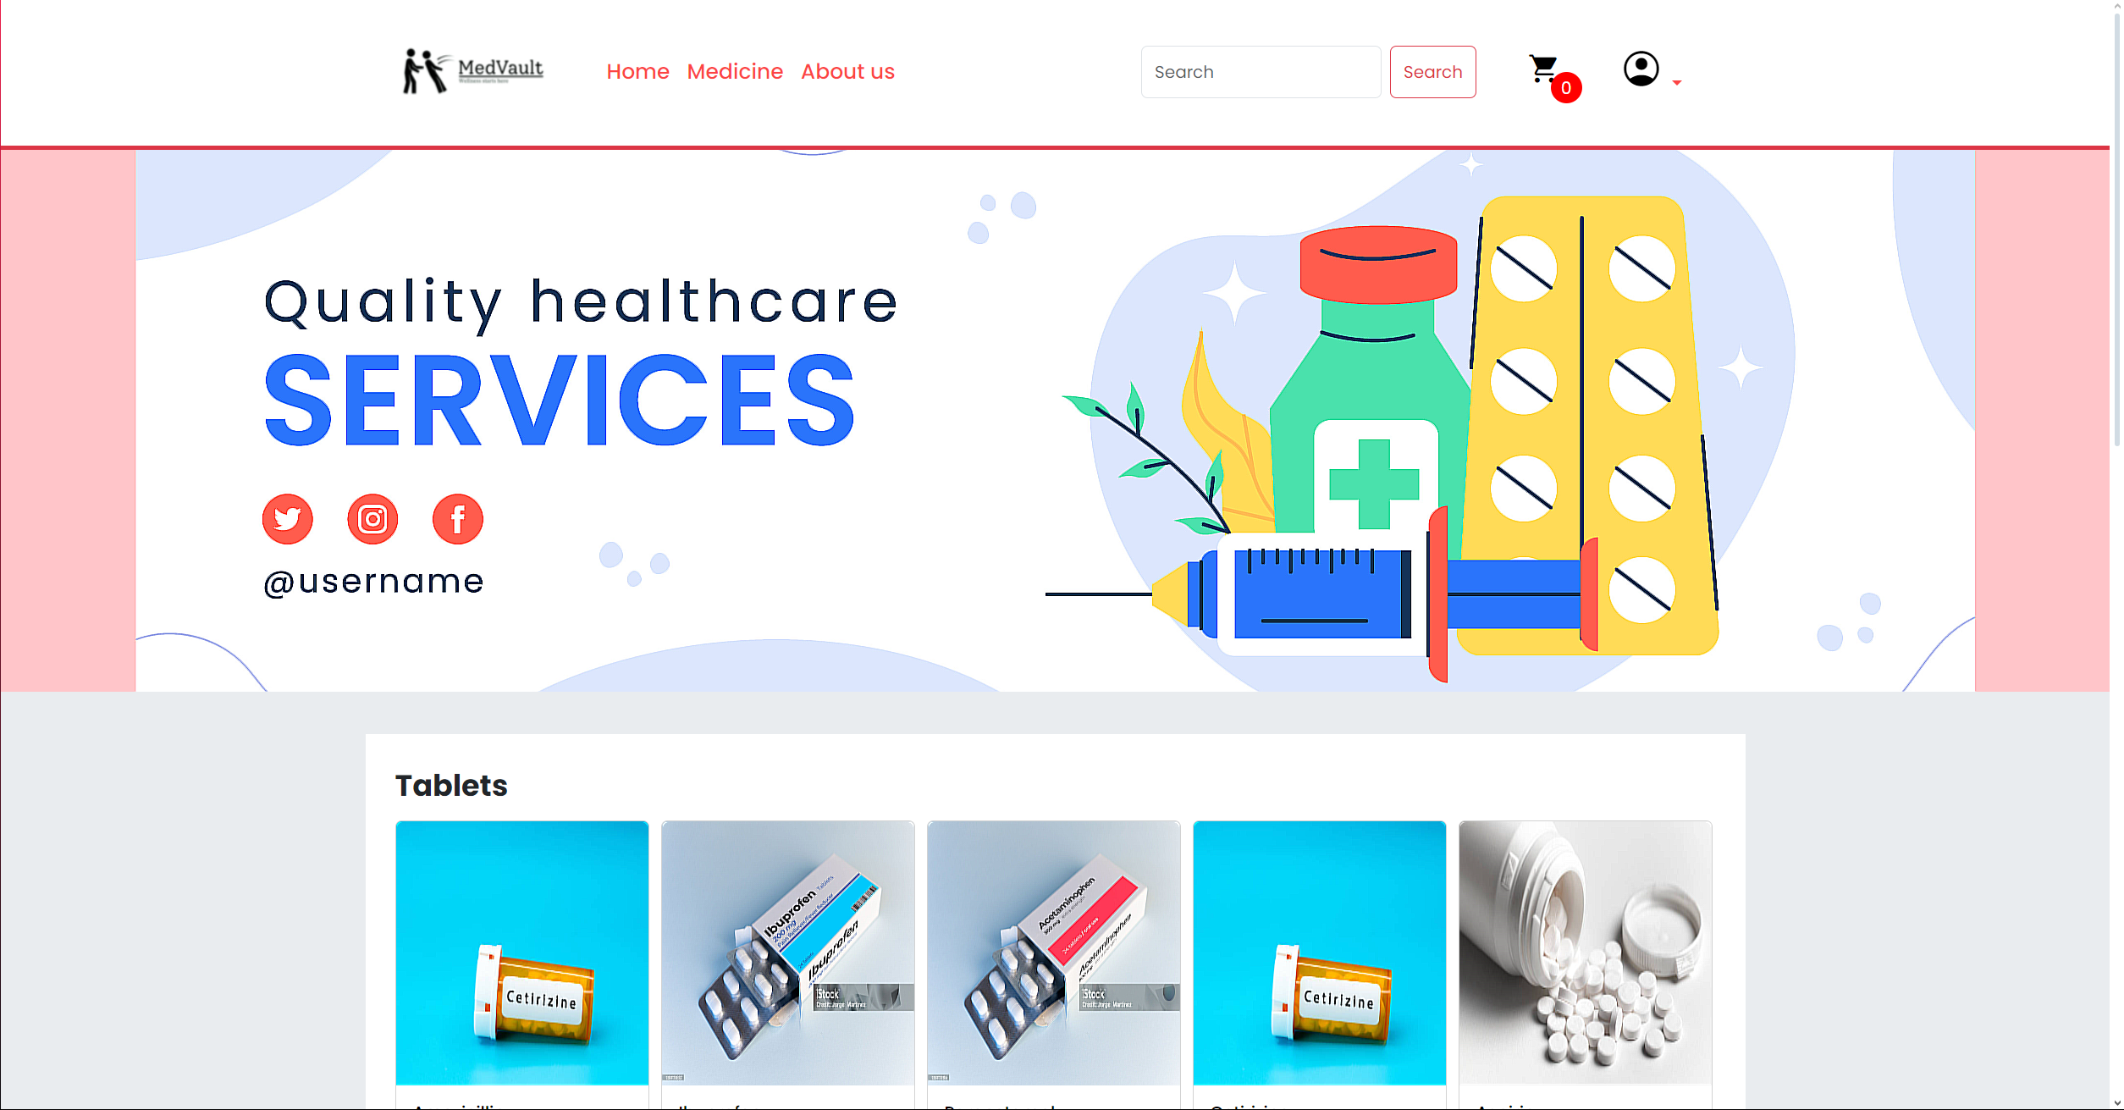
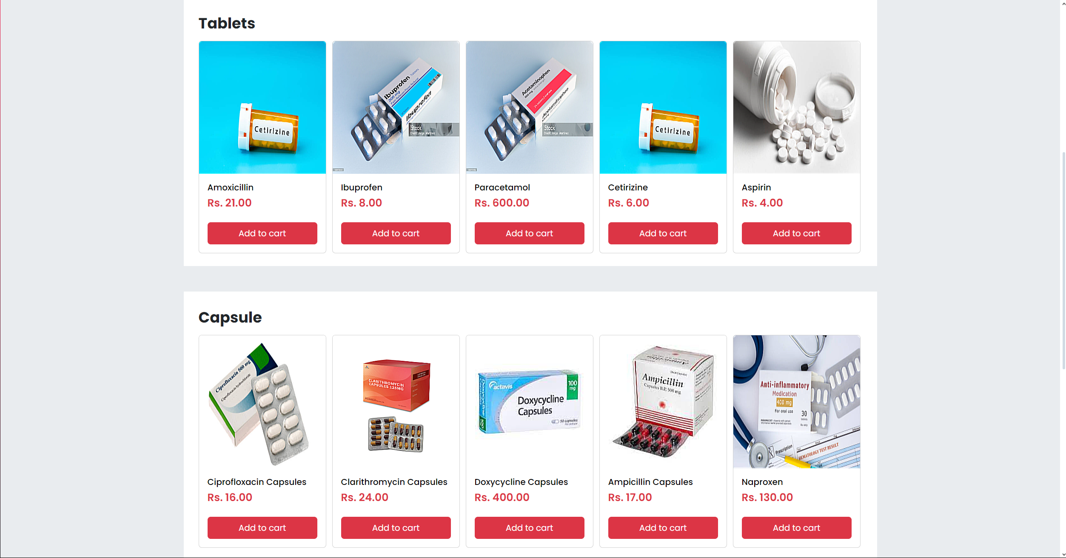
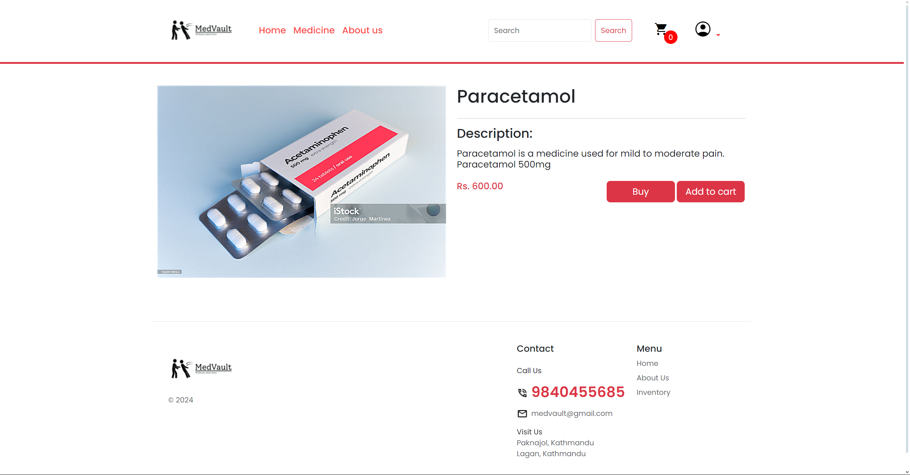
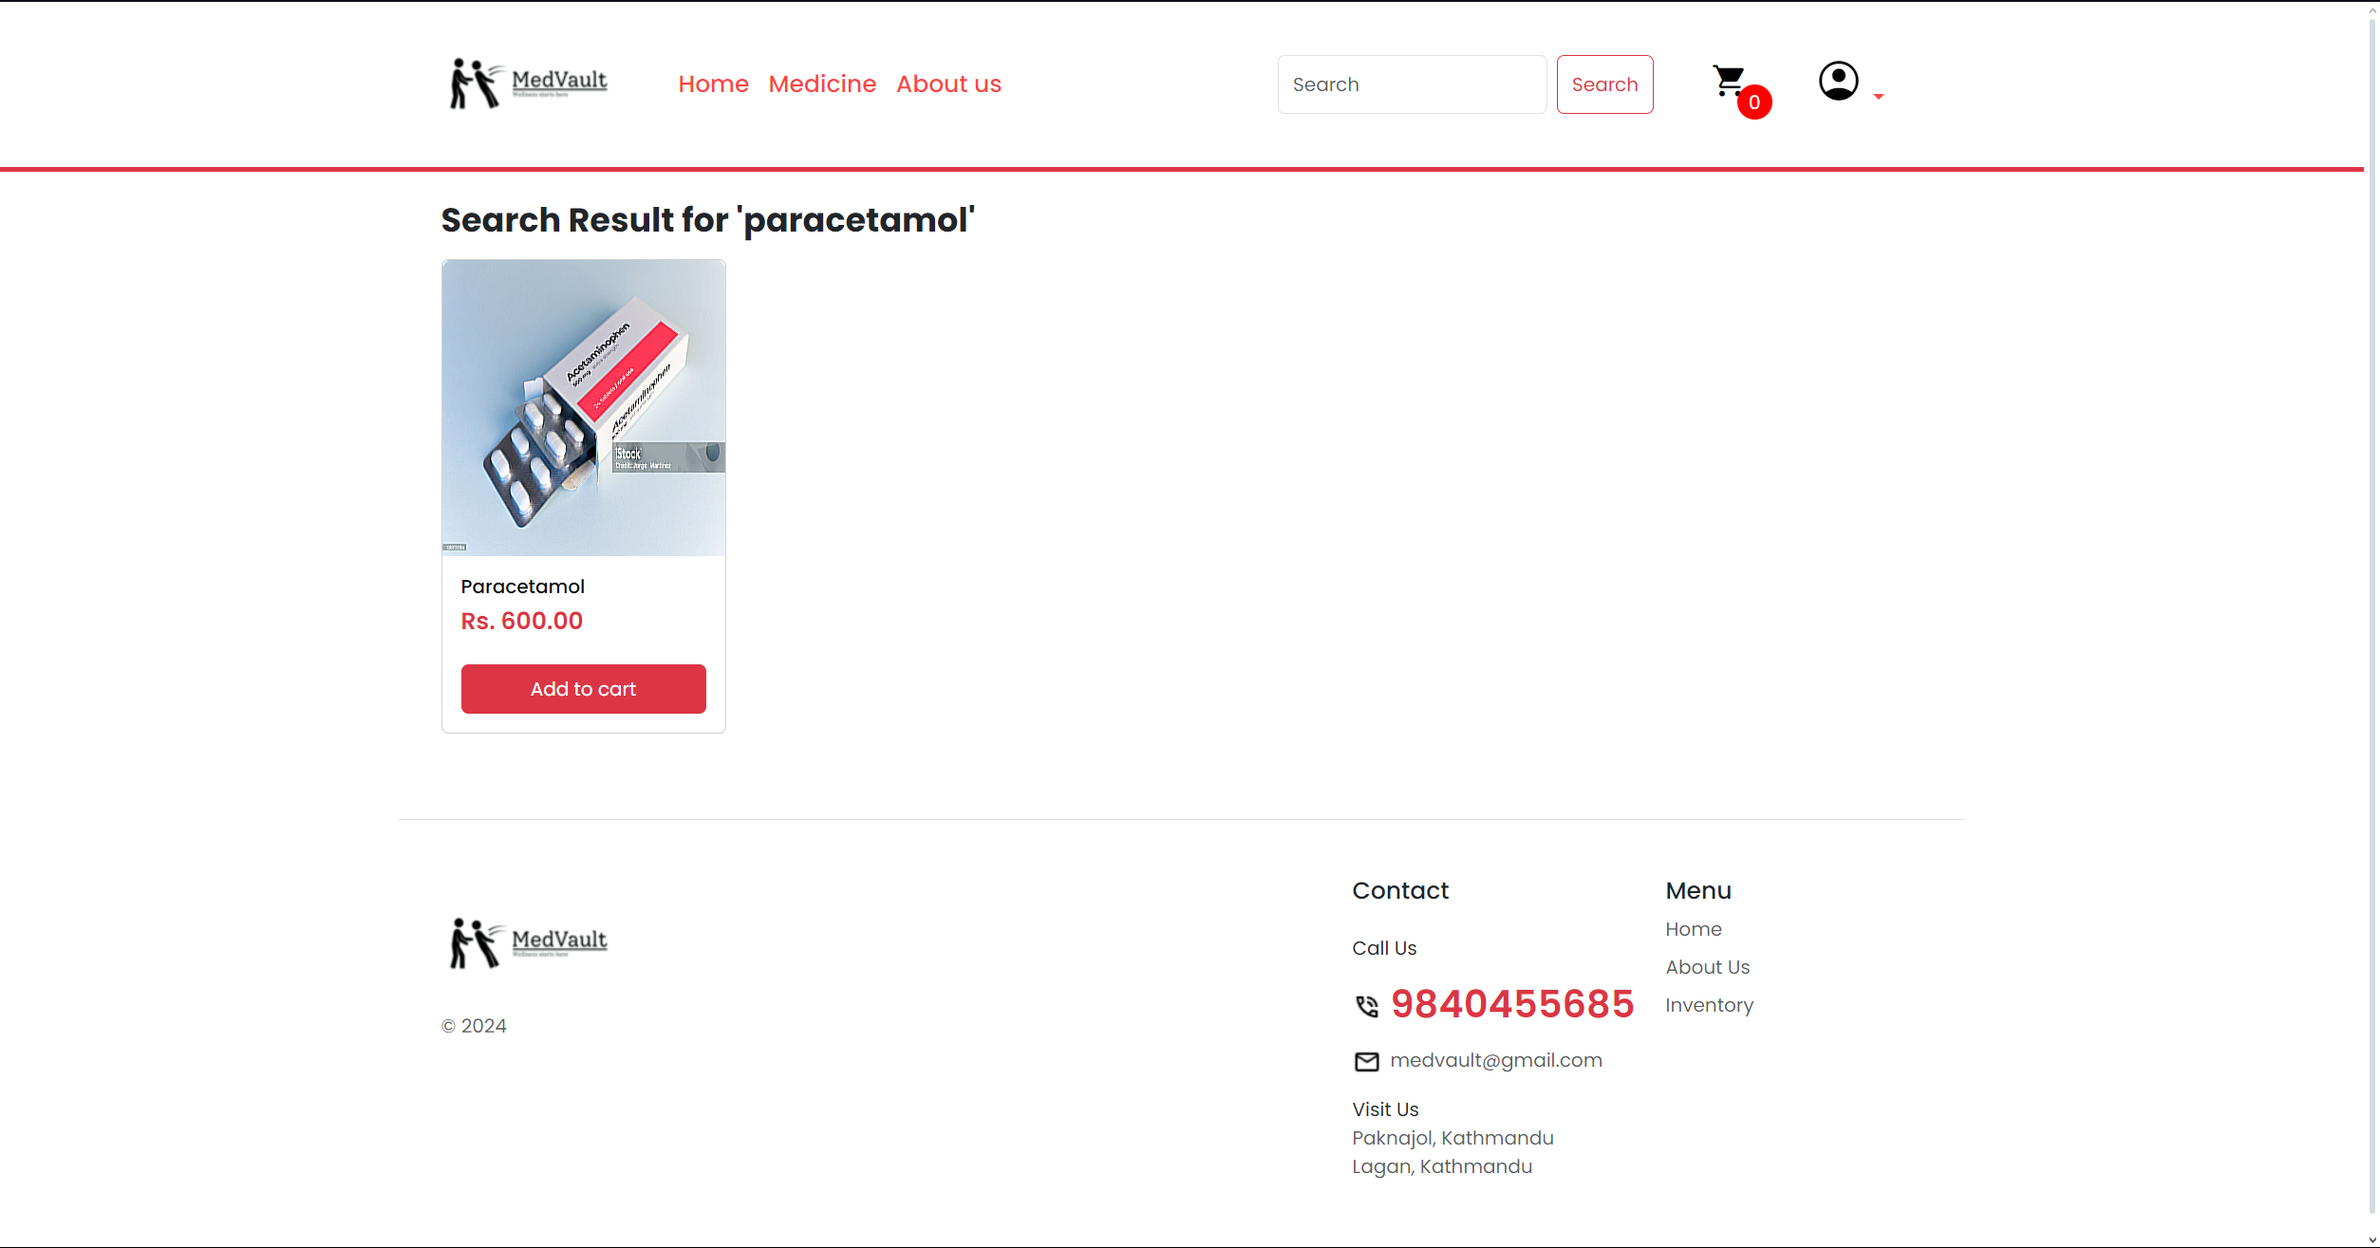

Login page
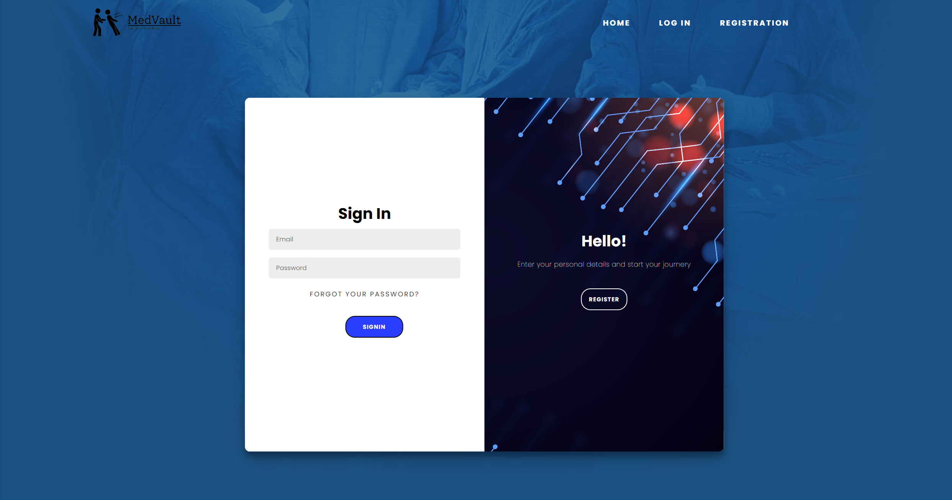
Admin page