

COS30043

Interface Design and Development

Assessment: S1 2026 Project

Name: Ricardo Zhen Wei CHEW

Student ID: 104392756

Presentation Link: https://youtu.be/EIuQuOuc-0o

Total number of pages: 42
Table of Contents
Assessment: S1 2026 Project 1
Name: Ricardo Zhen Wei CHEW 1
Student ID: 104392756 1
Presentation Link: https://youtu.be/EIuQuOuc-0o 1
Total number of pages: 42 1
1 Introduction 4
2 System Overview 4
2.1 Architectural Core and Single-Page Routing 4
2.2 Homepage Module 5
2.3 Character Details Module 5
2.4 Resource Calculators Module 6
2.5 The Wish Counter Module 6
2.6 Wish Analytics Module 6
2.7 Smart Todo List Module 7
2.8 Goal Planner Module 7
2.9 About Module 8
2.10 Login Module 8
2.11 Registration Module 8
2.12 Account Settings Module 9
2.13 Smart AI Companion Module 9
3 Wireframe design diagrams 10
3.1 Homepage 10
3.2 Character 11
3.3 Calculators 12
3.4 Wish Counter 13
3.5 Analytics 14
3.6 To-Do List 15
3.7 Planner 16
3.8 Account Settings 17
3.9 AI Assistant 18
3.10 About 19
3.11 Login 20
3.12 Register 21
3.13 Pity Progress Bar 22
4 Screenshot of the web application in action 23
4.1 Homepage 23
4.2 Character 25
4.3 Calculators 25
4.4 Wish Counter 26
4.5 Analytics 27
4.6 Todo List 28
4.7 Planner 28
4.8 Account Setting 29
4.9 AI assistant 29
4.10 About 30
4.11 Login 31
4.12 Register 31
4.13 Pity Progress Bar 31
5 Describe how you achieve a responsive UI 32
5.1 Dynamic Layout Shifts via Computed Route Monitoring 32
5.2 Flexible CSS Layout Engines and Mobile-First Viewport Bounds 32
5.3 Asymmetric Media Query Interception and Breakpoint Scaling 33
5.4 Adaptive UI Fluidity via Inertial Smooth Scroll Synchronization 34
5.5 Hardware-Accelerated Micro-Interactions and UI Layer Isolation 35
6 Usability and accessibility evaluation 36
6.1 Identifying Potential Usability Issues 36
6.2 Evaluating Navigation Efficiency 36
6.3 Evaluating Form Usability 37
6.4 Ensuring Accessibility for Different Users 38
6.5 Proposed Structural UI Improvements 39
7 Additional/advanced techniques implement 40
7.1 Cloud-Native Backend Integration via Supabase 40
7.2 Agentic AI Companion with Tool Calling and API Rotation 40
7.3 Hardware-Accelerated Smooth Scrolling via Lenis Physics 41
7.4 Algorithmic Resource Distribution (Greedy Approach) 41
7.5 Native Drag-and-Drop API paired with Anime.js 41
7.6 Architectural UI Escapes using Vue Teleport 42
7.7 Edge Delivery Hosting via Cloudflare 42

Introduction
Genshin Companion is a comprehensive, full-stack web application developed to serve as a premium assistant for players of the popular action role-playing game, Genshin Impact. The primary objective of this project is to eliminate the player base's reliance on complex, fragmented external spreadsheets by streamlining daily gameplay routines into a single, cohesive web dashboard. The platform empowers users to track their wish history, calculate character and weapon ascension materials, and manage farming schedules efficiently.
This project demonstrates a modern, component-based architectural approach by utilizing Vue.js 3 and the Pinia state management library for the frontend. To satisfy the requirement for an appropriate backend technology and demonstrate a clear separation of concerns, the application integrates Supabase, a cloud-native PostgreSQL database. This integration enables real-time cloud synchronization of user data, such as wish counts, to-do items, and progression goals, facilitated through RESTful API communication.
The application heavily prioritizes user experience through the implementation of responsive, mobile-first design principles and fluid interface animations driven by the Lenis scroll physics engine. Furthermore, the system expands significantly beyond the minimum project scope of eight interconnected pages. The application features 11 fully functional routing endpoints, which explicitly consist of the Homepage, Character Details, Wish Counter, Wish Analytics, Resource Calculator, Smart Todo List, Goal Planner, About page, Account Settings, and secure User Authentication views split into dedicated Login and Registration pages. By combining responsive interface design with advanced features such as an agentic AI assistant capable of dynamic interface navigation, this project presents a robust, user-centric solution to a real-world digital management problem.

System Overview

Architectural Core and Single-Page Routing
Genshin Companion is a Vue 3/Pinia Single Page Application (SPA) interacting asynchronously with a Supabase database. Bootstrapped in main.js, it registers Pinia, Vue Router, Bootstrap, and custom CSS.
App.vue manages the main Flex shell containing the navbar, footer, RouterView, and AI assistant. It applies an 80px padding offset via computed isNotHomepage on sub-pages to clear the sticky header. To prevent race conditions, onMounted executes sequential hydration: first authStore.loadData() resolves the active session, then Promise.all() parallelizes todos, wishes, and goals. Inertial scrolling uses a CDN-loaded Lenis instance in onMounted synced with requestAnimationFrame. A route watcher triggers scrollTo(0) instantly on page transitions.
The SPA runs in HTML5 History Mode, controlling 11 routes: / (homepage), /character (AI suggestions), /wish-counter (pity logs), /wish-analytics (charts), /calculator (character/weapon/resin), /todo-list (todo), /planner (saving targets), /about (metadata), /login /registration (auth/provisioning), and /account_setting (profile/deletions).

Homepage Module
The Homepage Module acts as a single-page presentation layer managing user onboarding, feature discovery, and promotional tracking. Using a 300vh scroll container (trackRef), the module calculates viewport positions via getBoundingClientRect() to compute a reactive scrollProgress ratio, dynamically switching between Linnea and Chasca promotional banners. Users can also utilize background circle anchors to trigger smooth programmatic navigation resets via scrollIntoView(). Adjacent to this, an intermediate showcase section houses high-fidelity navigational cards for the Advanced Material Calculator, Cloud-Synced Wish Counter, and Reactive Dynamic Todo List, which animate during the onMounted lifecycle hook using an Anime.js staggered timeline with an easeOutQuad easing curve.
The lower dashboard handles authentication and user reward data by integrating with the global Pinia state engine (gacha_store.js). On mount, the component triggers gachaStore.fetch_codes_data() to populate active redeemable codes, formatting them via parseRewards and getRewardIcon helper functions while enabling one-click copying through the native navigator.clipboard API. For unauthenticated guests, conditional rendering boundaries (v-if="!authStore.currentUser") expose dark call-to-action blocks that smoothly redirect users to login or registration views using programmatic Vue Router paths.

Character Details Module
Character Details Module serves as the presentation layer for real-time promotional banner evaluations. The module works asynchronously with an artificial intelligence summarizer service (ai_summarizer.js) to generate character capability matrices and summoning verdicts on demand. To mitigate remote overhead, the architecture implements a local JavaScript Map() instance (characterCache) as a session-caching layer. Upon lifecycle mounting, cache hits instantly hydrate component states, whereas cache misses fallback to remote generation before committing the new payload to the cache registry for future use.
The user interface layouts data models across structured portrait cards (.portrait-card) within a symmetric, responsive grid. To maintain a clean visual hierarchy, the layout utilizes progressive disclosure driven by local reactive boolean flags (showMoreLinnea, showMoreChasca). Interacting with the card toggle element switches these states, expanding the DOM structure to render nested payload data. A local try-catch wrapper intercepts runtime network disruptions and catches execution errors gracefully, formatting a localized status update on-screen to isolate failures without breaking the main client viewport.

Resource Calculators Module
Defined in src/views/calculator.vue, this module serves as the analytical layer for progression.
- Experience Optimization Engine: Queries arrays from character_exp.js and weapon_exp.js to determine required experience (). It uses a greedy distribution algorithm to allocate material tiers, tracking overflow as , while calculating Mora costs via (character) or (weapon) multipliers.
- Resin Tracking Engine: Calculates stamina deficits and projects recovery timestamps using a minute-per-Resin rate. It localizes recovery strings and converts deficits into Condensed Resin tokens.
- Persistence: All requirements are dispatched to todo_store.js as structured payloads, enabling seamless integration with the Todo List.

The Wish Counter Module
The Gacha Store (src/gacha_store.js) functions as the system’s state engine for tracking wish history across limited character, weapon, and standard banners. Upon authentication, the store synchronizes banner pity counters with Supabase profiles metadata and hydrates pull logs from the wishes database table for real-time cloud persistence.
To ensure data accuracy, the add_pull() action preserves pity state checkpoints before performing threshold evaluations. This allows remove_pull() to execute non-destructive state rollbacks by reading these checkpoints, ensuring database records and internal store counters remain synchronized.
The wish_counter.vue view handles presentation, rendering reactive PullStatusCard widgets for banner monitoring and tabular logs for history review. To maintain performance without mutating store state, the view renders history in reverse-chronological order by utilizing reactive array cloning (slice().reverse()), ensuring the data layer remains consistent while facilitating an intuitive user experience.

Wish Analytics Module
The Wish Analytics serves as a telemetry dashboard that processes and visualizes traveler pulling efficiency and asset expenditure. The backend couples computed data directly to Pinia store getters (gacha_store.js), dynamically evaluating key performance indexes such as absolute wish totals, average five-star pity intervals, cumulative asset metrics, and single-item cost peaks. It features rapid data-hydration hooks (handleSimulateDemo, handleClearData) to populate the interface with simulated data streams or wipe local history on command.
The front-end renders across an adaptive grid layout using lightweight, cloud-scale inline SVG graphics to bypass heavy graphic plug-in frameworks:
- Monthly Spending Trend: An SVG path layout translates calculated data blocks (monthlyChartPoints) into vector geometries (linePathData, areaPathData), backed by mouse-hover listeners to render contextual tooltips.
- Spending Categories Distribution: A circular vector donut chart translates banner category percentages into offset radial strokes (stroke-dasharray, stroke-dashoffset), mapping a clean color legend beside an internal center total summary.
- Five-Star Cost History: A scrolling ledger lists five-star acquisitions in reverse-chronological order, arranging character badges, specific pity thresholds, and exact timestamps within a readable tabular matrix.

Smart Todo List Module
The Smart Todo List (src/views/todo_list.vue) serves as the centralized task engine, synchronized via todo_store.js. It aggregates calculator data into persistent farmable lists, employing transactional operations to ensure status integrity across sessions.
The architecture manages empty states via conditional rendering (v-if="todoStore.todos.length === 0"), swapping the list UI for a redirection prompt when necessary. Active tasks render via reactive iteration, displaying the progression trajectory (e.g., Level ) to provide clear farming context.
The module decomposes costs by iterating over item arrays and calculating Mora totals using toLocaleString(). User interactions, such as @click="todoStore.removeTodo(task.id)", facilitate task node removal, triggering real-time re-hydration of global material totals and immediate component refreshing.

Goal Planner Module
goal_planner.vue acts as the long-term projection engine, managing user-defined saving objectives via goal_store.js to bridge current pity status with future banner targets.
Computational Engine: The module utilizes JavaScript Date and ISO-8601 parsing (YYYY-Www) to determine temporal constraints. It calculates weeksRemaining relative to system time and derives required resources by subtracting currentPity (from gacha_store.js) from neededWishes. Daily requirements are projected using: .
State Reactivity: The UI provides a reactive grid observing the state engine:
- Visuals: Maps banner types to dynamic CSS badges and progress bar states.
- Validation: Enforces logical form constraints (e.g., needed wishes > 0) before dispatching to Supabase.
- Monitoring: Dynamically flags goals as "Overdue" or "Goal Met" by reconciling current pity against deadlines, ensuring continuous visibility of progress toward limited-banner milestones.

About Module
The About page serves as a high-fidelity information portal that documentations the application's overarching project goals, key feature clusters, and core deployment environment. The architecture bypasses dense textual blocks by grouping development features into an optimized layout, utilizing clear semantic iconography via Bootstrap Icons to reinforce visual navigation hooks. Because it renders static educational and overview variables, the view operates independently of state-hydrating Pinia stores, enabling instant DOM compilation and client-side rendering without backend database processing bottlenecks.
The front-end layout delivers a clean presentation hierarchy through cascading, glassmorphic layout wrappers (.about_glass-card) that dynamically scale across diverse traveler viewports. A multi-column descriptive grid partitions the application stack, matching feature summaries like material calculation algorithms, cloud-native pull tracking, and automated router navigation to distinct card configurations. The structural metadata maps core dependencies into frontend, backend, automation, and user-experience badges, concluding with a bottom-aligned educational callout that explicitly links the dashboard's interface design mechanics to its respective academic framework.

Login Module
This module functions as the user authentication interface, regulating client entry sessions and backend system initialization. The module couples standard input elements via Vue 3 proxy states (username, password) to capture user validation strings securely. Upon form submission, the local system triggers an asynchronous dispatch to the global state engine (auth_store.js), executing authStore.loginUser(username.value, password.value) to verify credentials. Successful validation hydrates active state properties, synchronizes cloud session parameters, and invokes programmatic router tracking (router.push("/")) to transition the viewport smoothly to the dashboard interface.
The presentation layer utilizes a glassmorphic visual card shell (.auth_glass-card) overlaid against a themed image background container (.auth_wallpaper-container) to provide high visual contrast. To prevent data corruption, built-in validation constraints immediately intercept incomplete submittals, throwing a client-side warning popup if input values remain blank. Furthermore, cross-link routing elements (router-link) allow seamless micro-navigation between active sub-views, enabling guest travelers to toggle directly between sign-in templates and registration views without causing full-browser layout repaints.

Registration Module
This module serves as the entry point for new traveler accounts, managing user provisioning and profile database initialization. The component captures data using reactive proxy references (username, password, confirmPassword) bound directly to HTML form inputs. Upon submission, the module executes strict client-side validation to intercept incomplete field data and verify that twin password submittals match exactly. Validated credentials then invoke the global state engine via authStore.registerUser(), triggering an asynchronous background callback that safely provisions the user identity across backend services.
The presentation layer shares the project's signature glassmorphic look, layering an adaptive form layout (.auth_glass-card) over a fixed scenic background asset (.auth_wallpaper-container). To provide responsive feedback, structural error handlers catch system anomalies or credential collisions, displaying clear modal alerts while preserving the user's current input strings. Once backend verification returns a success state, the internal routing mechanics issue an immediate redirect via router.push("/login"), smoothly transitioning the active client viewport to the authentication panel without triggering a full-browser layout repaint.

Account Settings Module
This account settings page serves as the control panel for identity management, password updates, and data purge operations. The architecture binds HTML input fields directly to reactive proxy variables (displayName, username, dateOfBirth) to manage profile modifications through the global state engine (auth_store.js). Security actions use a separate form structure to evaluate current password parameters before executing modifications or rendering contextual update logs inside reactive notification blocks.
The presentation layer groups administrative procedures into an asymmetrical grid built from dark card containers (.account_setting_dark-card). Destructive data actions are isolated within a dedicated management block, allowing travelers to clear pulling data streams or permanently delete account footprints. To prevent accidental data loss, these routines use nested native confirmation windows (confirm()) as a circuit breaker. Upon execution, the module wipes state pity counters from the global engine (gacha_store.js), purges backend records, terminates the user session, and routes the viewport back to onboarding views.

Smart AI Companion Module
The Smart AI Companion (components/ai_assistant_widget.vue) functions as an agentic interface powered by resilient, multi-provider LLM engines. It utilizes the unified ai_summarizer.js service to process natural language, supporting dynamic function calling to execute core system operations like log_gacha_pull, manage_todo_task, or Maps_application.
The architecture prioritizes seamless interaction through a glassmorphic floating action button (FAB) and a reactive chat panel. It implements transition-based visibility toggles and contextual quick-action chips to reduce user friction. By decoupling intent recognition from UI logic, the assistant automatically populates complex calculator forms and triggers state mutations, enabling hands-free dashboard navigation and automated resource scheduling directly through natural text commands.

Wireframe design diagrams

Homepage
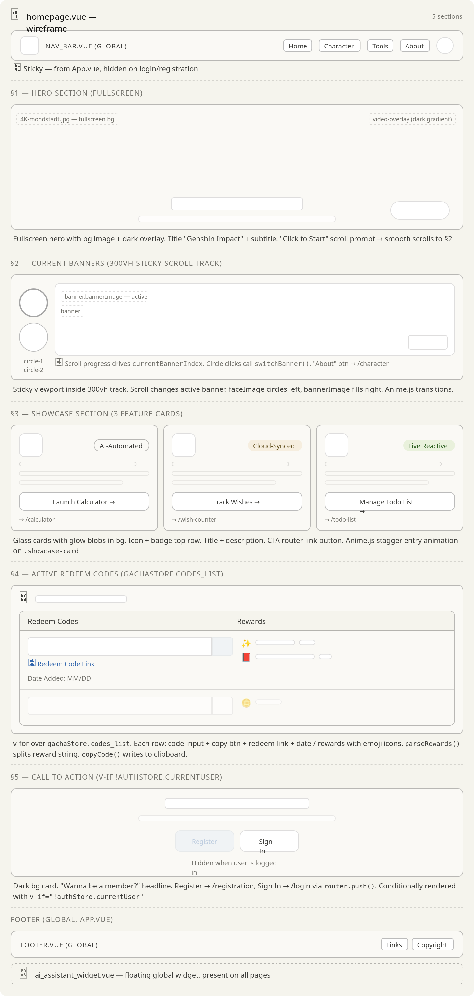

Character
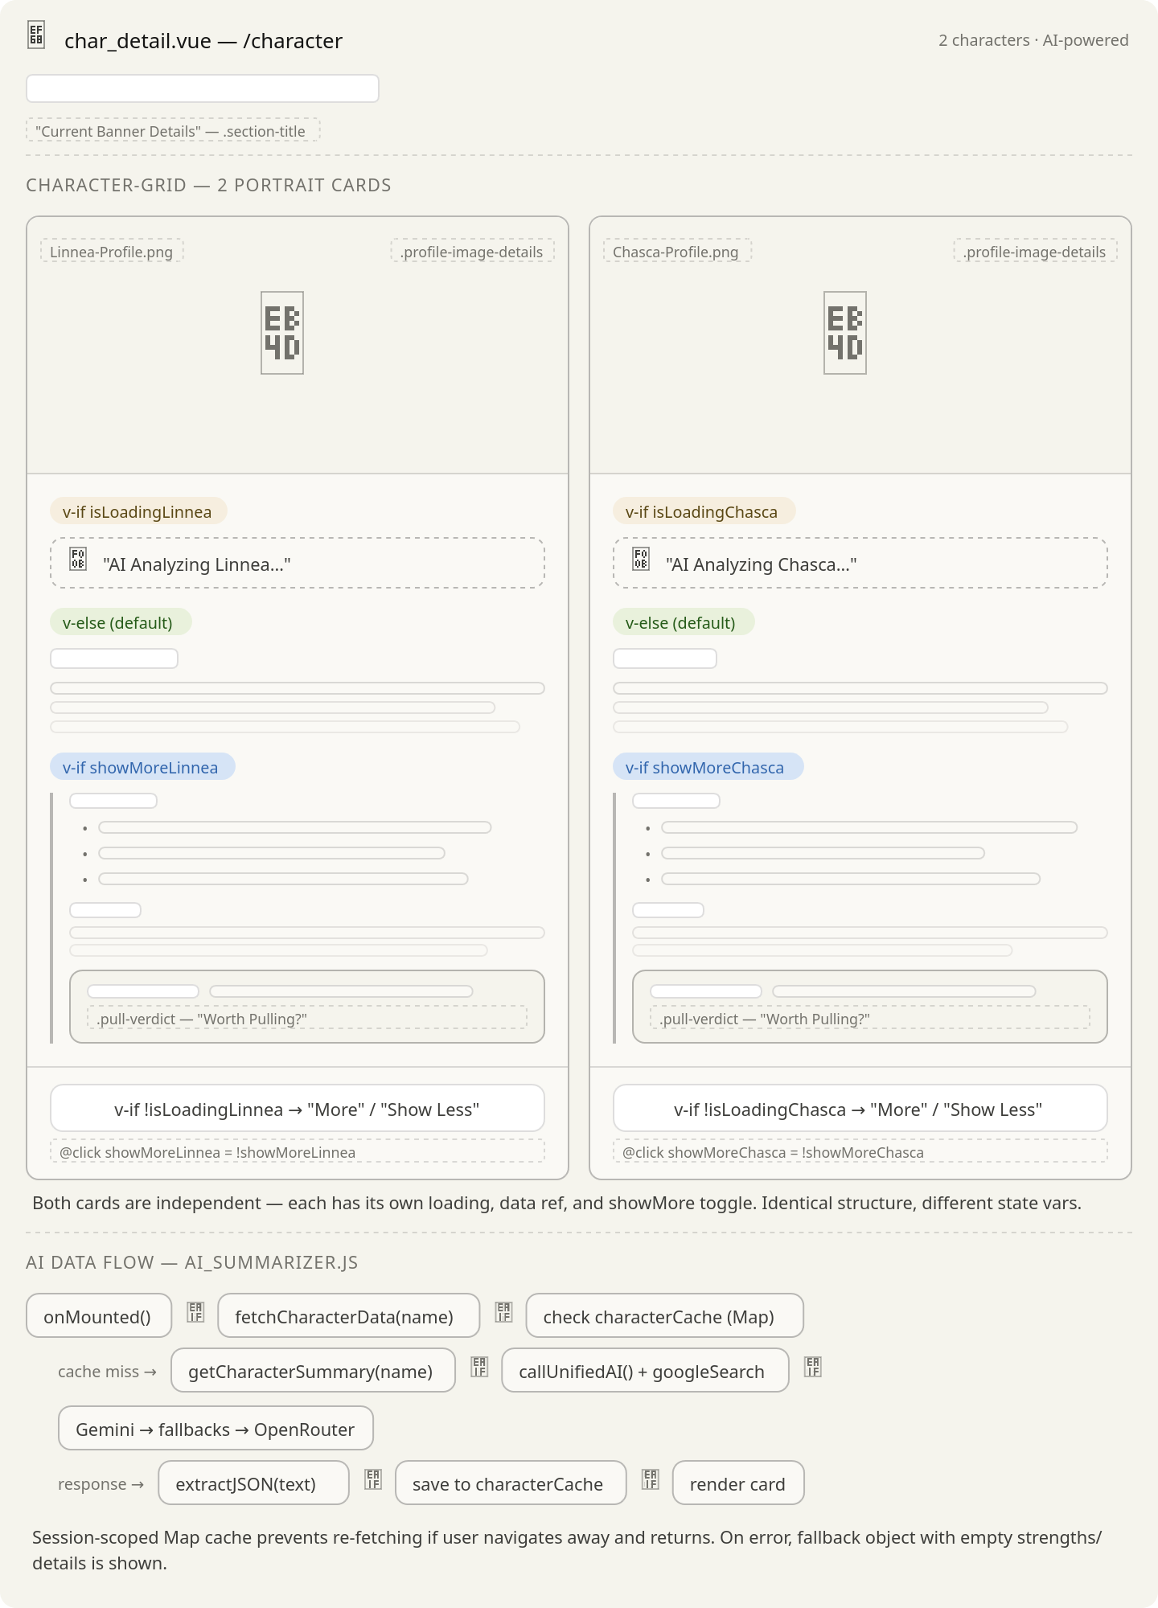

Calculators
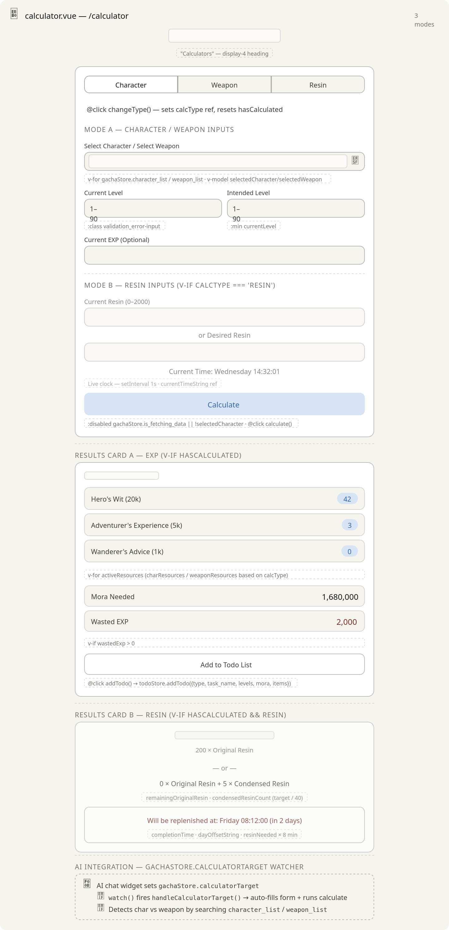

Wish Counter
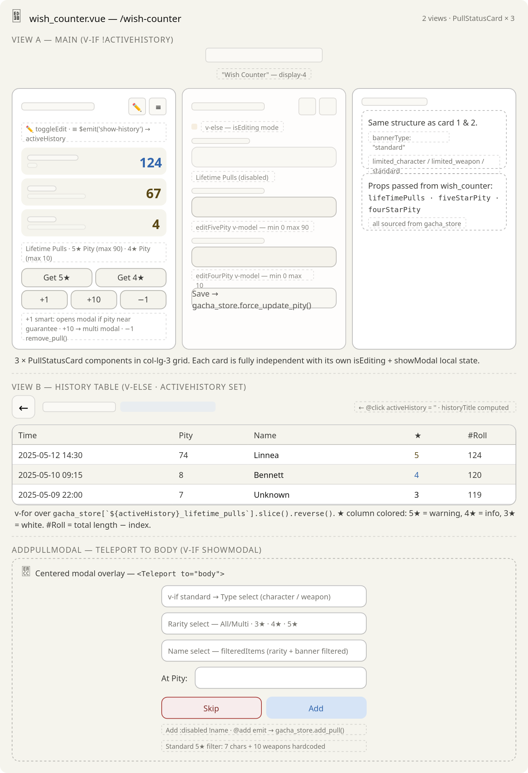

Analytics
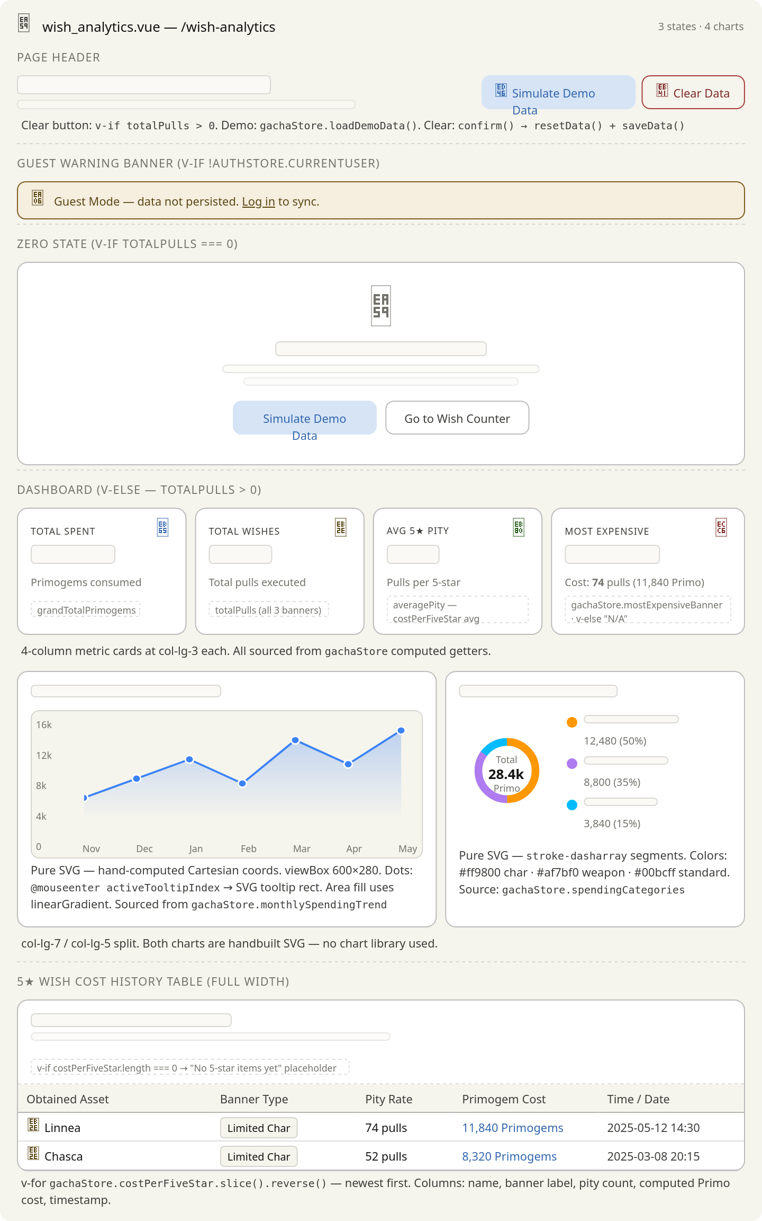

To-Do List
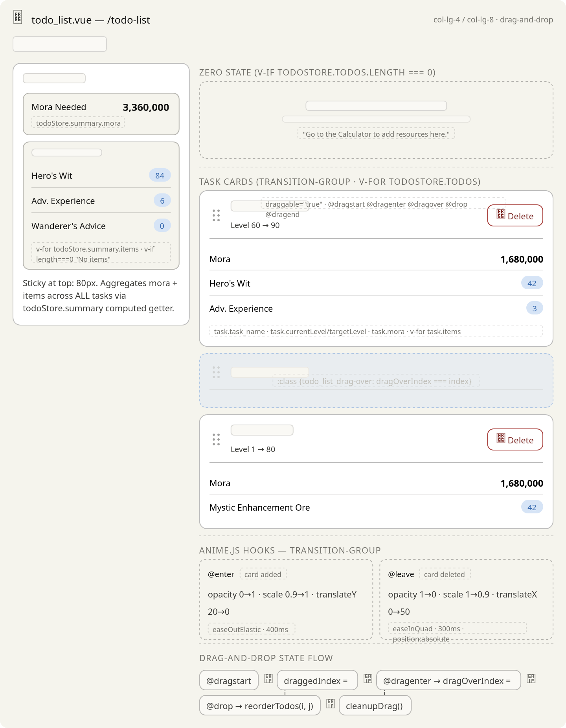

Planner
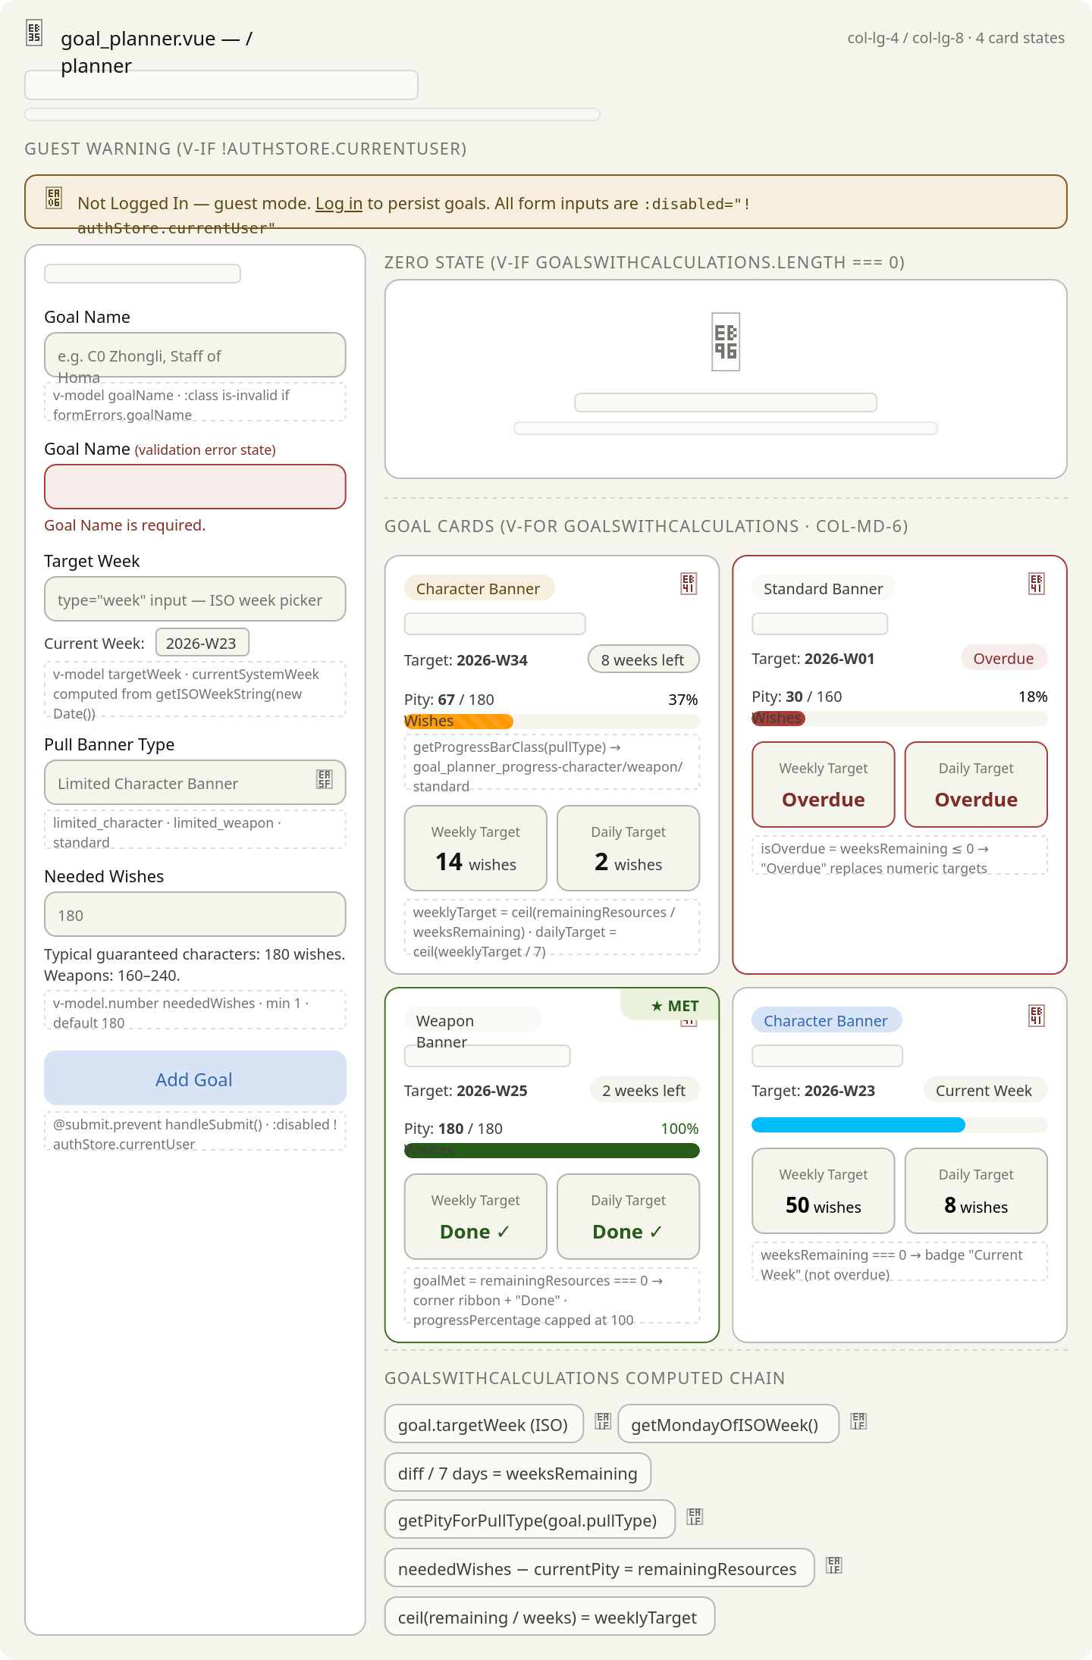

Account Settings
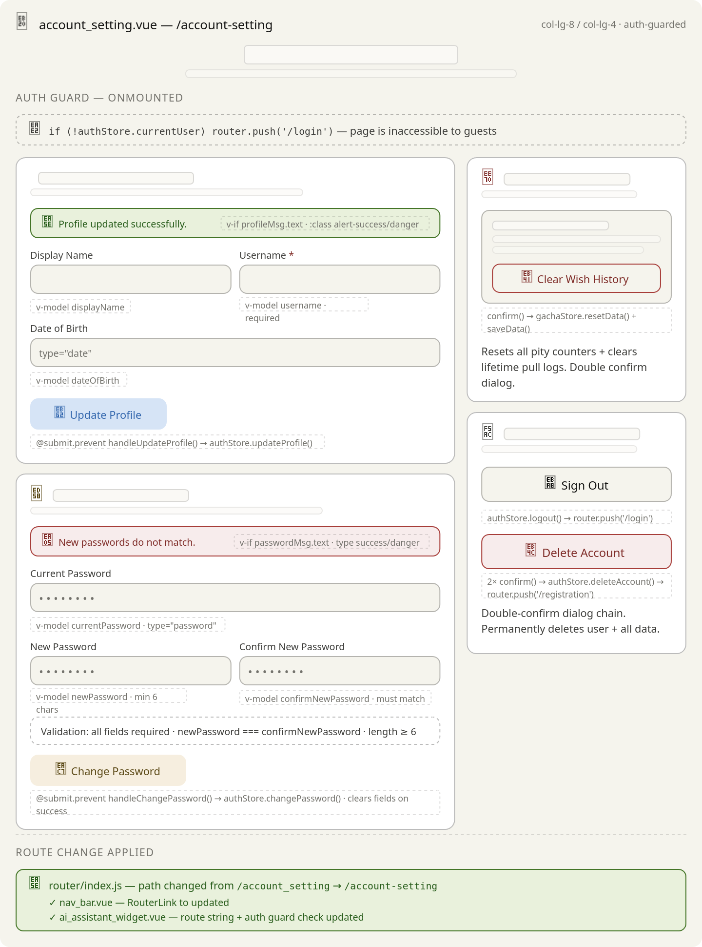

AI Assistant
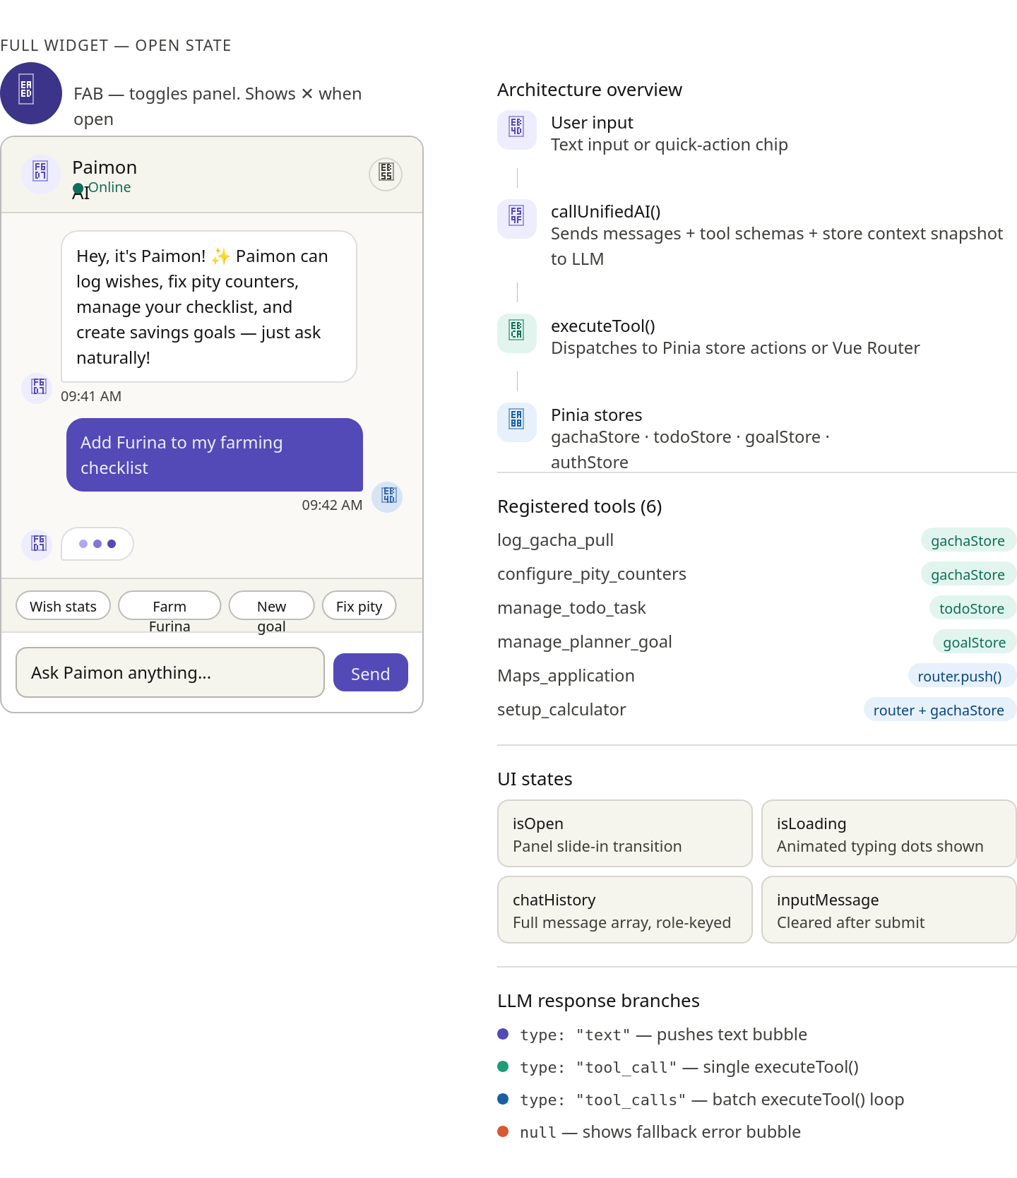

About
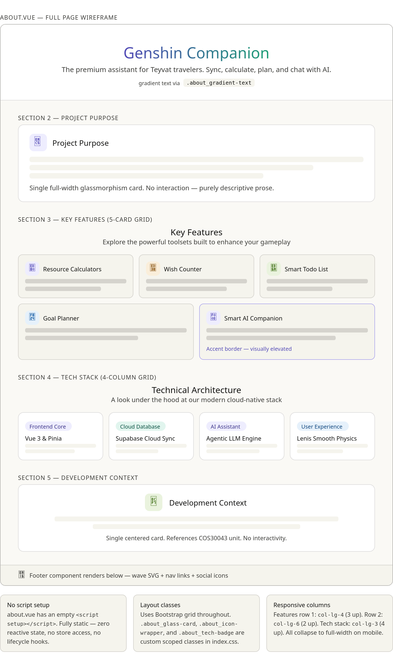

Login
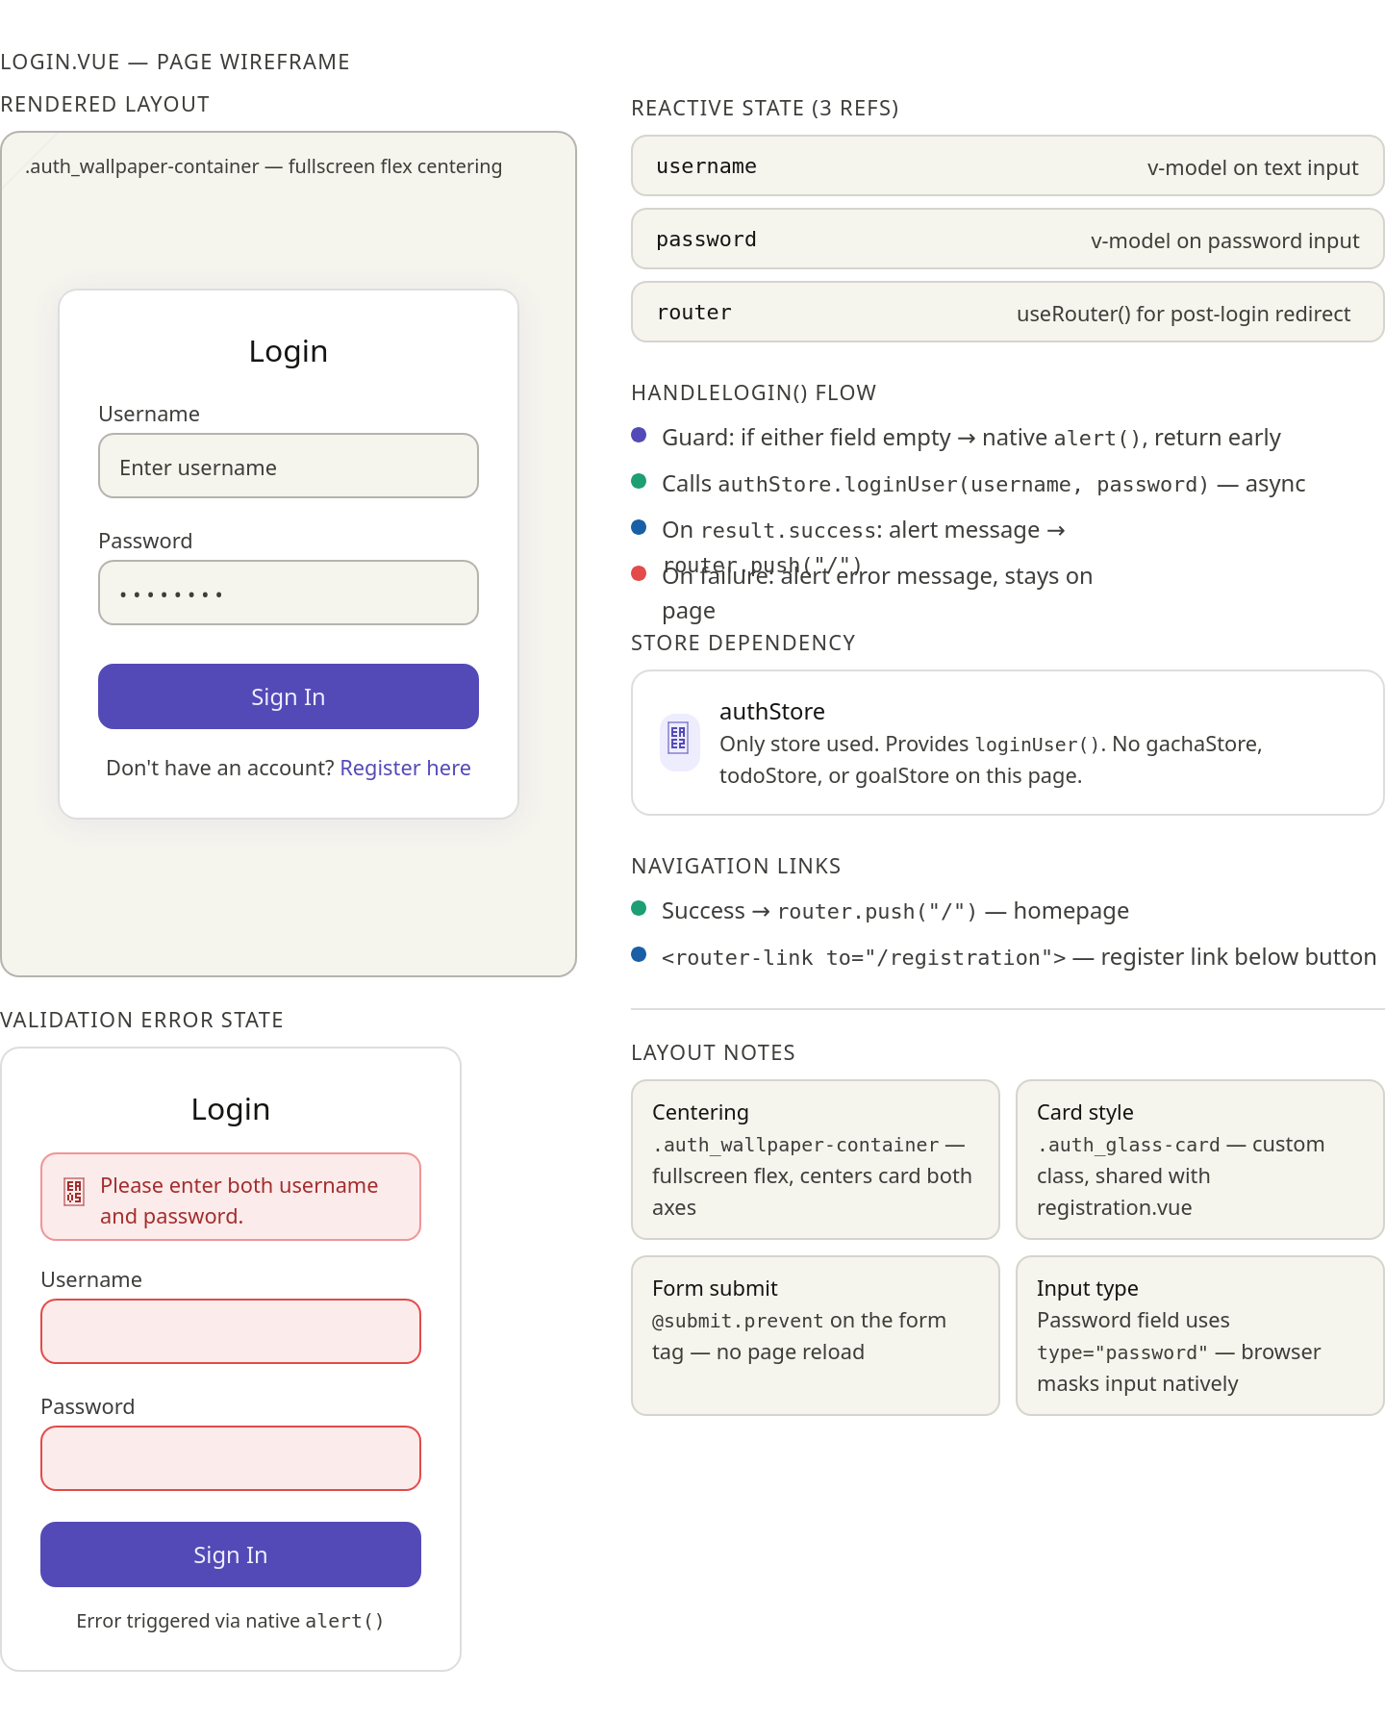

Register
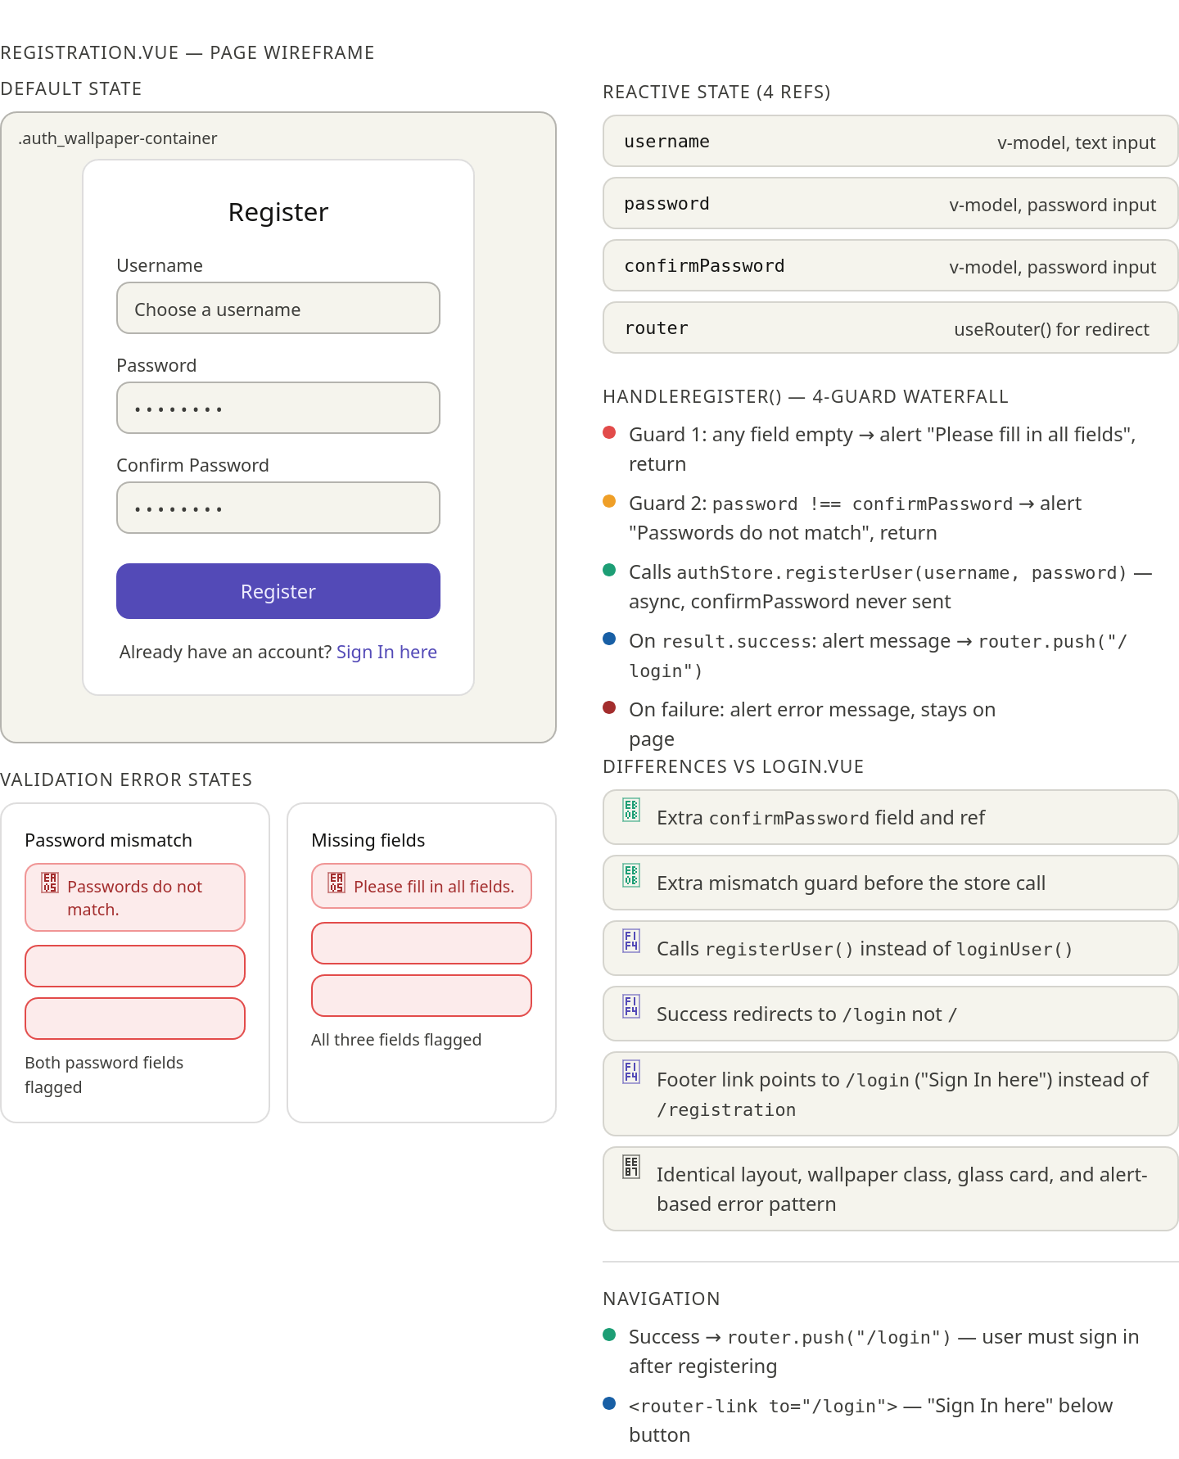

Pity Progress Bar
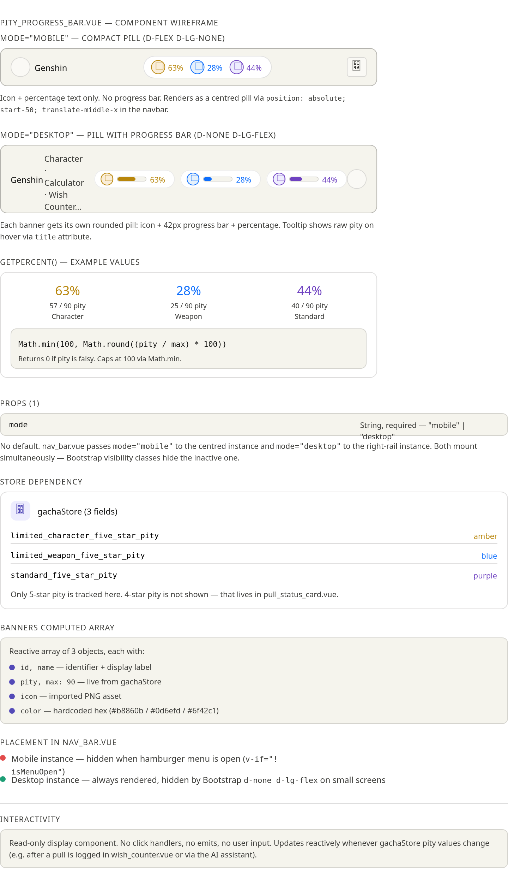

Screenshot of the web application in action

Homepage
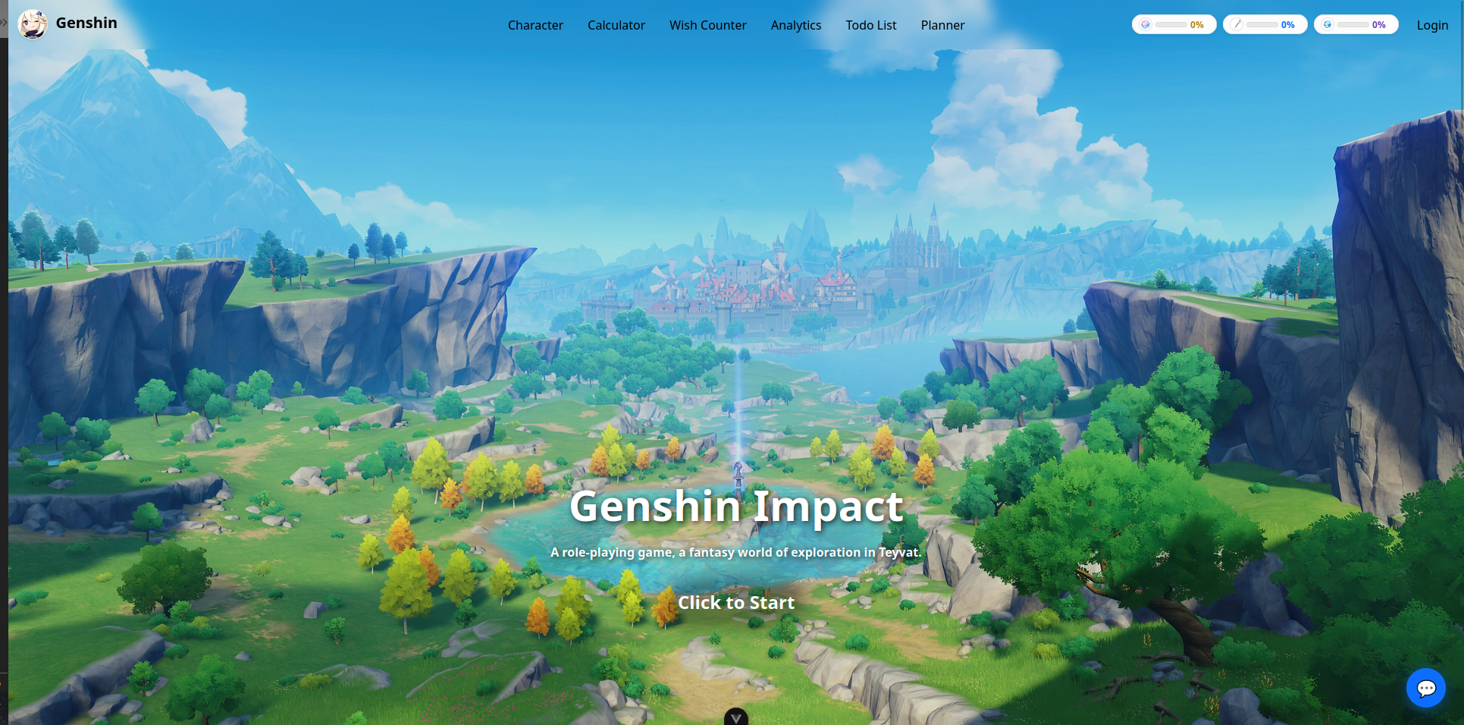
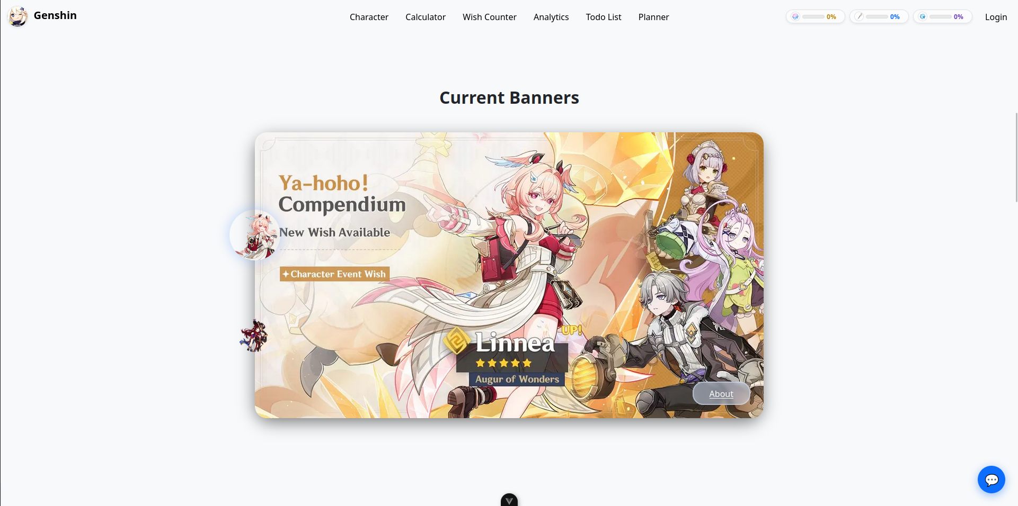
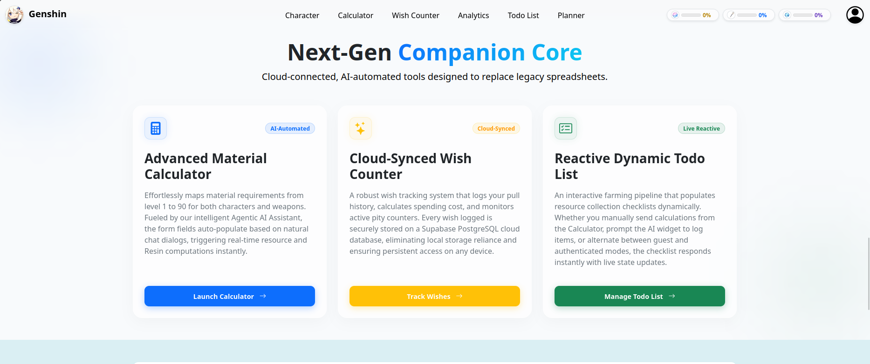
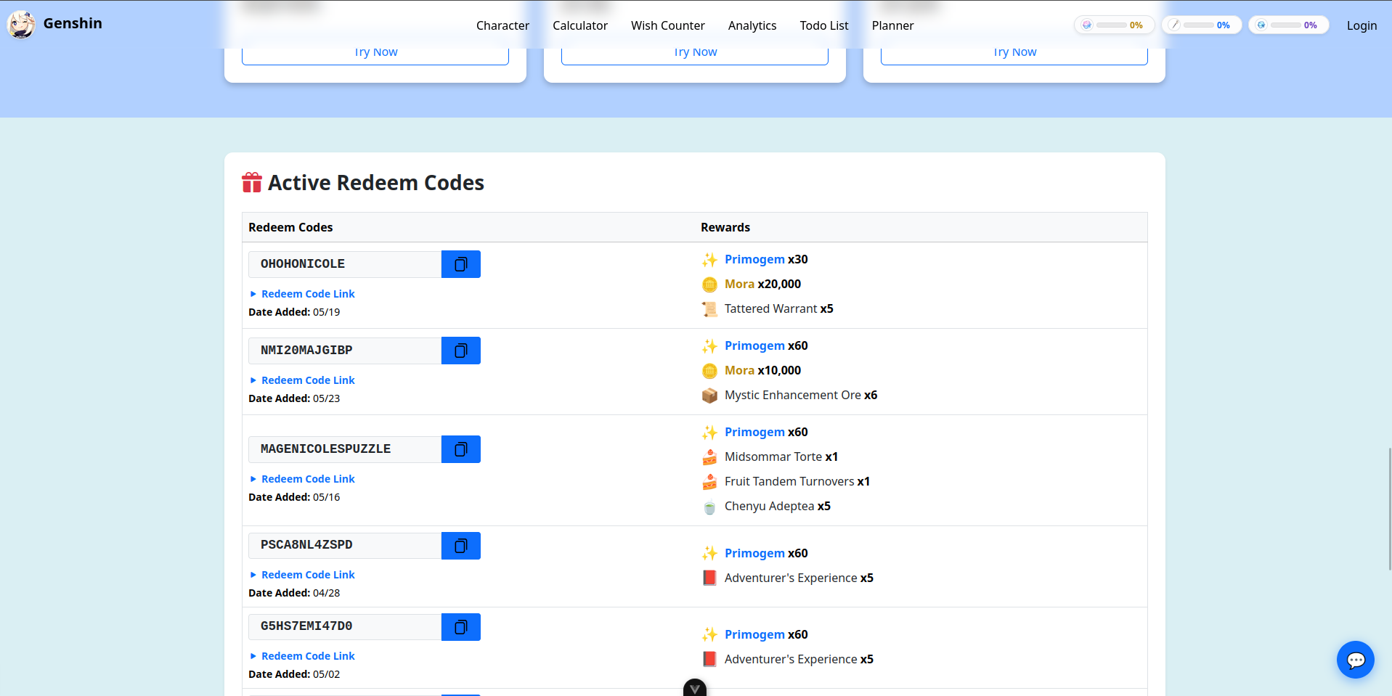
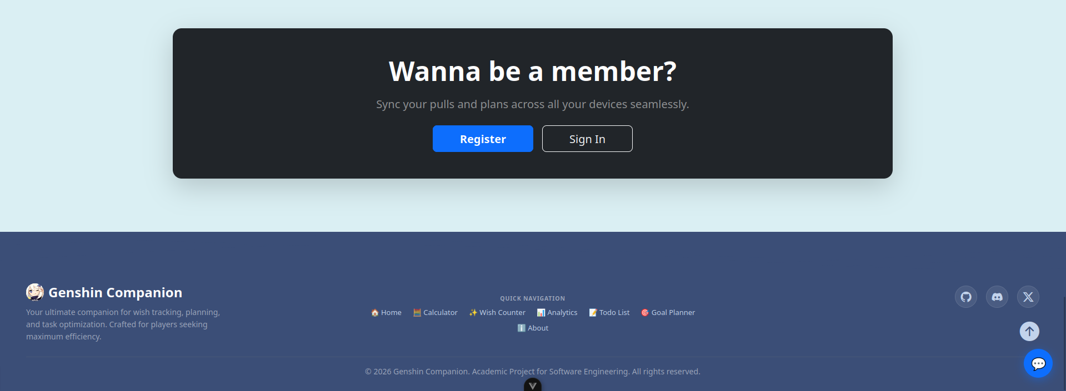

Character
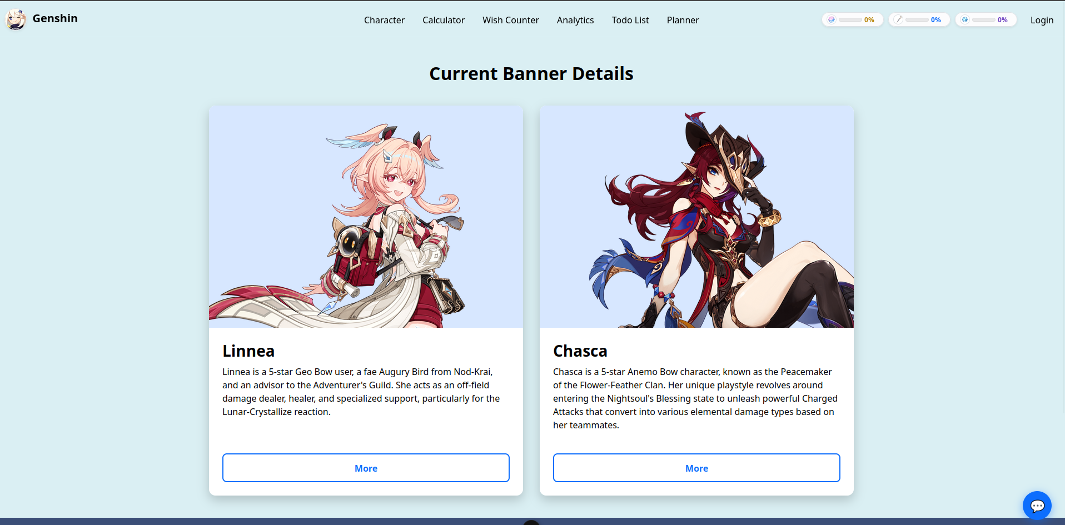

Calculators
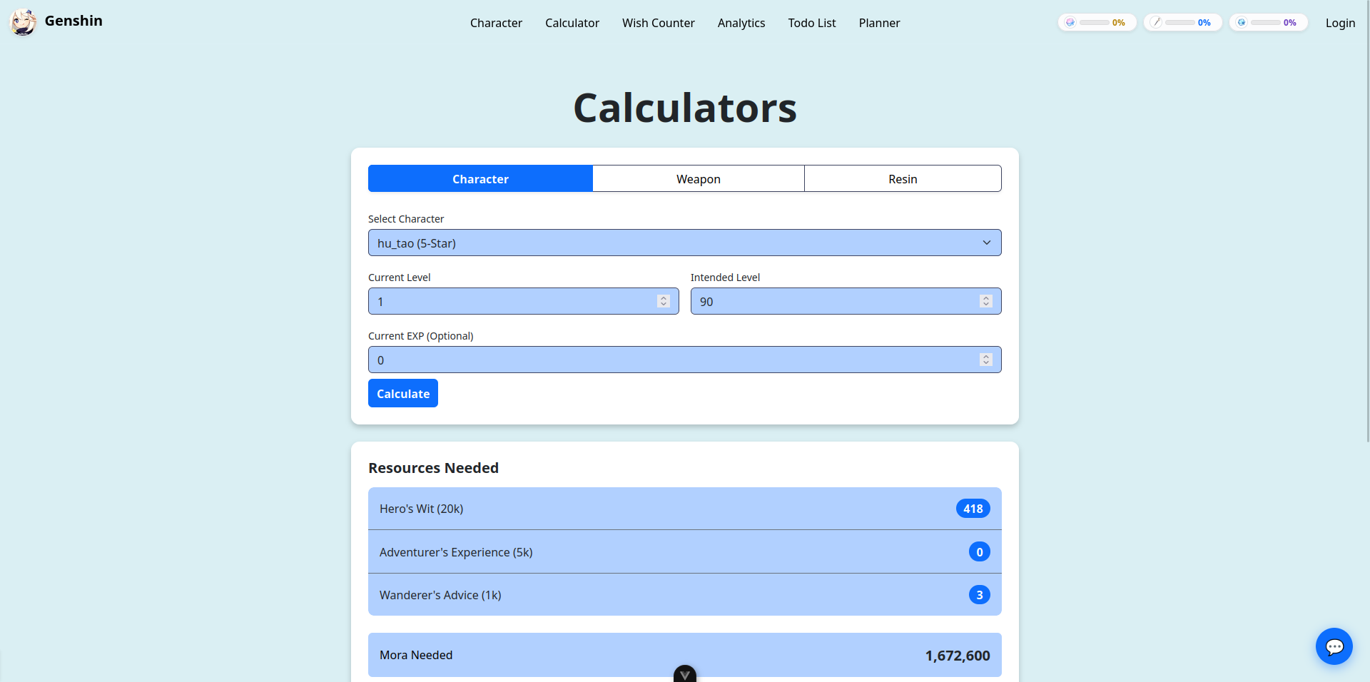

Wish Counter
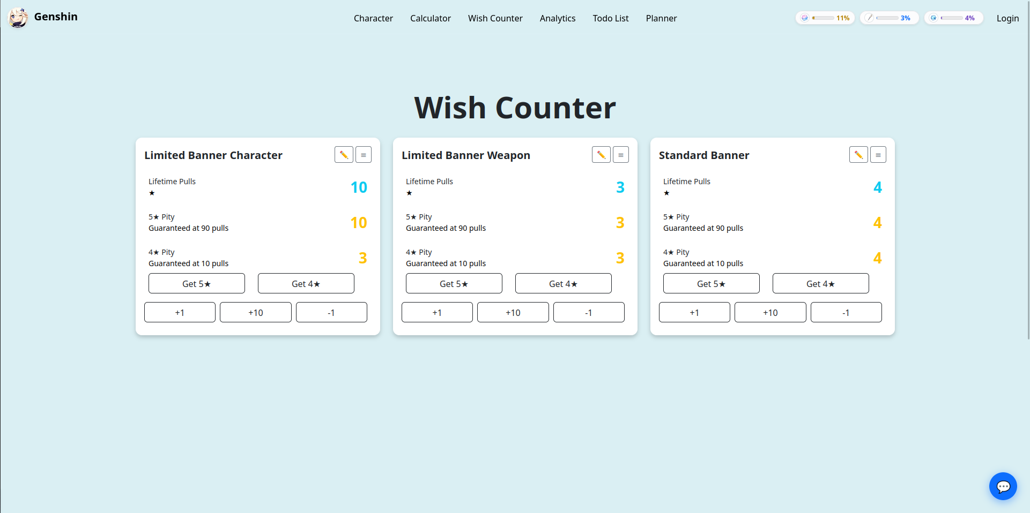
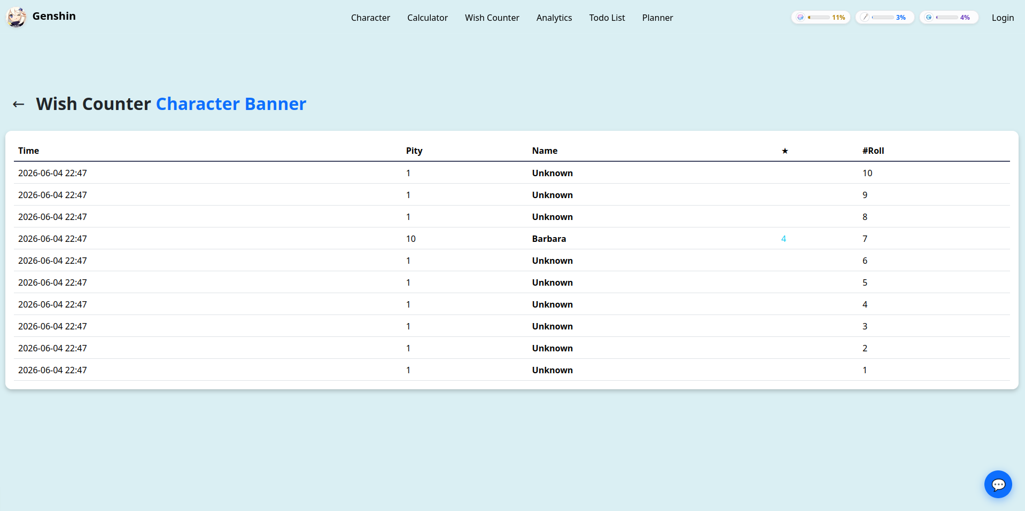

Analytics
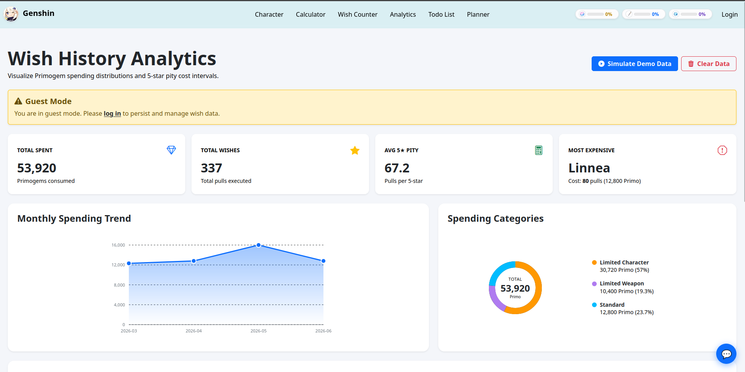
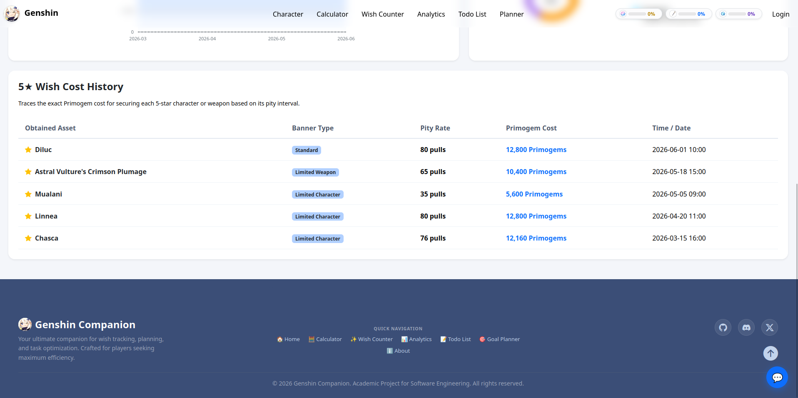

Todo List
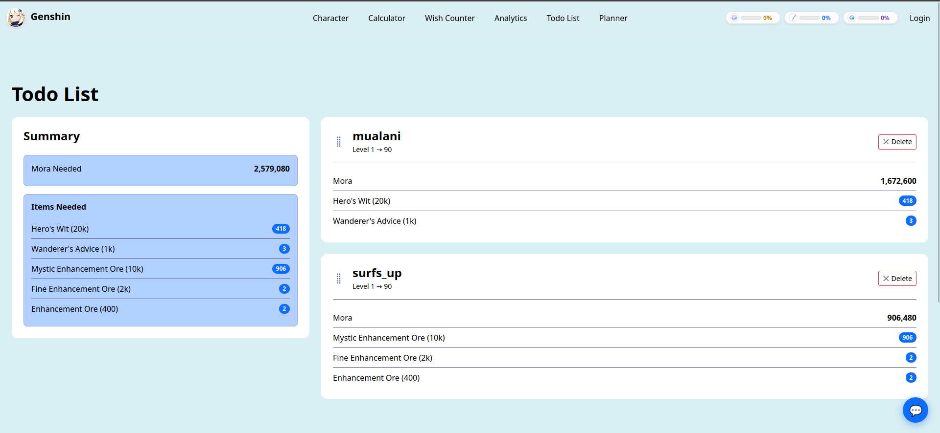

Planner
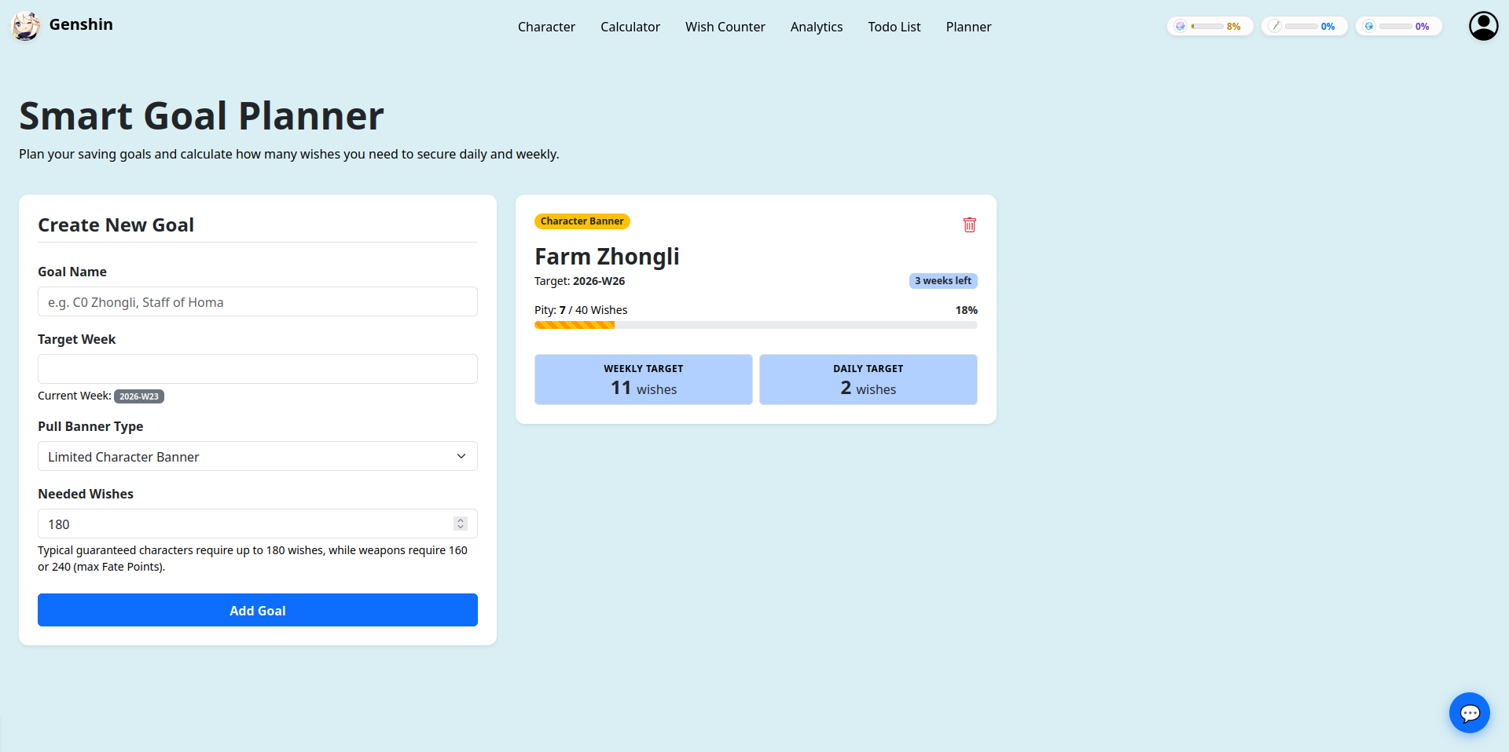

Account Setting
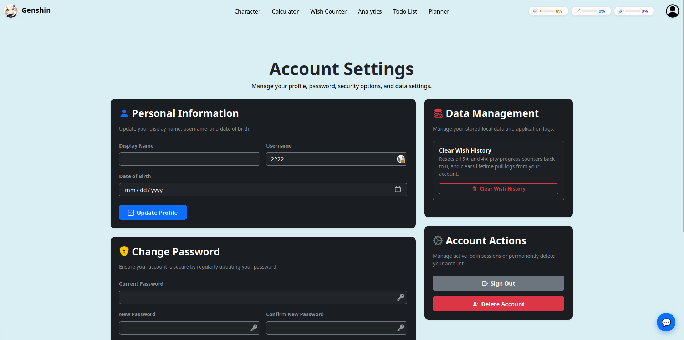

AI assistant
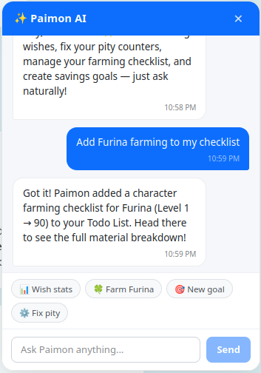

About
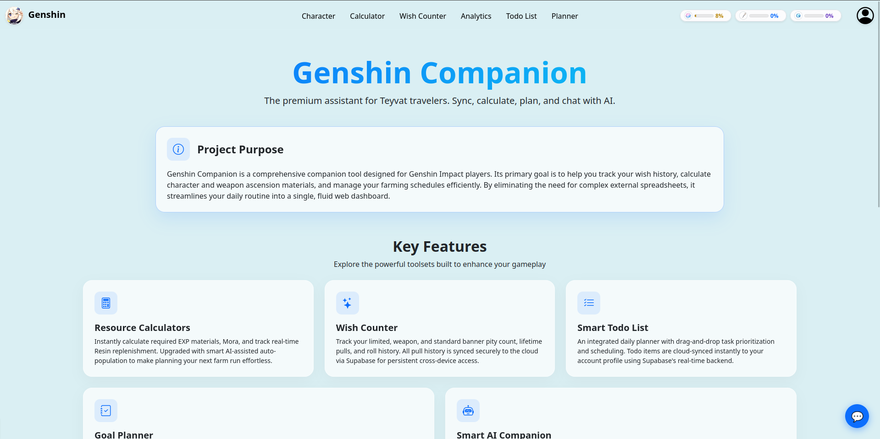
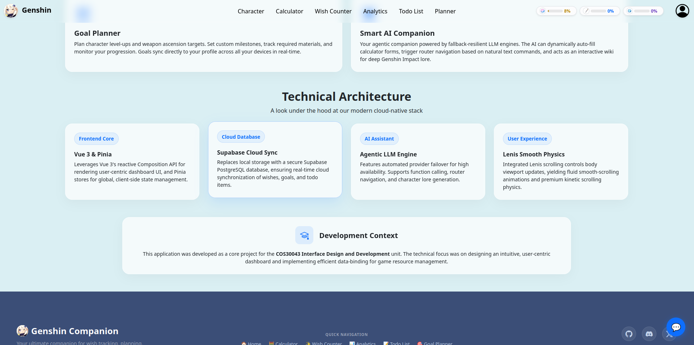

Login
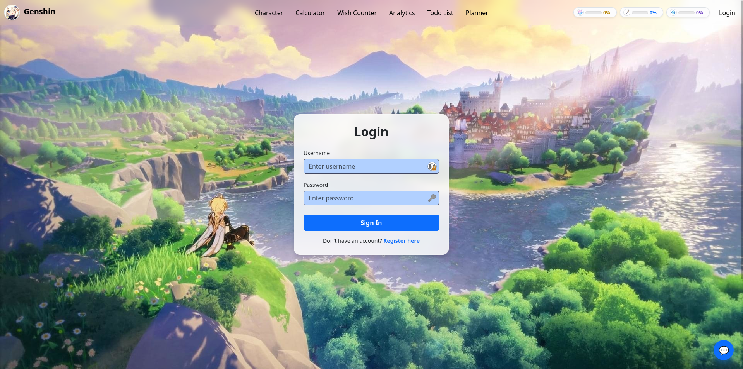

Register
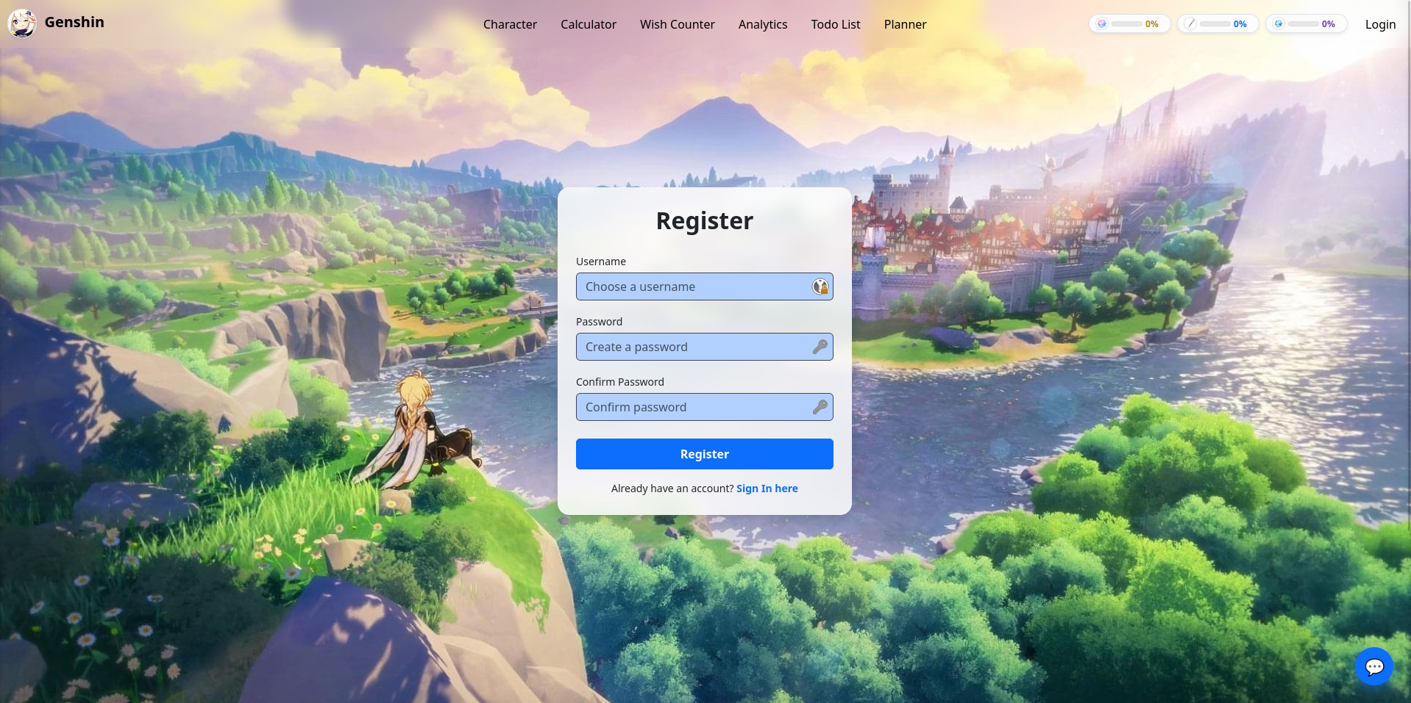

Pity Progress Bar
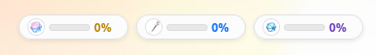

Describe how you achieve a responsive UI
To ensure that Genshin Companion acts as a premium, omnipresent gaming assistant, the user interface was designed from the ground up using mobile-first strategies, fluid viewport adaptation, and hardware-accelerated scrolling container models. By combining modern layout engines, tactical breakpoints, and dynamic Vue 3 state checks, the client container dynamically adjusts across diverse mobile devices, tablets, and wide-screen desktop monitors without displaying broken layout geometries.

Dynamic Layout Shifts via Computed Route Monitoring
At the core of the application shell design lies a responsive mechanism inside src/App.vue that regulates top content buffers based on page routing states. Because the web application utilizes an absolute, glassmorphic floating header (.nav_bar_fixed-top), loading standard content fields directly underneath would cause the nav-bar to clip and obscure nested forms or headers.
To counter this across fluctuating screen widths, src/App.vue implements a computed variable isNotHomepage to evaluate the active window path:
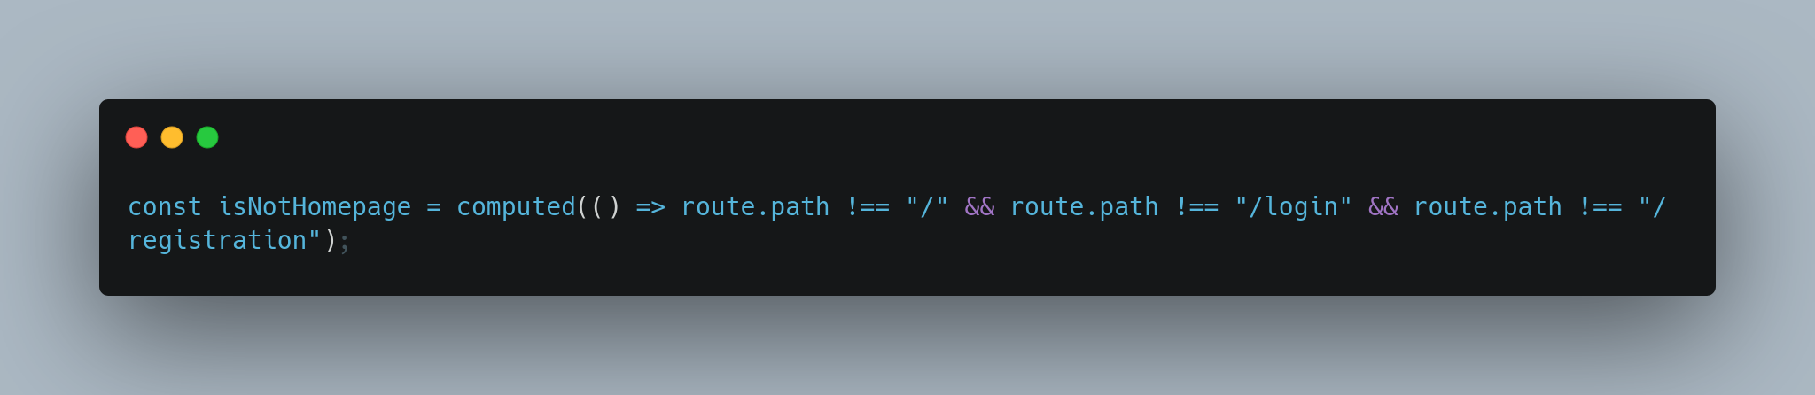
When this logic returns true, the primary layout container injects a dynamic CSS layout rule via class binding: :class="{ 'main-content-offset': isNotHomepage }". This binds directly to src/assets/index.css, implementing .main-content-offset { padding-top: 70px; }. This programmatically manages the display offset, preventing layout bugs on tiny mobile viewports where vertical space is tightly constrained, while seamlessly collapsing the padding during cinematic screen states like the registration backdrop wall.

Flexible CSS Layout Engines and Mobile-First Viewport Bounds
Rather than calculating static viewport matrices via obsolete absolute positioning units, the application relies entirely on modern flexbox wrappers and grid alignments to manage component flow. The parent wrapper in src/App.vue defines a flexible structure using utility classes: class="d-flex flex-column min-vh-100". This setup establishes a sticky-footer hierarchy across any vertical frame; the inner elements use flexible content distribution, forcing the footer component to anchor cleanly at the base of the viewport regardless of variations in data structure density.
Looking inside src/assets/index.css, custom layouts utilize precise relative viewport definitions to guarantee multi-device symmetry:
- The Cinematic Homepage Wrapper: Uses .homepage-wrapper { height: calc(100vh - 56px); overflow: hidden; } to establish an aspect-accurate background canvas across various client screen heights, perfectly offsetting standard framework menu limits.
- Component-Level Grid Systems: Page sections like the Banner Details area define modern CSS grids with strict fluid separation rules:
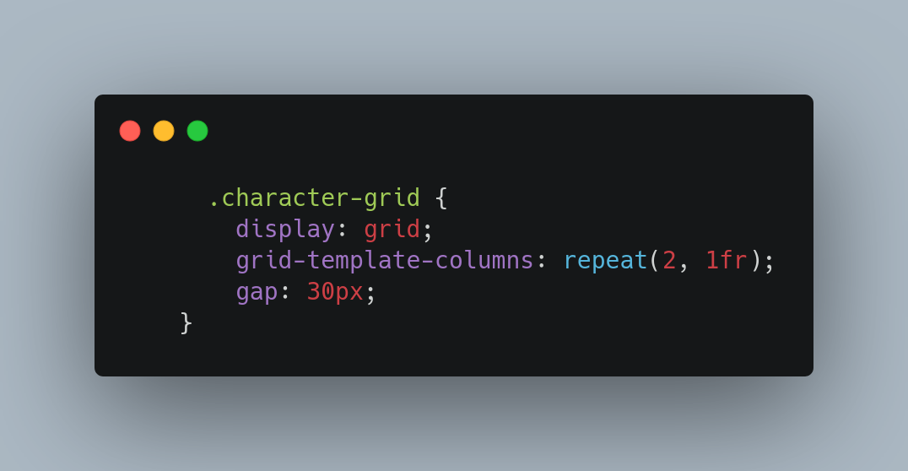
This forces the template engine to compute equal column partitions (1fr) natively, maintaining perfect element balance on desktop layouts without risking overflow layout clipping.

Asymmetric Media Query Interception and Breakpoint Scaling
To handle extreme variations in viewport geometry, the user interface features customized media queries that override default framework constraints. This layout strategy addresses structural changes at critical resolution boundaries:
- Small Viewports and Smart Phones (max-width: 768px)
When web users view the interface via compact handheld mobile devices, dual-column horizontal segments collapse into single-column layouts to preserve reading flow. The grid engine shifts dynamically to fit narrow viewports:
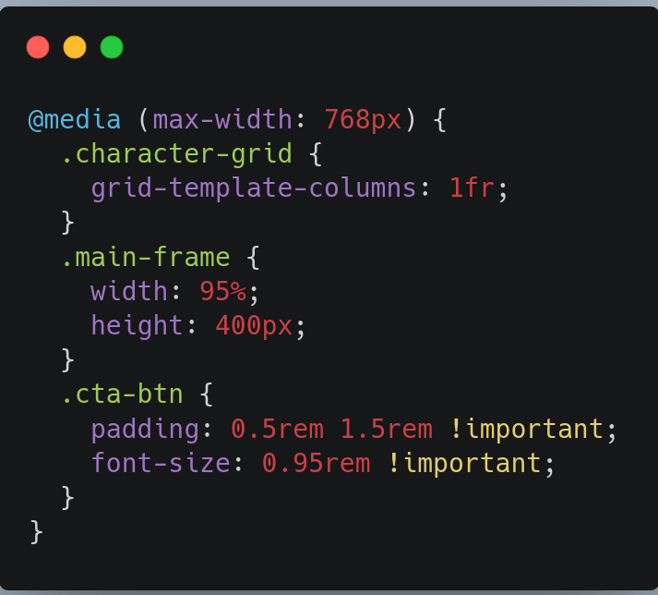
This query shrinks oversized elements down to a balanced width, prevents character frames from clipping narrow screen edges, and reduces call-to-action button click fields (.cta-btn) to optimize ergonomics for thumb tracking.
- Large and Ultra-Wide Desktop Displays (min-width: 1200px to 1600px)
On oversized screens, content structures can often suffer from unwanted lateral stretching. To enforce strict readability standards, the application injects constraining max-width bounds that systematically lock down layout proportions as resolutions grow:
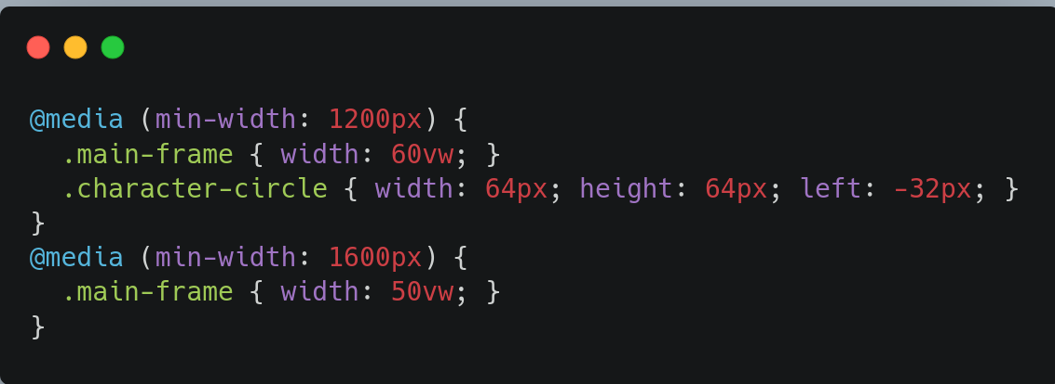
This architecture helps prevent layout issues on ultra-wide monitors, locking critical elements like interactive canvas nodes into readable display regions.

Adaptive UI Fluidity via Inertial Smooth Scroll Synchronization
Achieving a truly professional responsive interface requires maintaining fluid rendering speed during user input loops. Traditional browser scroll mechanisms cause stuttering on modern mobile touch displays or high-refresh-rate desktop monitors. To resolve this, src/App.vue initializes an isolated Lenis smooth scrolling engine asynchronously during the mounting lifecycle hook:
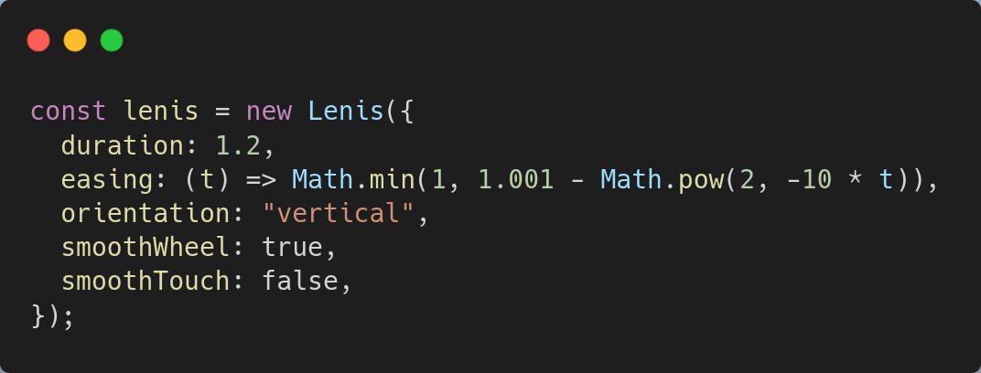
The rendering timeline links directly with the system hardware refresh rate via a recursive requestAnimationFrame animation loop. The engine coordinates smoothly with responsive style rules declared inside src/assets/index.css:

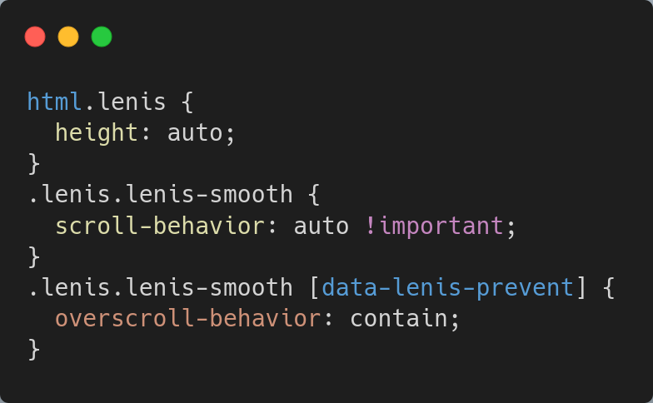
Setting scroll-behavior: auto !important forces the native layout engine to bypass legacy thread blocks, allowing Lenis to control linear interpolation calculations directly. For interactive sub-modules with inner scrollbars, appending [data-lenis-prevent] isolates container boundaries. This setup stops outer frame scrolling issues, guaranteeing predictable user interactions on touch screens and desktop displays alike.

Hardware-Accelerated Micro-Interactions and UI Layer Isolation
True responsiveness also relies on optimized UI rendering speeds during dynamic page changes and layout transitions. To maintain a smooth experience, the application layer isolates demanding animation properties onto dedicated GPU layers by utilizing css compilation variables like will-change.
For instance, the adaptive navigation bar transitions utilize specialized style configurations to optimize processing overhead:
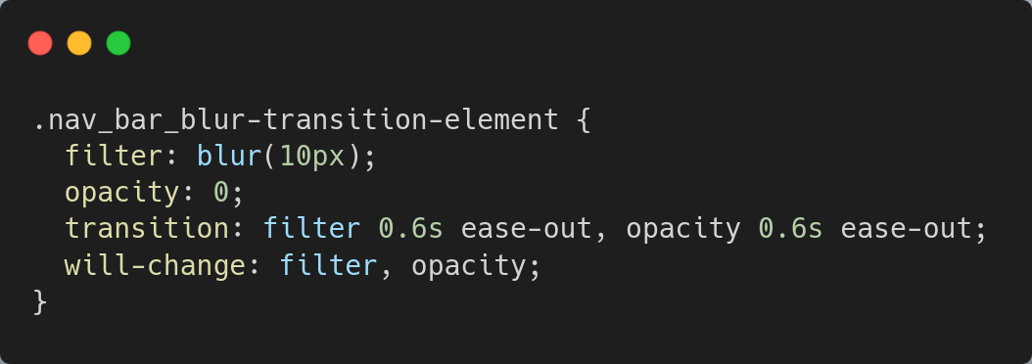
By explicitly declaring will-change: filter, opacity;, the application informs the browser's layout engine to optimize resources for these changing properties beforehand. This avoids expensive layout recalculations and heavy screen repaints when toggling sidebar panels or changing routes. The client layout scales and updates instantly, providing a crisp user experience free of frame drops across devices from low-power smartphones to desktop hardware.

Usability and accessibility evaluation
To ensure that Genshin Companion delivers an exceptional user experience while strictly adhering to professional design standards, the interface underwent rigorous testing against established design principles and accessibility frameworks. This section details a comprehensive usability and accessibility audit of the application, utilizing industry-standard evaluation techniques such as Nielsen’s Heuristic Evaluation, Goal-Directed Task Analysis, and the Web Content Accessibility Guidelines (WCAG 2.1). The following sections dissect key components of the system to identify potential issues, evaluate cognitive friction, and propose concrete architectural improvements.

Identifying Potential Usability Issues
The user interface was evaluated against Nielsen’s ten usability heuristics to uncover hidden friction points where a user's mental model might conflict with system operations.
- System Status Visibility and Aesthetic Balance
The dynamic state design utilizes clean visual cards to clearly illustrate complex state changes. For example, the wish_analytics.vue workspace provides zero-state fallbacks that directly guide user onboarding when local database tables are empty. However, a minor vulnerability was observed regarding the real-time feedback loops during background database queries. When asynchronous processes are fetching local files or syncing with remote Supabase servers, a subtle loading indicator displays on screen. On slower mobile connections, this indicator can sometimes cause brief layout shifts that temporarily lower visual clarity.
- Destructive Action Boundaries and User Control
The system respects user control by offering straightforward undo paths and structural data resets. The state engine handles tracking updates by keeping state checkpoints right before running logic. This design choice allows non-destructive local updates, ensuring client state counters match cloud database records perfectly.
However, a serious usability risk was identified within the administrative account workspace (account_setting.vue). The data management interface groups highly destructive actions, such as clearing local history logs or permanently purging user account profiles. While these actions are secured by native confirmation modals (confirm()), they lack progressive, multi-step authentication gates. This design gap increases the risk of irreversible, accidental account deletions due to user reflex clicks on modal prompts.

Evaluating Navigation Efficiency
Navigation efficiency was evaluated by calculating the absolute click-depth required to execute core workflows and assessing how cleanly the menu layout guides users across diverse pages.
- Structural Layout Architecture and Route Management
The global application layout establishes a persistent, sticky header configuration (nav_bar.vue) to ensure that top-level paths remain accessible at all times across all viewports. This menu system is optimized by route monitoring, which automatically calculates dynamic padding offsets across sub-views to keep content cards from clipping behind the absolute header. Click-depth tracking reveals that users can navigate to any primary module such as the Pity Calculators, global Todo Planners, or smart Goal Planners within a single interaction loop from the home screen. Additionally, route changes run an instant scroll-reset watcher inside App.vue that sets window positioning directly back to top coords (0), preventing broken vertical view alignments when shifting contexts.
- Cross-Module Data Mapping and Friction Points
A key strength of the system's navigation design is its cross-module data integration. The resource calculator component allows users to seamlessly map computed targets directly into the global planner store on command:
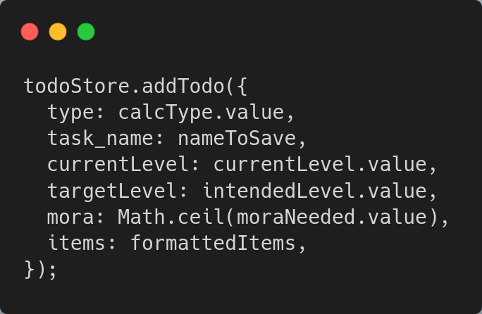
This data bridge automatically pushes resource parameters straight into the traveler's active todo ledger, eliminating the need to manually copy values across screens.
However, a minor navigation flaw exists on the main landing dashboard. The hero showcase area implements custom scroll physics that smoothly track user scrolling via interpolation algorithms. While this delivers a highly polished desktop experience, it can introduce slight scroll fatigue on narrow touchscreens, requiring repetitive thumb gestures to bypass large banner cards.

Evaluating Form Usability
Form usability was audited across critical authentication modules and data entry inputs, focusing specifically on error prevention, real-time error mapping, and cognitive workload.
- Input Validation Boundaries and Live Feedback Loops
The identity entry forms (login.vue and registration.vue) implement input processing gates to prevent form submission if fields are left incomplete. The registration module uses reactive state bindings (username, password, confirmPassword) to check form conditions before dispatching authentication requests:
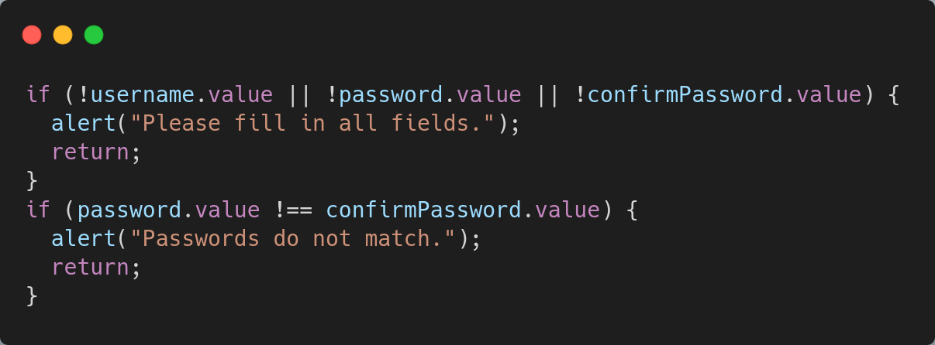
This logic acts as an immediate front-end filter, catching input errors and alerting users before executing remote database calls.
The primary usability limitation lies in how errors are reported. Relying on basic modal window alerts breaks user focus and hides underlying form blocks. This pattern forces users to close popups before correcting mistakes, rather than showing clean inline warning labels directly next to the fields that need attention.
- Dropdown Usability and Dynamic Filtering Filters
The system features highly scalable forms inside the wish management modal (add_pull_modal.vue), which uses reactive computed filters to dynamically control selector items. The asset selection menus adapt automatically based on the user's active banner context:
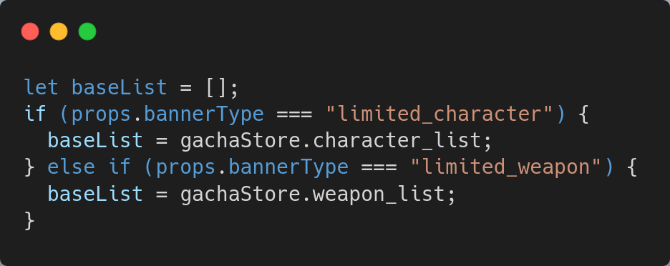
This dynamic configuration filters out irrelevant items automatically, preventing data pollution by making sure players can only select valid category assets. The form also uses a custom string formatter (formatName) to clean up database IDs, displaying clear, readable item labels instead of raw code snippets.

Ensuring Accessibility for Different Users
The codebase was evaluated against WCAG 2.1 AA standards to identify assistive device blocks, structural typography gaps, or insufficient contrast parameters.
- Visual Hierarchy and Contrast Ratio Auditing
The application uses clear text contrast levels to guarantee layout readability under diverse environments. The typography system pairs heavy font-weights (fw-bold, display-4) with clean light or dark colors (text-dark, text-white-50) to create a clear visual hierarchy. In the analytical dashboard (wish_analytics.vue), categorical legends use distinct color chips to make data clear and readable. This design approach ensures that users who experience low-vision or color-vision deficiencies can scan graphs and pull logs without losing track of vital data points.
- Semantic Code Layout and Assistive Device Hurdles
While the layout structure looks highly polished, several semantic accessibility barriers were discovered during the markup audit:
  - Interactive Elements: The code relies on un-mapped button targets and structural div hooks to run form routines. Assistive screen readers can miss tracking these nodes if they lack clear aria tags, which can prevent smooth navigation for users who rely on screen readers.
  - Form Controls: Form inputs use placeholder texts as substitute label indicators (placeholder="Create a password"), rather than linking to explicit semantic label hooks (<label for="...">). This design flaw causes form controls to lose context once text is entered, introducing unnecessary cognitive friction.
  - SVG Graphs: Scalable dashboard elements, such as inline SVG charts, lack explicit description and title elements (<title>, <desc>), meaning screen readers cannot describe data visualizations to users with visual impairments.

Proposed Structural UI Improvements
To resolve the usability and accessibility limitations identified above, three specific interface enhancements will be implemented in future development cycles:
- Implementation of Inline Validation and Accessible Form Controls
To eliminate disruptive browser alerts, all form containers will be upgraded to use reactive inline validation states. Input fields will bind directly to custom <label> tags with matching for properties to ensure screen reader compatibility. Additionally, error properties will be rendered inside live notification containers using clear aria attributes (aria-live="assertive"), providing immediate feedback within the user's focus field.
- Advanced Multi-Step Destructive Action Safeguards
To safeguard critical user data, simple confirmation popups for account actions will be replaced with structured, multi-step verification forms. Users will need to type their account username manually to confirm changes before destructive database functions run. This implementation provides an intentional confirmation process that mitigates the risk of accidental data deletion.
- Semantic SVG Accessibility Mapping
To ensure chart data is fully accessible, inline SVG layouts will be updated to include semantic accessibility attributes. Chart blocks will be configured with matching descriptive tags to ensure screen readers can announce data changes cleanly:
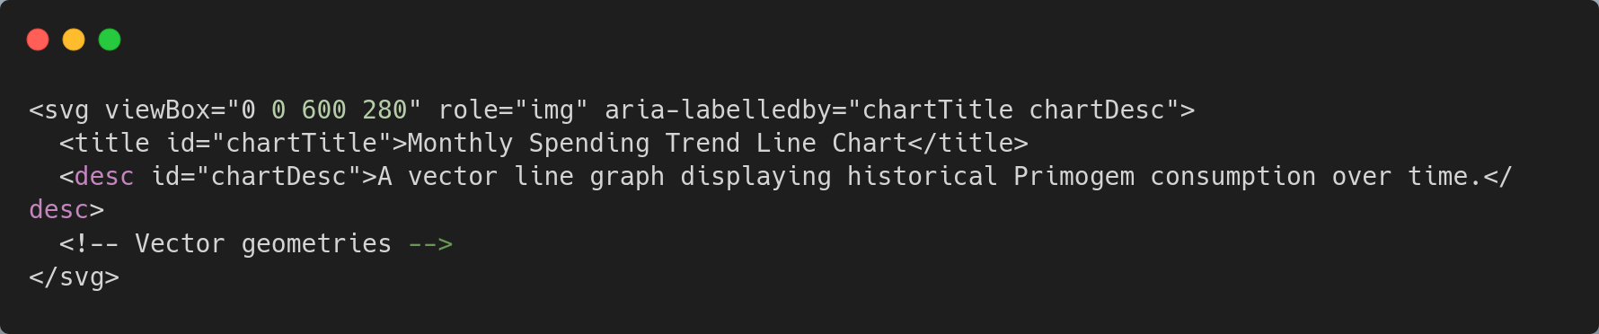
Additionally, tracking points will be mapped to clean keyboard tab focuses (tabindex="0"), enabling users who navigate via assistive keyboards to read data values smoothly without relying on precise cursor tracking.

Additional/advanced techniques implement
This project incorporates several advanced software engineering techniques and third-party integrations that extend significantly beyond the core syllabus of the Interface Design and Development unit. The following sub-sections detail the advanced architectural decisions, algorithms, and cloud deployments utilized to elevate the application's performance, user experience, and reliability.

Cloud-Native Backend Integration via Supabase
While standard frontend applications often rely on volatile browser localStorage for data persistence, Genshin Companion integrates Supabase, an open-source Firebase alternative backed by a robust PostgreSQL database. This advanced backend integration enables real-time, cross-device synchronization for user profiles, wish history logs, and to-do lists.
The global Pinia state engine (gacha_store.js) handles complex asynchronous hydration operations during the application's mounting phase. By leveraging await supabase.from("wishes").select("*"), the application seamlessly queries remote rows and maps them into local reactive arrays while strictly handling database error exceptions via try-catch blocks. This ensures that the player's pulling data remains secure, persistent, and globally accessible, representing a complete decoupling of the presentation layer from the data persistence layer.

Agentic AI Companion with Tool Calling and API Rotation
The application introduces a highly advanced "Smart AI Companion" (ai_assistant_widget.vue) that surpasses standard chatbot functionality. Rather than functioning merely as a text-generation tool, the AI operates as an agentic interface capable of executing system commands based on natural language processing.
- Automated Function Calling: The AI can interpret user intent and dynamically trigger internal Vue Router navigation or dispatch payloads directly to the Pinia state stores (e.g., auto-populating farming checklists or calculating resin deficits).
- Automatic Rotating API Calls: To ensure fallback-resilient high availability and bypass strict provider rate limits, the underlying inference engine (ai_summarizer.js) implements an automated API rotation script. If the primary Large Language Model (LLM) endpoint fails or times out, the system automatically falls back to secondary API keys and alternative model providers, guaranteeing an uninterrupted user experience even during network degradation.

Hardware-Accelerated Smooth Scrolling via Lenis Physics
Native browser scrolling often suffers from thread-blocking and jitter, particularly on complex Single Page Applications viewed on high-refresh-rate monitors. To resolve this, the project implements the Lenis smooth scroll physics engine.
Initialized asynchronously inside App.vue, Lenis intercepts native scroll events and recalculates vertical progression using advanced easing functions: easing: (t) => Math.min(1, 1.001 - Math.pow(2, -10 * t)). The engine is manually bound to the browser’s requestAnimationFrame loop, allowing scroll interpolation to be rendered directly by the GPU. This yields a premium, fluid kinetic scrolling experience that mimics native mobile applications, fundamentally elevating the application's interaction design.

Algorithmic Resource Distribution (Greedy Approach)
The Resource Calculator (calculator.vue) relies on custom algorithmic logic to determine the exact number of experience books or enhancement ores a user requires. Instead of arbitrary estimations, the module implements a Greedy Distribution Algorithm to solve the resource allocation problem optimally.
When calculating required materials, the script iteratively divides the remaining experience points by the highest-value asset (e.g., Hero's Wit, worth 20,000 EXP) using Math.floor(). The mathematical remainder is then cascaded down to the next tier of items (Adventurer's Experience, worth 5,000 EXP), repeating until the exact target is met. This programmatic approach ensures players are given the most mathematically efficient farming route with the least amount of "Wasted EXP" possible.

Native Drag-and-Drop API paired with Anime.js
The Smart Todo List (todo_list.vue) implements the native HTML5 Drag and Drop API to allow users to prioritize their daily farming tasks visually. By utilizing event listeners such as @dragstart, @dragenter, and @drop, the component tracks active drag indices and updates the global Pinia array order upon release.
To enhance the visual feedback of this operation, the module integrates Anime.js into Vue's native <transition-group> lifecycle hooks. Rather than relying on simple CSS transitions, DOM elements execute complex elastic animations upon entering or leaving the list:
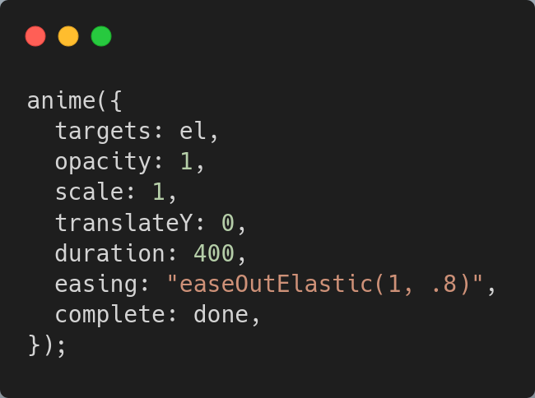
This Javascript-driven animation library provides advanced spring physics that are impossible to replicate with standard CSS, resulting in a highly polished and responsive micro-interaction.

Architectural UI Escapes using Vue Teleport
Managing modal dialogue boxes in deeply nested component trees often leads to CSS z-index conflicts and overflow: hidden clipping issues. To solve this, the application utilizes Vue 3's advanced <Teleport> component within the add_pull_modal.vue file.
By wrapping the modal's markup in <Teleport to="body">, the Vue compiler physically moves the DOM nodes of the modal out of the parent component's hierarchy and injects them directly at the root <body> level. This ensures the modal overlay consistently covers the entire viewport, immune to any restrictive CSS properties defined by its parent containers, representing a sophisticated approach to interface layering.

Edge Delivery Hosting via Cloudflare
To ensure the application meets modern deployment standards, the compiled production build is hosted using Cloudflare. Moving beyond basic local hosting or standard web servers, Cloudflare deploys the Vue SPA across a global Content Delivery Network (CDN) of edge nodes. This architecture ensures instantaneous asset delivery, low-latency routing, and strict HTTPS security enforcement, providing end-users with a rapid, secure, and production-grade web experience regardless of their geographical location.

