Humain => statique VS dynamique
Humain => seul ou groupe (4 classes Alone, Duo, Semi-circle and Circle)
Agent Omniscient {state agent ,( state object, state humain)] Behavioral cloning with simple policy
Agent cone {State agent , binary object (depth and position), binary human (depth and position) }

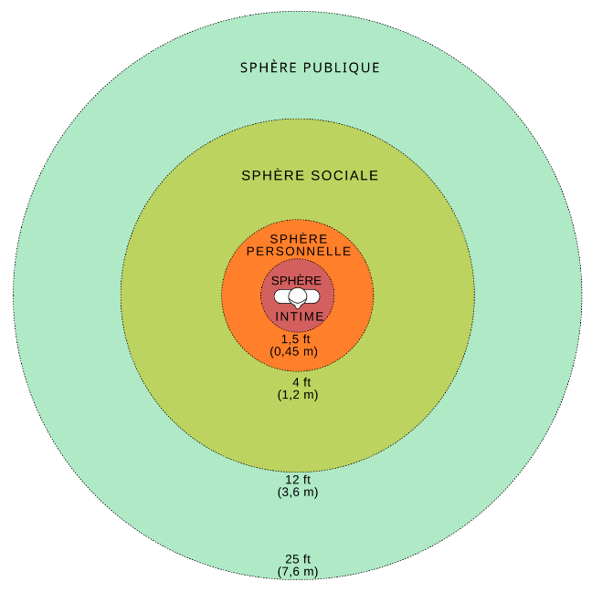
Rewards :
- Rewards about the Goal :
- Goal = +10
- Reward about Human :
4 situations : alone/face-to-face/arc of circle/circle :
- Alone situation:
  - Hit human = -10
  - Intimal zone = -5
  - Personal zone = -2
  - Social zone = 0
  - Public zone = 0
- Face-to-face situation:
  - Hit human = -10
  - Between human = -5
  - Personal zone = -2
- Semi-circle situation:
  - Hit Human = -10
  - Personal zone = -2
- Circle situation:
  - Hit human = -10
  - Across the circle = - 5
  - Personal zone = -2

- Reward about Objects:
- Hit Object = -3

- State of art.
Hall, E.T. The Hidden Dimension: An Anthropologist Examines Man’s Use of Space in Private and Public; Anchor Books; Doubleday &Company Inc.: New York, NY, USA, 1966
- distance intime : moins de 40 cm (mode proche : moins de 15 cm, mode éloigné : de 15 cm à 40 cm) ;
- distance personnelle : de 45 cm à 125 cm (mode proche : de 45 cm à 75 cm, mode éloigné : de 75 cm à 125 cm) ;
- distance sociale : de 120 cm à 360 cm (mode proche : de 120 cm à 210 cm, mode éloigné : de 210 cm à 360 cm) ;
- distance publique : au-delà de 360 cm (mode proche : de 360 cm à 750 cm, mode éloigné : au-delà de 750 cm).
An approach of Social Navigation Based on Proxemics for Crowded Environments of Humans and Robots.
https://www.mdpi.com/2072-666X/12/2/193
Evaluation of the agent :
https://arxiv.org/pdf/2306.16740
Principle P1: Safety - Protect humans, other robots and their environments
Principle P2: Comfort - Do not create annoyance or stress.
Principle P3: Legibility - Behave so goals can be understood
Principle P4: Politeness - Be respectful and considerate.
Principle P5: Social Competency - Comply with social norms.
Principle P6: Understanding Other Agents - Predict and accommodate the behavior of other agents.
Principle P7: Proactivity - Taking the Initiative to Prevent and Resolve Issues
Principle P8: Contextual Appropriateness – Behave properly in the current context.
- Cultural Context:
- Diversity Context:
- Environmental Context: Geometric Context, Operational Context
- Task Context:
- Interpersonal Context:

- Algorithm :
Parameters and algorithm choice, fidelity of the implementation (if you have implemented an existing algorithm and/or if you have followed specific standards for the implementation of an existing algorithm), proposed alternatives.
- Environment description :
- Behavioural cloning :
- Reinforcement learning PPO :

- Algorithm Details :
Depth of understanding of the algorithm(s).

- Results :
Depth of analysis and number of comparisons.

- Discussion

Metriques :
Nombres de step
Types de rewards

