Emisiones de CO2 en el mundo.

# Taller CO2

## Taller 1 datos CO2

Con los datos del CO2

### Pregunta 1 Data wranling

Reducir el código lo más posible y actualizar la función gather para obtener la tabla pivotada que contenga el código de país, el nombre del país el año el CO2 brutos el CO2 per cápita y los metadatos de los países en una tibble construid a partir de las dos hojas de raw data y de la hoja de metadatos.

PerCapita <- read_excel("World_Bank_CO2.xlsx",sheet = "CO2 Per Capita RAW DATA")  
KT <- read_excel("World_Bank_CO2.xlsx",sheet = "CO2 (kt) RAW DATA")  
Metadatos <- read_excel("World_Bank_CO2.xlsx",sheet = "Metadata - Countries")  
PerCapita=as_tibble(PerCapita)  
KT=as_tibble(KT)  
Metadatos=as_tibble(Metadatos)  
PerCapita=PerCapita %>% select(!c("Indicator Name","Indicator Code")) %>%   
 pivot_longer(`1960`:`2015`, names_to="Year",values_to="CO2") %>%  
 naniar::replace_with_na(replace =list(CO2 ="null")) %>%  
 mutate(Year=as.integer(Year),CO2=as.numeric(CO2))  
KT=KT %>% select(!c("Indicator Name","Indicator Code")) %>%   
 pivot_longer(`1960`:`2015`, names_to="Year",values_to="CO2") %>%   
 naniar::replace_with_na(replace =list(CO2 ="null")) %>%mutate(Year=as.integer(Year),  
 CO2=as.numeric(CO2))  
Tot=left_join(PerCapita,KT,by=c("Country Name","Country Code","Year"))%>%   
 rename(CO2PC=CO2.x,CO2=CO2.y)   
names(Tot)=gsub(" ","_",names(Tot))  
names(Metadatos)=gsub(" ","_",names(Metadatos))  
Metadatos=Metadatos%>% rename(Country_Name = TableName)  
DataClean=inner_join(Tot,Metadatos,by=c("Country_Name","Country_Code"))  
glimpse(DataClean)

## Rows: 13,328  
## Columns: 8  
## $ Country_Name <chr> "Aruba", "Aruba", "Aruba", "Aruba", "Aruba", "Aruba", "A…  
## $ Country_Code <chr> "ABW", "ABW", "ABW", "ABW", "ABW", "ABW", "ABW", "ABW", …  
## $ Year <int> 1960, 1961, 1962, 1963, 1964, 1965, 1966, 1967, 1968, 19…  
## $ CO2PC <dbl> NA, NA, NA, NA, NA, NA, NA, NA, NA, NA, NA, NA, NA, NA, …  
## $ CO2 <dbl> NA, NA, NA, NA, NA, NA, NA, NA, NA, NA, NA, NA, NA, NA, …  
## $ Region <chr> "Latin America & Caribbean", "Latin America & Caribbean"…  
## $ IncomeGroup <chr> "High income: nonOECD", "High income: nonOECD", "High in…  
## $ SpecialNotes <chr> "SNA data for 2000-2011 are updated from official govern…

### Pregunta 2 Dibujos del mapa del mundo

Dibujad un mapa del mundo coloreando por país las distintas variables y por años o décadas.

Hemos comprovado y sustituido los paises que tienen nombres distintos en las tablas *WorldData* y *DataClean*, de forma que si aparezcan en los mapas.

DataClean$Country_Name=plyr::mapvalues(DataClean$Country_Name,from=c("Congo, Rep.",  
"Bahamas, The","United Kingdom","Egypt, Arab Rep.","Russian Federation","United States",  
"Virgin Islands (U.S.)","Yemen, Rep.","Syrian Arab Republic","Slovak Republic",  
"Macedonia, FYR","Korea, Rep.","Venezuela, RB"),  
to=c("Democratic Republic of the Congo","Bahamas","UK","Egypt","Russia","USA","Virgin Islands",  
"Yemen","Syria","Slovakia","Macedonia","South Korea","Venezuela"))  
  
  
WorldData <- map_data('world')  
  
DataClean=DataClean%>% mutate(Decada=floor((Year-1960)/10))  
  
 DataClean ->auxCO2  
 color = auxCO2 %>% group_by(Country_Name,Decada) %>% summarise(media=mean(CO2,na.rm=TRUE))

## `summarise()` regrouping output by 'Country_Name' (override with `.groups` argument)

Mydata_plot <- inner_join(WorldData , color,by=c("region"="Country_Name"))  
 for (i in (0:5)) {  
 print(Mydata_plot %>% filter(Decada==i) %>% ggplot() +  
 geom_polygon(aes(x=long, y=lat, group = group,fill=media),colour="black") +  
 scale_fill_continuous(low = "thistle2", high = "darkred", guide="colorbar") +  
 theme_bw() +  
 labs(fill = "legend" ,title = paste(i*10+1960,"s",sep = ""), x="", y="") +  
 scale_y_continuous(breaks=c()) +  
 scale_x_continuous(breaks=c()) +  
 theme(panel.border = element_blank())+coord_fixed(1))  
 }

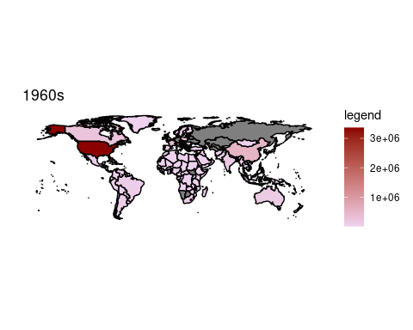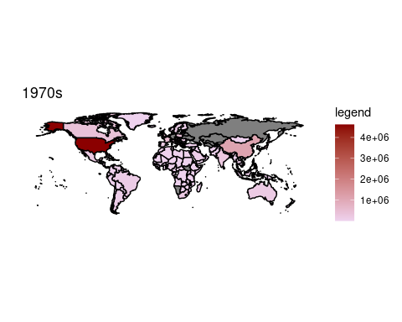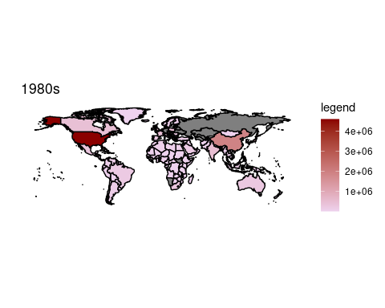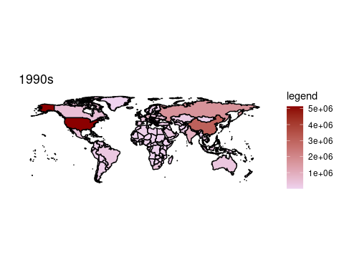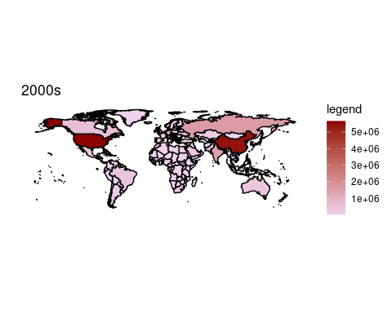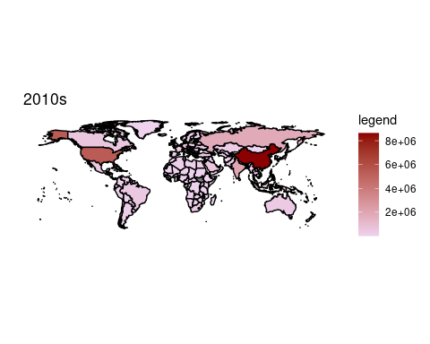

DataClean ->auxCO2PC  
 color = auxCO2PC %>% group_by(Country_Name,Decada) %>% summarise(media=mean(CO2PC,na.rm=TRUE))

## `summarise()` regrouping output by 'Country_Name' (override with `.groups` argument)

Mydata_plot <- inner_join(WorldData , color,by=c("region"="Country_Name"))  
 for (i in (0:5)) {  
 print(Mydata_plot %>% filter(Decada==i) %>% ggplot() +  
 geom_polygon(aes(x=long, y=lat, group = group,fill=media),colour="black") +  
 scale_fill_continuous(low = "thistle2", high = "darkred", guide="colorbar") +  
 theme_bw() +  
 labs(fill = "legend" ,title = paste(paste(i*10+1960,"s",sep = ""),"per Capita"), x="", y="") +  
 scale_y_continuous(breaks=c()) +  
 scale_x_continuous(breaks=c()) +  
 theme(panel.border = element_blank())+coord_fixed(1))  
 }

