

TIF Chat
Internal AI Chatbot Platform
Project Brief — Data Science & Technology
March 2026
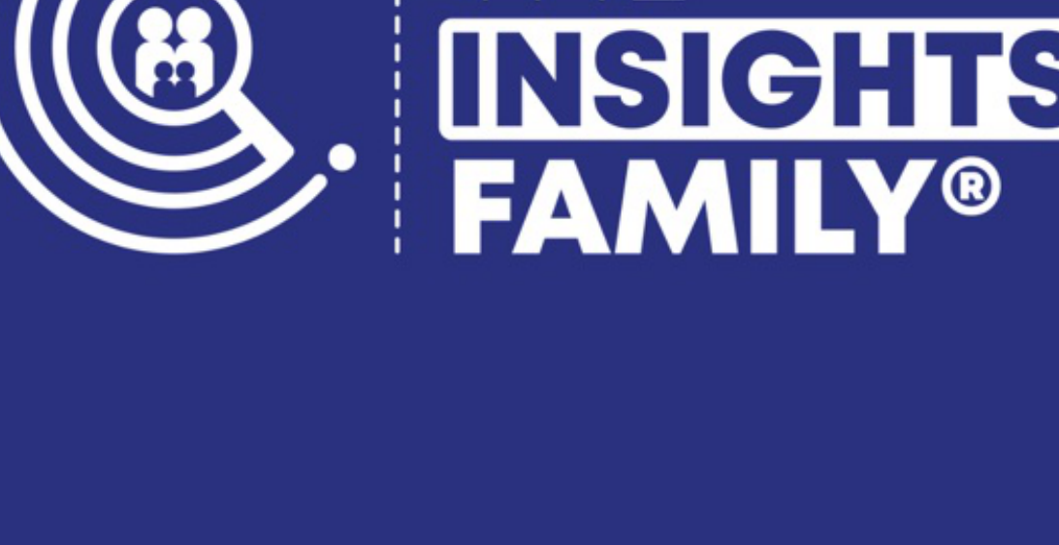

THE INSIGHTS FAMILY
Project Overview
What We’re Building
A company-wide AI chatbot platform that gives every TIF team member access to leading AI models through a single, branded interface. Built on the open-source Vercel Chatbot template (Next.js + AI SDK), the platform will integrate directly with our Microsoft SSO for seamless authentication, offer a choice of AI providers (Anthropic Claude, OpenAI GPT, and Perplexity), and connect to custom MCP tool servers for company-specific and survey data workflows.
Why This Matters
Today, team members use a patchwork of different AI tools with separate logins, no shared context, and no connection to our proprietary data. This project consolidates AI access into one platform that understands TIF’s business, connects to our survey data infrastructure, and maintains conversation history for every user.
Key Objectives
• Provide all TIF staff with secure, SSO-authenticated access to AI assistants
• Offer model choice: Anthropic Claude, OpenAI, and Perplexity
• Connect two MCP tool servers for company use and survey data querying
• Maintain conversation history and file upload capabilities
• Apply TIF branding for a professional, consistent experience
Target Users
All TIF employees across all departments. No technical knowledge required — users simply sign in with their Microsoft account and start chatting.

THE INSIGHTS FAMILY
Technical Architecture
Technology Stack
Component | Technology | Notes
Frontend | Next.js + React | Vercel Chatbot template
UI Framework | shadcn/ui + Tailwind | Customised with TIF branding
Authentication | Auth.js + Microsoft Entra ID | SSO via TIF tenant
AI Providers | AI SDK (Vercel) | Anthropic, OpenAI, Perplexity
Database | Neon Serverless Postgres | Chat history, users, sessions
File Storage | Vercel Blob | User-uploaded files
MCP Tools | @ai-sdk/mcp | Two servers via SSE transport
Hosting | Vercel (or AWS) | One-click deploy option
MCP Server Integration
Two Model Context Protocol servers will be connected as tool providers, giving the AI models direct access to TIF systems:

• Company Use MCP — General-purpose tools for company operations, document access, and internal workflows. Available to all users in every conversation.

• TIF Survey Tools MCP — Connects to the existing TIF Agent infrastructure for natural language querying of survey databases, IP Currency Score analysis, and demographic data exploration. Leverages the existing AWS Bedrock + Aurora MySQL pipeline.
Authentication Flow
Users navigate to the app URL → Click “Sign in with Microsoft” → Redirected to Microsoft Entra ID → Authenticated against TIF tenant → Redirected back to chat interface with session created. Only users within the TIF Microsoft tenant can access the platform.

THE INSIGHTS FAMILY
Branding & Models
TIF Brand Application
The chatbot interface will be customised with TIF branding, including:
• Primary colour palette: TIF Navy (#2A317F), Coral (#F86C6E), Purple (#652581)
• Typography: Poppins font throughout the interface
• TIF logo displayed in the header/sidebar
• Custom colour scheme applied via Tailwind CSS custom properties
• Consistent with existing TIF digital products and documentation
AI Model Providers
Users will be able to select from three AI providers, each suited to different tasks:

Provider | Models | Best For
Anthropic | Claude Opus, Sonnet, Haiku | Analysis, writing, coding, MCP tools
OpenAI | GPT-4o, GPT-4o-mini | General tasks, image generation
Perplexity | Sonar models | Research, web search, fact-checking

Model selection will be available per conversation via a dropdown in the chat interface. The default model can be configured globally or per-user.
Database Purpose
The Postgres database serves several functions: storing user accounts and session tokens from Microsoft SSO, persisting full conversation history so users can resume chats, saving message metadata and model usage, and managing file upload references. This is a lightweight operational database, completely separate from the TIF survey data infrastructure.

THE INSIGHTS FAMILY
Implementation
Delivery Timeline
Phase | Tasks | Duration
Phase 1 | Fork repo, deploy to Vercel, configure Microsoft SSO | 1–2 days
Phase 2 | Add Anthropic, OpenAI, Perplexity providers + model selector UI | 1 day
Phase 3 | Integrate Company Use and TIF Survey Tools MCP servers | 1–2 days
Phase 4 | Apply TIF branding (colours, logo, Poppins font) | 0.5 days
Phase 5 | Testing, user onboarding, documentation | 1–2 days

Total estimated time: 5–8 working days from kickoff to internal launch. The majority of the work involves configuration rather than custom development, thanks to the mature template and existing MCP server infrastructure.
Environment Variables Required
The following secrets and configuration values will be needed:
• AUTH_SECRET — Random string for session encryption
• AUTH_MICROSOFT_ENTRA_ID_ID — Azure app registration client ID
• AUTH_MICROSOFT_ENTRA_ID_SECRET — Azure app registration client secret
• AUTH_MICROSOFT_ENTRA_ID_TENANT_ID — TIF Microsoft tenant ID
• ANTHROPIC_API_KEY — Anthropic API key
• OPENAI_API_KEY — OpenAI API key
• PERPLEXITY_API_KEY — Perplexity API key
• POSTGRES_URL — Neon Postgres connection string
• BLOB_READ_WRITE_TOKEN — Vercel Blob storage token
• MCP_COMPANY_SERVER_URL — Company MCP server SSE endpoint
• MCP_SURVEY_SERVER_URL — TIF Survey Tools MCP server SSE endpoint
Next Steps
1. Register an Azure app in the TIF Microsoft Entra ID tenant for SSO
2. Provision a Neon Postgres database (free tier is sufficient initially)
3. Confirm API keys are available for all three AI providers
4. Confirm MCP server endpoints are accessible from Vercel’s network
5. Begin implementation using Claude Code with the accompanying implementation plan

